

Contact Information:

Kerry Wrenick, LMSW

(303) 866-6930

wrenick_k@cde.stat.co.us



**As we kick off another great academic year in Colorado, it is important to highlight the support and assistance needed to serve our McKinney-Vento students.**

**As the State Coordinator for Homeless Education, my responsibility is to provide**

**professional development, technical assistance, resources, and ensure the provisions of Every**

**Student Succeeds Act (ESSA) are upheld.**

**Monthly e-communication is a tool to share updates and important information.**

**McKinney-Vento- September 2019**

Did you miss the **Back to School Webinar**? You can download the PowerPoint [here](http://www.cde.state.co.us/dropoutprevention/homeless_resources). You can also view the webinar [https://enetlearning.adobeconnect.com/pq34rxyprhpg/](https://enetlearning.adobeconnect.com/pq34rxyprhpg/?OWASP_CSRFTOKEN=bfdf35850ca52a1c842002bca645a0be9d34d14129bf331c42675ef2d7b29a03)

**A Few Reminders**

* Has there been a change within your school district for the McKinney-

Vento Liaison? If so, please email the updated contact information to

[Wrenick_k@cde.state.co.us](mailto:Wrenick_k@cde.state.co.us). Please include: School District, Name, email,

phone number

* The beginning of the school year is an opportune time to meet with

administrators, registrars, and other school personnel regarding the

identification, enrollment, and rights afforded to students experiencing homelessness. CDE provides training videos and additional resources you

may find helpful [here](http://www.cde.state.co.us/dropoutprevention/homeless_resources)

**November is Homeless Awareness Month-** What activities are you planning? How can you raise awareness within your community?Find out ways to get involved [here](https://www.1800runaway.org/nrpm/)

**USDE McKinney-Vento Survey**

Survey links will be emailed during the week of September 16th to all McKinney-Vento Liaisons to complete the 2018-2019 U.S. Department of Education Survey.



As reminders: (1) Districts **are not** required to submit K-12 student counts. This information will be pulled from End of Year Reports. (2) Districts **are** required to submit Birth-2 and 3-5 (not Kindergarten) counts. This will be an informal collection, as this subgroup will not be identified through SASIDs.

Surveys must be completed by **November 15, 2019**. Please check your email (and spam) to ensure you have received the individualized link and instructions. You

can contact Kerry Wrenick, (wrenick_k@cde.state.co.us) with questions.

**Updated McKinney-Vento Webpage with Templates!**

We are updating our McKinney-Vento webpage to provide you with current information, resources, and tools. One of the additions, “Templates/Samples,”

will serve as an access point when looking for sample documents such as

Residency Questionnaire, Caregiver’s Authorization, etc.

Changes will take place over the next few weeks, so check out the

[revised webpage](http://www.cde.state.co.us/dropoutprevention/homeless_index) when you have a chance.

**Professional Development**

Every Student Succeeds Act (ESSA) highlights the requirement for Liaisons to

participate in and conduct ongoing professional development that enhances

knowledge and skills within the McKinney-Vento program. There are various

opportunities for professional development including, but not limited to:

Liaison trainings, [NAEHCY Conference](https://naehcy.org/conference/2019-conference/), State Conferences, webinars, national

trainings. It is important to stay current within homeless education and changes that may impact your work.

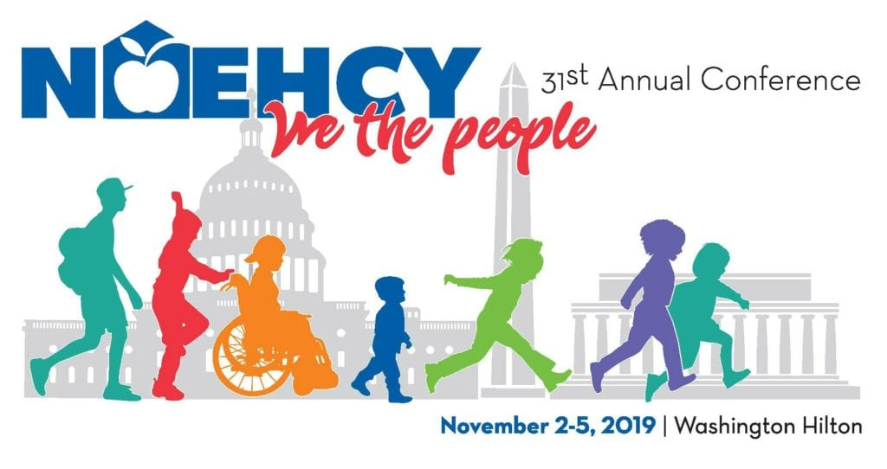

Speaking of Trainings (flyer on last page)….

The [2019 National Dropout Prevention Conference](http://dropoutprevention.org/conferences/2019-national-dropout-prevention-conference/), Gaining New Heights

in Dropout Prevention is October 5-8, 2019. This conference features strategies

and programs from across the country that have proven effective in engaging and

sustaining students through graduation.

*For Colorado participants, use code COED2019 to receive a 10% discount.

**Free Trainings provided by NCHE-** <https://nche.ed.gov/group-training/>

#### ****SUPPORTING YOUTH AND YOUNG ADULTS EXPERIENCING HOMELESSNESS THROUGH EDUCATION AND WORKFORCE PARTNERSHIPS****

Friday September 13, 2019 | 12:00PM-1:00PM MST

**Register:**<https://uncg.webex.com/uncg/onstage/g.php?MTID=ec6b5e606e31e759078a38659090e968a>

**Description:**In this webinar, attendees will learn about:

* the connection between education, employment, and housing affordability outcomes, including as addressed in Home, Together: The Federal Strategic Plan to Prevent and End Homelessness;
* federal education and employment programs that serve youth experiencing homelessness (McKinney-Vento Education for Homeless Children and Youth, Perkins Career and Technical Education, Adult Education, WIOA Youth Formula, YouthBuild, and Job Corps);
* policy and practice levers to encourage more targeted local efforts to ensure education and employment program access and success for young people experiencing homelessness;
* two local programs (Los Angeles and Washington, DC) that serve youth experiencing homelessness through intentional education and employment partnerships.

#### ****UNDERSTANDING DOUBLED UP****

Tuesday September 24, 2019 | 12:00PM-1:00PM MST

**Register:** <https://uncg.webex.com/uncg/onstage/g.php?MTID=e1f9080621a296dfc8a1309bae6309e63>

**Description:** In this 45-minute NCHE webinar, presenters explore the issue of doubling-up. Doubled-up is the informal wording used to describe a concept included in the McKinney-Vento Act's definition of homeless. It refers to shared living arrangements, some of which may be considered homeless, while others may not be, depending on various factors. In this session, attendees will explore some of these factors in greater detail. Attendees also will have the opportunity to interact with presenters and fellow attendees through polls and Q&A/discussion periods.

**Handouts:** You may download webinar handouts at [https://nche.ed.gov/understanding-doubled-up/](https://nche.ed.gov/understanding-doubled-up/?customize_changeset_uuid=4be8d709-a84b-49a3-8a56-e1f1f0323d5b&customize_autosaved=on&customize_messenger_channel=preview-21).

#### ****MCKINNEY-VENTO SCHOOL SELECTION RIGHTS****

Wednesday October 16, 2019 | 12:00PM-1:00PM MST

**Register:** <https://uncg.webex.com/uncg/onstage/g.php?MTID=ebd4246265075858373d0a65c786eadc1>

**Description:** In this interactive NCHE webinar, presenters will review important changes related to school selection for homeless children and youth under the McKinney-Vento Act, as amended by the Every Student Succeeds Act (ESSA). Presenters will cover:

* McKinney-Vento basics and context
* The McKinney-Vento Act’s definition of school of origin
* McKinney-Vento provisions related to determining the best interest of a student in terms of school selection (local school or school of origin)
* The provision of school-of-origin transportation to currently homeless students and formerly homeless students who have become permanently housed
* McKinney-Vento provisions related to dispute resolution, including disputes about school enrollment and selection

Attendees will have the opportunity to interact with presenters and fellow attendees through polls and Q&A/discussion periods.

**Handouts:** You may download webinar handouts at [https://nche.ed.gov/mckinney-vento-school-selection-rights/](https://nche.ed.gov/mckinney-vento-school-selection-rights/?customize_changeset_uuid=a94190d4-da99-4b17-bd72-29be86b10286&customize_autosaved=on&customize_messenger_channel=preview-0).

