Contact Information:
Kerry Wrenick, LMSW
(303) 866-6930
wrenick_k@cde.state.co.us
November is Homeless Awareness Month
What activities have you planned or are planning? How can you raise awareness within your community? Share what is happening: wrenick_k@cde.state.co.us

View the Governor’s Proclamation here

Go Green on November 12th

Colorado Department of Education is hosting a collection drive for personal care, hygiene products, socks, and needed items to be distributed to school districts. Share the easily accessible Amazon wish list here

Save the Date- Subgrantee and Liaison Training, January 16, 2020

CDE will be providing an opportunity for professional development and networking for those within the field of homeless education. The training is January 16, 2020 from 9am-3pm. This is a mandatory training for subgrantees, but anyone is welcome to attend. Location and registration to follow.

McKinney-Vento E-Communication

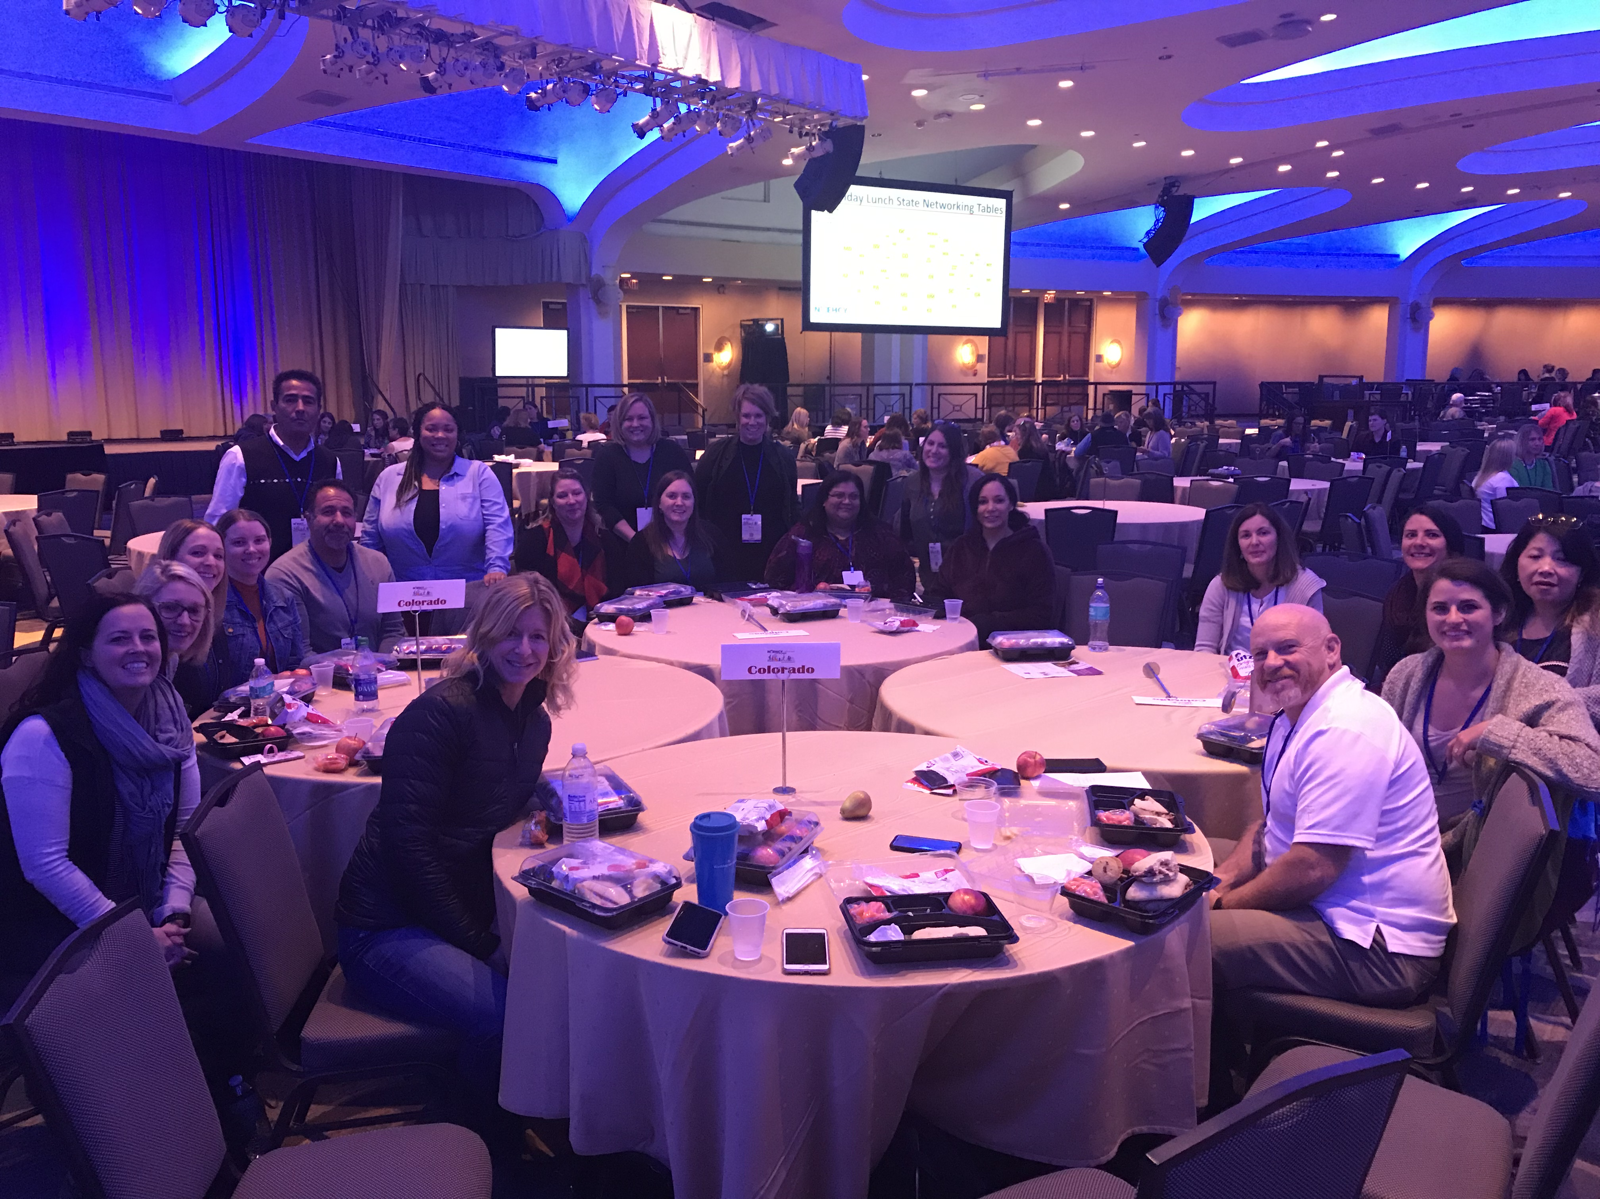

Colorado was representing during the National Association for the Education
of Homeless Children and Youth Conference, Washington DC, November 2019

A Few Reminders
- Survey links have been emailed to all McKinney-Vento Liaisons to complete the 2018-2019 U.S. Department of Education Survey. As a reminder, (1) Districts are not required to submit K-12 student counts. This information will be pulled from End of Year Reports. (2) Districts are required to submit Birth-2 and 3-5 (not Kindergarten) counts. This will be an informal collection, as this subgroup will not be identified through SASIDs.
Surveys must be completed by November 15th. Please check your email (and spam) to ensure you have received the individualized link and instructions. Please contact Kerry Wrenick, (wrenick_k@cde.state.co.us) with questions.
- Has there been a change within your school district for the McKinney-
Vento Liaison? If so, please email the updated contact information to
wrenick_k@cde.state.co.us. Please include: School District, Name, email, phone number

Application period open for 2020 Daniels Scholarship. Applications due Nov 15
For more information on the scholarship, including what items are needed to
apply, go to https://www.danielsfund.org/scholarships/daniels-scholarship-program/overview.

Grant Opportunities
Check out all grant opportunities by visiting the Competitive Grants webpage
- K-5 Social Emotional Health Pilot- The intent of the pilot program is to provide funding for social and emotional health to determine the impact of dedicated school mental health professionals in kindergarten through fifth grade elementary schools that have high-poverty, high-need students. Find out more on CDE’s Health and Wellness webpage
- Tony Grampsas Youth Services Program- TGYS funds prevention, intervention, and education programs for children, youth, and families aimed at reducing youth crime and violence, child abuse and neglect, school dropout, and/or adolescent and youth marijuana use across the state of Colorado.
All application details can be accessed on our website at: https://www.colorado.gov/pacific/cdhs/tony-grampsas-youth-services-program

Free Trainings provided by NCHE- https://nche.ed.gov/group-training/

MCKINNEY-VENTO 101: UNDERSTANDING THE RIGHTS OF STUDENTS EXPERIENCING HOMELESSNESS
Wednesday November 13, 2019 | 12:00PM-1:00PM MST
Register: https://register.gotowebinar.com/register/3263401490239158019
Description: In this interactive NCHE webinar, presenters will provide a high-level overview of the educational rights of children and youth experiencing homelessness under Subtitle VII-B of the McKinney-Vento Homeless Assistance Act, as amended by the Every Student Succeeds Act (ESSA). Presenters will cover:
- Understanding the relationship between housing and school performance
- McKinney-Vento basics and context
- Eligibility for McKinney-Vento rights and services
- Immediate school enrollment, school selection, and transportation rights under McKinney-Vento
- The McKinney-Vento dispute resolution process
Attendees will have the opportunity to interact with presenters and fellow attendees through polls and Q&A/discussion periods.
Handouts: You may download webinar handouts at https://nche.ed.gov/mckinney-vento-101-understanding-the-rights-of-students-experiencing-homelessness/.

UNDERSTANDING DOUBLED UP
Tuesday November 19, 2019 | 12:00PM-1:00PM MST
Register: https://register.gotowebinar.com/register/1698026785774662403
Description: In this 45-minute NCHE webinar, presenters explore the issue of doubling-up. Doubled-up is the informal wording used to describe a concept included in the McKinney-Vento Act's definition of homeless. It refers to shared living arrangements, some of which may be considered homeless, while others may not be, depending on various factors. In this session, attendees will explore some of these factors in greater detail. Attendees also will have the opportunity to interact with presenters and fellow attendees through polls and Q&A/discussion periods.
Handouts: You may download webinar handouts at https://nche.ed.gov/understanding-doubled-up/.

MCKINNEY-VENTO SCHOOL SELECTION RIGHTS
Thursday November 21, 2019 | 12:00PM-1:00PM MST
Register: https://register.gotowebinar.com/register/1992301177344671235
Description: In this interactive NCHE webinar, presenters will review important changes related to school selection for homeless children and youth under the McKinney-Vento Act, as amended by the Every Student Succeeds Act (ESSA). Presenters will cover:
- McKinney-Vento basics and context
- The McKinney-Vento Act’s definition of school of origin
- McKinney-Vento provisions related to determining the best interest of a student in terms of school selection (local school or school of origin)
- The provision of school-of-origin transportation to currently homeless students and formerly homeless students who have become permanently housed
- McKinney-Vento provisions related to dispute resolution, including disputes about school enrollment and selection
Attendees will have the opportunity to interact with presenters and fellow attendees through polls and Q&A/discussion periods.
Handouts: You may download webinar handouts at https://nche.ed.gov/mckinney-vento-school-selection-rights/.

SUPPORTING THE EDUCATION OF UNACCOMPANIED STUDENTS EXPERIENCING HOMELESSNESS
Tuesday December 3, 2019 | 12:00PM-1:00PM MST
Register: https://uncg.webex.com/uncg/onstage/g.php?MTID=e20bf2510dec0d27d52c8417c09a78544
Description: In this interactive NCHE webinar, presenters will review key concepts related to the education of unaccompanied youth experiencing homelessness included in the McKinney-Vento Act, as amended by the Every Student Succeeds Act (ESSA). Presenters will cover:
- McKinney-Vento Act definitions of unaccompanied and homeless
- K-12 educational rights and supports for unaccompanied homeless students
- Supports for unaccompanied homeless youth transitioning to higher education
Attendees will have the opportunity to interact with presenters and fellow attendees through polls and Q&A/discussion periods.
Handouts: You may download webinar handouts at https://nche.ed.gov/supporting-the-education-of-unaccompanied-students-experiencing-homelessness/.

PAVING THE WAY TO COLLEGE FOR STUDENTS EXPERIENCING HOMELESSNESS
Wednesday December 11, 2019 | 12:00PM-1:00PM MST
Register: https://uncg.webex.com/uncg/onstage/g.php?MTID=edcf4ae01faa9950b8039f5ed643c7de9
Description: In this interactive NCHE webinar, presenters will review important information about supports available to youth experiencing homelessness as they seek to attend college. Attendees can hope to gain a better understanding of:
- Fee waiver options for college entrance exams and college application fees
- The FAFSA (Free Application for Federal Student Aid) process for students experiencing homelessness with their family/parent/guardian, and students experiencing homelessness on their own (unaccompanied homeless youth)
- Options for seeking financial assistance beyond federal financial aid
- Options for undocumented youth wishing to attend college
Attendees will have the opportunity to interact with presenters and fellow attendees through polls and Q&A/discussion periods.
Handouts: You may download webinar handouts at https://nche.ed.gov/nche-webinar-materials-paving-the-way-to-college-for-students-experiencing-homelessness/.

DETERMINING ELIGIBILITY FOR MCKINNEY-VENTO RIGHTS AND SERVICES
Thursday December 19, 2019 | 12:00PM-1:00PM ET
Register: https://uncg.webex.com/uncg/onstage/g.php?MTID=e39f799f8efb57e2b9219769eb7ec95cb
Description: In this interactive NCHE webinar, presenters will review the McKinney-Vento definition of homeless children and youth, as amended by the Every Student Succeeds Act (ESSA). Presenters will cover:
- McKinney-Vento Act basics and context
- Understanding the dynamics of family and youth homelessness
- The McKinney-Vento definition of homeless
- McKinney-Vento provisions on dispute resolution, including disputes related to eligibility
Attendees will have the opportunity to interact with presenters and fellow attendees through polls and Q&A/discussion periods.
Handouts: You may download webinar handouts at https://nche.ed.gov/determining-eligibility-webinar/.

