

Contact Information:

Kerry Wrenick, LMSW

(303) 815-7010

wrenick_k@cde.state.co.us

**Data Elements for Homeless Students**

Effective July 1, 2020- school districts are required to track additional information related to the “Cause of Housing Crisis.” A webinar was conducted on August 4, 2020 and a recording can be found [here](https://enetlearning.adobeconnect.com/pgbu8y6emvy1/).

Make every effort to connect with data managers to ensure these elements have been added to your Student Information System.

**It is important for parents/UHY to select one of the “Causes” rather than “None of the Above” to reflect needs of the community.

**Birth-2 and 3-5 (not K) Reporting**

Districts **are** required to submit Birth-2 and 3-5 (not Kindergarten) counts through the USDE Survey submitted in November. This will be an informal collection, as this subgroup will not be identified through SASIDs. Districts can decide the most effective tracking strategies, or reach out to State Coordinator for guidance.

**Monthly e-communication is a tool to stay connected and keep up-to-date with relevant MKV information. Do you have something to share or celebrate? We want to know!**

**McKinney-Vento May 2021**

**Feed the Children** and the **Colorado Department of Education** are continuing their partnership to provide backpacks, books, and school supplies to Colorado School Districts to distribute to students experiencing homelessness.

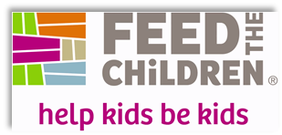

**Details included in the attachments.** If you

are interested in receiving backpacks for

students in your district experiencing

homelessness,please email before May 28th.

**McKinney-Vento Data Collection**

As a Liaison, are you communicating with your Local Access Manager to ensure McKinney-Vento student counts are accurate? End of Year reporting is fast approaching and we want to make sure accurate reporting of students.

**ARP Homeless Children and Youth Fund**

U.S. Department of Education (Department) under section 2001(b)(1) of the *American Rescue Plan Act of 2021* (ARP) for the purposes of identifying homeless children and youth, providing wraparound services in light of the impact of the COVID-19 pandemic, and providing assistance needed to enable homeless children and youth to attend school and participate fully in school activities, including in-person instruction this spring and summer learning and enrichment programs

* $199,750,000 (25% of the $799 million) will be made available to States now. This first disbursement is designed to provide funding to States immediately as a supplement to their McKinney-Vento Education for Homeless Children and Youth (EHCY) funds, so that States can address urgent needs of homeless children and youth—including academic, social, emotional, and mental health needs—and so States and local educational agencies (LEAs) can increase capacity by hiring staff, dedicating resources, and planning partnerships with community-based organizations, among other strategies. Funds must be administered by the Office of the State Coordinator for the Education of Homeless Children and Youth, consistent with the requirements for EHCY funds.
* $599,250,000 (75% of the $799 million) will be made available as soon as June after the Department completes necessary regulations to change EHCY’s required competitive subgrant process for the purpose of the

second allocation of funding. The Department anticipates that the new regulation would require States to distribute funds that they will receive in the second phase to LEAs via a formula that uses the LEA’s allocation under Title I, Part A (Title I) of the Elementary and Secondary Education Act of 1965 (ESEA) and the number of identified homeless children and youth in 2018-19.

**Highly-Mobile Coffee Chats**

In partnership with Foster Care Education, we are hosting a monthly ‘Highly-Mobile’ Coffee Chat. The Coffee Chats are an opportunity to connect with other Liaisons on important issues related to your work. We will highlight colleagues and showcase best practices. We strive to make the setting more informal and casual in an effort to interact and build community. There will not be a registration process, just join when you can.

When: Second Thursday of the Month, 10-11am

Where: Zoom (link to be sent prior)

Topics: Varying, but relevant

**\*\* See attached Memo as a follow-up to SB 20-106 as discussed during April Coffee Chat with CDHS**

**Vaccines and Unaccompanied Youth**

Colo. Rev. Stat. §13-22-103: A minor eighteen years of age or older, or a minor fifteen years of age or older who is living separate and apart from his or her parent, parents, or legal guardian, with or without the consent of his or her parent, parents, or legal guardian, and is managing his or her own financial affairs, regardless of the source of his or her income, or any minor who has contracted a lawful marriage may give consent to organ or tissue donation or the furnishing of hospital, medical (which encompasses vaccines), dental, emergency health, and surgical care to himself or herself.

**USDA Extends Meal Flexibilities Through the 2021-2022 School Year**

U.S. Department of Agriculture (USDA) [issued a broad range of flexibilities](https://serve.bmetrack.com/c/l?u=C2396A9&e=12478D8&c=A98FB&t=0&l=23E02E67&email=SMoEbKkTeUyCj%2BukgxSixzciHg%2FVbFy1&seq=2) to allow school meal programs and childcare institutions across the country to return to serving healthy meals in fall 2021 as part of the Biden-Harris Administration’s commitment to reopen schools safely. Several meal service flexibilities that enable social distancing are now extended through June 30, 2022.

Read the [full USDA press release](https://serve.bmetrack.com/c/l?u=C2396A9&e=12478D8&c=A98FB&t=0&l=23E02E67&email=SMoEbKkTeUyCj%2BukgxSixzciHg%2FVbFy1&seq=3) to learn more about the specific flexibilities that have been extended through the 2021-2022 school year, and for a refresher on nutrition-related provisions included in the American Rescue Plan Act.

**\*NEW* NCHE’s Education Goals and Supports: A Guided Discussion**

This tool may be used by service providers working with youth and young adults (YYA) experiencing homelessness to guide YYA clients through a discussion of their interests and skills. The tool uses motivational interviewing questions to help determine the client’s interest in pursuing education, provides online resources to help the client explore education and career pathways and determine possible pathway options in areas of interest, includes information on how to pay for higher education, and recommends next steps towards the client’s goals.

The tool can be used during the intake process or later after a client’s basic needs have been met. Regardless of a client's readiness to pursue educational goals, the questions in Section 1 may be used to plant seeds for revisiting the discussion at a later time. It is recommended that the service provider and client walk through the tool and record the client’s responses in either electronic or hard-copy format (Attached to email).

**HEAR US Inc.**

HEAR US Inc. has released a new video about family homelessness surging amidst COVID-19. Check it out [here](https://hearus.us/understand-homelessnses/videos/capital-failure.html). Additional materials and resources can be found on their website [Home - HEAR US: Voice and Visibility for Homeless Children and Youth](https://hearus.us/).

**Free Webinars and Professional Development**

# **Supporting the Health and Wellness of Children Experiencing Homelessness in the Time of COVID-19**

## ****Thursday, May 13, 2021**** ****12–1 p.m. MT****

## [****Register Online Now!****](https://urldefense.proofpoint.com/v2/url?u=https-3A__hendall.cmail20.com_t_j-2Dl-2Dfolke-2Dqiusmlk-2Dt_&d=DwMFaQ&c=sdnEM9SRGFuMt5z5w3AhsPNahmNicq64TgF1JwNR0cs&r=wKdSaC6KgNGP9Bo2rdtETYkrC8lDYGNZv4AtYOkHLOk&m=6kQVNkkHg5dRzGH2T8otF3cIuQFfCACkXexTVX8n4y4&s=M0sTaQ8K9n-Kl2MEq3JHkF7iGYpbt0BB_spKQxPmGLg&e=)

Join this webinar to learn about impact of the COVID-19 pandemic on family homelessness. Discover strategies that Head Start programs can use to address the barriers to health and wellness facing families experiencing homelessness. Jacki Hart, MD, and Katie Volk, MA, subject matter experts on homelessness for the National Center on Health, Behavioral Health, and Safety (NCHBHS), will present.

**Provided by SchoolHouse Connection-** [Upcoming Webinars | SchoolHouse Connection](https://schoolhouseconnection.org/learn/webinars/upcoming-webinars/)

Topics include: Bold Ideas for Using ARP Homeless Education Funding

Racial Equity and Students Experiencing Homelessness

**Provided by NCHE-** <https://nche.ed.gov/group-training/>

#### ****UNDERSTANDING DOUBLED UP****

Thursday, May 13, 2021 | 12:00PM-1:00PM MT **Register:**<https://uncg.zoom.us/webinar/register/WN_BTHqwqiOTHqfawBjABC8fA>

**Description:** In this 45-minute NCHE webinar, presenters explore the issue of doubling-up. Doubled-up is the informal wording used to describe a concept included in the McKinney-Vento Act's definition of homeless. It refers to shared living arrangements, some of which may be considered homeless, while others may not be, depending on various factors. In this session, attendees will explore some of these factors in greater detail. Attendees also will have the opportunity to interact with presenters and fellow attendees through polls and Q&A/discussion periods.

**Handouts:** You may download webinar handouts at <https://nche.ed.gov/understanding-doubled-up/>.

#### ****PAVING THE WAY TO COLLEGE FOR STUDENTS EXPERIENCING HOMELESSNESS****

Tuesday, May 25, 2021 | 12:00PM-1:00PM MST **Register:**<https://uncg.zoom.us/webinar/register/WN_H6IUoPX5RD-yF0jamcP8Iw>

**Description:**In this interactive NCHE webinar, presenters will review important information about supports available to youth experiencing homelessness as they seek to attend college. Attendees can hope to gain a better understanding of:

* Fee waiver options for college entrance exams and college application fees
* The FAFSA (Free Application for Federal Student Aid) process for students experiencing homelessness with their family/parent/guardian, and students experiencing homelessness on their own (unaccompanied homeless youth)
* Options for seeking financial assistance beyond federal financial aid
* Options for undocumented youth wishing to attend college

Attendees will have the opportunity to interact with presenters and fellow attendees through polls and Q&A/discussion periods.

**Handouts:** You may download webinar handouts at <https://nche.ed.gov/nche-webinar-materials-paving-the-way-to-college-for-students-experiencing-homelessness/>.

#### ****MCKINNEY-VENTO 101: bASIC REQUIREMENTS OF THE MCKINNEy-VENTO ACT****

Thursday, June 10, 2021 | 12:00PM-1:00PM MST **Register:**https://uncg.zoom.us/webinar/register/WN_0_Yy3mlgT4GIiFFNSJWHPw

**Description:** In this interactive NCHE webinar, presenters will provide a high-level overview of the educational rights of children and youth experiencing homelessness under Subtitle VII-B of the McKinney-Vento Homeless Assistance Act, as amended by the Every Student Succeeds Act (ESSA). Presenters will cover:

* Understanding the relationship between housing and school performance
* McKinney-Vento basics and context
* Eligibility for McKinney-Vento rights and services
* Immediate school enrollment, school selection, and transportation rights under McKinney-Vento
* The McKinney-Vento dispute resolution process

Attendees will have the opportunity to interact with presenters and fellow attendees through polls and Q&A/discussion periods.

**Handouts:** You may download webinar handouts at  <https://nche.ed.gov/mckinney-vento-101-basic-requirements-of-the-mckinney-vento-act/>.

#### ****Supporting the education of unaccompanied students experiencing homelesness****

Tuesday, June 22, 2021 | 12:00PM-1:00PM MST **Register:**<https://uncg.zoom.us/webinar/register/WN_6HrYo258RGexj-dQApbnjg>

**Description:** In this interactive NCHE webinar, presenters will review key concepts related to the education of unaccompanied youth experiencing homelessness included in the McKinney-Vento Act, as amended by the Every Student Succeeds Act (ESSA). Presenters will cover:

* McKinney-Vento Act definitions of unaccompanied and homeless
* K-12 educational rights and supports for unaccompanied homeless students
* Supports for unaccompanied homeless youth transitioning to higher education

Attendees will have the opportunity to interact with presenters and fellow attendees through polls and Q&A/discussion periods.

**Handouts:** You may download webinar handouts at <https://nche.ed.gov/supporting-the-education-of-unaccompanied-students-experiencing-homelessness/>

**Provided by NAEHCY:** [2021 NAEHCY Conference – National Association for the Education of Homeless Children and Youth](https://naehcy.org/2021-conference/)

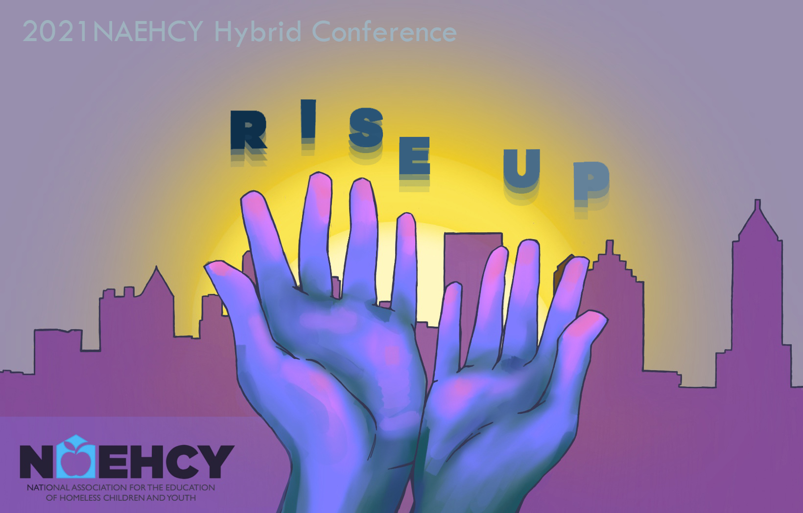

## Atlanta, GA November 13 – 16, 2021

### Hyatt Regency, Peachtree Street

