Contact Information:
Kerry Wrenick, LMSW
(303) 866-6930
wrenick_k@cde.state.co.us

Adams 12 Five Star School District went green for Homeless Awareness Month

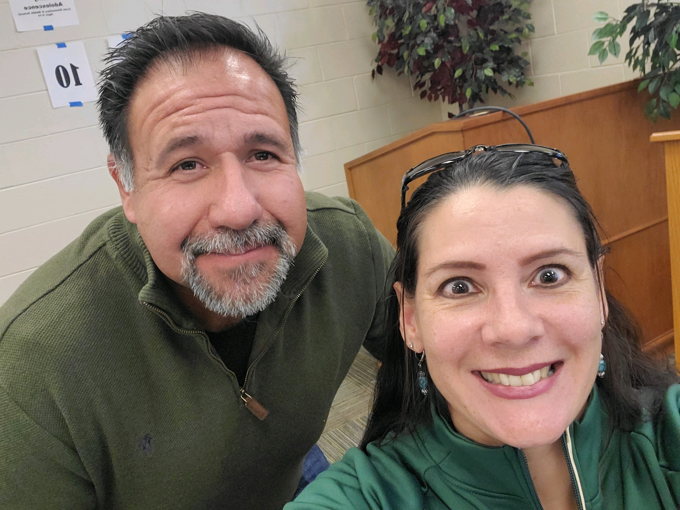

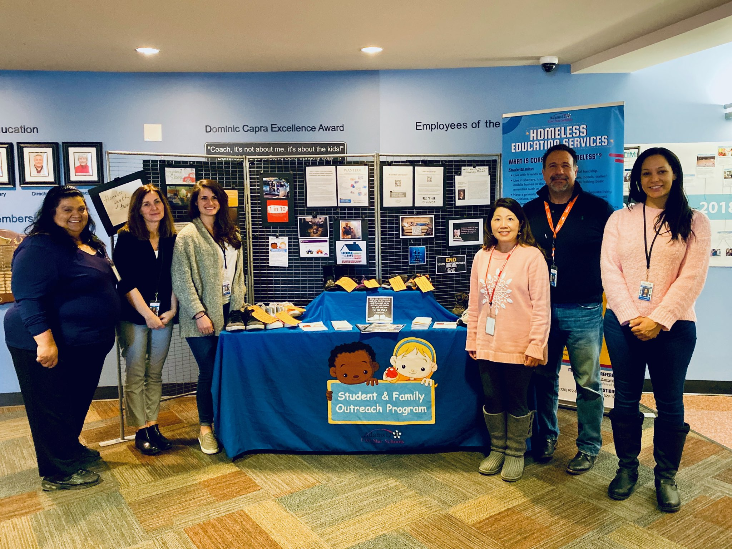

Monthly e-communication is a tool to stay connected and keep up-to-date with relevant MKV information. Do you have something to share or celebrate? We want to know!

McKinney-Vento- January 2020
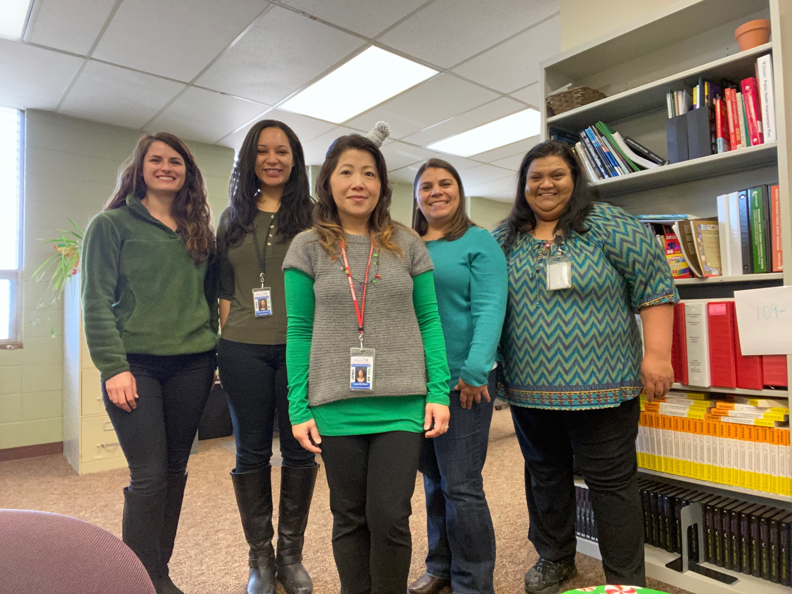
Celebrating Success
"When I was in elementary school, my mother and I moved from house to house and had regular stints of homelessness. We eventually found a home and lived there for three years. It was pretty good except for my acting out. This is
mostly because my mom was not the best mom. She would often leave spontaneously, and I would be left alone and would have to fend for myself.
One day in eighth grade, I came home, not to my mom, but to my uncle Phil,
who sat me down and said she had lung cancer. I just sat there and cried
because I knew she smoked at least three packs a day, but I thought my mom
was invincible. I thought nothing could hurt her, that nothing could take her
down. I remember thinking about the last time I saw her. We were in each
other's face. I guess I was just venting because I hated being at my uncle's. I
hated having to conform to his rules. I hated myself for being so selfish and hateful to my mom. I couldn't say any of that. All I could do was hold her hand
and think about all the missed opportunities. I had a hard time with depression, but eventually I reached acceptance that my mom was gone and that the only thing I can do is be better than she could have ever imagined I would be. After being passed around from family member to family member, I am on my own.
I am a high school senior, and my goal is to go to college and make something
of myself so my children will never experience what I have."

Focus on Identification in 2020
With a new year and a new decade comes a time for reflection and an
opportunity to elevate our goals. Colorado has made great strides to identify students experiencing homelessness and over the next year there will be an even greater focus on identification. We will use data to look at trends, under identification, and make informed decisions around technical assistance.

Did you know…McKinney-Vento identification should be approximately 10% of
the total free lunch recipients within a school district.

Point-In-Time Count and School District Participation
The National Center on Homeless Education (NCHE) has created resources geared towards a school audience, providing information about the U.S. Department of Housing and Urban Development's annual Point-In-Time (PIT) count, and suggests strategies for how schools can help ensure the most comprehensive and effective count of youth experiencing homelessness.
Download the fact sheet: https://nche.ed.gov/data-collection/ (scroll down and
look along the right)

Updated McKinney-Vento Webpage with Templates!
We have updated the MKV webpage to provide you with current information, resources, and tools. The revised “District Liaisons” tab includes Sample
Documents such as Residency Questionnaire, Caregiver’s Authorization, etc.
Check out the revised webpage when you have a chance.
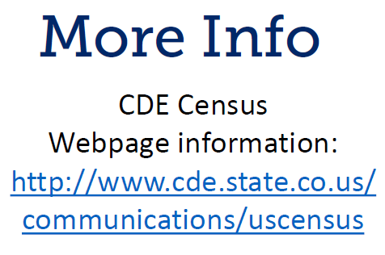
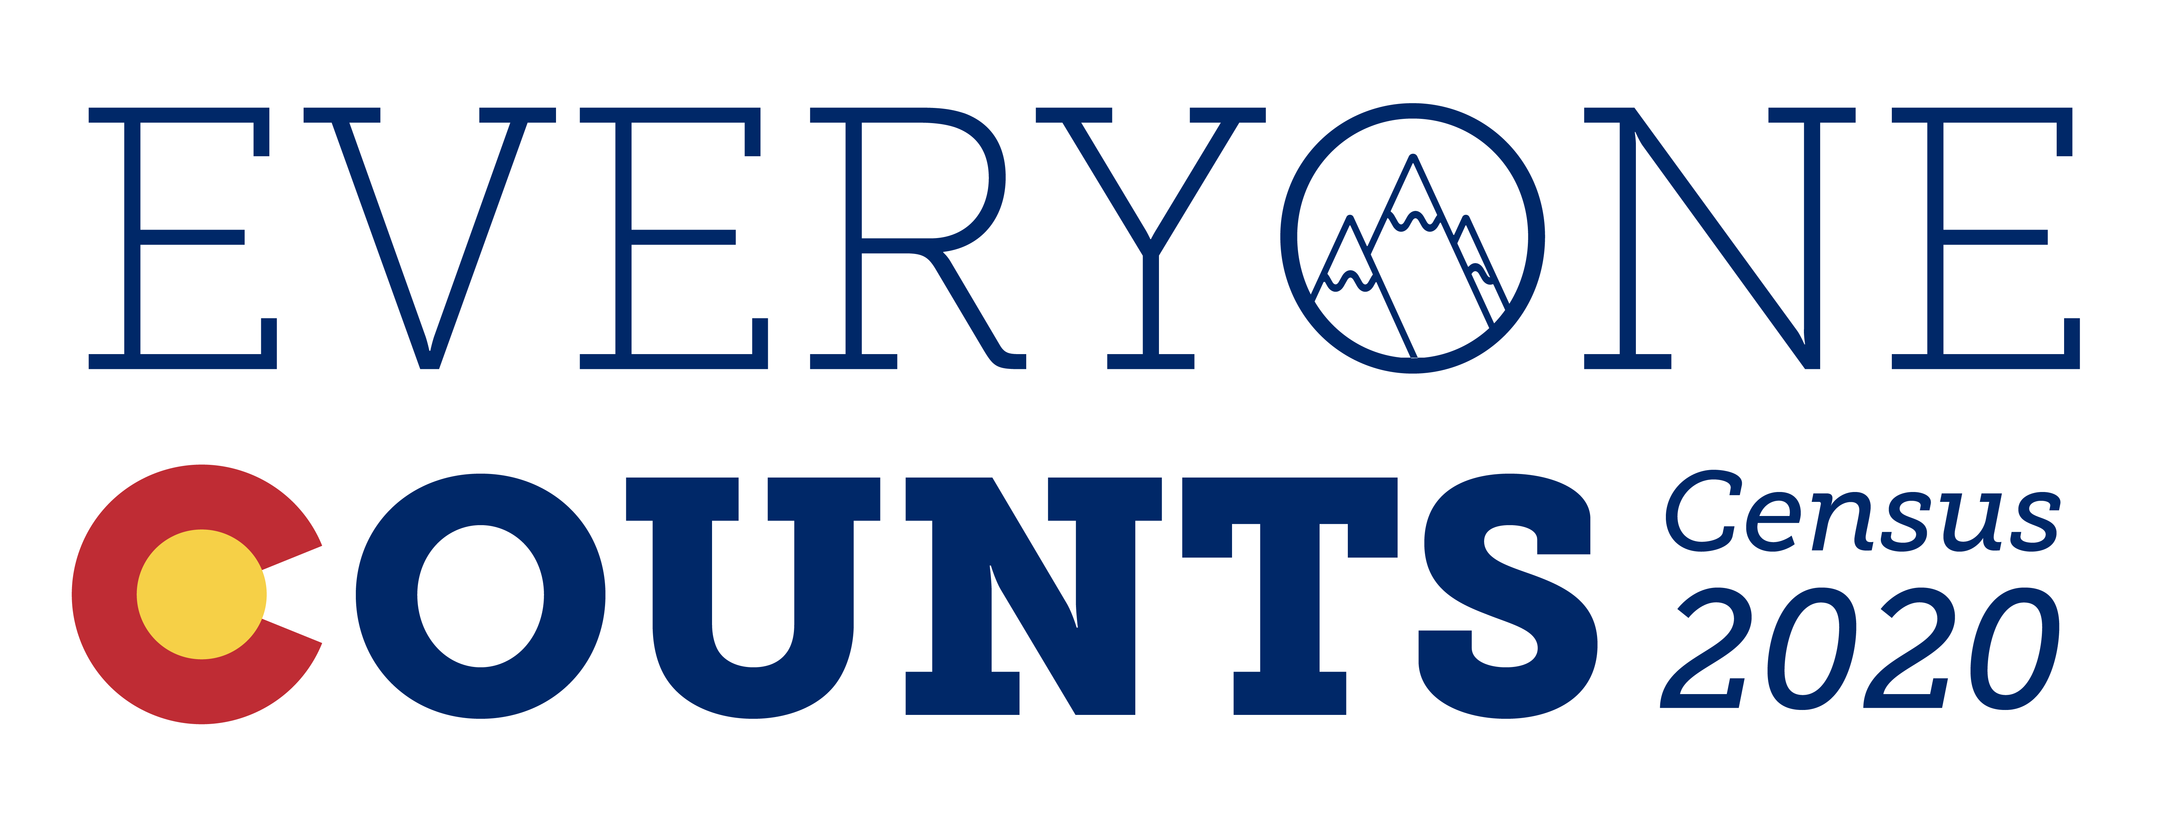
The 2020 Census is right around the corner! Please join the 2020 Census, Family Promise, First Focus on Children, and SchoolHouse Connection for a webinar on February 4, from 1:30 – 2:30 p.m. MST. During this time we’ll highlight the importance of the census, how the census impacts family and youth homelessness, and how the census impacts YOU! Below is a high-level agenda of the event.
- 2020 Census Overview
- Overview of the State of Homelessness
- Shelters and Group Quarters Overview
- What communities are doing relating to the 2020 Census
  - The Count All Kids Committee
  - Focus groups
  - Shared housing (“doubled-up”); Households where parents and guardians are not the head
- Unaccompanied Youth
- Motels
- Families in Homeless Situations
- Partners we’re working with, and who YOU think we should work with
- Question & Answer
Webinar link:
2020 Census Partnership Outreach Webinars
Please join my meeting from your computer, tablet or smartphone.
https://global.gotomeeting.com/join/699255437
You can also dial in using your phone.
(For supported devices, tap a one-touch number below to join instantly.)
United States: +1 (872) 240-3212
- One-touch: tel:+18722403212,,699255437#

Professional Development
Every Student Succeeds Act (ESSA) highlights the requirement for Liaisons to participate in and conduct ongoing professional development that enhances knowledge and skills within the McKinney-Vento program. There are various opportunities for professional development including, but not limited to: Liaison trainings, NAEHCY Conference, State Conferences, webinars, national trainings. It is important to stay current within homeless education and changes that may impact your work.

Free Trainings
Provided by NAEHCY- https://naehcy.org/webinar/

Early heaD start: supporting infants and toddler expereincing homelessness
Friday, January 24, 2020 11:00 AM – 12:00 PM MST at:
https://attendee.gototraining.com/r/3262786865983956738

Description: This webinar will provide an overview of the federal Early Head Start (EHS) program, including the goals of the program, the services offered, eligibility requirements, and benefits for families. Additionally, attendees will learn about why EHS is a great fit for families experiencing homelessness, the EHS policies and requirements specific to homelessness, and how McKinney-Vento liaisons and other stakeholders working with families experiencing homelessness can locate, refer to, and work with EHS programs in their communities.
Presenter: Tracy Duarte, Director, Pennsylvania Head Start State Collaboration Office
After registering you will receive a confirmation email containing information about joining the training.

Provided by NCHE- https://nche.ed.gov/group-training/
DETERMINING ELIGIBILITY FOR MCKINNEY-VENTO RIGHTS AND SERVICES
Thursday January 30, 2020 | 12:00PM-1:00PM MST
Register: https://uncg.webex.com/uncg/onstage/g.php?MTID=e98a4781c27dae374dceda86eafb94a41
Description: In this interactive NCHE webinar, presenters will review the McKinney-Vento definition of homeless children and youth, as amended by the Every Student Succeeds Act (ESSA). Presenters will cover:
- McKinney-Vento Act basics and context
- Understanding the dynamics of family and youth homelessness
- The McKinney-Vento definition of homeless
- McKinney-Vento provisions on dispute resolution, including disputes related to eligibility
Attendees will have the opportunity to interact with presenters and fellow attendees through polls and Q&A/discussion periods.
Handouts: You may download webinar handouts at https://nche.ed.gov/determining-eligibility-webinar/.

PAVING THE WAY TO COLLEGE FOR STUDENTS EXPERIENCING HOMELESSNESS
Tuesday, February 4, 2020 | 12:00PM-1:00PM MST Register: https://uncg.webex.com/uncg/onstage/g.php?MTID=e14601c701d53c36b07cab634eb8e2f42
Description: In this interactive NCHE webinar, presenters will review important information about supports available to youth experiencing homelessness as they seek to attend college. Attendees can hope to gain a better understanding of:
- Fee waiver options for college entrance exams and college application fees
- The FAFSA (Free Application for Federal Student Aid) process for students experiencing homelessness with their family/parent/guardian, and students experiencing homelessness on their own (unaccompanied homeless youth)
- Options for seeking financial assistance beyond federal financial aid
- Options for undocumented youth wishing to attend college
Attendees will have the opportunity to interact with presenters and fellow attendees through polls and Q&A/discussion periods.
Handouts: You may download webinar handouts at https://nche.ed.gov/nche-webinar-materials-paving-the-way-to-college-for-students-experiencing-homelessness/.

MCKINNEY-VENTO SCHOOL SELECTION RIGHTS
Thursday, February 13, 2020 | 12:00PM-1:00PM MST Register: https://uncg.webex.com/uncg/onstage/g.php?MTID=ed7105c9d0d4c1227ff21d228bd4c992c
Description: In this interactive NCHE webinar, presenters will review important changes related to school selection for homeless children and youth under the McKinney-Vento Act, as amended by the Every Student Succeeds Act (ESSA). Presenters will cover:
- McKinney-Vento basics and context
- The McKinney-Vento Act’s definition of school of origin
- McKinney-Vento provisions related to determining the best interest of a student in terms of school selection (local school or school of origin)
- The provision of school-of-origin transportation to currently homeless students and formerly homeless students who have become permanently housed
- McKinney-Vento provisions related to dispute resolution, including disputes about school enrollment and selection
Attendees will have the opportunity to interact with presenters and fellow attendees through polls and Q&A/discussion periods.
Handouts: You may download webinar handouts at https://nche.ed.gov/mckinney-vento-school-selection-rights/.

SUPPORTING THE EDUCATION OF UNACCOMPANIED STUDENTS EXPERIENCING HOMELESSNESS
Thursday, February 20, 2020 | 12:00PM-1:00PM MST Register: https://uncg.webex.com/uncg/onstage/g.php?MTID=ec72caccaaa73c346a9125ca000c547c4
Description: In this interactive NCHE webinar, presenters will review key concepts related to the education of unaccompanied youth experiencing homelessness included in the McKinney-Vento Act, as amended by the Every Student Succeeds Act (ESSA). Presenters will cover:
- McKinney-Vento Act definitions of unaccompanied and homeless
- K-12 educational rights and supports for unaccompanied homeless students
- Supports for unaccompanied homeless youth transitioning to higher education
Attendees will have the opportunity to interact with presenters and fellow attendees through polls and Q&A/discussion periods.
Handouts: You may download webinar handouts at https://nche.ed.gov/supporting-the-education-of-unaccompanied-students-experiencing-homelessness/.

MCKINNEY-VENTO 101: UNDERSTANDING THE RIGHTS OF STUDENTS EXPERIENCING HOMELESSNESS
Tuesday, March 3, 2020 | 12:00PM-1:00PM MST Register: https://uncg.webex.com/uncg/onstage/g.php?MTID=e8e9b7b1af418dfaed5b9cfb83857edce
Description: In this interactive NCHE webinar, presenters will provide a high-level overview of the educational rights of children and youth experiencing homelessness under Subtitle VII-B of the McKinney-Vento Homeless Assistance Act, as amended by the Every Student Succeeds Act (ESSA). Presenters will cover:
- Understanding the relationship between housing and school performance
- McKinney-Vento basics and context
- Eligibility for McKinney-Vento rights and services
- Immediate school enrollment, school selection, and transportation rights under McKinney-Vento
- The McKinney-Vento dispute resolution process
Attendees will have the opportunity to interact with presenters and fellow attendees through polls and Q&A/discussion periods.
Handouts: You may download webinar handouts at https://nche.ed.gov/mckinney-vento-101-understanding-the-rights-of-students-experiencing-homelessness/.

