Please use the following guidance when planning and completing the budget in GAINS for your grant application for the Colorado Nonprofits Out-of-School Time Grant program.

Performance Period
The Colorado Nonprofits Out-of-School Time Grant Program is considered a three-year grant because it is inclusive of three fiscal years (FY2024-25, FY2025-26, and FY2026-27). The performance period for this grant is from March 2025 through June 2027, which spans 28 months. Awarded applicants, also known as grantees, will receive their Grant Award Letters and funds disbursement in March 2025. As stated on page 5 of the RFA, grantees “must begin their programming for students and families in May 2025 when the 2024-2025 school year ends and summer session starts. Funded programs will run continuously from May 2025 through June 2027 with both school year and summer sessions for students and families.”

Funds Disbursement
Since this is a state grant, it is forward funded, meaning that grantees will receive two lump sums from CDE for both the 2024-25 and the 2025-26 fiscal years. The FY2024-25 disbursement from CDE to grantees will be in March 2025; the FY2025-26 disbursement from CDE to grantees will be in July/August 2025.

Fund Requests
Applicants may request the maximum award amount of $750,000 for both FY2024-25 and FY2025-26, meaning their total requested amount for this funding opportunity can be up to $1.5 million. Please note that all funding requests must be reasonable, appropriate, allocable and allowable according to the applicant’s proposed programs for May-June 2025 and for July 2025-June 2026.

Competing the Budget in GAINS
In GAINS, applicants should budget for a total of 14 months, covering summer programs in May and June 2025 (FY2024-25) as well as school year and summer programs in FY2025-26. Please create separate FY24-25 budget line items and FY25-26 line items. See the screenshots below for an example of how to budget for a club coordinator staffing position that spans FY24-25 and FY25-26.

EXAMPLE GAINS Budget Line Item 1:
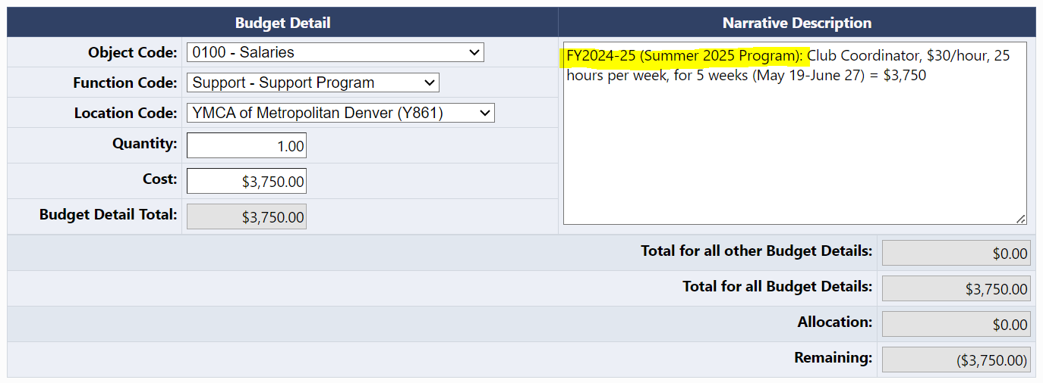

EXAMPLE GAINS Budget Line Item 2:
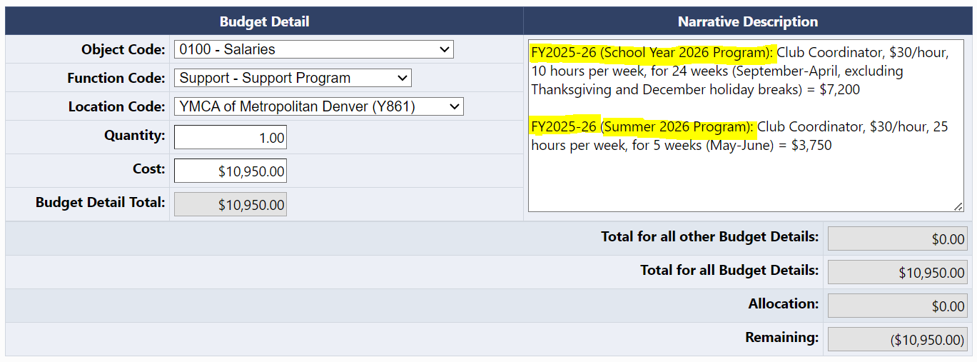

EXAMPLE GAINS Budget Summary with Line Items 1 and 2 above:
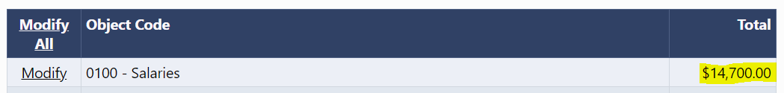

Definitions
To budget properly for both fiscal years spanning 14 months, below are helpful definitions and terms for school year and summer.

School year: Also known as the academic year, the school year is the portion of the calendar year during which the public schools of a school district are in regular session, beginning about the last week in August to the first week in September and ending about the end of May or the first week in June the following year (C.R.S. 22-63-103).

Summer: Summer Seasonal Break is the time between the end of one school year and the beginning of the next school year. The break occurs during the non-school months in the summer from May/June to August/September. For students to receive effective dosage of out-of-school time programming during the summer months, CDE recommends that summer programs run for 4-8 weeks during the summer seasonal break.

Questions?
If you have any additional questions about how to create a budget for this grant application, please contact Anna Young, OST Manager.

If you have any issues with creating a budget in GAINS for this grant application, please email GAINS@cde.state.co.us.

