Instructional Unit Authors
Greeley School District 6
Kelly Kennedy
Meagan Reliford
Brad Farbo
Robert Bustrum

Based on a curriculum overview Sample authored by
Aurora Public Schools
Chris Strater
Colorado Springs School District 11
Aaron Ford
Community Leadership
Shannon Loveridge
Woodland Park School District Re-2
Sue Wright

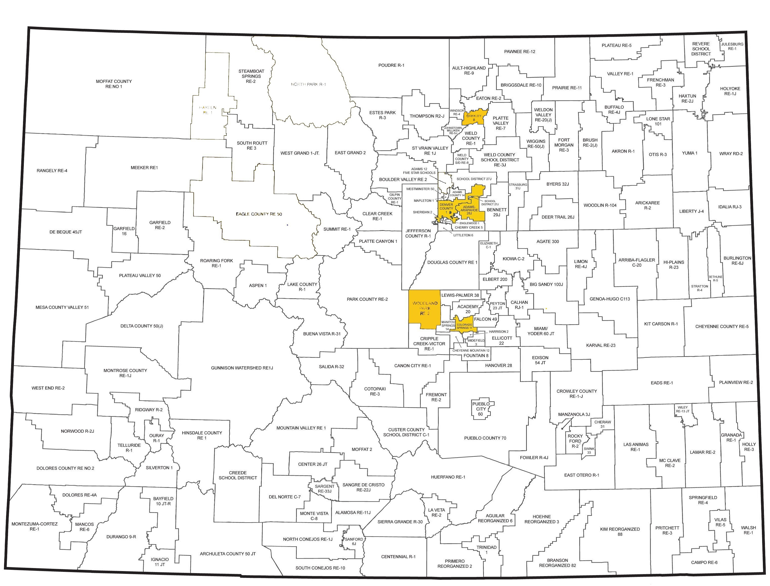

This unit was authored by a team of Colorado educators. The template provided one example of unit design that enabled teacher-authors to organize possible learning experiences, resources, differentiation, and assessments. The unit is intended to support teachers, schools, and districts as they make their own local decisions around the best instructional plans and practices for all students.
Colorado’s District Sample Curriculum Project
Date Posted: APRIL, 2018
Physical Education
Kindergarten
Colorado Teacher-Authored Instructional Unit Sample

Unit Title: Relationships with Others
Content Area | Physical Education |  |  | Grade Level | Kindergarten
Relationships with Others | Relationships with Others
Standard | Grade Level Expectations (GLE) |  |  |  |  |  | GLE Code
Movement Competence and Understanding | 1. Demonstrate body and spatial awareness through safe movement |  |  |  |  |  | PE09-GR.k-S.1-GLE.1
 | 2. Locate the major parts of the body |  |  |  |  |  | PE09-GR.k-S.1-GLE.2
Physical and Personal Wellness | 1.Understand that physical activity increases the heart rate, making the heart stronger |  |  |  |  |  | PE09-GR.k-S.2-GLE.1
Emotional and Social Wellness | 1.Demonstrate respect for self, others, and equipment |  |  |  |  |  | PE09-GR.k-S.3-GLE.1
 | 2.Demonstrate the ability to follow directions |  |  |  |  |  | PE09-GR.k-S.3-GLE.2
Prevention and Risk  Management | - Expectations for this standard are integrated into the other standards at this grade level movement control for safe participation in games and sports
Colorado 21st Century Skills  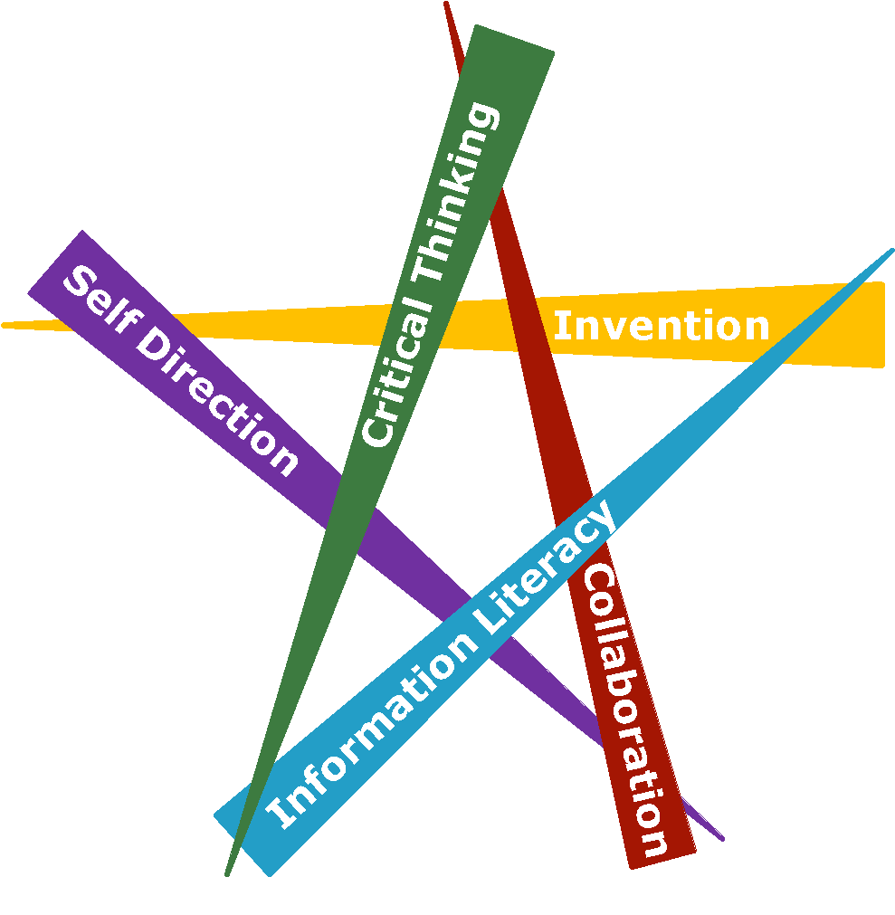  Critical Thinking and Reasoning: Thinking Deeply, Thinking Differently  Information Literacy: Untangling the Web  Collaboration: Working Together, Learning Together  Self-Direction: Own Your Learning  Invention: Creating Solutions |  | 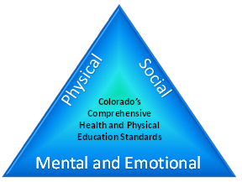
Unit Titles |  |  | Length of Unit/Contact Hours |  |  | Unit Number/Sequence
Relationships with Others |  |  | Teacher’s Discretions

Unit Title |  | Relationships with Others |  | Length of Unit | Teacher’s Discretions
Focusing Lens(es) | Cooperation |  | Standards and Grade Level Expectations Addressed in this Unit |  |  | PE09-GR.k-S.1-GLE.1  PE09-GR.k-S.3-GLE.1  PE09-GR.k-S.3-GLE.2
Inquiry Questions (Engaging- Debatable): | - What does it mean to have rhythm? (PE09-GR.1-S.1-GLE.1-EO.d,e; IQ. 2,4;)  - Why is it important to have personal space? (PE09-GR.1-S.1-GLE.3-EO.d; IQ. 4; RA. 1,3; N.1)  - Why are dances (like the “chicken dance, “bunny hop,” and “electric slide”) so popular at group gatherings such as wedding receptions? (PE09-GR.1-S.1-GLE.1-EO.d,e; IQ.2; RA.1; N.2,3)
Unit Strands | Movement Competence and Understanding; Social and Emotional Wellness
Concepts | Cooperation, Empathy, Social Cues, Critical Thinking and Reasoning, Synchronicity, Movement, Participation, Relationships, Strategies, Imitation, Respect, Laws and Rules, Sequencing, Responsibility

Generalizations  My students will Understand that… | Guiding Questions  Factual Conceptual
Respect exemplifies the acceptance of personal responsibility for actions and following laws and rules. (PE09-GR.k-S.1-GLE.1-EO.f,g; IQ. 1,3,4; RA. 1; N.1,2) | What should you do if you accidentally run into another person? | How are you showing respect to others by following  rules of a game?
Strong relationships develop through cooperation and empathy. (PE09-GR.k-S.3-GLE.1-EO.a; IQ. 1; RA. 2; N.1,2) | Are you showing citizenship if you do not cooperate with others? | Why is there relationship between cooperation and empathy?
Movement participation requires knowledge of various spatial relationships. (PE09-GR.k-S.3-GLE.2-EO.a,b,c,d; RA. 1; N.1) | How do you know how fast you should move in a game or activity? | How can you determine the difference between imitation and synchronization?

Critical Content:  My students will Know… | Key Skills:  My students will be able to (Do)…
- Synchronized movement with others (PE09-GR.k-S.1-GLE.1-EO.f)  - Chase-and-flee activities that include various spatial relationships (PE09-GR.k-S. 1-GLE.1-EO.g)  - Simple series of instructions for an activity (PE09-GR.k-S.1-GLE.2-EO.b)  - Appropriate times of speaking (PE09-GR.k-S.1-GLE.2-EO.c)  - Established class protocols (PE09-GR.k-S.1-GLE.2-EO.d)  - Equipment management (PE09-GR.k-S.3-GLE.1-EO.d) | - Move synchronously with others (PE09-GR.k-S.1-GLE.1-EO.f)  - Participate in chase-and-flee activities that include various spatial relationships (PE09-GR.k-S. 1-GLE.1-EO.g)  - Follow a simple series of instructions for an activity (PE09-GR.k-S.1-GLE.2-EO.b)  - Speak at appropriate times (PE09-GR.k-S.1-GLE.2-EO.c)  - Follow established class protocols (PE09-GR.k-S.1-GLE.2-EO.d)  - Help to manage equipment (PE09-GR.k-S.3-GLE.1-EO.d)

Critical Language: includes the Academic and Technical vocabulary, semantics, and discourse which are particular to and necessary for accessing a given discipline.
EXAMPLE: A student in Language Arts can demonstrate the ability to apply and comprehend critical language through the following statement: “Mark Twain exposes the hypocrisy of slavery through the use of satire.”
A student in ______________ can demonstrate the ability to apply and comprehend critical language through the following statement(s): |  | Straight, high, medium, low, demonstrate
Academic Vocabulary: | Opposition, alternately, body plane, hands, arms, torso, feet, legs, locomotor
Technical Vocabulary: | Tempo, movement, rhythm, travel, force, flow

Unit Description: | The purpose of this unit is to allow students to develop positive relationships in physical education. Concepts that are focused on include: cooperation, respect, acceptance, and responsibility. Additionally, skills are being developed to create an environment of trust and collaboration while following rules and understanding the importance of spatial awareness, boundaries, and pathways. The unit culminates with a performance assessment in which each student becomes a superhero to assist a friend in danger of not following rules and directions.
Unit Generalizations
Key Generalization (s): | Respect exemplifies the acceptance of personal responsibility for actions and following laws and rules.
Supporting Generalizations: | Strong relationships develop through cooperation and empathy.  Movement participation requires knowledge of various spatial relationships.
Considerations: | Before teaching a relationships unit in physical education, please consider:  - Culture and language  - Space  - Equipment  - Length of class  - Time of year the unit would be taught  - Full day versus half day  - Accommodations (e.g. IEP, 504, etc.) and modifications

Performance Assessment: The capstone/summative assessment for this unit.
Claims:  (Key generalization(s) to be mastered and demonstrated through the capstone assessment.) | Strong relationships develop through cooperation and empathy.
Stimulus Material:  (Engaging scenario that includes role, audience, goal/outcome and explicitly connects the key generalization) | You will become a superhero (e.g. Batman, Wonder Woman, The Flash, etc.) to assist a friend in danger of not following rules and directions. You will guide them through pathways and around obstacles, using your super power motor skills (e.g. walk, skip, gallop, run, etc.) in order to get them to their destination. You will reverse roles with your peers so both partners travel through multiple challenge courses.
Product/Evidence:  (Expected product from students) | Students will become a superhero (e.g. Batman, Wonder Woman, The Flash, etc.) who have been tasked to assist a friend in danger of not following rules and directions; therefore, at risk of going on a wrong pathway. The superhero will perform various motor skills (e.g. walk, run, skip, crawl, etc.) to guide their friend to safety. Students will reverse roles to allow both peers to demonstrate cooperation, responsibility, safety, and the ability to create positive relationships.  Examples of Elements in Challenge Courses:  - Traverse Wall  - Hurdles  - Hula Hoops  - Cones  - Mats
Differentiation:  (Multiple modes for student expression) | Students may:  - dress in superhero costumes  - perform one on one with the teacher  - discuss one on one with the teacher  - work with a partner to develop the movement/skill

Texts for independent reading or for class read aloud to support the content
Informational/Non-Fiction | Fiction
Saying What You Mean: A Children’s Book About Communication Skills by Joy Wilt Berry (Lexile range 300-500)  Talk and Work It Out by Cheri Meiners (Lexile level 510)  Respect and Take Care of Things by Cheri J. Meiners, M.Ed. Lexile level 510)  Words are Not For Hurting by Elizabeth Verdick (Lexile level 200)  If You Had to Choose, What Would You Do? – by Sandra McLeod Humphrey (25 scenarios for decision making) (Lexile range 300)  What Should I Do? Making Good Decisions – by John Burstein (Making good decisions) (Lexile level 660)  Can We Get Along? Dealing With Differences – by John Burstein (Decision Making) (Lexile range 300) | Teamwork Isn’t My Thing and I don’t Like To Share by Julia Cook (Lexile range 140 - 240)  Personal Space Camp by Julia Cook (Lexile range 300-500)  Respect and Take Care of Things by Cheri J. Meiners, M.Ed. Lexile level 510)  Fun with Friends by Margaret Gay Malone (Lexile level BR)  The Berenstain Bears and the In-Crowd by Stan and Jan Berenstain (Lexile level 790)  We are Best Friends by Aliki (Lexile level 60)  Martha doesn’t say sorry! by Samantha Berger (Lexile range 300-500)  How to be a Friend by Laurie Brown (Lexile level 140)  My Mouth is a Volcano! by Julia Cook and Carrie Hartman (Lexile range 140 - 240)  I Just Want to Do It My Way! by Julia Cook and Kelsey DeeWeerd (Lexile range 140 - 240)  A Bad Case of Tattle Tongue by Julia Cook and Anita Dufalla (Lexile range 140 - 240)  Listen, Buddy- Book by Helen Lester (Lexile Level 520)  The Unfriendly Book - by Charlotte Zolotow. (Lexile range 300)  Howard B Wigglebottom Learns to Listen - Book by Howard Binkow (Picture Book, Lexile Level 460)

Ongoing Discipline-Specific Learning Experiences
1. | Description: | Think like/Work like a responsible physical education student to demonstrate peer cooperation. | Teacher Resources: | https://www.metronomeonline.com/  Define Tempo
 |  |  | Student Resources: | http://physedgames.com/category/kindergarten/ (Various Teamwork/Cooperation Activities and Videos)  https://www.youtube.com/watch?v=1aZmB7rdci8 (Hoop Pass Game)
 | Skills: | - Follow a simple series of instructions for an activity  - Speak at appropriate times  - Follow established class protocols  - Help to manage equipment  - Move synchronously with others | Assessment: | http://physedgames.com/category/kindergarten/ (Various Teamwork/Cooperation Activities and Videos)  https://www.youtube.com/watch?v=1aZmB7rdci8 (Hoop Pass Game)
2. | Description: | Think like/Work like a responsible physical education student to demonstrate respect and acceptance. | Teacher Resources: | https://www.youtube.com/watch?v=PCSLhFlRcHE (Respect and Difference Video)  http://www.playworks.org/blog/game-week-i-love-my-neighbor (I Love My Neighbor Game Description)  https://vimeo.com/106128107 (I Love My Neighbor Video Demonstration)
 |  |  | Student Resources: | https://www.youtube.com/watch?v=PCSLhFlRcHE (Respect and Difference Video)  http://www.playworks.org/blog/game-week-i-love-my-neighbor (I Love My Neighbor Game Description)  https://vimeo.com/106128107 (I Love My Neighbor Video Demonstration)
 | Skills: | - Follow a simple series of instructions for an activity  - Speak at appropriate times  - Follow established class protocols  - Help to manage equipment  - Move synchronously with others | Assessment: | Students will demonstrate examples of: taking turns, sharing equipment, helping other students, being polite, being a good teammate, and showing sportsmanship.
3. | Description: | Think like/Work like a responsible physical education student to demonstrate participation and movement skills. | Teacher Resources: | http://hpemerritt.blogspot.ca/search?max-results=7&start=28&updated-max=2012-09-09T16:23:00-07:00&by-date=false (Ticket Out the Door)  http://www.pecentral.org/lessonideas/ViewLesson.asp?ID=4015#.V_fD__krLIU (Hula Hoop Twister)
 |  |  | Student Resources: | http://hpemerritt.blogspot.ca/search?max-results=7&start=28&updated-max=2012-09-09T16:23:00-07:00&by-date=false (Ticket Out the Door)  http://www.pecentral.org/lessonideas/ViewLesson.asp?ID=4015#.V_fD__krLIU (Hula Hoop Twister)
 | Skills: | - Follow a simple series of instructions for an activity  - Speak at appropriate times  - Follow established class protocols  - Help to manage equipment  - Move synchronously with others  - Participate in chase-and-flee activities that include various spatial relationships | Assessment: | Students will demonstrate examples of active participation which includes following directions. Additionally, students will demonstrate the ability to perform various motor skills such as: skipping, galloping, walking, running, and hopping.

Prior Knowledge and Experiences
It is presumed that kindergarten students have prior learning experiences and/or working knowledge of: social and emotional status, personal awareness, vocabulary, ability to follow instructions, and basic motor skills. However, it cannot be assumed that all students have had the same family infrastructure and opportunity to attend preschool/daycare to achieve the same developmental milestones.

Learning Experience # 1
Task Description:  The teacher may… so that students can… | The teacher may discuss the importance of PE rules and procedures (e.g. safety, behavior, equipment use, etc.) so students can begin to reflect upon their own daily routines.
Generalization Connection(s): | Respect exemplifies the acceptance of personal responsibility for actions and following laws and rules.  Strong relationships develop through cooperation and empathy.
Teacher Resources: | https://www.youtube.com/watch?v=8EXPDbDV48g (Following Directions Video)  http://www.pecentral.org/climate/perules.html (PE Rules)
Student Resources: | https://www.youtube.com/watch?v=8EXPDbDV48g (Following Directions Video)  https://www.pinterest.com/pin/461196818067423224/ (PE Rules Poster)
Assessment: | Students will discuss with a partner one example of a PE rule or procedure (e.g. raise hand, hands and feet to self, etc.) they have been exposed to. Each student will demonstrate one of these procedures to their partner.
 | Access (Resources and/or Process) |  | Expression (Products and/or Performance)
Differentiation:  (Multiple means for students to access content and multiple modes for student to express understanding.) | The teacher may provide a selected list of rules and procedures for students to choose from. |  | Students may:  - choose from a selected list of rules and procedures  - demonstrate a rule or procedure to the teacher
Extensions for depth and complexity: | N/A |  | N/A
Critical Content: | - Simple series of instructions for an activity  - Appropriate times of speaking  - Established class protocols  - Equipment management | Key Skills: | - Follow a simple series of instructions for an activity  - Speak at appropriate times  - Follow established class protocols  - Help to manage equipment
Critical Language: | Rules, Responsibilities, Participation, Personal Needs

Learning Experience # 2
Task Description:  The teacher may… so that students can… | The teacher may provide examples of responsibility (e.g. classroom, home, etc.) so students can begin to make connections to responsible behaviors in PE (e.g. personal needs, equipment, being prepared, etc.).
Generalization Connection(s): | Respect exemplifies the acceptance of personal responsibility for actions and following laws and rules.
Teacher Resources: | https://www.youtube.com/watch?v=l8kHhj1Imxs (Clean Your Backyard Variation)  https://www.youtube.com/watch?v=QVJeJ-cmvV0 (Locomotor Movements)  http://physedgames.com/category/kindergarten/ (Various Activities and Videos)
Student Resources: | https://www.youtube.com/watch?v=QVJeJ-cmvV0 (Locomotor Movements)  https://www.youtube.com/watch?v=jM3M27b1TOs (Clean Your Backyard Variation/Explanation)  http://physedgames.com/category/kindergarten/ (Various Activities and Videos)
Assessment: | Students will participate in a variation of the Clean Up Your Backyard game to demonstrate how to organize and care for PE equipment safely. The game requires students to use a locomotor movement (e.g. skip, gallop, run, etc.) to pick up and separate a variety of equipment into its proper location around the gym.
 | Access (Resources and/or Process) |  | Expression (Products and/or Performance)
Differentiation:  (Multiple means for students to access content and multiple modes for student to express understanding.) | The teacher may:  - group students with specific types of equipment to move during the game.  - use pictures so students can determine where equipment goes. |  | Students may:  - participate in groups to move specific pieces of equipment to appropriate locations.  - use pictures to determine where the equipment goes.
Extensions for depth and complexity: | N/A |  | N/A
Critical Content: | - Synchronized movement.  - Appropriate times of speaking.  - Established class protocols.  - Equipment management. | Key Skills: | - Move synchronously with others.  - Speak at appropriate times.  - Follow established class protocols.  - Help to manage equipment.
Critical Language: | Responsibilities, Participation, Personal Needs, Laws and Rules

Learning Experience # 3
Task Description:  The teacher may… so that students can… | The teacher may show a video clip of students showing respect and acceptance so students can reflect upon their own actions and experiences.
Generalization Connection(s): | Respect exemplifies the acceptance of personal responsibility for actions and following laws and rules.  Strong relationships develop through cooperation and empathy.
Teacher Resources: | https://www.youtube.com/watch?v=PCSLhFlRcHE (Respect and Difference Video)  http://www.playworks.org/blog/game-week-i-love-my-neighbor (I Love My Neighbor Game Description)  https://vimeo.com/106128107 (I Love My Neighbor Video Demonstration)
Student Resources: | https://www.youtube.com/watch?v=PCSLhFlRcHE (Respect and Difference Video)  http://www.playworks.org/blog/game-week-i-love-my-neighbor (I Love My Neighbor Game Description)  https://vimeo.com/106128107 (I Love My Neighbor Video Demonstration)
Assessment: | Students will participate in a team building game (e.g. I Love My Neighbor, Never Have I Ever) to recognize similarities and differences.  - I Love My Neighbor- Students will say a true statement about themselves and students who have the same thing in common, will move to a different spot. The student without a spot, will be the next person to say a statement.  - Never Have I Ever: Students will say a true statement about themselves and students who have not done the same thing, will move to a different spot. The student without a spot, will be the next person to say a statement.
 | Access (Resources and/or Process) |  | Expression (Products and/or Performance)
Differentiation:  (Multiple means for students to access content and multiple modes for student to express understanding.) | The teacher may:  - use a list and/or pictures for students to select from for each game.  - provide a variety of equipment (e.g. hoops, cones, etc.) for students. |  | Students may use different locomotor skills to move from place to place.
Extensions for depth and complexity: | N/A |  | N/A
Critical Content: | - Series of instructions for an activity  - Appropriate times for speaking  - Established class protocols | Key Skills: | - Series of instructions for an activity  - Appropriate times for speaking  - Established class protocols
Critical Language: | Relationships, Responsibilities, Participation, Cooperation, Empathy, Social Cues, Personal Needs

Learning Experience # 4
Task Description:  The teacher may… so that students can… | The teacher may examine the importance of positive relationships so students can discover why positive relationships cultivate team building.
Generalization Connection(s): | Strong relationships develop through cooperation and empathy.
Teacher Resources: | http://physedgames.com/category/kindergarten/ (Various Teamwork/Cooperation Activities and Videos)  https://www.youtube.com/watch?v=1aZmB7rdci8 (Hoop Pass Game)
Student Resources: | http://physedgames.com/category/kindergarten/ (Various Teamwork/Cooperation Activities and Videos)  https://www.youtube.com/watch?v=1aZmB7rdci8 (Hoop Pass Game)
Assessment: | Students will be introduced to the Hoop Pass team building game. Students will stand in a circle and connect by holding hands. The goal is to stay linked while moving a hoop around the circle.
 | Access (Resources and/or Process) |  | Expression (Products and/or Performance)
Differentiation:  (Multiple means for students to access content and multiple modes for student to express understanding.) | The teacher may provide verbal cues to assist students. |  | Students may:  - help peers by moving hoop over the head or feet  - give peers verbal cues to assist in problem-solving
Extensions for depth and complexity: | N/A |  | N/A
Critical Content: | - Synchronized movement with others.  - Simple series of instructions for an activity.  - Established class protocols. | Key Skills: | - Synchronized movement with others.  - Simple series of instructions for an activity.  - Established class protocols.
Critical Language: | Relationships, Cooperation, Movement, Strategies, Personal Needs

Learning Experience # 5
Task Description:  The teacher may… so that students can… | The teacher may convey the relevance of spatial awareness and pathways so students can expand their knowledge of various movement patterns.
Generalization Connection(s): | Movement participation requires knowledge of various spatial relationships.
Teacher Resources: | http://www.pecentral.org/lessonideas/ViewLesson.asp?ID=4015#.V_fD__krLIU (Hula Hoop Twister)  http://www.pecentral.org/lessonideas/ViewLesson.asp?ID=537#.V_fFHfkrLIU (Musical Hoops)  https://www.youtube.com/watch?v=YbmeGiRuaCA (Freeze Dance)
Student Resources: | http://www.pecentral.org/lessonideas/ViewLesson.asp?ID=4015#.V_fD__krLIU (Hula Hoop Twister)  http://www.pecentral.org/lessonideas/ViewLesson.asp?ID=537#.V_fFHfkrLIU (Musical Hoops)  https://www.youtube.com/watch?v=YbmeGiRuaCA (Freeze Dance)
Assessment: | Students will participate in a spatial awareness/pathways game (e.g. Hula Hoop Twister, Freeze Dance, Musical Hoops, etc.). While music is playing, students will perform different locomotor movements (e.g. speed, direction, levels, etc.) within a designated area/boundary (e.g. hula hoop, lines, cones, etc.).
 | Access (Resources and/or Process) |  | Expression (Products and/or Performance)
Differentiation:  (Multiple means for students to access content and multiple modes for student to express understanding.) | The teacher may:  - modify the size of the hoops.  - pair students with a selected partner. |  | Students may:  - work with a partner to move to various hoops.  - discuss one on one with the teacher movements others are performing during the game.
Extensions for depth and complexity: | N/A |  | N/A
Critical Content: | - Simple series of instructions for an activity  - Appropriate times of speaking  - Established class protocols  - Equipment management | Key Skills: | - Simple series of instructions for an activity  - Appropriate times of speaking  - Established class protocols  - Equipment management
Critical Language: | Relationships, Rules, Cooperation, Movement, Participation, Spatial Awareness, Boundaries, Social Cues, Personal Needs

Learning Experience # 6
Task Description:  The teacher may… so that students can… | The teacher may discuss the importance of active engagement so students can examine their participation in physical activities.
Generalization Connection(s): | Movement participation requires knowledge of various spatial relationships.
Teacher Resources: | http://physedgames.com/category/kindergarten/ (Various Activities and Videos)  http://hpemerritt.blogspot.ca/search?max-results=7&start=28&updated-max=2012-09-09T16:23:00-07:00&by-date=false (Ticket Out the Door)
Student Resources: | http://physedgames.com/category/kindergarten/ (Various Activities and Videos)  http://hpemerritt.blogspot.ca/search?max-results=7&start=28&updated-max=2012-09-09T16:23:00-07:00&by-date=false (Ticket Out the Door)
Assessment: | Students will participate by staying on-task while engaging in a variety of games (e.g. tag games, stations, instant activities, etc.) to self-assess their participation (e.g. thumbs up, thumbs down, ticket out the door, etc.).
 | Access (Resources and/or Process) |  | Expression (Products and/or Performance)
Differentiation:  (Multiple means for students to access content and multiple modes for student to express understanding.) | The teacher may:  - pair students up with a selected partner.  - provide a variety of equipment. |  | Students may work with a partner.
Extensions for depth and complexity: | N/A |  | N/A
Critical Content: | - Synchronized movement with others  - Chase-and-flee activities that include various spatial relationships  - Simple series of instructions for an activity  - Appropriate times of speaking  - Established class protocols  - Equipment management | Key Skills: | - Synchronized movement with others  - Chase-and-flee activities that include various spatial relationships  - Simple series of instructions for an activity  - Appropriate times of speaking  - Established class protocols  - Equipment management
Critical Language: | Rules, Responsibilities, Cooperation, Movement, Participation, Spatial Awareness, Boundaries, Chase-and-Flee, Personal Needs

