Colorado’s District Sample Curriculum Project
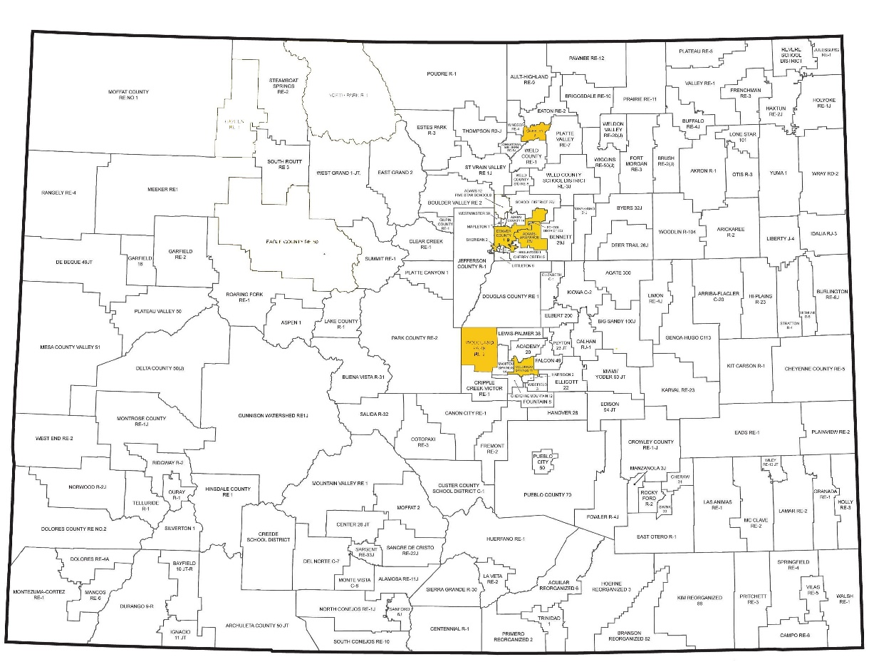

Instructional Unit Authors
Greeley School District 6
Kelly Kennedy
Meagan Reliford
Brad Farbo
Robert Bustrum

Based on a curriculum overview Sample authored by
Aurora Public Schools
Chris Strater
Colorado Springs School District 11
Aaron Ford
Community Leadership
Shannon Loveridge
Woodland Park School District Re-2
Sue Wright

This unit was authored by a team of Colorado educators. The template provided one example of unit design that enabled teacher-authors to organize possible learning experiences, resources, differentiation, and assessments. The unit is intended to support teachers, schools, and districts as they make their own local decisions around the best instructional plans and practices for all students.
Date Posted: APRIL, 2018
Physical Education
Kindergarten
Colorado Teacher-Authored Instructional Unit Sample

Unit Title: Playing Responsibly

Content Area | Physical Education |  |  | Grade Level | Kindergarten
Relationships with Others | Playing Responsibly
Standard | Grade Level Expectations (GLE) |  |  |  |  |  | GLE Code
Movement Competence and Understanding | 1. Demonstrate body and spatial awareness through safe movement |  |  |  |  |  | PE09-GR.k-S.1-GLE.1
 | 2. Locate the major parts of the body |  |  |  |  |  | PE09-GR.k-S.1-GLE.2
Physical and Personal Wellness | 1.Understand that physical activity increases the heart rate, making the heart stronger |  |  |  |  |  | PE09-GR.k-S.2-GLE.1
Emotional and Social Wellness | 1.Demonstrate respect for self, others, and equipment |  |  |  |  |  | PE09-GR.k-S.3-GLE.1
 | 2.Demonstrate the ability to follow directions |  |  |  |  |  | PE09-GR.k-S.3-GLE.2
Prevention and Risk  Management | Expectations for this standard are integrated into the other standards at this grade level movement control for safe participation in games and sports
Colorado 21st Century Skills  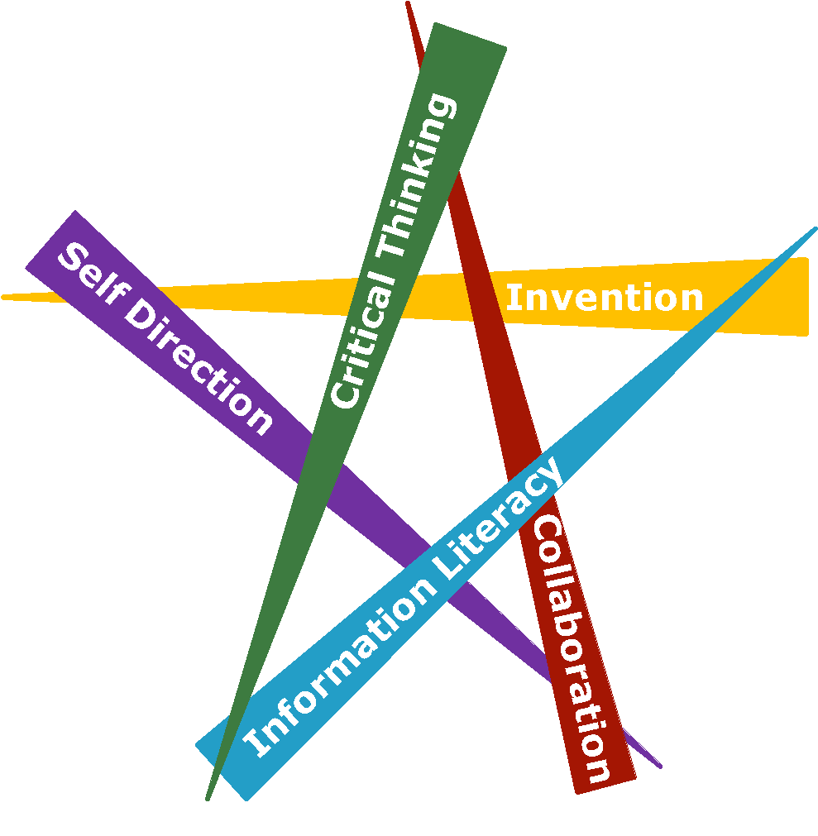  Critical Thinking and Reasoning: Thinking Deeply, Thinking Differently  Information Literacy: Untangling the Web  Collaboration: Working Together, Learning Together  Self-Direction: Own Your Learning  Invention: Creating Solutions |  | 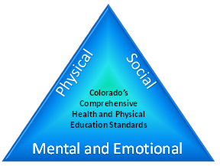
Unit Titles |  |  | Length of Unit/Contact Hours |  |  | Unit Number/Sequence
Playing Responsibly |  |  | Teacher’s Discretions

Unit Title | Playing Responsibly | Teacher's’ Discretion | Teacher's Discretion
Focusing Lens(es) | Social Responsibility | Standards and Grade Level Expectations Addressed in this Unit |  | PE09-GR.k- S.3-GLE.2  PE09-GR.k- S.3-GLE.1
Inquiry Questions (Engaging- Debatable): | - Why is sharing sometimes difficult? (PE09-GR.k- S.3-GLE.1- EO.a; IQ.1)  - Would you rather be a leader or a follower? Why? (PE09-GR.k- S.3-GLE.1- EO.c; IQ.2)  - What would equipment look like if we didn’t take care of it? (PE09-GR.k- S.3-GLE.1- EO.d; IQ.3)
Unit Strands | Physical and Personal Wellness in Physical Education  Emotional and Social Wellness in Physical Education
Concepts | Leadership; sharing; empathy; understanding rules; demonstration; listening; responsible participation; management; awareness of others and self; citizenship; respect; laws and rules; sequencing; responsibility

Generalizations  My students will Understand that… | Guiding Questions  Factual Conceptual
Responsible participation, empathy and self-awareness  promote kind actions in all activities. (PE09-GR.k- S.3- GLE.1-EO.a,e; IQ.1,3,5; RA.2,3; N.1,2) | What does responsible participation look like? (PE09-  GR.k-S.3- GLE.1-EO.a,b; IQ.2,3,5; RA.1,3; N.1) | Responsible behavior can be used in what environments? (PE09-GR.k- S.3-GLE.1- EO.a; RA.1,3; N.1,2)  Why is it important to take care of equipment? (PE09-  GR.k-S.3- GLE.1-EO.d; IQ.3,5; RA.3; N.1)
Active listening and visual awareness assist students in  their management of self. (PE09-GR.k- S.3-GLE.2-  EO.a,b,c,d; IQ.1,2; RA.1,2; N.1) | What does active listening look like? (PE09-GR.k- S.3-  GLE.2-EO.a,b,c,d; IQ.1,2; RA.1,2; N.1) | Why does active listening help self-management? (PE09-  GR.k-S.3- GLE.2-EO.a,b,c,d; IQ.1,2; RA.1,2; N.1)  How does playing “Simon says” make you feel? (PE09-GR.k-S.3- GLE.2-EO.a,b,c,d; IQ.1,2; RA.1,2; N.1)
Responsible participation as both a leader and follower in  a sharing environment supports positive social encounters. (PE09-GR.k- S.3-GLE.1- EO.c,e; IQ. 2; RA.1; N.2) | Which is more important, to lead or to follow?  (PE09-GR.k-S.3-GLE.1-EO.c,e; IQ. 2; RA.1; N.2) | How is it different when leading or following?(PE09-GR.k-S.3-GLE.1-EO.c,e; IQ. 2; RA.1; N.2)
Awareness of rules promotes good citizenship when  participating in group activities. (PE09-GR.k- S.3-GLE.2-  EO.a,b,c,d; IQ.1,2; RA.1,2; N.1) | What are rules in physical education? (PE09-GR.k- S.3-  GLE.2-EO.a,b,c,d; IQ.1,2; RA.1,2; N.1) | Why are rules important? (PE09-GR.k- S.3-GLE.2-  EO.a,b,c,d; IQ.1,2; RA.1,2; N.1)

Critical Content:  My students will Know… | Key Skills:  My students will be able to (Do)…
- Leaders and followers (PE09-GR.k- S.3-GLE.1- EO.c)  - Cooperation with others (PE09-GR.k- S.3-GLE.1- EO.e)  - Auditory and visual signals for starting and stopping (PE09-GR.k- S.3-GLE.2- EO.a)  - Established class protocol (PE09-GR.k- S.3 GLE.2-EO.d)  - Appropriate times of speaking (PE09-GR.k- S.3 GLE.2-EO.c)  - Simple series of instructions for an activity (PE09-GR.k- S.3 GLE.2-EO.b)  - Equipment management (PE09-GR.k- S.3 GLE.1-EO.d)  - Characteristics of sharing (PE09-GR.k- S.3 GLE.1-EO.c) | - Participate as a leader and follower (PE09-GR.k- S.3-GLE.1- EO.c)  - Play without interfering with others (PE09-GR.k- S.3-GLE.1- EO.e)  - Start and stop on an auditory and visual signal (PE09-GR.k- S.3-GLE.2- EO.a)  - Follow established class protocols (PE09-GR.k- S.3 GLE.2-EO.d)  - Speak at appropriate times (PE09-GR.k- S.3 GLE.2-EO.c)  - Follow a simple series of instructions for an activity (PE09-GR.k- S.3 GLE.2-EO.b)  - Help manage equipment (PE09-GR.k- S.3 GLE.1-EO.d)  - Demonstrate the characteristics of sharing (PE09-GR.k- S.3 GLE.1-EO.c)

Critical Language: includes the Academic and Technical vocabulary, semantics, and discourse which are particular to and necessary for accessing a given discipline.
EXAMPLE: A student in Language Arts can demonstrate the ability to apply and comprehend critical language through the following statement: “Mark Twain exposes the hypocrisy of slavery through the use of satire.”
A student in ______________ can demonstrate the ability to apply and comprehend critical language through the following statement(s): |  | Working together, showing respect, taking turns and listening makes class more fun for everyone.
Academic Vocabulary: | Leadership; sharing; empathy; demonstration; listening; management; citizenship.
Technical Vocabulary: | Responsible behavior; awareness of others and self, characteristics, auditory and visual signals.

Unit Description: | The purpose of this unit is to allow students to build their character through responsible participation in physical education. Concepts that are focused on include: leadership, sharing, empathy and respect. Additionally, skills are being developed to create an environment of cooperation and collaboration while playing games and the importance of being responsible. The unit culminates with a performance assessment in which each student becomes a cartoon character to assist peers in solving a series of tasks when presented with a challenge.
Unit Generalizations
Key Generalization (s): | Responsible participation as both a leader and follower in a sharing environment supports positive social encounters.
Supporting Generalizations: | Responsible participation, empathy, and self-awareness promote kind actions in all activities.  Active listening and visual awareness assist students in their management of self.  Awareness of rules promotes good citizenship when participating in group activities.
Considerations: | Before teaching a unit in responsible participation, please consider:  - Culture and language  - Space  - Equipment  - Length of class  - Time of year the unit would be taught  - Full day versus half day  - Accommodations (e.g. IEP, 504, etc.) and modifications

Performance Assessment: The capstone/summative assessment for this unit.
Claims:  (Key generalization(s) to be mastered and demonstrated through the capstone assessment.) | Responsible participation as both a leader and follower in a sharing environment supports positive social encounters.
Stimulus Material:  (Engaging scenario that includes role, audience, goal/outcome and explicitly connects the key generalization) | You will become a cartoon character (e.g. Mickey Mouse, Scooby Doo, Teenage Mutant Ninja Turtles, etc.) to assist peers in solving a series of tasks (e.g. building a castle, balancing on a beam, finding the objects, etc.). You will guide them through different scenarios, using your leadership skills (e.g. modeling, directing, guiding) in order to get them to complete the challenges. You will exchange roles with your peers to participate as a leader and follower.
Product/Evidence:  (Expected product from students) | Students will become a cartoon character (e.g. Mickey Mouse, Scooby Doo, Teenage Mutant Ninja Turtles, etc.) who have been tasked to assist peers in solving a series of tasks (e.g. building a castle, balancing on a beam, finding the objects, etc.). The cartoon character (e.g. Mickey Mouse, Scooby Doo, Teenage Mutant Ninja Turtles, etc.) will perform different scenarios, using your leadership skills (e.g. modeling, directing, guiding) in order to get them to complete the challenges. Students will reverse roles to allow peers to demonstrate leading, following, listening, responsibility, and positive social encounters.  Examples of Elements in Scenarios:  - Hurdles  - Hula Hoops  - Cones  - Balance beam  - Manipulatives
Differentiation:  (Multiple modes for student expression) | Students may:  - dress in cartoon costumes  - participate one on one or with a group  - discuss one on one with the teacher  - use a variety of manipulatives to meet ability levels

Texts for independent reading or for class read aloud to support the content
Informational/Non-Fiction | Fiction
Respect and Take Care of Things by Cheri J. Meiners, M.Ed. Lexile level 510)  If You Had to Choose, What Would You Do? – by Sandra McLeod Humphrey (25 scenarios for decision making) (Lexile level 300)  What Should I Do? Making Good Decisions – by John Burstein (Making good decisions) (Lexile level 660)  Can We Get Along? Dealing With Differences – by John Burstein (Decision Making) (Lexile level 300) | Respect and Take Care of Things by Cheri J. Meiners, M.Ed. Lexile level 510)  The Boy Who Cried Wolf - by Mairi Mackinnon (Lexile 250)  The Ant and the Grasshopper - by Diane Marwood (Lexile level 560)  The Lion and the Mouse - by Gene Thompson (Lexile level 350)  Dog and Bear: Two’s Company - by Laura Vaccaro Seeger (Lexile level 250)

Ongoing Discipline-Specific Learning Experiences
1. | Description: | Think like/Work like a responsible physical education student to demonstrate responsible participation as both a leader and follower in a sharing environment. | Teacher Resources: | http://physedgames.com/category/kindergarten/ (Various Teamwork/Cooperation Activities and Videos)  https://www.youtube.com/watch?v=1aZmB7rdci8 (Hoop Pass Game)
 |  |  | Student Resources: | http://physedgames.com/category/kindergarten/ (Various Teamwork/Cooperation Activities and Videos)  https://www.youtube.com/watch?v=1aZmB7rdci8 (Hoop Pass Game)
 | Skills: | - Participate as a leader and follower  - Play without interfering with others  - Follow established class protocols  - Speak at appropriate times  - Follow a simple series of instructions for an activity  - Demonstrate the characteristics of sharing | Assessment: | Students will participate in a variety of teambuilding activities and demonstrate responsibility with their team. Each student will discuss one of their contributions to their team and/or class.
2. | Description: | Think like/Work like a responsible physical education student to show  empathy and self-awareness and  promote kind actions when participating in all activities. | Teacher Resources: | http://www2.peacefirst.org/digitalactivitycenter/files/rainstorm.pdf (Rain Storm)  http://www.playworks.org/playbook/games/shipwreck (Shipwreck)  http://www.playworks.org/playbook/games/one-fish-two-fish-red-fish-blue-fish (One Fish, Two Fish, Red Fish, Blue Fish Game)
 |  |  | Student Resources: | http://www2.peacefirst.org/digitalactivitycenter/files/rainstorm.pdf (Rain Storm)  http://www.playworks.org/playbook/games/shipwreck (Shipwreck)  http://www.playworks.org/playbook/games/one-fish-two-fish-red-fish-blue-fish (One Fish, Two Fish, Red Fish, Blue Fish Game)
 | Skills: | - Follow a simple series of instructions for an activity  - Speak at appropriate times  - Follow established class protocols  - Help to manage equipment  - Move synchronously with others | Assessment: | Students will demonstrate examples of empathy and self-awareness by following directions, showing citizenship, being a good teammate, and showing sportsmanship.
3. | Description: | Think like/Work like a responsible physical education student to become an active listener and manage self. | Teacher Resources: | http://www.pecentral.org/lessonideas/ViewLesson.asp?ID=6116#.WH0kHVMrLIU (Couch Potato Activity)  http://www.pecentral.org/lessonideas/ViewLesson.asp?ID=4015#.V_fD__krLIU (Hula Hoop Twister)
 |  |  | Student Resources: | http://www.pecentral.org/lessonideas/ViewLesson.asp?ID=6116#.WH0kHVMrLIU (Couch Potato Activity)  http://www.pecentral.org/lessonideas/ViewLesson.asp?ID=4015#.V_fD__krLIU (Hula Hoop Twister)
 | Skills: | - Participate as a leader and follower  - Play without interfering with others  - Demonstrate the characteristics of sharing  - Follow a simple series of instructions for an activity | Assessment: | Students will successfully participate in activities and games by actively listening to show responsibility of self.
4. | Description: | Think like/Work like a responsible physical education student to become a good citizen by following rules when participating in group activities. | Teacher Resources: | http://www.pecentral.com/lessonideas/ViewLesson.asp?ID=4233#.WH0uMFMrLIU (Scooterville Lesson)  https://www.youtube.com/watch?v=YcZNTqK6ato (Scooterville/Scooter City Video)
 |  |  | Student Resources: | http://www.pecentral.com/lessonideas/ViewLesson.asp?ID=4233#.WH0uMFMrLIU (Scooterville Lesson)  https://www.youtube.com/watch?v=YcZNTqK6ato (Scooterville/Scooter City Video)
 | Skills: | - Participate as a leader and follower  - Play without interfering with others  - Start and stop on an auditory and visual signal  - Follow established class protocols  - Speak at appropriate times  - Follow a simple series of instructions for an activity  - Demonstrate the characteristics of sharing | Assessment: | Students will demonstrate good citizenship that includes following instructions, sharing with others, and showing leadership and responsible behavior.

Prior Knowledge and Experiences
It is presumed that kindergarten students have prior learning experiences and/or working knowledge of: social and emotional status, personal awareness, vocabulary, ability to follow instructions, and basic motor skills. However, it cannot be assumed that all students have had the same family infrastructure and opportunity to attend preschool/daycare to achieve the same developmental milestones.

Learning Experience # 1
Task Description:  The teacher may… so that students can… | The teacher may describe the characteristics of responsible participation (e.g. engagement, on-task, cooperation, etc.) so students can begin to identify responsible participation in their physical education environment.
Generalization Connection(s): | Responsible participation as both a leader and a follower in a sharing environment supports positive social encounters.
Teacher Resources: | http://www.playworks.org/playbook/games/triangle-tag (Triangle Tag)  https://www.youtube.com/watch?v=1aZmB7rdci8 (Hoop Pass Game)  http://physedgames.com/category/kindergarten/ (Various Teamwork/Cooperation Activities and Videos)
Student Resources: | http://www.playworks.org/playbook/games/triangle-tag (Triangle Tag)  https://www.youtube.com/watch?v=1aZmB7rdci8 (Hoop Pass Game)  http://physedgames.com/category/kindergarten/ (Various Teamwork/Cooperation Activities and Videos)
Assessment: | Students will participate in a variety of teambuilding activities (e.g. Triangle Tag, Hoop Pass Game, etc.) and demonstrate responsibility (e.g. engagement, on-task, cooperation, etc.) with their team. Each student will discuss one of their contributions to their team and/or class.
 | Access (Resources and/or Process) |  | Expression (Products and/or Performance)
Differentiation:  (Multiple means for students to access content and multiple modes for student to express understanding.) | The teacher may:  - select teams.  - provide a selected list of team responsibilities for students to choose from. |  | Students may:  - choose from a selected list of team responsibilities.  - discuss responsible participation to the teacher.
Extensions for depth and complexity: | N/A |  | N/A
Critical Content: | - Leaders and followers  - Cooperation with others  - Established class protocol  - Appropriate times of speaking  - Simple series of instructions for an activity  - Characteristics of sharing | Key Skills: | - Leaders and followers  - Cooperation with others  - Established class protocol  - Appropriate times of speaking  - Simple series of instructions for an activity  - Characteristics of sharing
Critical Language: | Leadership; sharing; demonstration; listening; management; responsible behavior; awareness of others and self.

Learning Experience # 2
Task Description:  The teacher may… so that students can… | The teacher may describe the qualities of a leader (e.g. works with others, proactive, role model, etc.) so students can begin to initiate their own style of influence and direction.
Generalization Connection(s): | Responsible participation as both a leader and a follower in a sharing environment supports positive social encounters.
Teacher Resources: | http://www.playworks.org/playbook/games/simon-says (Simon Says Leader Game)  http://www.playworks.org/playbook/games/blob-tag (Blob Tag)
Student Resources: | http://www.playworks.org/playbook/games/simon-says (Simon Says Leader Game)  http://www.playworks.org/playbook/games/blob-tag (Blob Tag)
Assessment: | Students will lead a game of Simon Says with a small group of their peers. Every student will have a turn to lead and follow verbal directions (e.g. hop on one foot, clap, spin in a circle, etc.).
 | Access (Resources and/or Process) |  | Expression (Products and/or Performance)
Differentiation:  (Multiple means for students to access content and multiple modes for student to express understanding.) | The teacher may:  - select small groups.  - pair students up with selected partner.  - provide pictures or cue cards to support verbal directions. |  | Students may:  - use pictures or cue cards to lead the game.  - work with a partner
Extensions for depth and complexity: | N/A |  | N/A
Critical Content: | - Leaders and followers  - Cooperation with others  - Auditory and visual signals for starting and stopping  - Appropriate times of speaking  - Simple series of instructions for an activity  - Equipment management  - Characteristics of sharing | Key Skills: | - Participate as a leader and follower  - Play without interfering with others  - Start and stop on an auditory and visual signal  - Speak at appropriate times  - Follow a simple series of instructions for an activity  - Help to manage equipment  - Demonstrate the characteristics of sharing
Critical Language: | Leadership; sharing; empathy; demonstration; listening; management; citizenship; responsible behavior; awareness of others and self.

Learning Experience # 3
Task Description:  The teacher may… so that students can… | The teacher may present a video of students sharing (e.g. equipment, space, ideas, etc.) so students can examine their own actions.
Generalization Connection(s): | Responsible participation as both a leader and a follower in a sharing environment supports positive social encounters.
Teacher Resources: | https://www.youtube.com/watch?v=KTFJ9gjfAXg (Sesame Street Sharing Video)  https://www.youtube.com/watch?v=OINm7Te7lxg (Sharing In Class)  https://www.youtube.com/watch?v=YNOnFsnjYhY (Sharing Video)
Student Resources: | https://www.youtube.com/watch?v=KTFJ9gjfAXg (Sesame Street Sharing Video)  https://www.youtube.com/watch?v=OINm7Te7lxg (Sharing In Class)  https://www.youtube.com/watch?v=YNOnFsnjYhY (Sharing Video)
Assessment: | Students will rotate through a variety of activity stations (e.g. basketball, jump ropes, scooters, etc.) to model sharing (e.g. equipment, space, ideas, etc.) at each station.
 | Access (Resources and/or Process) |  | Expression (Products and/or Performance)
Differentiation:  (Multiple means for students to access content and multiple modes for student to express understanding.) | The teacher may:  - provide a variety of equipment.  - pair students with a partner. |  | Students may:  - use equipment that meets their ability level.  - work with a partner at a station.
Extensions for depth and complexity: | N/A |  | N/A
Critical Content: | - Cooperation with others  - Equipment management  - Characteristics of sharing  - Simple series of instructions for an activity | Key Skills: | - Play without interfering with others  - Help to manage equipment  - Demonstrate the characteristics of sharing  - Follow a simple series of instructions for an activity
Critical Language: | Sharing; empathy; demonstration; listening; responsible behavior; awareness of others and self.

Learning Experience # 4
Task Description:  The teacher may… so that students can… | The teacher may examine the importance of positive relationships so students can discover why positive relationships cultivate team building.
Generalization Connection(s): | Responsible participation, empathy, and self-awareness promote kind actions in all activities.  Active listening and visual awareness assist students in their management of self.
Teacher Resources: | http://www2.peacefirst.org/digitalactivitycenter/files/rainstorm.pdf (Rain Storm)  http://www.playworks.org/playbook/games/shipwreck (Shipwreck)  http://www.playworks.org/playbook/games/one-fish-two-fish-red-fish-blue-fish (One Fish, Two Fish, Red Fish, Blue Fish Game)
Student Resources: | http://www2.peacefirst.org/digitalactivitycenter/files/rainstorm.pdf (Rain Storm)  http://www.playworks.org/playbook/games/shipwreck (Shipwreck)  http://www.playworks.org/playbook/games/one-fish-two-fish-red-fish-blue-fish (One Fish, Two Fish, Red Fish, Blue Fish Game)
Assessment: | Students will engage in a cooperative game (e.g. Rain Storm, Shipwreck, One Fish game, etc.) to demonstrate listening skills.
 | Access (Resources and/or Process) |  | Expression (Products and/or Performance)
Differentiation:  (Multiple means for students to access content and multiple modes for student to express understanding.) | The teacher may provide verbal cues to assist students. |  | Students may:  - help peers by moving hoop over the head or feet  - give peers verbal cues to assist in problem-solving
Extensions for depth and complexity: | N/A |  | N/A
Critical Content: | - Leaders and followers  - Cooperation with others  - Auditory and visual signals for starting and stopping  - Established class protocol  - Appropriate times of speaking  - Simple series of instructions for an activity  - Characteristics of sharing | Key Skills: | - Participate as a leader and follower  - Play without interfering with others  - Start and stop on an auditory and visual signal  - Follow established class protocols  - Speak at appropriate times  - Follow a simple series of instructions for an activity  - Demonstrate the characteristics of sharing
Critical Language: | Sharing; empathy; listening; responsible behavior; awareness of others and self

Learning Experience # 5
Task Description:  The teacher may… so that students can… | The teacher may present concepts of management and awareness of self, rules, and environment so students can generalize their personal behaviors (e.g. work ethic, self-control, mindfulness, etc.) in a variety of settings.
Generalization Connection(s): | Responsible participation, empathy, and self-awareness promote kind actions in all activities.  Active listening and visual awareness assist students in their management of self.  Awareness of rules promotes good citizenship when participating in group activities.
Teacher Resources: | http://www.pecentral.org/lessonideas/ViewLesson.asp?ID=6116#.WH0kHVMrLIU (Couch Potato Activity)  https://www.choosemyplate.gov/ (Nutrition Website)
Student Resources: | http://www.pecentral.org/lessonideas/ViewLesson.asp?ID=6116#.WH0kHVMrLIU (Couch Potato Activity)  https://www.choosemyplate.gov/ (Nutrition Website)
Assessment: | Students will partake in a game of Couch Potato to demonstrate self-awareness and management skills. This activity requires students to connect personal behaviors to real life experiences.
 | Access (Resources and/or Process) |  | Expression (Products and/or Performance)
Differentiation:  (Multiple means for students to access content and multiple modes for student to express understanding.) | The teacher may:  - use a variety of locomotor skills.  - increase or decrease boundary area.  - assign roles and tasks to students. |  | Students may:  - choose a locomotor skill.  - choose a role or task.
Extensions for depth and complexity: | N/A |  | N/A
Critical Content: | - Leaders and followers  - Cooperation with others  - Auditory and visual signals for starting and stopping  - Established class protocol  - Appropriate times of speaking  - Simple series of instructions for an activity)  - Equipment management  - Characteristics of sharing | Key Skills: | - Participate as a leader and follower  - Play without interfering with others  - Start and stop on an auditory and visual signal  - Follow established class protocols  - Speak at appropriate times  - Follow a simple series of instructions for an activity  - Help manage equipment  - Demonstrate the characteristics of sharing
Critical Language: | Sharing; empathy; demonstration; listening; management; citizenship; responsible behavior; awareness of others and self; auditory and visual signals.

Learning Experience # 6
Task Description:  The teacher may… so that students can… | The teacher may promote citizenship (e.g. acceptance, roles, sense of belonging, etc.) so students can begin to aspire to be a positive role model within their community.
Generalization Connection(s): | Awareness of rules promotes good citizenship when participating in group activities.
Teacher Resources: | http://www.pecentral.com/lessonideas/ViewLesson.asp?ID=4233#.WH0uMFMrLIU (Scooterville Lesson)  https://www.youtube.com/watch?v=YcZNTqK6ato (Scooterville/Scooter City Video)
Student Resources: | http://www.pecentral.com/lessonideas/ViewLesson.asp?ID=4233#.WH0uMFMrLIU (Scooterville Lesson)  https://www.youtube.com/watch?v=YcZNTqK6ato (Scooterville/Scooter City Video)
Assessment: | Students will participate in Scooterville to demonstrate real-life situations (e.g. following traffic rules, money management, driver’s test, etc.) as they relate to citizenship.
 | Access (Resources and/or Process) |  | Expression (Products and/or Performance)
Differentiation:  (Multiple means for students to access content and multiple modes for student to express understanding.) | Teacher may:  - provide different size scooters, connect-a-scooter, or a mat car (two scooters with a mat on top).  - pair students with a partner. |  | Students may:  - use a scooter that meets their ability level.  - work with a partner.
Extensions for depth and complexity: | N/A |  | N/A
Critical Content: | - Leaders and followers  - Cooperation with others  - Auditory and visual signals for starting and stopping  - Established class protocol  - Appropriate times of speaking  - Simple series of instructions for an activity  - Equipment management  - Characteristics of sharing | Key Skills: | - Participate as a leader and follower  - Play without interfering with others  - Start and stop on an auditory and visual signal  - Follow established class protocols  - Speak at appropriate times  - Follow a simple series of instructions for an activity  - Help manage equipment  - Demonstrate the characteristics of sharing
Critical Language: | Leadership; sharing; empathy; demonstration; listening; citizenship; responsible behavior; awareness of others and self; auditory and visual signals.

