Content Area | World Languages |  |  | Proficiency Range Level | Novice Low
Course Name/Course Code
Standard | Grade Level Expectations (GLE) |  |  |  |  |  | GLE Code
- Communication in Languages Other Than English | - Communicate about very familiar topics (written or oral) using isolated words and high frequency phrases (interpersonal mode) |  |  |  |  |  | WL09-NL-S.1-GLE.1
- Communication in Languages Other Than English | - Comprehend isolated learned words and high- frequency phrases (written or oral) on very familiar topics (interpretive mode) |  |  |  |  |  | WL09-NL-S.1-GLE.2
- Communication in Languages Other Than English | - Present on very familiar topics (written or oral) using isolated words, and high-frequency phrases (presentational mode) |  |  |  |  |  | WL09-NL-S.1-GLE.3
- Knowledge and Understanding of Other Cultures | - Identify common practices within the target cultures studied |  |  |  |  |  | WL09-NL-S.2-GLE.1
- Knowledge and Understanding of Other Cultures | - Identify common products of the target cultures studied |  |  |  |  |  | WL09-NL-S.2-GLE.2
- Connections with Other Disciplines and Information Acquisition | - Identify information that can be gathered from target language resources connected to other content areas |  |  |  |  |  | WL09-NL-S.3-GLE.1
 | - Locate and use basic information from target language resources |  |  |  |  |  | WL09-NL-S.3-GLE.2
- Comparisons to Develop Insight into the Nature of Language and Culture | - Identify similarities and differences of the most basic vocabulary through comparisons of the student’s own language and the language studied |  |  |  |  |  | WL09-NL-S.4-GLE.1
 | - Identify and recognize the nature of culture through comparisons of the target culture(s) and the student’s own culture |  |  |  |  |  | WL09-NL-S.4-GLE.2
Colorado 21st Century Skills  Critical Thinking and Reasoning: Thinking Deeply, Thinking Differently  Information Literacy: Untangling the Web  Collaboration: Working Together, Learning Together  Self-Direction: Own Your Learning  Invention: Creating Solutions |  | 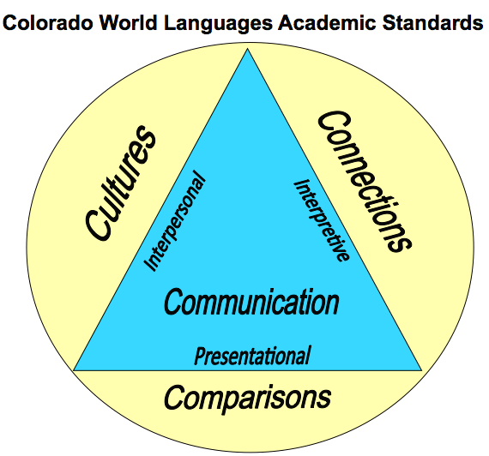  The Colorado World Languages Standards describe what learners should know and be able to do as they develop proficiency in a foreign language. Communication is at the center using the interpersonal, interpretive and presentational modes. Communication is then supported by understanding cultural perspectives, making connections to other disciplines and comparing one’s own language and culture with the new language.
Unit Titles |  |  | Length of Unit/Contact Hours |  |  | Unit Number/Sequence
Let’s Hang Out! |  |  | 3 Weeks = 15 Days = 15 Hours

Unit Title | Let’s Hang Out! |  | Length of Unit |  | 3 Weeks = 15 Days = 15 Hours
Focusing Lens(es) | Connections | Standards and Grade Level Expectations Addressed in this Unit |  | WL09-NL-S.1-GLE.1; WL09-NL-S.1-GLE.2; WL09-NL-S.1-GLE.3;  WL09-NL-S.2-GLE.1; WL09-NL-S.2-GLE.2;  WL09-NL-S.3-GLE.1; WL09-NL-S.3-GLE.2;  WL09-NL-S.4-GLE.1; WL09-NL-S.4-GLE.2
Inquiry Questions (Engaging- Debatable): | - Can a person have too many free time activities?
Unit Strands | 1. Communication in Languages Other Than English 2. Knowledge and Understanding of Other Cultures  3. Connections with Other Disciplines and Information Acquisition 4. Comparisons to Develop Insight into the Nature of Language and Culture
Foundational Concepts in World Languages | Interpersonal Communication, Interpretive Communication, Presentational Communication, Cultures, Connections, Comparisons
Concepts | Leisure, Relationships, Identity, Interactions, Health, Community

Generalizations  My students will Understand that… | Guiding Questions  Factual Conceptual
Participation in leisure activities of the target culture allows connections with others and helps increase cross-cultural feelings of camaraderie and personal well-being. | What are common leisure activities in the target culture? | How does an understanding of the relationship between the practices of a given culture allow people to communicate with those who speak the language of the culture? WL09-NM-S.2-GLE.1-IQ.1
Effective, positive, interpersonal interactions develop healthy relationships with peers and family to promote individual happiness. | How do we include others in leisure activities? | Why does developing healthy relationships promote individual happiness?
Leisure activities reflect interests and personalities and give insight into personal identity. | What are your favorite activities? | Why do we engage in leisure activities?

Critical Content:  My students will Know… |  | Key Skills:  My students will be able to (Do)…
Culture: | - Leisure activities  - Differences in calendar and time | Within the context of this unit, students will be able to demonstrate in the target language the three modes of communication – interpersonal, interpretive and presentational. Some examples can include, but may not be limited to:  - Express likes and dislikes WL09-NM-S.1-GLE.1-EO.b  - Make plans  - Ask and answer questions about leisure time activities WL09-NM-S.1-GLE.1-EO.c  - Discuss leisure time activities  - Compare and contrast leisure time activities  - Share information about personal interests WL09-NM-S.1-GLE.3-EO.b  (WL09-NL-S.1-GLE.1) and (WL09-NL-S.1-GLE.2) and (WL09-NL-S.1-GLE.3)
Context: | - Leisure Activities  - Calendar  - Places  - Temporal expressions
Structure: | - Present tense verbs  - Subject pronouns  - Forming questions  - Comparative and superlative
Connections to: | - Physical education  - The Arts

Critical Language: includes the Academic and Technical vocabulary, semantics, and discourse which are particular to and necessary for accessing a given discipline.
Academic Vocabulary: | compare, contrast, discuss, tell, express, answer, ask, reflect, share, describe
Technical Vocabulary: | interpersonal, interpretive, presentational, grammatical terms, practices, products, perspectives, connections, performance, proficiency range

