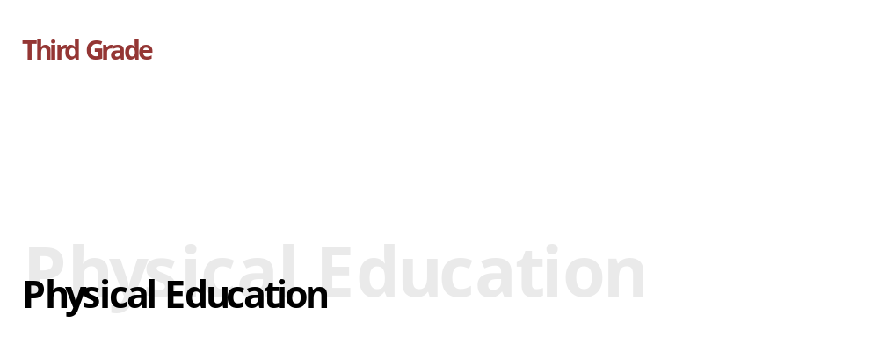
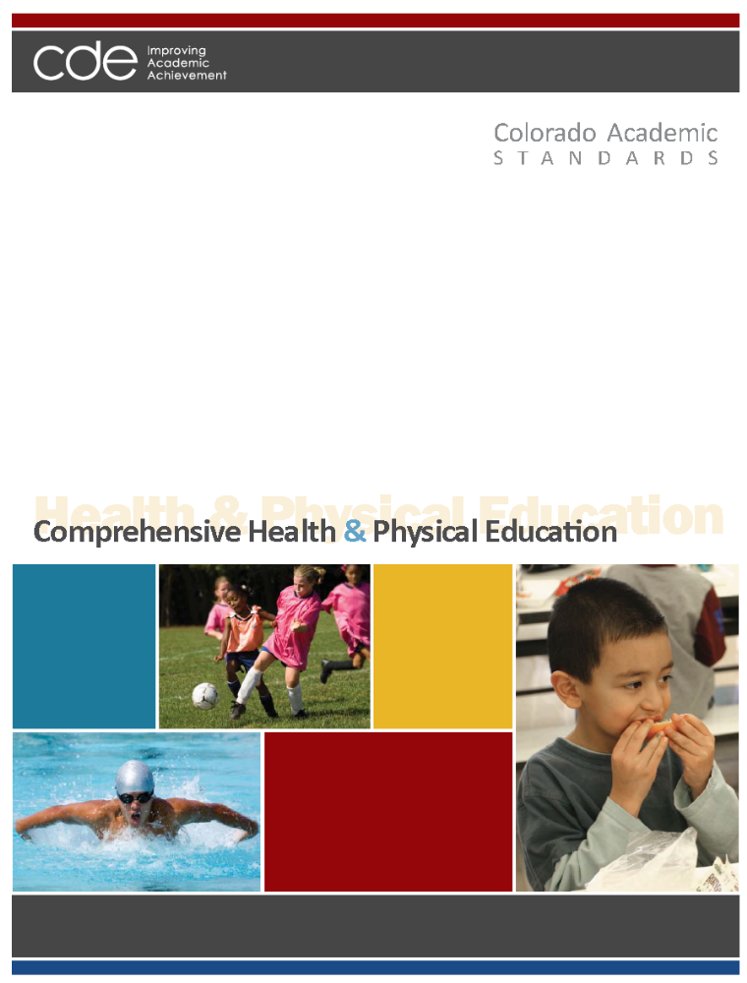
Adopted: December 10, 2009

Colorado Academic Standards
Comprehensive Health and Physical Education Standards

“In the great work of education, our physical condition, if not the first step in point of importance, is the first in order of time. On the broad and firm foundation of health alone can the loftiest and most enduring structures of the intellect be reared.” ~Horace Mann
~~~~~~~~~~~~~~~~~~~~~~~~~~~~~~~~~~
"We know what the Greeks knew: that intelligence and skill can only function at the peak of their capacity when the body is healthy and strong, and that hardy spirits and tough minds usually inhabit sound bodies." ~John F. Kennedy
~~~~~~~~~~~~~~~~~~~~~~~~~~~~~~~~~~

Preparing students for the 21st century cannot be accomplished without a strong and sustained emphasis on all students’ health and wellness. It no is longer acceptable to think of “gym class” and “hygiene lessons.” Today’s world has exploded with physical, mental, and social influences that affect not only learning in school, but also the lifelong health of the citizens that schools are preparing for graduation. Health and physical education prepare students to function optimally as students, global citizens, and workers who demonstrate personal responsibility for one’s health and fitness through an active, healthy lifestyle that fosters a lifelong commitment to wellness.

Health education and physical education are separate disciplines, each with a distinct body of knowledge and skills. However, the two disciplines are naturally interdisciplinary and clearly complement and reinforce each other to support wellness. Schools have a unique role and responsibility to address both health and physical education from preschool through twelfth grade to instill and reinforce knowledge and skills needed to be healthy and achieve academically.

Colorado's comprehensive health and physical education standards lay out a vision for these vitally important disciplines, and describe what all students should know and be able to do at each grade level through eighth grade and in high school. The authors of this document were preschool through twelfth-grade educators, higher education professors, business representatives, and community members. The group developed a set of competencies starting with "the end in mind." What concepts and skills would a "prepared graduate" in the 21st century posses when he or she left high school? The answers to this question framed the work that led to the development of four standards in comprehensive health and physical education for preschool through twelfth grade.
Standards Organization and Construction

As the subcommittee began the revision process to improve the existing standards, it became evident that the way the standards information was organized, defined, and constructed needed to change from the existing documents. The new design is intended to provide more clarity and direction for teachers, and to show how 21st century skills and the elements of school readiness and postsecondary and workforce readiness indicators give depth and context to essential learning.

The “Continuum of State Standards Definitions” section that follows shows the hierarchical order of the standards components. The “Standards Template” section demonstrates how this continuum is put into practice.

The elements of the revised standards are:

Prepared Graduate Competencies: The preschool through twelfth-grade concepts and skills that all students who complete the Colorado education system must master to ensure their success in a postsecondary and workforce setting.

Standard: The topical organization of an academic content area.

High School Expectations: The articulation of the concepts and skills of a standard that indicates a student is making progress toward being a prepared graduate. What do students need to know in high school?

Grade Level Expectations: The articulation (at each grade level), concepts, and skills of a standard that indicate a student is making progress toward being ready for high school. What do students need to know from preschool through eighth grade?

Evidence Outcomes: The indication that a student is meeting an expectation at the mastery level. How do we know that a student can do it?

21st Century Skills and Readiness Competencies: Includes the following:

- Inquiry Questions:
Sample questions are intended to promote deeper thinking, reflection and refined understandings precisely related to the grade level expectation.

- Relevance and Application:
Examples of how the grade level expectation is applied at home, on the job or in a real-world, relevant context.

- Nature of the Discipline:
The characteristics and viewpoint one keeps as a result of mastering the grade level expectation.

Continuum of State Standards Definitions
Prepared Graduate Competency
Prepared Graduate Competencies are the P-12 concepts and skills that all students leaving the Colorado education system must have to ensure success in a postsecondary and workforce setting.

Standards

Standards are the topical organization of an academic content area.
Grade Level Expectations

Expectations articulate, at each grade level, the knowledge and skills of a standard that indicates a student is making progress toward high school.

What do students need to know?
High School Expectations

Expectations articulate the knowledge and skills of a standard that indicates a student is making progress toward being a prepared graduate.

What do students need to know?
Evidence Outcomes
Evidence outcomes are the indication that a student is meeting an expectation at the mastery level.

How do we know that a student can do it?
Evidence Outcomes
Evidence outcomes are the indication that a student is meeting an expectation at the mastery level.

How do we know that a student can do it?
High School
P-8
21st Century and PWR Skills
Inquiry Questions:
Sample questions intended to promote deeper thinking, reflection and refined understandings precisely related to the grade level expectation.
Relevance and Application:
Examples of how the grade level expectation is applied at home, on the job or in a real-world, relevant context.
Nature of the Discipline:
The characteristics and viewpoint one keeps as a result of mastering the grade level expectation.

21st Century and PWR Skills
Inquiry Questions:
Sample questions intended to promote deeper thinking, reflection and refined understandings precisely related to the grade level expectation.
Relevance and Application:
Examples of how the grade level expectation is applied at home, on the job or in a real-world, relevant context.
Nature of the Discipline:
The characteristics and viewpoint one keeps as a result of mastering the grade level expectation.

STANDARDS TEMPLATE

Content Area: NAME OF CONTENT AREA
Standard: The topical organization of an academic content area.
Prepared Graduates:
- The P-12 concepts and skills that all students who complete the Colorado education system must master to ensure their success in a postsecondary and workforce setting
High School and Grade Level Expectations
Concepts and skills students master:
Grade Level Expectations: The articulation, at each grade level, the concepts and skills of a standard that indicates a student is making progress toward being ready for high school.

What do students need to know?

Evidence Outcomes | 21st Century Skills and Readiness Competencies
Students can:  Evidence outcomes are the indication that a student is meeting an expectation at the mastery level.  How do we know that a student can do it? | Inquiry Questions:  Sample questions intended to promote deeper thinking, reflection and refined understandings precisely related to the grade level expectation.
Relevance and Application:

Examples of how the grade level expectation is applied at home, on the job or in a real-world, relevant context.

Nature of the Discipline:

The characteristics and viewpoint one keeps as a result of mastering the grade level expectation.

Prepared Graduate Competencies in
Comprehensive Health and Physical Education

The prepared graduate competencies are the preschool through twelfth-grade concepts and skills that all students who complete the Colorado education system must master to ensure their success in a postsecondary and workforce setting.

Prepared Graduates in Movement Competence and Understanding:
- Demonstrate competency in motor skills and movement patterns needed to perform a variety of physical activity
- Demonstrate understanding of movement concepts, principles, strategies, and tactics as they apply to learning and performing physical activities

Prepared Graduates in Physical and Personal Wellness:
- Participate regularly in physical activity
- Achieve and maintain a health-enhancing level of physical fitness
- Apply knowledge and skills to engage in lifelong healthy eating
- Apply knowledge and skills necessary to make personal decisions that promote healthy relationships and sexual and reproductive health
- Apply knowledge and skills related to health promotion, disease prevention, and health maintenance

Prepared Graduates in Emotional and Social Wellness:
- Utilize knowledge and skills to enhance mental, emotional, and social well-being
- Exhibit responsible personal and social behavior that respects self and others in physical activity settings

Prepared Graduates in Prevention and Risk Management:
- Apply knowledge and skills to make health-enhancing decisions regarding the use of alcohol, tobacco, and other drugs
- Apply knowledge and skills that promote healthy, violence-free relationships
- Apply personal safety knowledge and skills to prevent and treat intentional or unintentional injury

Colorado Academic Standards
Comprehensive Health and Physical Education

The Colorado Academic Standards in comprehensive health and physical education are the topical organization of the concepts and skills every Colorado student should know and be able to do throughout their preschool through twelfth-grade experience.

- Movement Competence and Understanding (Physical Education)
Includes motor skills and movement patterns that teach skill and accuracy in a variety of routines, games, and activities that combine skills with movement; demonstrates the connection between body and brain function; and creates patterns for lifelong physical activity.

- Physical and Personal Wellness (Shared Standard)
Includes physical activity, healthy eating, and sexual health and teaches lifelong habits and patterns for a fit, healthy, and optimal childhood and adulthood; examines society, media, family, and peer influence on wellness choices; practices decision-making and communication skills for personal responsibility for wellness; and identifies the consequences of physical inactivity, unhealthy eating, and early sexual activity. Includes health promotion and disease prevention, and teaches responsibility and skills for personal health habits as well as behavior and disease prevention; sets personal goals for optimal health; examines common chronic and infectious diseases and causes; and recognizes the physical, mental, and social dimensions of personal health.

- Emotional and Social Wellness (Shared Standard)
Includes mental, emotional, and social health skills to recognize and manage emotions, develop care and concern for others, establish positive relationships, make responsible decisions, handle challenging situations constructively, resolve conflicts respectfully, manage stress, and make ethical and safe choices; examines internal and external influences on mental and social health; and identifies common mental and emotional health problems and their effect on physical health.

- Prevention and Risk Management (Shared Standard)
Includes alcohol, tobacco, and other drug prevention; violence prevention; and safety; teaches skills to increase safe physical and social behavior in at home, in school, in the community, and in personal relationships; provides specific knowledge on avoidance of intentional and unintentional injuries; and practices decision-making and communication skills to avoid drug use, bullying, and dating violence.

The standards are organized in the following manner:

  - Physical Education Standards
- Movement Competence and Understanding
- Physical and Personal Wellness
- Emotional and Social Wellness
- Prevention and Risk Management

  - Comprehensive Health Education Standards
- Physical and Personal Wellness
- Emotional and Social Wellness
- Prevention and Risk Management

21st Century Skills and Readiness Competencies in

Comprehensive Health and Physical Education

Colorado's Description of 21st Century Skills
Colorado’s description of 21st century skills is a synthesis of the essential abilities students must apply in our rapidly changing world. Today’s students need a repertoire of knowledge and skills that are more diverse, complex, and integrated than any previous generation. Comprehensive health and physical education are inherently demonstrated in each of Colorado’s 21st century skills, as follows:

Critical Thinking and Reasoning
Health and physical education are disciplines grounded in critical thinking and reasoning. Developing and maintaining lifelong wellness habits involves decision-making and communication skills that sometimes can determine life-and-death outcomes. The skills and knowledge gained in health and physical education provide the structure that makes it possible to prevent risk behavior and adopt healthy lifestyles. Without good health and physical activity, critical thinking and reasoning are compromised.

Information Literacy
The disciplines of health and physical education equip students with the tools and habits of mind to organize and interpret a multitude of rapidly changing information resources. Students who are literate in health and physical education can analyze effectively primary and secondary sources, detect bias, use learning tools, including technology and media, and clearly communicate thoughts using sound reasoning.

Collaboration
The health and physical education content areas directly involve students in teams, problem-solving groups, and community connections to support the overall health of the individual and the community. Students offer ideas, strategies, solutions, justifications, and proofs for others to evaluate. In turn, students use feedback to improve performance and interpret and evaluate the ideas, strategies, solutions, and justifications of others.

Self-Direction
Understanding and participating in health and physical education requires a productive disposition, curiosity, personal motivation, and self-direction. Health and physical education are more than passive learning. Individual active participation, practice, and competence are underlying principles of these content areas.

Invention
The health and physical education disciplines are a dynamic set of content area disciplines, ever expanding with new research, ideas, and understandings. Invention is the key element of the expansion as students make and test theories and skills, create and use tools, search for patterns and themes, and make connections among ideas, strategies, and solutions.

Colorado’s Description for School Readiness
(Adopted by the State Board of Education, December 2008)
School readiness describes both the preparedness of a child to engage in and benefit from learning experiences, and the ability of a school to meet the needs of all students enrolled in publicly funded preschools or kindergartens. School readiness is enhanced when schools, families, and community service providers work collaboratively to ensure that every child is ready for higher levels of learning in academic content.

Colorado’s Description of Postsecondary and Workforce Readiness
(Adopted by the State Board of Education, June 2009)
Postsecondary and workforce readiness describes the knowledge, skills, and behaviors essential for high school graduates to be prepared to enter college and the workforce and to compete in the global economy. The description assumes students have developed consistent intellectual growth throughout their high school career as a result of academic work that is increasingly challenging, engaging, and coherent. Postsecondary education and workforce readiness assumes that students are ready and able to demonstrate the following without the need for remediation: Critical thinking and problem-solving; finding and using information/information technology; creativity and innovation; global and cultural awareness; civic responsibility; work ethic; personal responsibility; communication; and collaboration.

How These Skills and Competencies are Embedded in the Revised Standards
Three themes are used to describe these important skills and competencies and are interwoven throughout the standards: inquiry questions; relevance and application; and the nature of each discipline. These competencies should not be thought of stand-alone concepts, but should be integrated throughout the curriculum in all grade levels. Just as it is impossible to teach thinking skills to students without the content to think about, it is equally impossible for students to understand the content of a discipline without grappling with complex questions and the investigation of topics.

Inquiry Questions – Inquiry is a multifaceted process requiring students to think and pursue understanding. Inquiry demands that students (a) engage in an active observation and questioning process; (b) investigate to gather evidence; (c) formulate explanations based on evidence; (d) communicate and justify explanations, and; (e) reflect and refine ideas. Inquiry is more than hands-on activities; it requires students to cognitively wrestle with core concepts as they make sense of new ideas.

Relevance and Application – The hallmark of learning a discipline is the ability to apply the knowledge, skills, and concepts in real-world, relevant contexts. Components of this include solving problems, developing, adapting, and refining solutions for the betterment of society. The application of a discipline, including how technology assists or accelerates the work, enables students to more fully appreciate how the mastery of the grade level expectation matters after formal schooling is complete.

Nature of Discipline – The unique advantage of a discipline is the perspective it gives the mind to see the world and situations differently. The characteristics and viewpoint one keeps as a result of mastering the grade level expectation is the nature of the discipline retained in the mind’s eye.

Physical Education
Grade Level Expectations at a Glance
Standard | Grade Level Expectation
Third Grade
1. Movement Competence and Understanding | 1. | Demonstrate a variety of motor patterns in simple combinations while participating in activities, games, and sports
1. Movement Competence and Understanding | 2. | Perform movements that engage the brain to facilitate learning
2. Physical and Personal Wellness | 1. | Identify the benefits of sustained physical activity that causes increased heart rate and heavy breathing
2. Physical and Personal Wellness | 2. | Understand that the body is composed of water, muscle, bones, organs, fat, and other tissues
3. Emotional and Social Wellness | 1. | Demonstrate positive social behaviors during class

- Movement, Competence and Understanding

Includes motor skills and movement patterns that teach skill and accuracy in a variety of routines, games, and activities that combine skills with movement; demonstrates the connection between body and brain function; and creates patterns for lifelong physical activity.

Prepared Graduates
The prepared graduate competencies are the preschool through twelfth-grade concepts and skills that all students who complete the Colorado education system must master to ensure their success in a postsecondary and workforce setting.

Prepared Graduates in the Movement Competence and Understanding standard are:
- Demonstrate competency in motor skills and movement patterns needed to perform a variety of physical activity
- Demonstrate understanding of movement concepts, principles, strategies, and tactics as they apply to learning and performing physical activities

Content Area: Comprehensive Health and Physical Education
Standard: 1. Movement Competence and Understanding in Physical Education
Prepared Graduates:
- Demonstrate competency in motor skills and movement patterns needed to perform a variety of physical activities
Grade Level Expectation: Third Grade
Concepts and skills students master:
- Demonstrate a variety of motor patterns in simple combinations while participating in activities, games, and sports
Evidence Outcomes | 21st Century Skills and Readiness Competencies
Students can:  - Demonstrate changes of pathways, levels, forces, and direction with manipulatives such as hoops, streamers, and balls (DOK 1-3)  - Combine locomotor movements in time to music (DOK 1-3)  - Dribble in soccer or basketball while changing speed and direction (DOK 1-2)  - Demonstrate throwing, catching, striking ,or trapping in an activity (DOK 1-2)  - Demonstrate skills of chasing, fleeing, and dodging to avoid others (DOK 1-3) | Inquiry Questions:  - Why is it enjoyable to combine locomotor movements in time to music?  - How is dribbling a soccer ball different from dribbling a basketball?  - Which combination of locomotor skills is most aesthetically pleasing?  - Why are some games more enjoyable than others?  - How do varying types of activity, challenges, and team versus individual activities contribute to enjoyment?  - Why do some people find some games more enjoyable than others?
Relevance and Application:
- Individuals move successfully and skillfully under a variety of movement conditions in their daily activities such as playing basketball or playing tag with friends.
- Individuals participate skillfully in a variety of games that require movement and skills.
- Individuals combine locomotor movements in time to music while dancing at home or at a social dance.
Nature of Physical Education:
- The ability to combine skills in meaningful ways is critical for success in most forms of physical activity.
- Games and sports have motor patterns that appear in simple combinations.

Content Area: Comprehensive Health and Physical Education
Standard: 1. Movement Competence and Understanding in Physical Education
Prepared Graduates:
- Demonstrate competency in motor skills and movement patterns needed to perform a variety of physical activities
Grade Level Expectation: Third Grade
Concepts and skills students master:
- Perform movements that engage the brain to facilitate learning
Evidence Outcomes | 21st Century Skills and Readiness Competencies
Students can:  - Describe, create, and demonstrate movements that require crossing the mid-line (DOK 1-3)  - Perform successfully a variety of jump-rope skills using both short and long ropes, and jump to various tempos (DOK 1-2)  - Combine jumping, tossing, dribbling, or catching to music or rhythmic beat (DOK 1-3)  - Perform a basic tinikling step to 3/4 time (close, tap, and tap) (DOK 1-3)  - Balance demonstrating momentary stillness in symmetrical and nonsymmetrical shapes on a variety of body parts (DOK 1-3)  - Perform forward and backward rolls with variation (DOK 1-2)  - Combine two or more rotational skills (DOK 1-2) | Inquiry Questions:  - What must one think about when doing a forward roll?  - Which activities are most effective for crossing the mid-line?  - How does one use his or her mind in various activities and sports?  - What are the benefits to combining activities such as jumping or dribbling to a rhythmic beat?
Relevance and Application:
- Individuals learn new movements such as jumping rope to engage the brain.
- Individuals perform routines of physical movement that may include dance steps, jumping rope, or a variation of forward and backward rolls.
Nature of Physical Education
- Individuals who learn to move safely, effectively, and efficiently and feel comfortable and confident in the performance of motor skills are more likely to participate in health-enhancing forms of physical activity throughout life.
- Exercise is linked to healthy brain development, and certain movements such as cross-laterals, patterns, rhythms are proven to be beneficial for making body and brain connections.

2. Physical and Personal Wellness

Includes physical activity, healthy eating, and sexual health and teaches lifelong habits and patterns for a fit, healthy, and optimal childhood and adulthood; examines society, media, family, and peer influence on wellness choices; practices decision-making and communication skills for personal responsibility for wellness; and identifies the consequences of physical inactivity, unhealthy eating, and early sexual activity. Includes health promotion and disease prevention, and teaches responsibility and skills for personal health habits as well as behavior and disease prevention; sets personal goals for optimal health; examines common chronic and infectious diseases and causes; and recognizes the physical, mental, and social dimensions of personal health.

Prepared Graduates
The prepared graduate competencies are the preschool through twelfth-grade concepts and skills that all students who complete the Colorado education system must master to ensure their success in a postsecondary and workforce setting.

Prepared Graduates in the Physical and Personal Wellness standard are:
- Participate regularly in physical activity
- Achieve and maintain a health-enhancing level of physical fitness
- Apply knowledge and skills to engage in lifelong healthy eating
- Apply knowledge and skills necessary to make personal decisions that promote healthy relationships and sexual and reproductive health
- Apply knowledge and skills related to health promotion, disease prevention, and health maintenance

Content Area: Comprehensive Health and Physical Education
Standard: 2. Physical and Personal Wellness in Physical Education
Prepared Graduates:
- Achieve and maintain a health-enhancing level of physical fitness
Grade Level Expectation: Third Grade
Concepts and skills students master:
- Identify the benefits of sustained physical activity that causes increased heart rate and heavy breathing
Evidence Outcomes | 21st Century Skills and Readiness Competencies
Students can:  - Explain why the body perspires, the heart beats faster and breathing increases when participating in moderate to vigorous physical activity (DOK 1-3)  - Recognize that the body will adapt to increased workloads (DOK 1-2)  - Describe the relationship among the heart, lungs, muscles, blood, and oxygen during physical activity (DOK 1-3)  - Identify several moderate to vigorous physical activities that provide personal pleasure (DOK 1-2)  - Identify all activities that children participate in on a regular basis (formal or informal) (DOK 1-2)  - Locate heart rate on at least two different pulse points on the body (DOK 1-2)  - Discuss how body temperature and blood volume are maintained during physical activity when an adequate amount of water is consumed (DOK 1-3)  - Demonstrate the ability to understand the concept of pacing during cardiovascular endurance activity (DOK 1-3)  - Explain how the intensity and duration of exercise as well as nutritional choices affect fuel use during physical activity (DOK 1-3) | Inquiry Questions:  - Which physical activities are the healthiest?  - What factors help you to decide why you enjoy an activity or sport?  - If you are bored with a current physical activity, how would you choose a new physical activity?  - Does your body feel different after you swim than after you run?
Relevance and Application:
- Individuals maintain healthy cardiovascular and respiratory system to prevent heart disease.
- Individuals participate in a wide range of physical activities over a lifetime such as swimming, bicycling, running, or hiking.
- Individuals participate safely in physical activity under a variety of environmental conditions such as high altitude, heat, humidity, or cold.
- Individuals use a watch to monitor their heart rate.
- Individuals compare the way riding a bicycle makes them feel to the way riding a skateboard makes them feel.
- Individuals keep a chart for a month of all physical activities, listing the amount of time for each.
Nature of Physical Education:
- Physical activity affects heart, lungs, and muscles.
- Physical activity affects the way one feels emotionally and physically.
- Taking responsibility for one's own health is an essential step toward developing and maintaining a healthy, active life.
- Different levels of exercise affect heart rate and overall health and fitness.

Content Area: Comprehensive Health and Physical Education
Standard: 2. Physical and Personal Wellness in Physical Education
Prepared Graduates:
- Achieve and maintain a health-enhancing level of physical fitness
Grade Level Expectation: Third Grade
Concepts and skills students master:
- Understand that the body is composed of water, muscle, bones, organs, fat, and other tissues
Evidence Outcomes | 21st Century Skills and Readiness Competencies
Students can:  - Identify the location of the lungs and heart (DOK 1)  - Identify muscles and fat (DOK 1)  - Locate the heart, and feel it beat after moderate to vigorous exercise (DOK 1)  - Compare heart rate before, during, and after exercise, and explain that increasing the heart rate during physical activity strengthens the heart muscles (DOK 1-3)  - Identify physical activities that cause the heart to beat faster (DOK 1-3) | Inquiry Questions:  - Do your heart and lungs feel different after you swim than after you run?  - If entire bodies were made of fat, how would people move?  - What would bodies look like if they had no bones?  - Which of your favorite activities do you think contribute most to your heart beating faster?
Relevance and Application:
- Individuals understand the role of fitness in preventing chronic disease.
- Individuals take a virtual tour of the body, focusing on the lungs and heart.
- Individuals prevent heart disease by engaging in aerobic activity such as bicycle riding, or playing tag or basketball.
- Individuals use a heart rate monitor to compare heart rate before, during, and after exercise.
- Individuals compare body parts to parts of a car or a computer.
Nature of Physical Education:
- The amount of exercise done does directly influences heart rate and overall health and fitness.
- The body is made up of different parts, and each part must be cared for with exercise.

3. Emotional and Social Wellness

Includes mental, emotional, and social health skills to recognize and manage emotions, develop care and concern for others, establish positive relationships, make responsible decisions, handle challenging situations constructively, resolve conflicts respectfully, manage stress, and make ethical and safe choices; examines internal and external influences on mental and social health; and identifies common mental and emotional health problems and their effect on physical health.

Prepared Graduates
The prepared graduate competencies are the preschool through twelfth-grade concepts and skills that all students who complete the Colorado education system must master to ensure their success in a postsecondary and workforce setting.

Prepared Graduates in the Emotional and Social Wellness standard are:
- Utilize knowledge and skills to enhance mental, emotional, and social well-being
- Exhibit responsible personal and social behavior that respects self and others in physical activity settings

Content Area: Comprehensive Health and Physical Education
Standard: 3. Emotional and Social Wellness in Physical Education
Prepared Graduates:
- Exhibit responsible personal and social behavior that respects self and others in physical activity settings
Grade Level Expectation: Third Grade
Concepts and skills students master:
- Demonstrate positive social behaviors during class
Evidence Outcomes | 21st Century Skills and Readiness Competencies
Students can:  - Identify the positive behaviors of self and others (DOK 1-2)  - Congratulate partners, opponents, or team upon conclusion of game or activity (DOK 1-2)  - Accept and give constructive feedback to peers (DOK 1-3)  - Follow directions, activity-specific rules, procedures, and etiquette with few reminders (DOK 1-2)  - Encourage others regularly, and refrain from put-down statements (DOK 1-3)  - Ask a partner to participate in a physical activity (DOK 1-2)  - Congratulate friends for a well-executed movement (DOK 1-2) | Inquiry Questions:  - How should you congratulate someone when he or she wins, and you lose?  - When would peer feedback be inappropriate?  - How can you give advice to a friend about how to improve at a physical activity?  - How does your body feel when you achieve success while working with others?  - What is your role in maintaining a positive learning environment that everyone can enjoy?  - Why is it important to be polite when you lose?
Relevance and Application:
- Individuals acknowledge the efforts of others when they have done something well such as sending a group email acknowledging the efforts of someone to other people.
- Individuals describe how they could use technology to assist a friend in learning a skill.
- Individuals are gracious winners and losers. For example, they shake the hand of a winning opponent.
- Individuals initiate social interaction with someone they don’t know in a social situation such as a school dance.
- Individuals send an electronic invitation to a friend asking him or her to join them in a physical activity such as playing Frisbee.

Nature of Physical Education:
- Physical education provides opportunities to reinforce positive social behaviors.
- Successful participation in physical activity requires cooperation with others.
- Group physical activities should be fun for everyone participating.
- How you behave when you win or lose influences how people look at you.

4. Prevention and Risk Management

Includes alcohol, tobacco, and other drug prevention; violence prevention; and safety; teaches skills to increase safe physical and social behavior in at home, in school, in the community, and in personal relationships; provides specific knowledge on avoidance of intentional and unintentional injuries; and practices decision-making and communication skills to avoid drug use, bullying, and dating violence.

Prepared Graduates
The prepared graduate competencies are the preschool through twelfth-grade concepts and skills that all students who complete the Colorado education system must master to ensure their success in a postsecondary and workforce setting.

Prepared Graduates in the Prevention and Risk Management standard are:
- Apply knowledge and skills to make health-enhancing decisions regarding the use of alcohol, tobacco, and other drugs
- Apply knowledge and skills that promote healthy, violence-free relationships
- Apply personal safety knowledge and skills to prevent and treat intentional or unintentional injury

Content Area: Comprehensive Health and Physical Education
Standard: 4. Prevention and Risk Management in Physical Education
Prepared Graduates:

Grade Level Expectation: Third Grade
Concepts and skills students master:
THERE ARE NO EXPECTATIONS AT THIS GRADE LEVEL IN THIS STANDARD
Evidence Outcomes | 21st Century Skills and Readiness Competencies
Students can: | Inquiry Questions:
Students can: | Relevance and Application:
Students can: | Nature of Physical Education:

Colorado Department of Education
Office of Standards and Instructional Support
201 East Colfax Ave. • Denver, CO 80203
http://www.cde.state.co.us/CoHealthPE/StateStandards.asp

