2011 Charter School Teacher Salary Survey Results

Summary Information:
- 64 responses out of 160 total possible respondents = 40% participation
- 51.6% of schools report that teacher salaries are between $35,000 and $43,999
- 73.4% of schools report that teacher salaries are between $32,000 and $46,999
- The average of the LOWEST teacher salary reported by the school is $30,769; the median is $30,750. The range of the LOWEST teacher salaries reported is $20,320 to $40,000.
- The average of the HIGHEST teacher salary reported by the school is $47,017; the median is $46,588. The range of the HIGHEST teacher salaries reported is $30,240 to $76,688.

Summary of Questions:
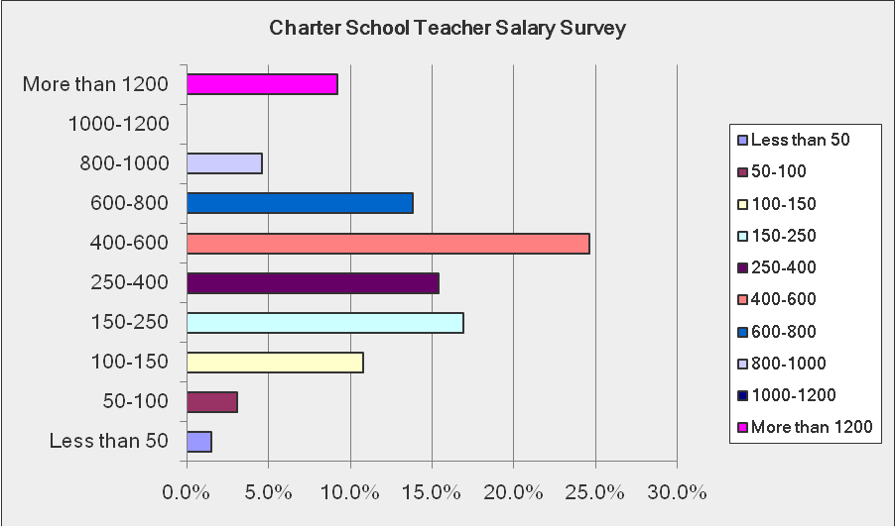
Approximately how many students are enrolled at your school?
Answer Options | Response Percent | Response Count
Less than 50 | 1.5% | 1
50-100 | 3.1% | 2
100-150 | 10.8% | 7
150-250 | 16.9% | 11
250-400 | 15.4% | 10
400-600 | 24.6% | 16
600-800 | 13.8% | 9
800-1000 | 4.6% | 3
1000-1200 | 0.0% | 0
More than 1200 | 9.2% | 6
answered question |  | 65
skipped question |  | 0

How long has your school been in existence, or been operational as an independent charter school?
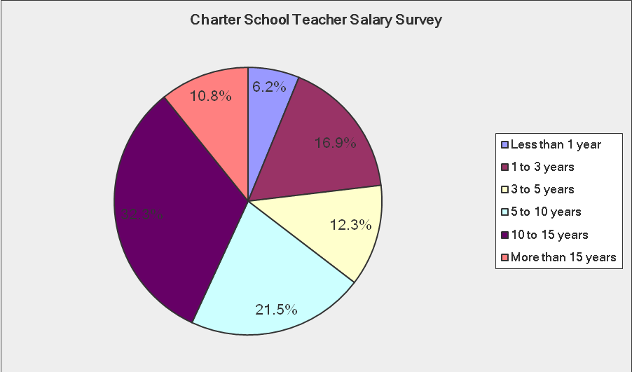
Answer Options | Response Percent | Response Count
Less than 1 year | 6.2% | 4
1 to 3 years | 16.9% | 11
3 to 5 years | 12.3% | 8
5 to 10 years | 21.5% | 14
10 to 15 years | 32.3% | 21
More than 15 years | 10.8% | 7
answered question |  | 65
skipped question |  | 0

How many total FULL TIME instructional staff members (teachers) are employed at your school?
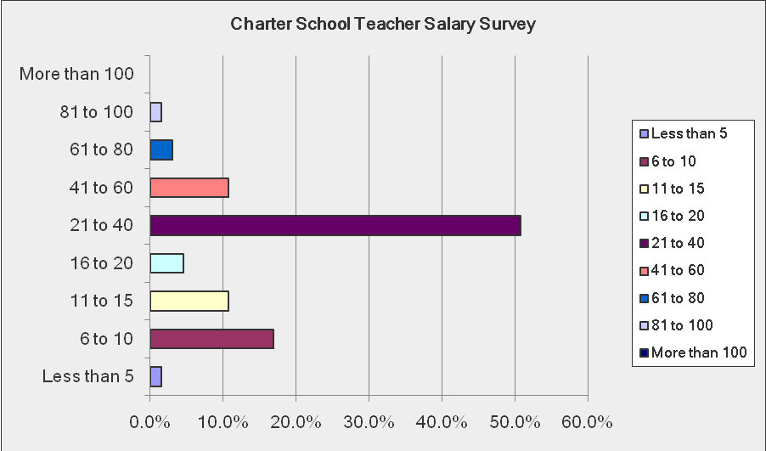
Answer Options | Response Percent | Response Count
Less than 5 | 1.5% | 1
6 to 10 | 16.9% | 11
11 to 15 | 10.8% | 7
16 to 20 | 4.6% | 3
21 to 40 | 50.8% | 33
41 to 60 | 10.8% | 7
61 to 80 | 3.1% | 2
81 to 100 | 1.5% | 1
More than 100 | 0.0% | 0
answered question |  | 65
skipped question |  | 0

How many total PART TIME instructional staff members (teachers) are employed at your school?
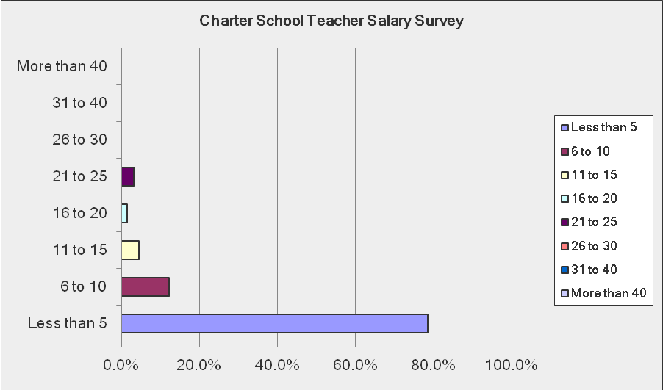
Answer Options | Response Percent | Response Count
Less than 5 | 78.5% | 51
6 to 10 | 12.3% | 8
11 to 15 | 4.6% | 3
16 to 20 | 1.5% | 1
21 to 25 | 3.1% | 2
26 to 30 | 0.0% | 0
31 to 40 | 0.0% | 0
More than 40 | 0.0% | 0
answered question |  | 65
skipped question |  | 0

How many instructional paras (FULL and PART TIME) are employed at your school?
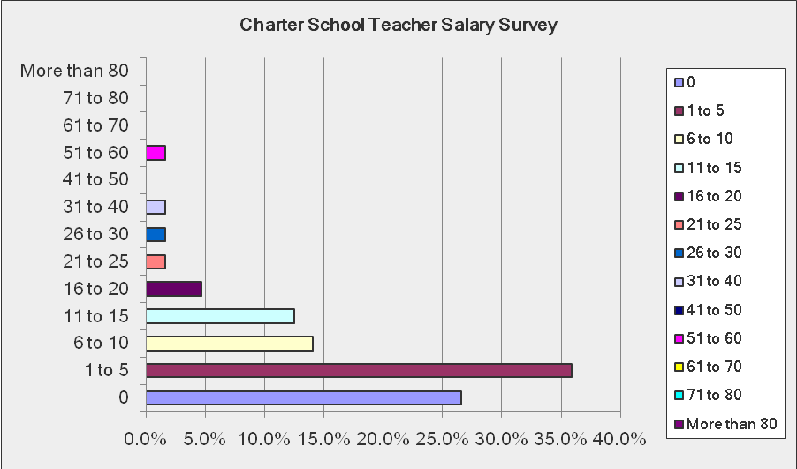
Answer Options | Response Percent | Response Count
0 | 26.6% | 17
1 to 5 | 35.9% | 23
6 to 10 | 14.1% | 9
11 to 15 | 12.5% | 8
16 to 20 | 4.7% | 3
21 to 25 | 1.6% | 1
26 to 30 | 1.6% | 1
31 to 40 | 1.6% | 1
41 to 50 | 0.0% | 0
51 to 60 | 1.6% | 1
61 to 70 | 0.0% | 0
71 to 80 | 0.0% | 0
More than 80 | 0.0% | 0
answered question |  | 64
skipped question |  | 1

If applicable, please indicate the elementary (grades K to 5) class size? (If class size varies, please use an average)
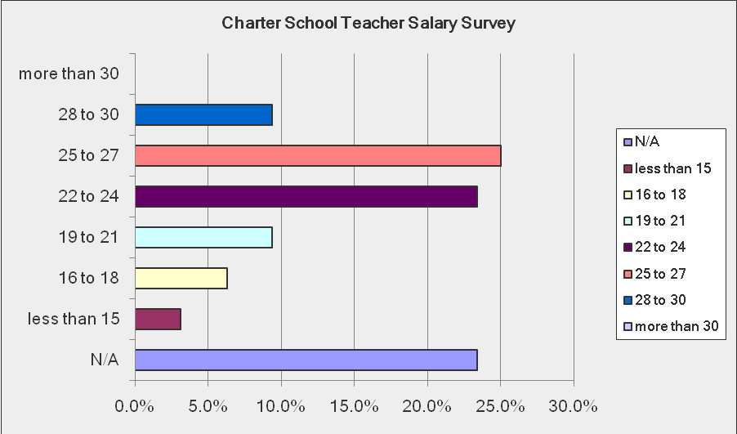
Answer Options | Response Percent | Response Count
N/A | 23.4% | 15
less than 15 | 3.1% | 2
16 to 18 | 6.3% | 4
19 to 21 | 9.4% | 6
22 to 24 | 23.4% | 15
25 to 27 | 25.0% | 16
28 to 30 | 9.4% | 6
more than 30 | 0.0% | 0
answered question |  | 64
skipped question |  | 1

If applicable, please indicate the middle school (grades 6 to 8) class size? (If class size varies, please use an average)
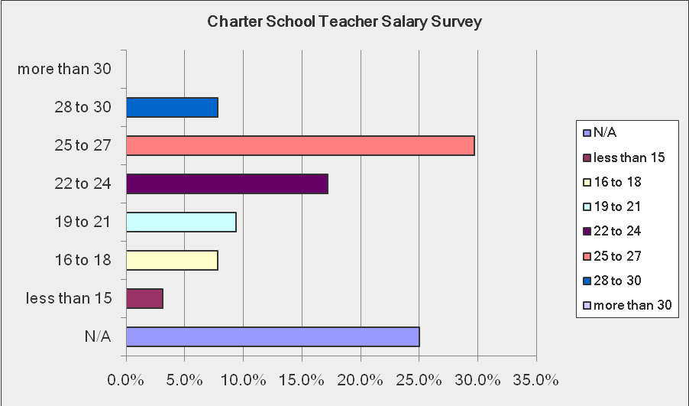
Answer Options | Response Percent | Response Count
N/A | 25.0% | 16
less than 15 | 3.1% | 2
16 to 18 | 7.8% | 5
19 to 21 | 9.4% | 6
22 to 24 | 17.2% | 11
25 to 27 | 29.7% | 19
28 to 30 | 7.8% | 5
more than 30 | 0.0% | 0
answered question |  | 64
skipped question |  | 1

If applicable, please indicate the high school (grades 9 to 12) class size? (If class size varies, please use an average)
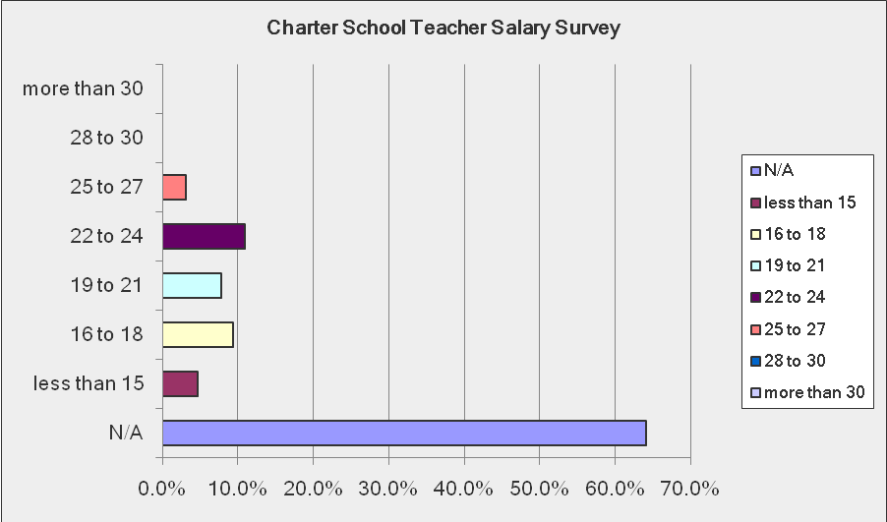
Answer Options | Response Percent | Response Count
N/A | 64.1% | 41
less than 15 | 4.7% | 3
16 to 18 | 9.4% | 6
19 to 21 | 7.8% | 5
22 to 24 | 10.9% | 7
25 to 27 | 3.1% | 2
28 to 30 | 0.0% | 0
more than 30 | 0.0% | 0
answered question |  | 64
skipped question |  | 1

For secondary schools, how many classes or course offerings per semester must be taught for an instructional staff member (teacher) to be considered FULL TIME?
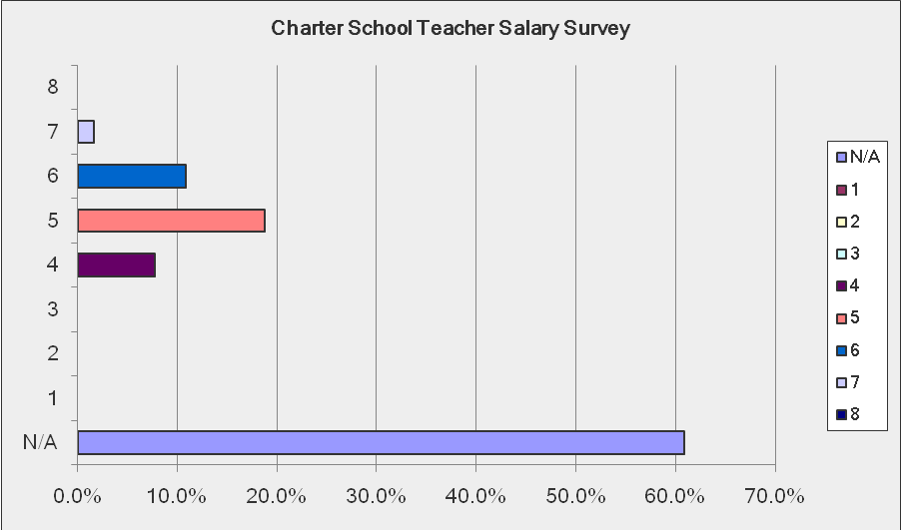
Answer Options | Response Percent | Response Count
N/A | 60.9% | 39
1 | 0.0% | 0
2 | 0.0% | 0
3 | 0.0% | 0
4 | 7.8% | 5
5 | 18.8% | 12
6 | 10.9% | 7
7 | 1.6% | 1
8 | 0.0% | 0
answered question |  | 64
skipped question |  | 1

What is the AVERAGE annual salary (including benefits and merit pay) for all FULL TIME instructional staff (teachers)?
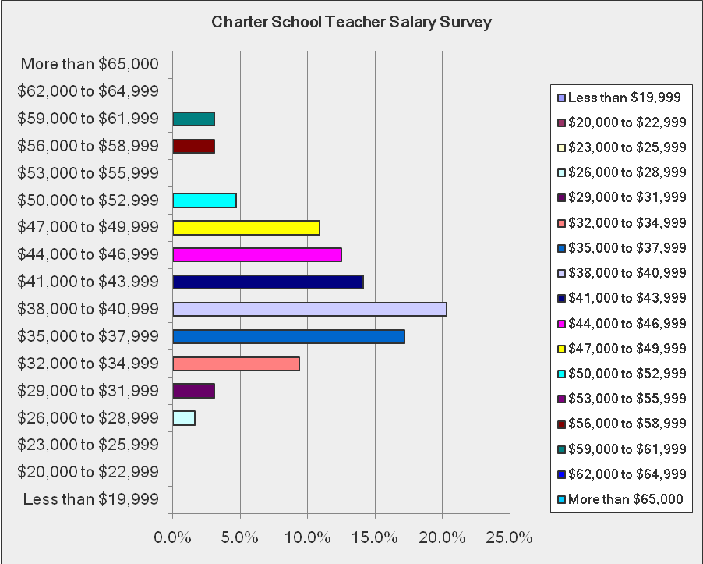
Answer Options | Response Percent | Response Count
Less than $19,999 | 0.0% | 0
$20,000 to $22,999 | 0.0% | 0
$23,000 to $25,999 | 0.0% | 0
$26,000 to $28,999 | 1.6% | 1
$29,000 to $31,999 | 3.1% | 2
$32,000 to $34,999 | 9.4% | 6
$35,000 to $37,999 | 17.2% | 11
$38,000 to $40,999 | 20.3% | 13
$41,000 to $43,999 | 14.1% | 9
$44,000 to $46,999 | 12.5% | 8
$47,000 to $49,999 | 10.9% | 7
$50,000 to $52,999 | 4.7% | 3
$53,000 to $55,999 | 0.0% | 0
$56,000 to $58,999 | 3.1% | 2
$59,000 to $61,999 | 3.1% | 2
$62,000 to $64,999 | 0.0% | 0
More than $65,000 | 0.0% | 0
answered question |  | 64
skipped question |  | 1

If your school uses merit pay in the compensation package, what percentage of salary is used for budgeting purposes?
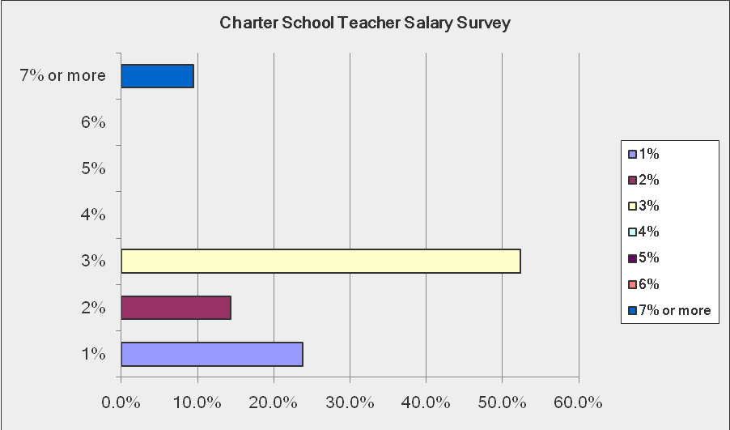
Answer Options | Response Percent | Response Count
1% | 23.8% | 5
2% | 14.3% | 3
3% | 52.4% | 11
4% | 0.0% | 0
5% | 0.0% | 0
6% | 0.0% | 0
7% or more | 9.5% | 2
answered question |  | 21
skipped question |  | 44

