Salary Survey Results
Summary Information

- 123 responses out of 149 total possible respondents = 82.5% participation
- 40 schools had multiple responses and had to be reconciled to a single response for data analysis
- When discrepancies in multiple responses existed, selected responses were kept based on the following priorities:
- Responses reflecting higher salary ranges for the single top administrator were retained
- Responses reflecting higher salary ranges for the combined total administrative salaries were retained
- Responses reflecting the higher salary range for the second highest paid administrator were retained.
- Responses reflecting the most complete information were retained.

- Administrative Salary Range Responses
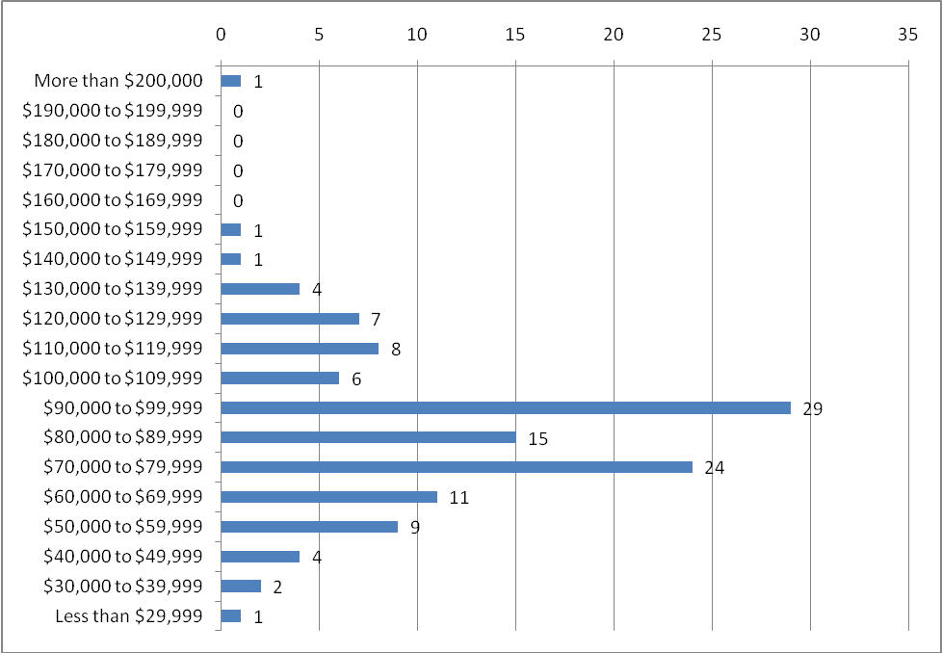
More than $200,000 | 1 | 0.8%
$190,000 to $199,999 | 0 | 0.0%
$180,000 to $189,999 | 0 | 0.0%
$170,000 to $179,999 | 0 | 0.0%
$160,000 to $169,999 | 0 | 0.0%
$150,000 to $159,999 | 1 | 0.8%
$140,000 to $149,999 | 1 | 0.8%
$130,000 to $139,999 | 4 | 3.3%
$120,000 to $129,999 | 7 | 5.7%
$110,000 to $119,999 | 8 | 6.5%
$100,000 to $109,999 | 6 | 4.9%
$90,000 to $99,999 | 29 | 23.6%
$80,000 to $89,999 | 15 | 12.2%
$70,000 to $79,999 | 24 | 19.5%
$60,000 to $69,999 | 11 | 8.9%
$50,000 to $59,999 | 9 | 7.3%
$40,000 to $49,999 | 4 | 3.3%
$30,000 to $39,999 | 2 | 1.6%
Less than $29,999 | 1 | 0.8%
- 64.2% of top administrator salaries are between $60,000 and $99,999
- 88.6% of top administrator salaries are between $40,000 and $129,999
- 5.6% of top administrator salaries are greater than $130,000
- 77.2% of top administrator salaries are below $99,999
- Breakdown of respondents based on number of students at the school
  - More than 1000 students (8 schools or 6.5%)
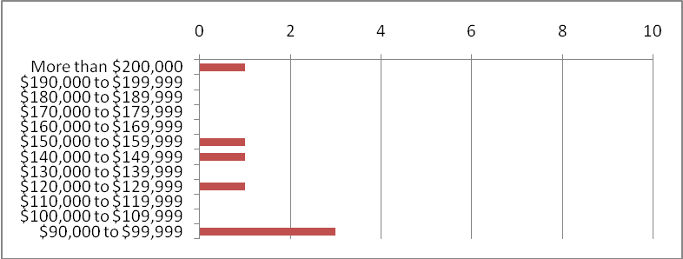
More than $200,000 | 1
$190,000 to $199,999 | 0
$180,000 to $189,999 | 0
$170,000 to $179,999 | 0
$160,000 to $169,999 | 0
$150,000 to $159,999 | 1
$140,000 to $149,999 | 1
$130,000 to $139,999 | 0
$120,000 to $129,999 | 1
$110,000 to $119,999 | 0
$100,000 to $109,999 | 0
$90,000 to $99,999 | 3
  - 600-1000 students (17 schools or 13.8%)
$130,000 to $139,999 | 3  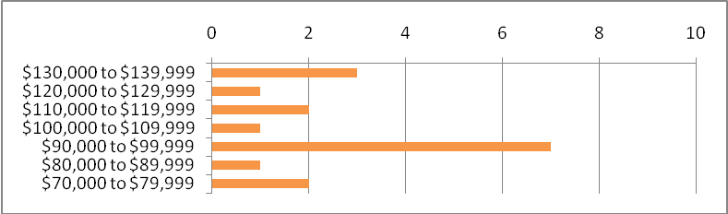
$120,000 to $129,999 | 1
$110,000 to $119,999 | 2
$100,000 to $109,999 | 1
$90,000 to $99,999 | 7
$80,000 to $89,999 | 1
$70,000 to $79,999 | 2
  - 400-600 students (27 schools or 22.0%)
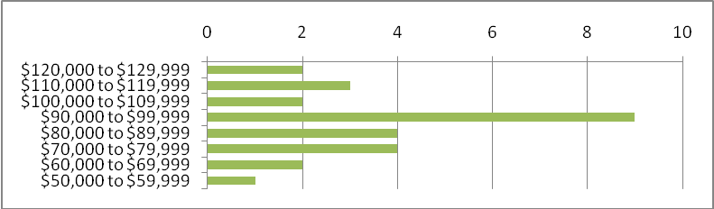
$120,000 to $129,999 | 2
$110,000 to $119,999 | 3
$100,000 to $109,999 | 2
$90,000 to $99,999 | 9
$80,000 to $89,999 | 4
$70,000 to $79,999 | 4
$60,000 to $69,999 | 2
$50,000 to $59,999 | 1
  - 250-400 students (28 schools or 22.8%)
$120,000 to $129,999 | 1  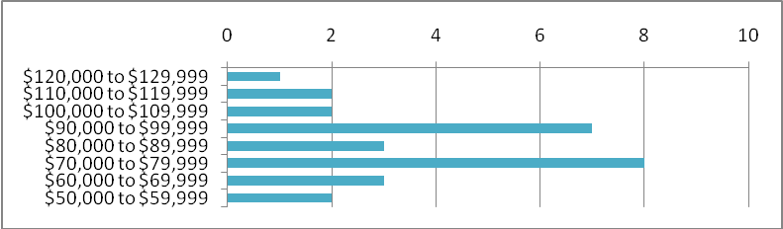
$110,000 to $119,999 | 2
$100,000 to $109,999 | 2
$90,000 to $99,999 | 7
$80,000 to $89,999 | 3
$70,000 to $79,999 | 8
$60,000 to $69,999 | 3
$50,000 to $59,999 | 2

  - 150-250 students (15 schools or 12.2%)
$120,000 to $129,999  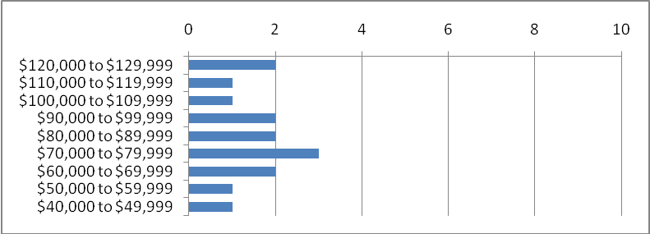 | 2
$110,000 to $119,999 | 1
$100,000 to $109,999 | 1
$90,000 to $99,999 | 2
$80,000 to $89,999 | 2
$70,000 to $79,999 | 3
$60,000 to $69,999 | 2
$50,000 to $59,999 | 1
$40,000 to $49,999 | 1
  - 100-150students (15 schools or 12.2%)
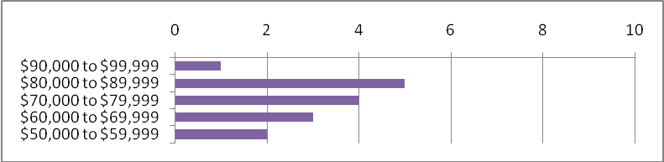
$90,000 to $99,999 | 1
$80,000 to $89,999 | 5
$70,000 to $79,999 | 4
$60,000 to $69,999 | 3
$50,000 to $59,999 | 2

  - 50-100 students (8 schools or 6.5%)
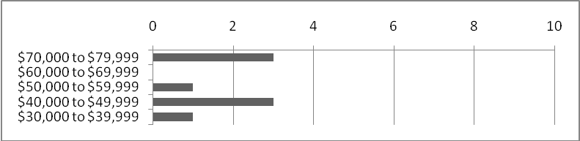
$70,000 to $79,999 | 3
$60,000 to $69,999 | 0
$50,000 to $59,999 | 1
$40,000 to $49,999 | 3
$30,000 to $39,999 | 1

  - Less than 50 students (5 schools or 4.1%)
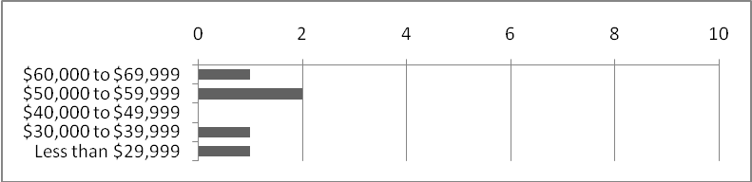
$60,000 to $69,999 | 1
$50,000 to $59,999 | 2
$40,000 to $49,999 | 0
$30,000 to $39,999 | 1
Less than $29,999 | 1

- 90 out of 123 respondents or 73.1% report more than one top administrator
- Second Top Administrator Salary Range Responses
More than $200,000 | 0 | 0.0%  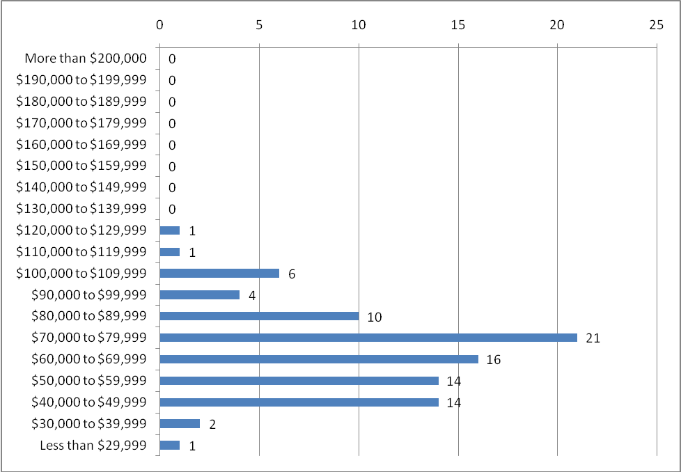
$190,000 to $199,999 | 0 | 0.0%
$180,000 to $189,999 | 0 | 0.0%
$170,000 to $179,999 | 0 | 0.0%
$160,000 to $169,999 | 0 | 0.0%
$150,000 to $159,999 | 0 | 0.0%
$140,000 to $149,999 | 0 | 0.0%
$130,000 to $139,999 | 0 | 0.0%
$120,000 to $129,999 | 1 | 1.1%
$110,000 to $119,999 | 1 | 1.1%
$100,000 to $109,999 | 6 | 6.7%
$90,000 to $99,999 | 4 | 4.4%
$80,000 to $89,999 | 10 | 11.1%
$70,000 to $79,999 | 21 | 23.3%
$60,000 to $69,999 | 16 | 17.8%
$50,000 to $59,999 | 14 | 15.6%
$40,000 to $49,999 | 14 | 15.6%
$30,000 to $39,999 | 2 | 2.2%
Less than $29,999 | 1 | 1.1%
- 56.7% of 2nd top administrator salaries are between $50,000 and $79,999
- 94.4% of 2nd top administrator salaries are between $40,000 and $109,999
- 8.9% of 2nd top administrator salaries are greater than $100,000
- 75.6% of 2nd top administrator salaries are below $79,999

