TO: School Business Officials, Pupil Count Coordinators, and Food Service Directors FROM: Aaron Oberg, School Finance Director
DATE: 5/9/2018

SUBJECT: Family Economic Data Survey – 2018-2019 School Year

The U.S. Department of Agriculture (USDA) has issued policy prohibiting the use of the Application for Free and Reduced Price Meals for any other programs in schools that do not participate in the federal child nutrition programs. Because there are other programs that link funding to free or reduced price meal eligibility, including additional state at-risk funding and potentially local waivers of school fees, the Colorado Department of Education has developed a Family Economic Data Survey form as an alternative data collection instrument for non-participating schools.

The Family Economic Data Survey form is attached along with family friendly instructions which explain how to complete the form and outlines the purpose of the form. Additional information on the use of these two forms related to at-risk funding and child nutrition programs can be found in the At-Risk and Child Nutrition Program Documentation Matrix.

State statute (Section 22-54-112(4), C.R.S.) requires every school to include the federal Application for Free and Reduced Price Meals or the state Family Economic Data Survey form in its registration materials. The materials shall include an explanation that these documents will be used to determine whether the school is eligible for at-risk funding on behalf of the pupil and, by filling out the form, the parent is ensuring the district or school will receive the at-risk funding to which it is entitled based on the population of at- risk pupils served by the district.

The district’s food service fund cannot be used for any processing or maintenance of documentation not associated with eligibility for the child nutrition programs as it is an unallowable cost. This includes collection, processing, and maintenance of the Family Economic Data Survey forms. Other district resources must be used. If the district wishes to have food service personnel process the surveys, the food service fund must be reimbursed for the cost of this processing.

Districts are responsible to ensure that the data collection complies with all applicable state and federal confidentiality rules. Questions regarding the documentation to evidence at-risk eligibility for School Finance purposes and CDE audits should be directed to Rebecca McRee at (303) 866-6805 or mcree_r@cde.state.co.us. Questions regarding the Community Eligibility Provision (CEP) or Provision 2 should be directed to Rachael Burnham (303) 866-6450 or burnham_r@cde.state.co.us.

Enclosures: District Determining Official Processing Instructions

2018-2019 FAMILY ECONOMIC DATA SURVEY
DETERMINING OFFICIAL PROCESSING INSTRUCTIONS

The procedures for processing the Family Economic Data Survey form are similar to those for a free or reduced price meal application, and utilize the same eligibility criteria. It is important to note that while similar, this survey does not substitute for an official meal benefit application, and families should not be led to believe that completion of the form will result in meal benefits for their child. If this form is used to document eligibility for state or federal program funding, it will be subject to audit by CDE and other program officials. Failure to process and document correctly may result in an audit exception, and subsequent recovery of funds.

The district should consider the following when processing applications:

- Student information must be accurate and can be linked to a child enrolled at the particular school.

- The application form must be completed correctly if a student is to be considered eligible for free meals/at-risk funding.

- The signature of the eligibility-determining official must be on all applications, including applications that have been denied.

- All SNAP case numbers in Colorado begin with '1B,' and case numbers are 7 digits long (a combination of letters and numbers).

- All Food Distribution Program on Indian reservations (FDPIR) case numbers are 9 numbers long and contain no letters.

- The following table outlines the income threshold consistent with free lunch eligibility for the 2018-2019 school year:

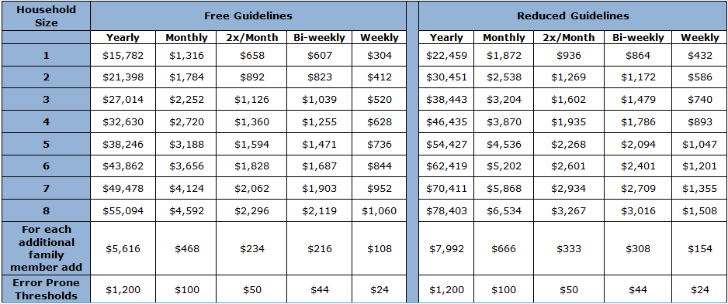

- The conversion factors for computing family income is:

If there is only one source of income or if all sources received are in the same frequency (example, monthly income), no conversion is required.
  - If there are multiple income sources with more than one frequency, the determining official must annualize all income by multiplying:
    - Weekly income by 52
    - Bi-weekly income (received every two weeks) by 26
    - Semi-monthly income (received twice a month) by 24
    - Monthly income by 12

- The district’s food service fund cannot be used for any processing or maintenance of documentation not associated with eligibility for the child nutrition programs as it is an unallowable cost. Other district resources must be used. If the district wishes to have food service personnel process the surveys, the food service fund must be reimbursed for the cost of this processing.

Refer also to the instructions for the parents for further guidance.

