**CDE HOMEPAGE – GO TO PUBLIC SCHOOL FINANCE PAGE**

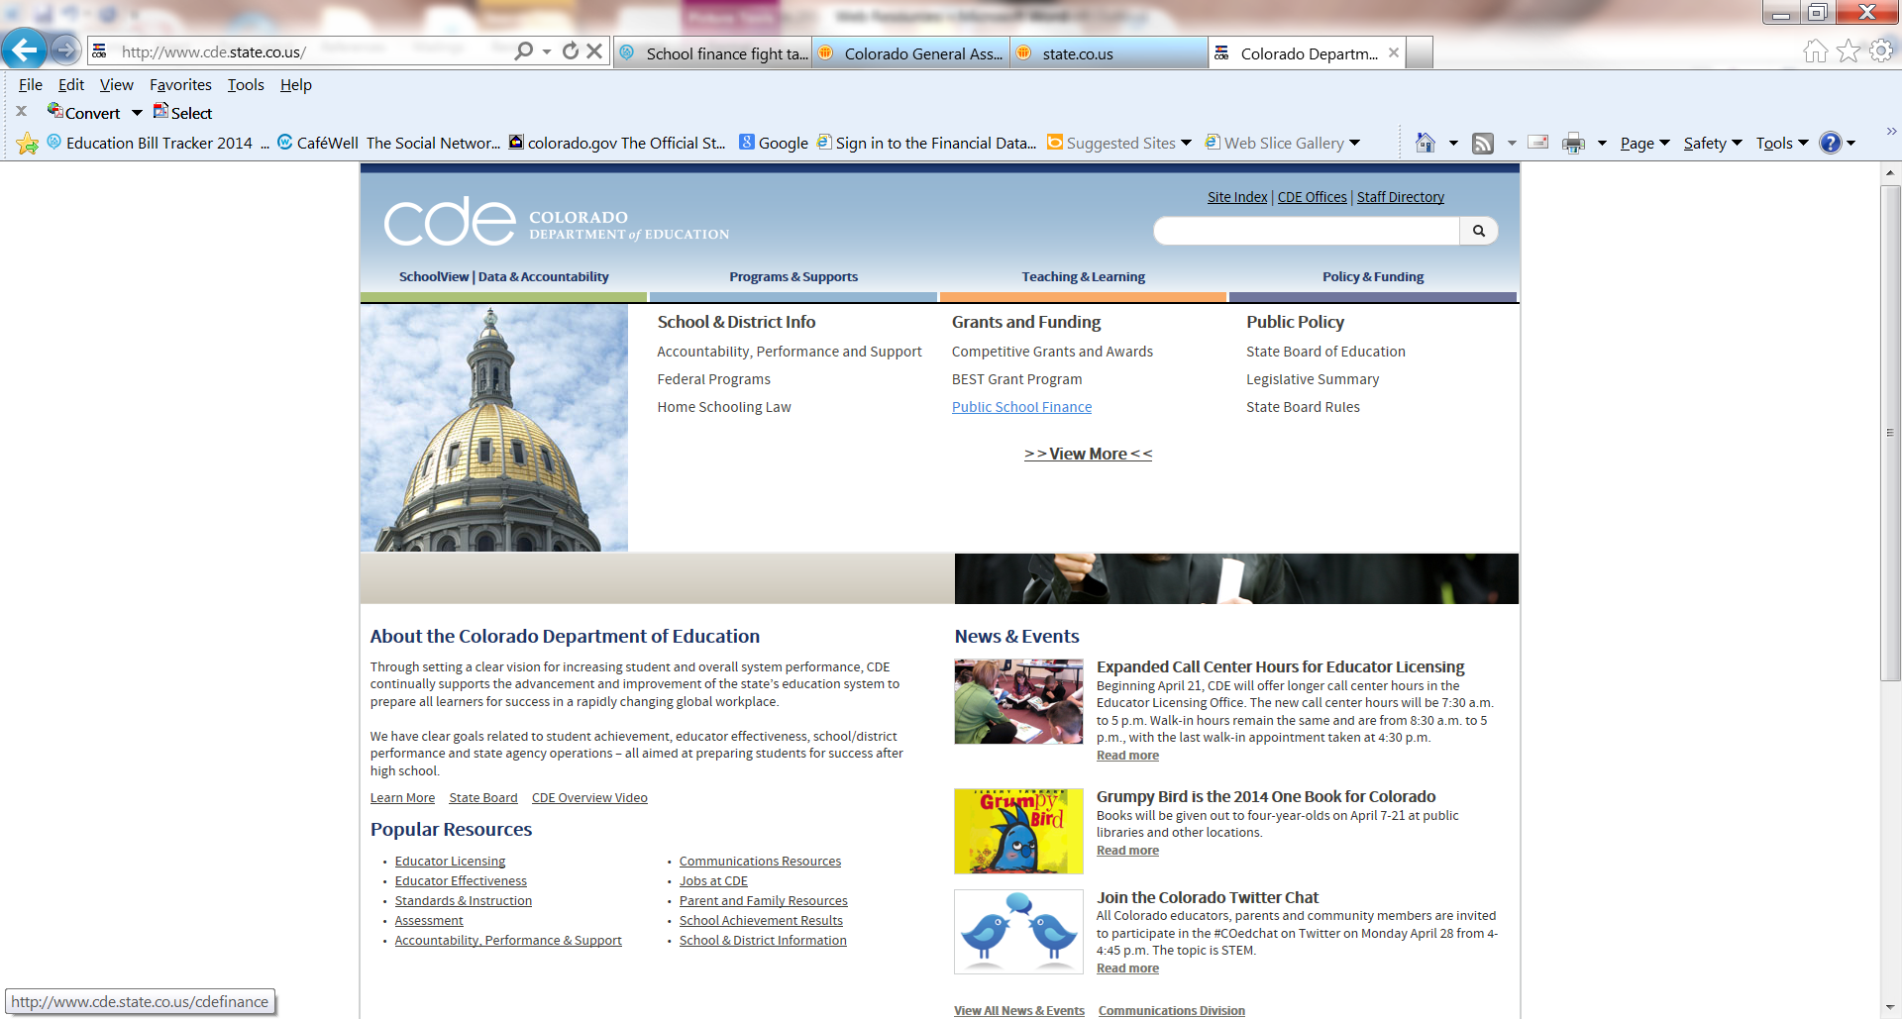

**GET FAMILIAR WITH THE PUBLIC SCHOOL FINANCE WEBPAGE**

1. **We will look at Public School Finance Funding & Payment Information**

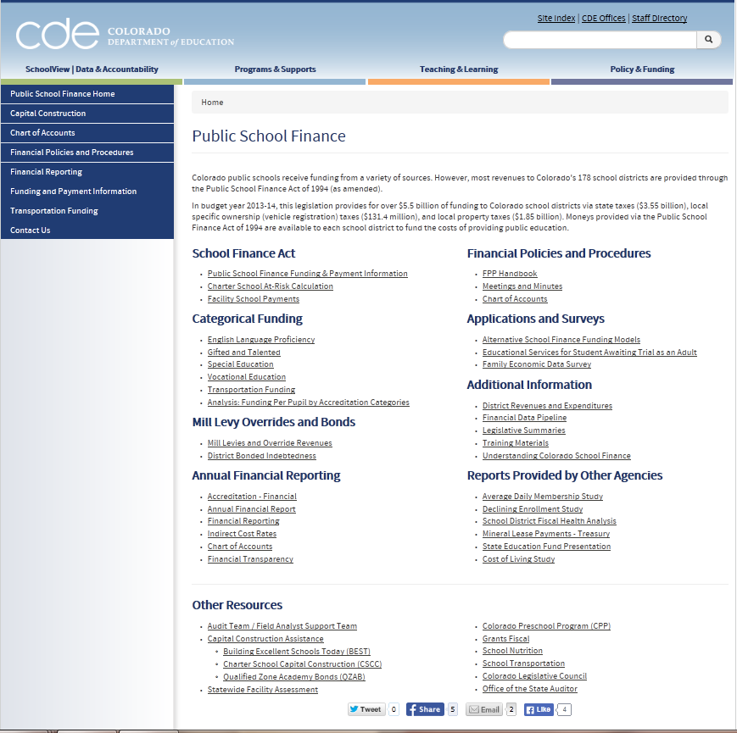

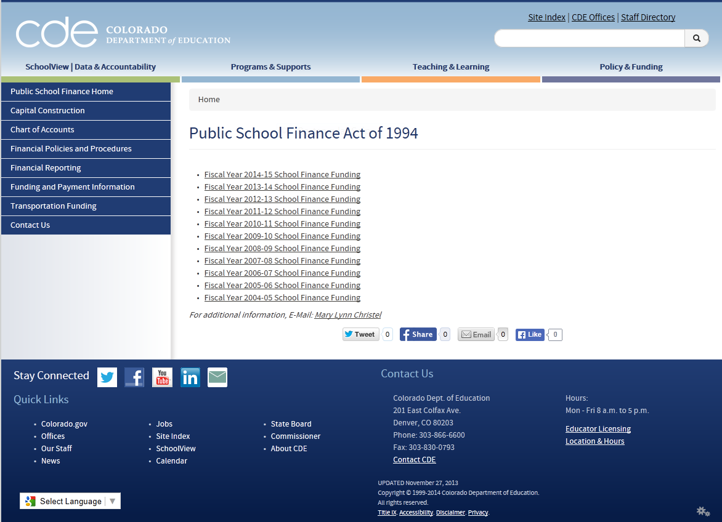

2013-14 will give current information

2014-15 will give projected information

**We will look at 2013-14 first.** 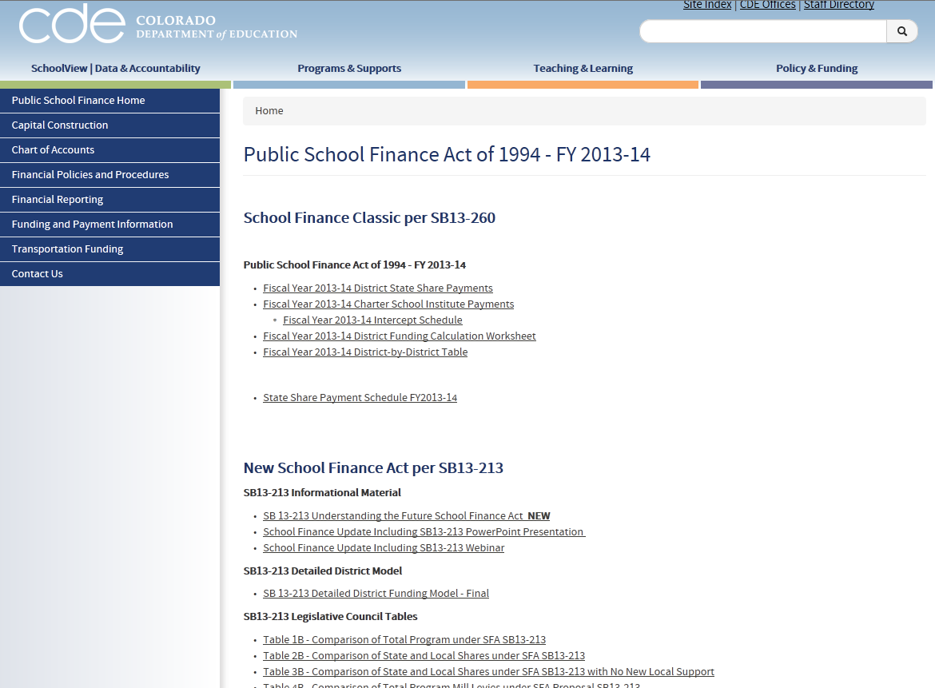

District State Share Payments will give current status of funding

This section is not relevant – it was for the potential new school finance act that did not pass.

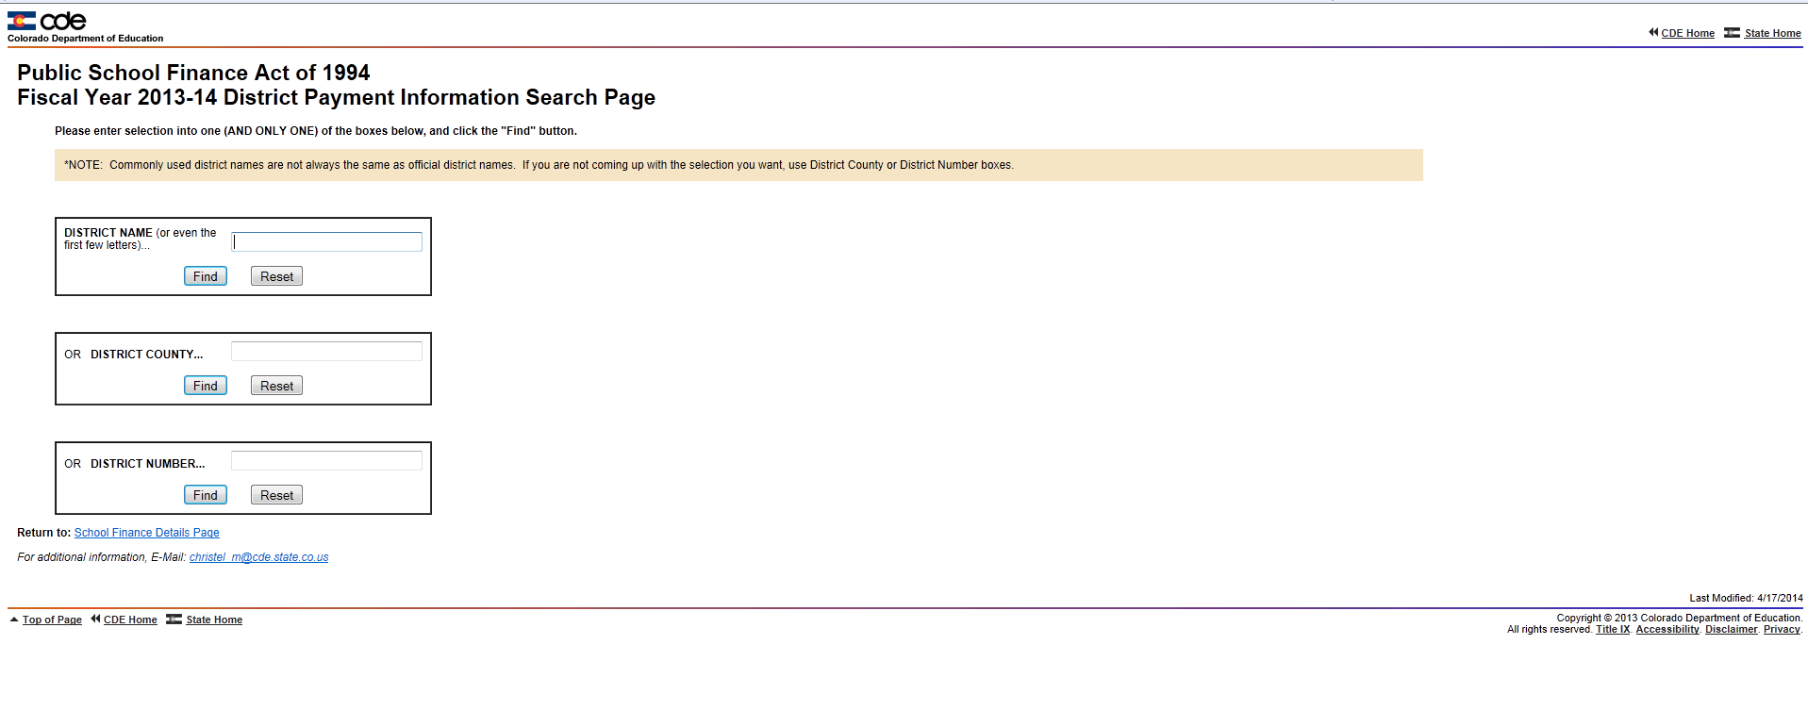

**The funding summary tells you your current status of funding.**

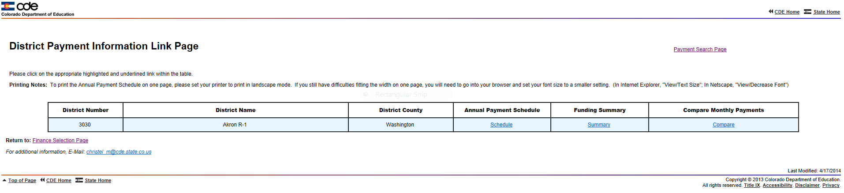

**The Funding Summary Worksheet is VERY IMPORTANT!** 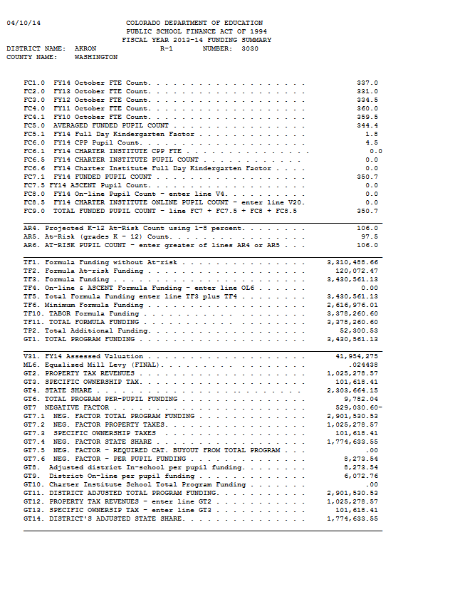

* **Negative factor**
* **Total Program AFTER the Negative Factor – USE THIS**
* **Components of Total Program**
  + **Taxes – 100%**
  + **Specific Ownership**
  + **State Share**
* **Per pupil funding**

**Total Program BEFORE Negative Factor**

**Funded pupil count**

**The 2014-15 School Finance Funding section will help you with budgeting/planning for next year. It is constantly updated during the legislative session.**

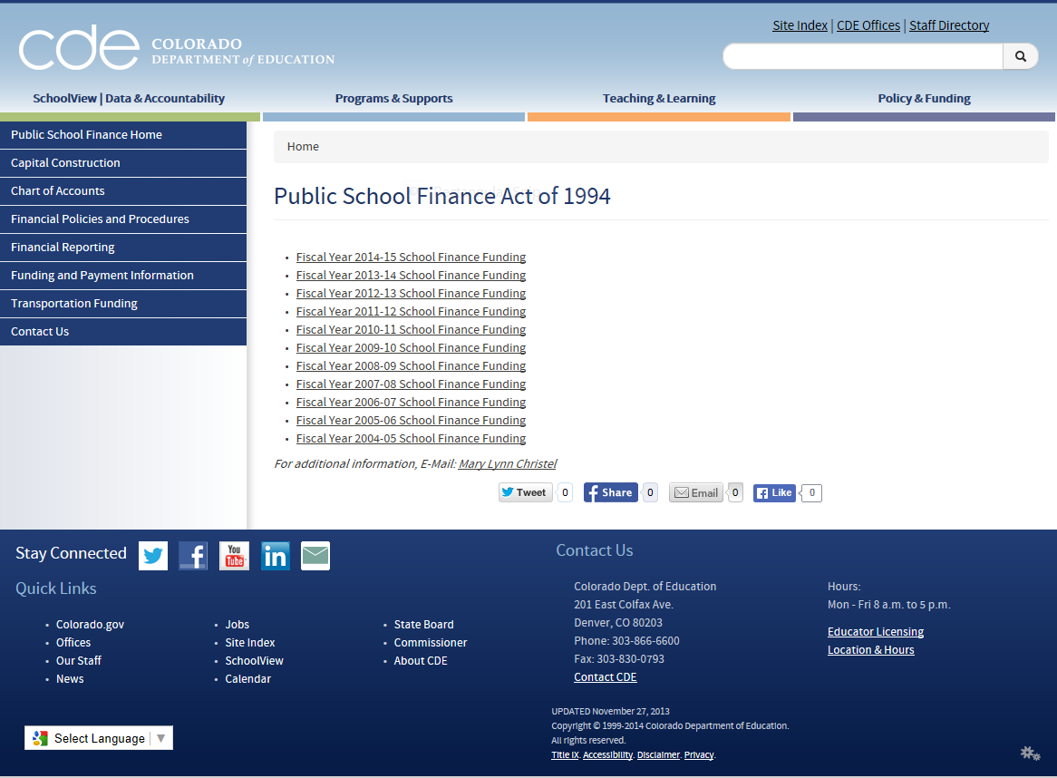

2014-15 will give projected information

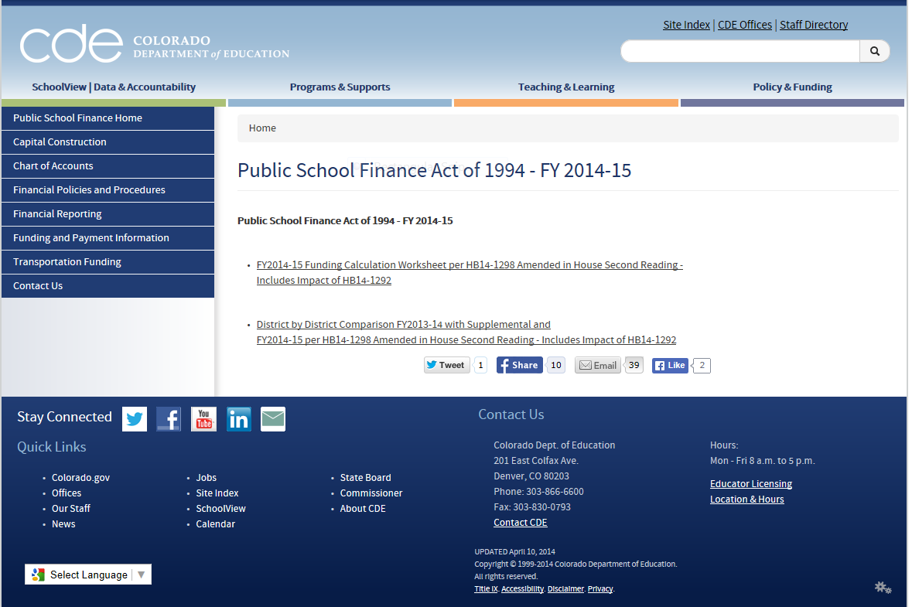

This is the summary spreadsheet that illustrates the changes between two years and is good for planning. culations.

This is the “big spreadsheet” with all of the calculations.

**This is a sample projection sheet – Mary Lynn Christel –** [**christel_m@cde.state.co.us**](mailto:christel_m@cde.state.co.us) **- 303-866-6818 will run projections for you if you want to change assumptions for student counts, etc.**



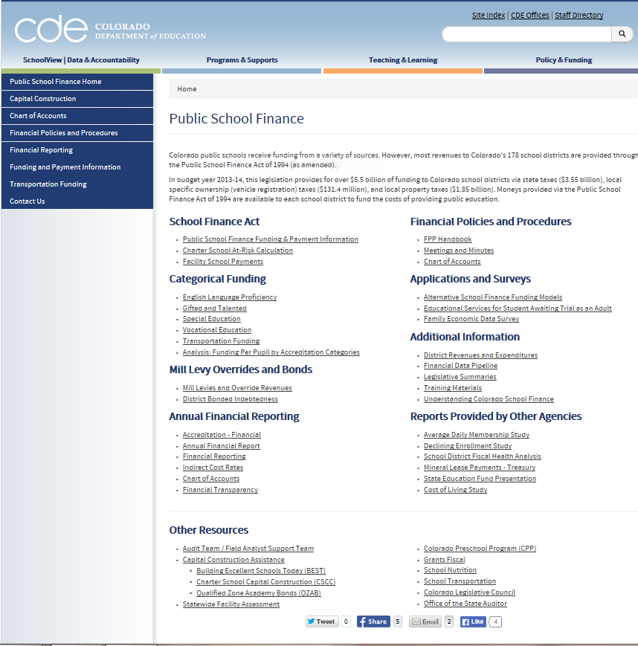

**CDE 18 & Critical Dates**

**CONTACTS WITHIN THE DIVISION OF PUBLIC SCHOOL FINANCE**

|  |  |  |  |
| --- | --- | --- | --- |
| Name | Phone | Email | Primary Duties |
| Leanne Emm | 303-866-6202 | [Emm_l@cde.state.co.us](mailto:Emm_l@cde.state.co.us) | Associate Commissioner |
| Jennifer Okes | 303-866-2996 | [Okes_j@cde.state.co.us](mailto:Okes_j@cde.state.co.us) | School Finance Director |
| Mary Lynn Christel | 303-866-6818 | [Christel_m@cde.state.co.us](mailto:Christel_m@cde.state.co.us) | Public School Finance Guru |
| Kirk Weber | 303-866-6610 | [Weber_k@cde.state.co.us](mailto:Weber_k@cde.state.co.us) | Technical Assistance – Financial Reporting; Budgeting; Accounting Requirements |
| Adam Williams | 303-866-6843 | [Williams_a@cde.state.co.us](mailto:Williams_a@cde.state.co.us) | Fiscal Analyst – Financial Reporting; Transportation Claims; Data Pipeline Submissions |
| Yolanda Lucero | 303-866-6847 | [Lucero_y@cde.state.co.us](mailto:Lucero_y@cde.state.co.us) | Fiscal Analyst – Financial Reporting; Data Pipeline; Data Reporting |
| David Schneiderman | 303-866-6689 | [Schneiderman_d@cde.state.co.us](mailto:Schneiderman_d@cde.state.co.us) | Grants Fiscal Supervisor |
| Scott Abbey | 303-866-6153 | [Abbey_s@cde.state.co.us](mailto:Abbey_s@cde.state.co.us) | FAST Supervisor - Pupil Count Audits |
| Wendi Chapin | 303-866-6137 | [Chapin_w@cde.state.co.us](mailto:Chapin_w@cde.state.co.us) | Transportation Supervisor; BEST Finances |
| Scott Newell | 303-866-6717 | [Newell_s@cde.state.co.us](mailto:Newell_s@cde.state.co.us) | BEST Director |
| Jane Brand | 303-866-6934 | [Brand_j@cde.state.co.us](mailto:Brand_j@cde.state.co.us) | School Nutrition Director |