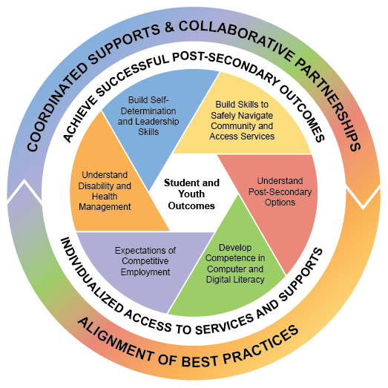
Sequencing of Services Interagency Collaboration Notes for Student Planning

School Team + Division of Vocational Rehabilitation + Community Centered Board + Center for Independent Living + Additional Partners as Appropriate
- Date (00/00)
- Check this document weekly for updates
- When emailing be sure to cc’ members of student’s team

Youth: Name
School or Program:
School Transition IEP:
Career/Employment Goal:
Education/Training Goal:
Independent Living Goal:
CIL Independent Living Plan:
Goal:
DVR IPE:
Employment Goal:
**CCB Connected? YES or NO or IN PROCESS or N/A ** SSI: YES or NO ** Guardianship: IN PLACE or NO
Agency or Team | Outcomes of Work/Meeting with Youth | Follow up Needed | Questions
School Team
Staff Contact Name
CIL
Staff Contact Name
DVR
Counselor Name
XXXX
Staff Contact Name

