Sequencing of Services
Assessments for 6 Core Outcomes
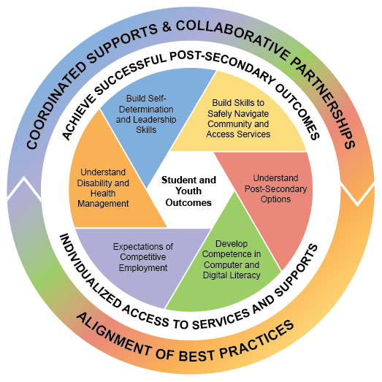

Build Self-Determination and Leadership Skills
Assessments | Identified Needs and Areas for Support | Goal

Build Skills to Safely Navigate the Community and Access Services
Assessments | Identified Needs and Areas for Support | Goal

Understand Post-Secondary Education and Training Options
Assessments | Identified Needs and Areas for Support | Goal

Develop Competence in Computer and Digital Literacy
Assessments | Identified Needs and Areas for Support | Goal

Expectation of Competitive Employment
Assessments | Identified Needs and Areas for Support | Goal

Understand Disability and Health Management
Assessments | Identified Needs and Areas for Support | Goal

