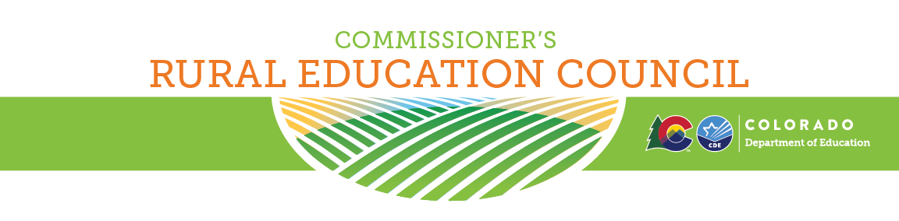
Friday, April 12, 2024 LOCATION: Remote TIME: 9AM - Noon
Join Zoom Meeting
Meeting ID: 833 1463 5731 Passcode: 196127

9:00 a.m. - 9:15 a.m. Welcome & Overview of Agenda - Susana Córdova

9:15 a.m. - 9:45 a.m. Rulemaking: Exceptional Children's Educational Act - Floyd Cobb

9:45 a.m. - 10:15 a.m. Rulemaking: Transportation and School Finance - Jennifer Okes & Susan Miller 10:15 a.m. - 10:30 a.m. Break
10:30 a.m. - 11:00 a.m. Legislative Updates - Shelbie Konkel

11:00 a.m. - 11:45 a.m. Commissioner & Rural Council: Hot Topics (Share Promising Practices) 11:45 a.m. - noon Farewell to Outgoing Members and Recruiting New Members - Zack Allen Noon Adjournment

The purpose of the Rural Education Council is to provide advice and counsel to the Commissioner of Education and the Colorado Department of Education on issues unique to rural school districts.

