PWR Playbook

- Building PWR Schools with
PWR Tools and
PWR People for
PWRful Students

PWR is a process, it’s a journey
PWR IS the culture of the school, embedded in the vision/mission
- Aligned with core values

Student

STUDENTS are supported by a PWR TEAM

  - PWR Family

  - PWR Counselors
  - PWR Teachers(any content/CTE)
  - PWR Coaches

  - PWR Community Members
  - Any PWRful influential & caring adult
  - Etc.

- who provide opportunities for the student that:
  - Are aligned, authentic, accessible, relevant, iterative, transferrable
  - Are Experiential: they take place in and out of the classroom
  - Cross all content areas, with universal skills and competencies
  - Are student-driven
  - Build in reflection
  - Lead to strong self-efficacy and better career development (supports students becoming their best self)

ICAP is the foundation for students’ PWR
- It IS THE THREAD that links everything together
- It is research-based with Quality Indicators that define a process
- It CONNECTS research to experiences to reflection to iteration to growth

Experiences
Research
Reflection

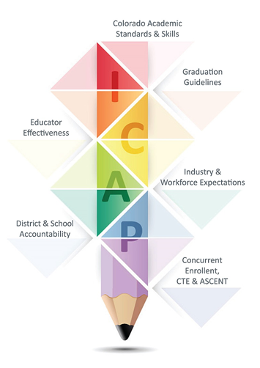
ICAP is the foundation for students’ PWR
- IT CONNECTS PWR with Essential Skills, Colorado Academic Standards, accountability, teacher effectiveness, UIP, assessment, CTE, Workforce, and ultimately with postsecondary success

The PWR PLAYBOOK is accessible to all players.

Each participant will know his/her/their role with ”I CAN…“ statements, for example:

Teacher
I CAN… connect a math lesson to future careers
I CAN…incorporate essential skills into each lesson

Administrator
I CAN… work with all adults to help capture students’ best selves i

Counselor
I CAN… guide the ICAP team
I CAN… engage adults in the PWR conversation
I CAN… model meaningful career conversations
I CAN… help students and staff apply Essential Skills in every activity/class/lesson/game/experience

Student
I CAN… show you who I am, by best self
I CAN… be motivated, set goals
I CAN… envision my journey and design my life

Family
I CAN… support my student and encourage him/her
I CAN… be a positive role model for my child(ren) in positivity, work ethic, resilience, acceptance

Community
I CAN… be open to internships, apprenticeships, job shadow, on the job training, entrepreneurships

AND, the PWR PLAYBOOK is full of HOW

I Individual Development
C Career Development
A Academic Development
P PWRful Demonstrations of Learning

Each section will
- incorporate the Quality Indicators, Essential Skills, and “I can” statements
- include Promising Practices for Elementary, Middle and High School, and Adults, that:
  - are based on Design Principles, and that are aligned, accessible, authentic, relevant, transferable, and iterative
  - include connections, reflections, experiences, conversations, stories, research application, collections
- suggest documents or evidence for PWR Demonstrations that can be stored/uploaded by students

How do we KNOW ICAP is effective?

Students will
- be more engaged in school
- exhibit positive behaviors
- show us their growth mindset, their curiosity, and their self-awareness
- own their learning and CONNECT it with their future (and future career)
- know how to fail, reflect, and succeed
- have COLLECTED PWRful demonstrations of their learning
- articulate and act on their sense of self-efficacy and career direction.
- demonstrate essential skills in action

- They will graduate by demonstrating readiness in math and English according to the Graduation Guidelines menu of options

Districts will see
- Improved academic performance, graduation rates, matriculation rates, engagement, attendance
  - reflected in the 3rd grade reading scores, in their 9th grade math scores
  - demonstrated through GRADUATION GUIDELINES
- Decreased dropout rates, rate of substance abuse, pregnancy rates, suicidal ideation, self-harm, behavior issues

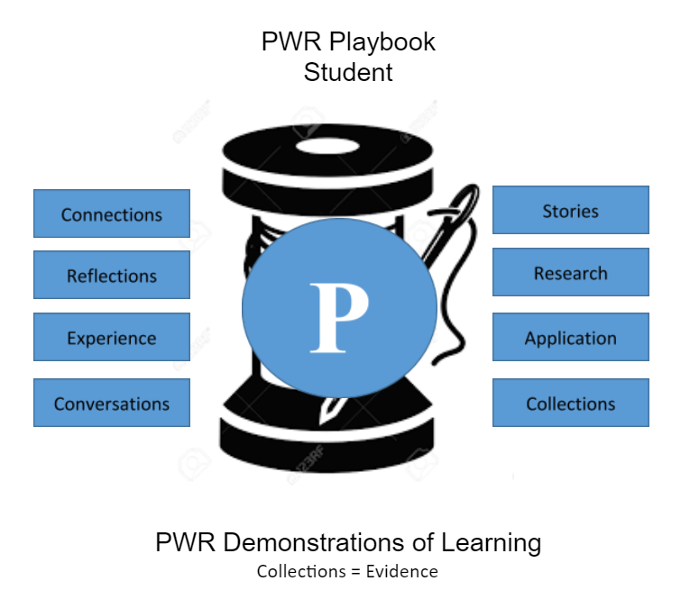

I Can …
I Can …

Elementary Middle School High School Adult

PWR Demonstrations of Learning

PWR Outcomes - Students
- I can adapt and grow based on feedback, reflective practices and changing situations.
- I can effectively communicate in a variety of verbal and non-verbal situations, considering my audience and purpose.
- I take responsibility for my actions and my personal well-being, and implement strategies to meet my needs.
- I can identify my own perspective and the perspectives of others, and act as an agent of change in the world.
- I can articulate my strengths, preferences, and interests, as they relate to potential career paths.
- I can gather, analyze, and evaluate information from a variety of reliable and credible sources.
- I can collaborate with others to achieve a common goal.
- I can design, evaluate, manage, and follow through with projects, and with meeting short and long term goals.
- I can gather, analyze, and evaluate information from a variety of reliable and credible sources.
- I can use a variety of discipline-specific techniques and/or processes to solve complex problems.

How do I know that I am PWRful?
I am more engaged in school
I can moderate and control my behavior
I own my learning
I am self-aware and I have a sense of self-efficacy
I know the direction I am heading

