ACT WorkKeys FAQs

Contact:
Carrie Ridenour, Ph.D.
Account Executive
719.430.5686
Carrie.Ridenour@act.org

General Questions

What are the 3 tests they need to take for the Bronze and what is the cost?
- Graphic Literacy $12
- Applied Math $12
- Workplace Documents $12

Do students need to take the 3 tests at once to earn a Bronze?
No. In fact, you could have them take one their sophomore year, one junior, and one senior.

How do I order?
Go to this link.
https://pages2.act.org/workkeys-info.html?_ga=2.268229769.681942274.1570205096-29994702.1570205096

What is on each Assessment?

Workplace Skill/  WorkKeys Assessment | Example Topics
Applied Math | • Addition and Subtraction in the Workplace  • Adding/Subtracting Negative Numbers  • Multiplying/Dividing in the Workplace  • Fractions in the Workplace  • Converting Units in the Workplace
Graphic Literacy | • Finding information in Tables  • Reading Simple Charts and Graphs  • Reading and Using Forms  • Reading Simple Gauges, Diagrams, Flowcharts
Workplace Documents | • Reading Emails, Memos, Policies  • Finding the Main Idea in Text  • Identifying Key Details  • Following Instructions
What are examples of the test questions from each of the 3 tests?
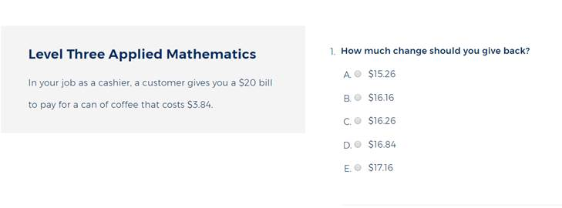
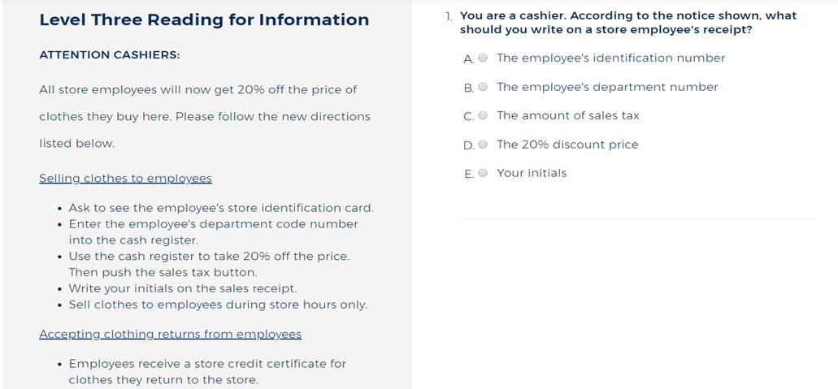

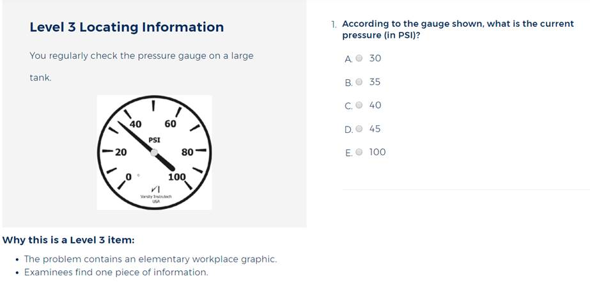

What are my students’ chances of earning a Bronze?
88.5% of all WorkKeys test takers score at least a Bronze. 4,700,519 certificates have been awarded.

When a student earns at least a Bronze for their NCRC certificate, how does that help them after high school?
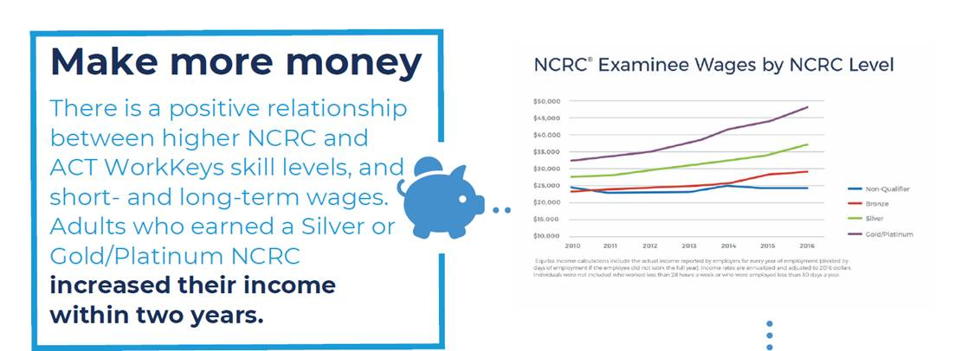

Is there a testing window?
No

Are there time of day requirements?
No

How is testing delivered?
Paper and/or Online, mix and match, your choice.

Do accommodations need approval?
No, however there are some guidelines and reporting is required. Click here for the guidelines.

What kind of reports?
The reports are not intended to drive curriculum decisions. They include level scores with descriptions, summary reports, roster reports, NCRC’s.

Can you delete students?
Not once they’ve taken a test.

Can you sign up groups?
Yes.

What does training consist of?
There are manual and resources for administering the tests, on demand webinars with a learning expert who can answer your questions, as well as opportunities to get personalized training at an additional cost. Info on the training can be found here.

When do they get billed?
Monthly, but only when a test has been delivered or scored (paper).

Is there an ability to do batch uploads of data?
Yes, spreadsheet.

Will it run on Chromebooks?
Yes, but it is not supported.

Are there specific computers or technology platform needs for testing?
Testing is browser based and does not need to be downloaded. You can use Firefox or Chrome on Windows, or Firefox on Mac for testing. Any browser is fine for proctoring. Click here for more info.

If we encounter technical problems during the test, can the test be restarted where student left off?
Yes, under most circumstances an interrupted assessment can be restarted within 1 hour. After 1 hour, a new test registration is required.

How long does it typically take to complete each WK test?
Standard time on the 3 NCRC tests is 55 minutes. Extended time accommodation is available (1.5x, 2x, 3x, controlled by the test administrator).

Are the tests standardized in the sense of time or student paced?
See above.

Will IEP students get accommodations? How does that work?
Test sites use our guidelines and approve their own accommodations that are similar to those accepted on the ACT.

How soon do we get results?
Online test results are almost instantaneous, within minutes.

How quickly can we get trained to administer the test if we bought training?
We have on demand training materials available immediately at no charge. If a site prefers the comfort and slower pace of hands-on involvement with an ACT WorkKeys SME, that can be arranged for a fee and a training can usually be scheduled within a few weeks.

How do students check their scores?
Students check their scores at www.myworkkeys.com.

How do we interpret scores?
There are five levels of difficulty for each test. Level 3 is the least complex, and Level 7 is the most complex. The levels build on each other, each incorporating the skills assessed at the previous levels.
Assessment scores are reported with both the level and a description of the skills the student demonstrated along with recommendations for skill improvement. Below are additional resources to interpret scores:
- ACT WorkKeys for Educators and Administrators: https://www.act.org/content/act/en/products-and-services/workkeys-for-educators.html
- The National Career Readiness Certificate: https://www.act.org/content/act/en/products-and-services/workkeys-for-educators/ncrc.html
- Using WorkKeys Scores: https://www.act.org/content/dam/act/unsecured/documents/UsingWorkKeysScores.pdf

WorkKeys Curriculum FAQs

What is the Curriculum?
This is the prep program for the WorkKeys exam.

Where do I go to log in to ACT WorkKeys Curriculum?
To log in, go to: https://workkeyscurriculum.act.org/login

Where do I go to order the Curriculum?
https://www.act.org/content/act/en/products-and-services/workkeys-for-educators/shared/contact-me-form.html

What training materials are available?
You can register to watch the ACT WorkKeys Curriculum on-demand training video and download the ACT WorkKeys Curriculum Administration User Guide and any other support documentation from the ACT WorkKeys Curriculum webpage under Administration Resources.

If we bought the curriculum, how much time does it typically take to complete the curriculum?
The curriculum is self-paced, so it’s really impossible to predict. There are placement quizzes in each skill area. One learner may need extensive remediation and another may not need any.

Is there a hierarchy in ACT WorkKeys Curriculum?
Yes. ACT WorkKeys Curriculum provides a tiered system composed of Organization, District, and Institution.
• Organization – the highest tier. An organization can contain multiple districts and institutions within each district (e.g., a state-level agency)
• District – the second highest tier. A district is composed of multiple institutions (sites) that are associated with a unit (e.g., a school district or workforce investment board)
• Institution – a single site (e.g., a single school or career center)

Does ACT WorkKeys Curriculum automatically log off/log out a student after a period of inactivity?
Not at this time, but the feature is on our list for future development.

Will ACT WorkKeys Curriculum be available in Spanish?
Not at this point, but the feature is on our list for future development.

Does ACT WorkKeys Curriculum have voice over?
Not at this time, but the feature is on our list for future development.

Are there answer keys in ACT WorkKeys Curriculum?
No, but there is a feature in ACT WorkKeys Curriculum that allows the student—during practice question and quiz question review—to see the correct answers to incorrectly answered questions. This feature can be set to on or off for the institution (site).

Are there classes or groups in ACT WorkKeys Curriculum?
ACT WorkKeys Curriculum uses groups to organize learners/students and instructors. Instructors have access to student data for students that are in their group(s).

How are Courses organized?
Courses are organized into levels and each level ends with a level quiz which results in a score of pass/fail. The Essential Skills courses are organized into topics, do not have placement quizzes, and include final quizzes which result in a score of pass/fail.

Does ACT WorkKeys Curriculum include pretests and final quizzes?
The placement quizzes for the courses are aligned to the ACT and indicate the level at which the student is performing.

Is there a batch import function within ACT WorkKeys Curriculum?
Yes. A user with the role of institution admin can upload multiple instructors, learners/students, and/or groups using a comma-delimited (.CSV) file import. Directions are available from the Institution Admin Dashboard by selecting Groups, Instructors, or Students from the left navigation menu, then selecting the corresponding New Group, New Instructors, or New Students button, and selecting Upload Multiple from the dropdown menu.
Directions are also included in the ACT WorkKeys Curriculum Administration User Guide.

What type of support is available for ACT WorkKeys Curriculum?
There are many types of support:
• ACT WorkKeys Curriculum offers in-app help guides for all users with the role of admin, supervisor, or instructor. Simply select the icon in the lower left corner of the screen.
• The ACT WorkKeys Curriculum Administration User Guide is available from the ACT website.
• Access to an on-demand training video is available from the ACT website.
• Email workkeyscurriculum@act.org or call 877.842.6205.

What types of reports are available in ACT WorkKeys Curriculum?
ACT WorkKeys Curriculum provides a variety of reports. Users with the role of institution supervisor, district supervisor, organization supervisor, or instructor have access to the reporting dashboard. The user’s role determines what level of reports can be run: student, group, institution, or district reports. The data in these reports is updated twice daily, as indicated by the date time stamp.
Note: Most users with the role of institution supervisor or district supervisor also have the role of institution admin or district admin, respectively.

District Reports
• Organization supervisors and district supervisors have access.
• There is a separate line for each institution in the district, which includes the institution name, total number of student accounts, total number of active student accounts, and student performance data on quizzes.

Institution Reports
• Institution supervisors see summary data on their institution, including: the total number of student accounts, the total number of active student accounts, along with student performance data on quizzes.
• Organization supervisors or district supervisors see a list of all institutions in the organization/district, respectively, with student summary data.

Group Reports
• Institution supervisors see summary data on each group in the institution, including the total number of student accounts in each group, the total number of active student accounts in each group, along with student performance data on quizzes.
• Organization supervisors or district supervisors see a list of all groups in the organization/district, respectively, with the student summary data.
• Instructors see a list of groups in which the instructor is a member along with the student summary data.

Student Reports
• Institution supervisors see a list of all students in the institution, including student name, date student was last active in any ACT WorkKeys Curriculum course, along with student performance data on quizzes for an individual course or all courses.
• Organization supervisors or district supervisors see a list of all students in the organization/district, respectively, with same student performance data on quizzes for an individual course or all courses.
• Users with the role of instructor see a list of students who are in groups in which the instructor is a member with student performance data on quizzes for an individual course or all courses.

Real-Time Reports
• Real-Time Reports provide real-time data per student, per course. This data can be exported in a separate CSV file for each course.
• Institution supervisors see a list of all students in the institution, including: student name, ID, username (email address), institution name, date student account was created, and date student was last active in any ACT WorkKeys Curriculum course. Selecting a specific student provides real-time data, per course, for the selected student. This data can be exported in a separate CSV file for each course.
• Organization supervisors or district supervisors see a list of all students in the organization/district, respectively, with the same student performance data.
• Instructors see a list of students who are in groups in which the instructor is a member, along with student performance data.

How much does the curriculum cost?
$2000 per site

How much does the optional onsite training cost?
$2900 per onsite day

