Colorado Department of Education
School Nutrition Unit
Online Claim System

SFSP Site Claims

Point of Sale (POS) File Specifications

V3.0

August 2, 2018

State of Colorado  Department of Education  Child Nutrition Programs | 

Submitted by:


22420 N. 18th Drive
Phoenix, Arizona, 85027
623-209-1700

Table of Contents
1. Point of Sale (POS) Interface 4
1.1 Interface Characteristics 4
1.2 Constraints 5
1.3 Process Overview 5
1.4 File Layout 6
2. Accessing SFSP Site Claim POS Option within THE ONLINE CLAIM SYSTEM 7

Document Revision History
Version | Status | Date | Change Description | Updated By
V1.0 | Final | 3/26/2018 | Initial draft submitted to CO-DOE Project Management Team for review | Ami Jordan
V2.0 | Final | 8/1/2018 | Upated to reflect 804 Template format | Ami Jordan
V3.0 | Final | 8/2/2018 | Updated Template format – verbiage | Ami Jordan

- Point of Sale (POS) Interface
Summer Food Service Program (SFSP) site claim data may be either manually entered into the Online Claim System via the SFSP Claims module or imported via a file in a designated, pre-defined file format. Since some Sponsors maintain meal administrative systems that automatically capture point of sale (POS) data for meals served and generate reimbursement claims by site, THE ONLINE CLAIM SYSTEM provides the ability for authorized users to import a POS file in a defined file format. Once the file is imported into THE ONLINE CLAIM SYSTEM, claim validation and error checking will function in the same manner as if the site data was manually entered into THE ONLINE CLAIM SYSTEM and the user had selected the Save button.
This option is available only for the Summer Food Service Program (SFSP) Meals, which includes the following:
- Breakfast
- Lunch
- Supper
- Snack

Interface Characteristics
The following table identifies the characteristics of this interface:
Table 1: POS Systems – Interface Characteristics
Category | Characteristic
Purpose of Interface(s) | To upload a Sponsor’s SFSP site-level claim data
Type of Interface(s) | Batch
Initial Frequency Setting | On-demand initiated by Sponsor user
Interface Direction | Import into THE ONLINE CLAIM SYSTEM
Import Method | Via YYYY-YYYY SFSP Claim Site List screen within the THE ONLINE CLAIM SYSTEM SFSP Claims module (see Section 2)
Acceptable File Formats | ASCII Fixed Width per specification in this document
CO-DOE Contact for Development Questions | - Ashley Meon  - Moen_A@cde.state.co.us  - 303-866-6653
CO-DOE Contact for Production Questions | - Ashley Meon  - Moen_A@cde.state.co.us  - 303-866-6653

Constraints
The import process relies on the creation of an interface file that is a fixed width ASCII text file and contains site-level claim reporting information from a Sponsor’s point of sale (POS) system. The file must be formatted according to the layout specified in the THE ONLINE CLAIM SYSTEM SFSP POS File Layout specifications. Sponsor will need to develop a method of creating this file, which may require working with their POS vendor.

Process Overview
Creating the THE ONLINE CLAIM SYSTEM SFSP Claims POS File
When a Sponsor is ready to import site claim data into THE ONLINE CLAIM SYSTEM for a specific month, they will initially execute an external process from their POS system to create the “import” file. This file can be saved on the Sponsor’s local computer hard drive, network directory, or in any location desired by the user. The name of the file is not relevant to THE ONLINE CLAIM SYSTEM, therefore the Sponsor can choose their own naming standard for the file. It is recommended that the Sponsor includes the claim month (e.g., May2012) in the file name.
Importing the SFSP Claims POS File into THE ONLINE CLAIM SYSTEM
Once the file is created, the user will log into THE ONLINE CLAIM SYSTEM to execute the import process. The interface process is initiated by a user with the appropriate THE ONLINE CLAIM SYSTEM security to load the file. The intent is for the Sponsor user to conduct the upload process; however, any authorized user, can upload a file given the proper THE ONLINE CLAIM SYSTEM security rights and access to the SFSP Claims POS file.
To upload the file into THE ONLINE CLAIM SYSTEM, the Sponsor will click on a button on the SFSP Claim Site List screen (see Section 2). THE ONLINE CLAIM SYSTEM will present the user with a “File Open” dialog box and the user will navigate to and select the “import” file from the location where the user saved the file. After selecting the file, the user will click on an “import” link. THE ONLINE CLAIM SYSTEM will import the file and save the data. Uploaded files will be validated to ensure that Sponsor can only upload data for their sites.

Data Validation
After the file has been imported, THE ONLINE CLAIM SYSTEM will display a results screen so the user understands which, if any, records needs to be corrected. If there are errors in the data, the user can either correct them manually in THE ONLINE CLAIM SYSTEM or correct the errors in the POS system and re-upload the corrected file. The file can be uploaded as many times as the Sponsor would like; however, THE ONLINE CLAIM SYSTEM will overlay any existing data with new data. Repetitive uploads will always overlay existing data until the claim is paid. After the claim for the month being uploaded is paid, subsequent uploads for the same month will result in the creation of a revised claim.

File Layout
Appendix A defines the file format for the THE ONLINE CLAIM SYSTEM SFSP Claims POS file. Please note the following:
- N = Numeric
Example: Numeric data that is represented with two digits and no decimal places will be shown in this document as N(2,0).
- C = Character
Example: Character data that fills a field that is 99 spaces wide will be shown in this document as C(99).
- Accessing SFSP Site Claim POS Option within THE ONLINE CLAIM SYSTEM
The following screens identify the steps required to upload SFSP site claims data.

Step 1: Access the SFSP Claims Sub-module
Once an authorized user has logged into the SFSP module, access to the claims component for SFSP Claims is via “Claims” on the Menu Bar.



Step 2: Select “Claim – SFSP”
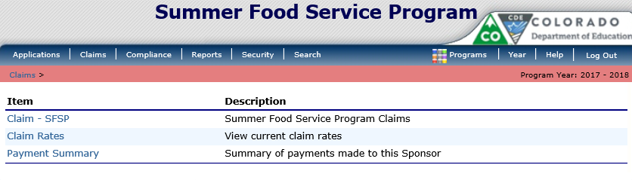

Step 3: On the SFSP Claim Year Summary screen, select Claim Month for the file to be uploaded
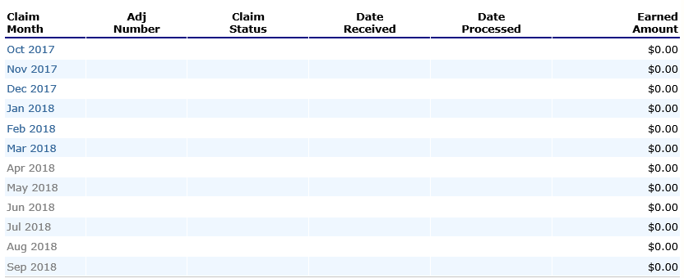

Step 4: On the SFSP Claim Month Details screen, select the “Add Original Claim” button
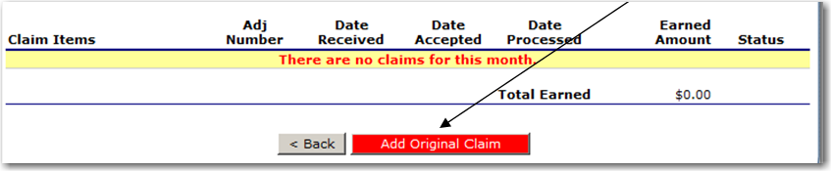
Step 5a: Select the “Upload Claim Data” button

Step 5b: Select the POS claim file to be uploaded (use the Browse button to locate the file)
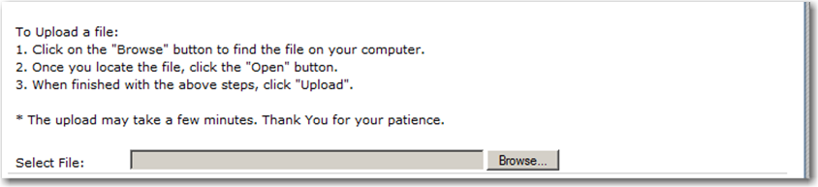

Step 5c: Select the “Upload” button
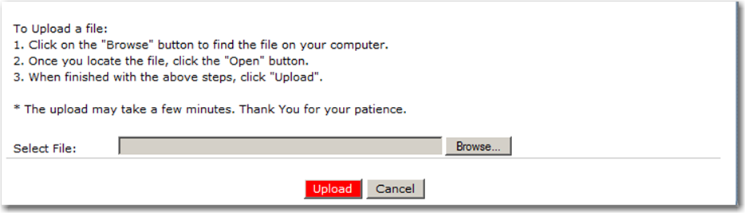

Appendix A

THE ONLINE CLAIM SYSTEM SFSP Point of Sale (POS) File Format Specifications

- Each row in the POS file is a site claim for a respective claim month; multiple sites (i.e., records) are included in a single POS file.
Field Seq. | Position From | Position To | Description | Field Length | Field Type | Required Field? | Instructions
1 | 1 | 3 | Upload Form ID | 3 | N(3,0) | Y | Claim General Information  Insert value = 804 for every record
2 | 4 | 9 | Sequential Number | 6 | N(6,0) | Y | Claim General Information  Sequential Record Number (1, 2, 3, etc.); with preceding zeros (ex. 000001)  The sequential number MUST be unique within a POS file
3 | 10 | 17 | Process Date | 8 | N(8,0) | N | Claim General Information  MMDDYYYY - Date the Sponsor exported the data from their system  Format: MMDDYYYY  NOTE: This data is not stored or used within THE ONLINE CLAIM SYSTEM; however, it may be useful to the Sponsor
4 | 18 | 33 | Blank | 16 | C(16) | Y | Leave Blank
4 | 34 | 133 | Sponsor Name | 100 | C(100) | Y | Claim General Information  Name of the Sponsor (as indicated within THE ONLINE CLAIM SYSTEM)
5 | 134 | 149 | Sponsor ID | 16 | C(16) | Y | Claim General Information  Unique Sponsor ID that was system generated by THE ONLINE CLAIM SYSTEM; this MUST match the CE ID defined within THE ONLINE CLAIM SYSTEM.  Zero fill from left (e.g. 01234)
6 | 150 | 249 | Site Name | 100 | C(100) | Y | Claim General Information  Name of the Site (as indicated within THE ONLINE CLAIM SYSTEM).
7 | 250 | 265 | Site ID | 16 | C(16) | Y | Claim General Information  Unique Site Number maintained within THE ONLINE CLAIM SYSTEM; this MUST match the Site ID defined within THE ONLINE CLAIM SYSTEM.  Zero fill from left (e.g., 0114)
8 | 266 | 267 | Claim Month | 2 | N(2,0) | Y | Claim General Information  The two-digit calendar month for which the claim is being submitted  Calendar month number (01, 02, …. 11, 12)  Example: January = 01; February = 02, etc.
9 | 268 | 271 | Claim Year | 4 | N(4,0) | Y | Claim General Information  The four digit calendar year for which the claim is being submitted  Example: 2012
10 | 272 | 273 | Rate for Lunch  "SP" or "VU" | 2 | C(2) |  | SP = Self Prep Rural  VU = Vended Urban
11 | 274 | 281 | Lunch - First Meals Served  Self-Prep and/or Vended-Rural | 7 | N(7,0) | N | Self-Prep and/or Vended-Rural Meals Served to Children  If not claiming Self-Prep and/or Vended-Rural lunch meals, leave blank
12 | 282 | 287 | Lunch - Second Meals Served  Self-Prep and/or Vended-Rural | 7 | N(7,0) | N | Self-Prep and/or Vended-Rural Meals Served to Children  If not claiming Self-Prep and/or Vended-Rural lunch meals, leave blank
13 | 288 | 294 | Lunch - Camp Meals Served  Self-Prep and/or Vended-Rural | 7 | N(7,0) | N | Self-Prep and/or Vended-Rural Meals Served to Children  If not claiming Self-Prep and/or Vended-Rural lunch meals, leave blank
14 | 295 | 301 | Lunch - Camp Second Meals Served | 7 | N(7,0) | N | Self-Prep and/or Vended-Rural Meals Served to Children  If not claiming Self-Prep and/or Vended-Rural lunch meals, leave blank
15 | 302 | 303 | Rate for Breakfast  "SP" or "VU” | 2 | C(2) | N | SP = Self Prep Rural  VU = Vended Urban
16 | 304 | 310 | Breakfast - First Meals Served  Self-Prep and/or Vended-Rural | 7 | N(7,0) | N | Self-Prep and/or Vended-Rural Meals Served to Children  If not claiming Self-Prep and/or Vended-Rural lunch meals, leave blank
17 | 311 | 317 | Breakfast - Second Meals Served  Self-Prep and/or Vended-Rural | 7 | N(7,0) | N | Self-Prep and/or Vended-Rural Meals Served to Children  If not claiming Self-Prep and/or Vended-Rural lunch meals, leave blank
18 | 318 | 324 | Breakfast - Camp Meals Served  Self-Prep and/or Vended-Rural | 7 | N(7,0) | N | Self-Prep and/or Vended-Rural Meals Served to Children  If not claiming Self-Prep and/or Vended-Rural lunch meals, leave blank
19 | 325 | 331 | Breakfast - Camp Second Meals Served | 7 | N(7,0) | N | Self-Prep and/or Vended-Rural Meals Served to Children  If not claiming Self-Prep and/or Vended-Rural lunch meals, leave blank
20 | 332 | 333 | Rate for Supper  "SP" or "VU" | 2 | C(2) | N | SP = Self Prep Rural  VU = Vended Urban
21 | 334 | 340 | Supper - First Meals Served  Self-Prep and/or Vended-Rural | 7 | N(7,0) | N | Self-Prep and/or Vended-Rural Meals Served to Children  If not claiming Self-Prep and/or Vended-Rural lunch meals, leave blank
22 | 341 | 347 | Supper - Second Meals Served  Self-Prep and/or Vended-Rural | 7 | N(7,0) | N | Self-Prep and/or Vended-Rural Meals Served to Children  If not claiming Self-Prep and/or Vended-Rural lunch meals, leave blank
23 | 348 | 354 | Supper - Camp Meals Served  Self-Prep and/or Vended-Rural | 7 | N(7,0) | N | Self-Prep and/or Vended-Rural Meals Served to Children  If not claiming Self-Prep and/or Vended-Rural lunch meals, leave blank
24 | 355 | 361 | Supper - Camp Second Meals Served | 7 | N(7,0) | N | Self-Prep and/or Vended-Rural Meals Served to Children  If not claiming Self-Prep and/or Vended-Rural lunch meals, leave blank
25 | 362 | 363 | Rate for AM Snack  "SP" or "VU” | 2 | C(2) | N | SP = Self Prep Rural  VU = Vended Urban
26 | 364 | 370 | AM Snack - First Meals Served  Self-Prep and/or Vended-Rural | 7 | N(7,0) | N | Self-Prep and/or Vended-Rural Meals Served to Children  If not claiming Self-Prep and/or Vended-Rural lunch meals, leave blank
27 | 371 | 377 | AM Snack - Second Meals Served  Self-Prep and/or Vended-Rural | 7 | N(7,0) | N | Self-Prep and/or Vended-Rural Meals Served to Children  If not claiming Self-Prep and/or Vended-Rural lunch meals, leave blank
28 | 378 | 384 | AM Snack - Camp Meals Served  Self-Prep and/or Vended-Rural | 7 | N(7,0) | N | Self-Prep and/or Vended-Rural Meals Served to Children  If not claiming Self-Prep and/or Vended-Rural lunch meals, leave blank
29 | 385 | 391 | AM Snack - Camp Second Meals Served | 7 | N(7,0) | N | Self-Prep and/or Vended-Rural Meals Served to Children  If not claiming Self-Prep and/or Vended-Rural lunch meals, leave blank
30 | 392 | 393 | Rate for PM Snack  "SP" or "VU" | 2 | C(2) | N | SP = Self Prep Rural  VU = Vended Urban
31 | 394 | 400 | PM Snack - First Meals Served  Self-Prep and/or Vended-Rural | 7 | N(7,0) | N | Self-Prep and/or Vended-Rural Meals Served to Children  If not claiming Self-Prep and/or Vended-Rural lunch meals, leave blank
32 | 401 | 407 | PM Snack - Second Meals Served  Self-Prep and/or Vended-Rural | 7 | N(7,0) | N | Self-Prep and/or Vended-Rural Meals Served to Children  If not claiming Self-Prep and/or Vended-Rural lunch meals, leave blank
33 | 408 | 414 | PM Snack - Camp Meals Served  Self-Prep and/or Vended-Rural | 7 | N(7,0) | N | Self-Prep and/or Vended-Rural Meals Served to Children  If not claiming Self-Prep and/or Vended-Rural lunch meals, leave blank
34 | 415 | 421 | PM Snack - Camp Second Meals Served | 7 | N(7,0) | N | Vended-Urban Meals Served to Children  If not claiming Self-Prep and/or Vended-Rural lunch meals, leave blank
34 | 422 | 458 | Blank | 37 | (37) | N | Leave Blank
36 | 459 | 470 | Lunch - Total Number  of Days  Food Served | 12 | N(12,0) | N | Vended-Urban Meals Served to Children  If not claiming Self-Prep and/or Vended-Rural lunch meals, leave blank
37 | 471 | 485 | Lunch - Average Daily  Attendance | 15 | N(15,0) | N | Vended-Urban Meals Served to Children  If not claiming Self-Prep and/or Vended-Rural lunch meals, leave blank
39 | 486 | 495 | Lunch - Number of  Eligible Children  (Camp only) | 10 | N(10,0) | N | Vended-Urban Meals Served to Children  If not claiming Self-Prep and/or Vended-Rural lunch meals, leave blank
40 | 496 | 506 | Breakfast - Total Number  of Days  Food Served | 11 | N(11,0) | N | Vended-Urban Meals Served to Children  If not claiming Self-Prep and/or Vended-Rural lunch meals, leave blank
42 | 507 | 522 | Breakfast - Average Daily  Attendance | 16 | N(16,0) | N | Vended-Urban Meals Served to Children  If not claiming Self-Prep and/or Vended-Rural lunch meals, leave blank
43 | 523 | 532 | Breakfast - Number of  Eligible Children  (Camp only) | 10 | N(10,0) | N | Vended-Urban Meals Served to Children  If not claiming Self-Prep and/or Vended-Rural lunch meals, leave blank
44 | 533 | 543 | Supper - Total Number  of Days  Food Served | 11 | N(11  ,0) | N | Vended-Urban Meals Served to Children  If not claiming Self-Prep and/or Vended-Rural lunch meals, leave blank
46 | 544 | 559 | Supper - Average Daily  Attendance | 16 | N(16,0) | N | Vended-Urban Meals Served to Children  If not claiming Self-Prep and/or Vended-Rural lunch meals, leave blank
47 | 560 | 569 | Supper - Number of  Eligible Children  (Camp only) | 10 | N(10,0) | N | Vended-Urban Meals Served to Children  If not claiming Self-Prep and/or Vended-Rural lunch meals, leave blank
48 | 570 | 580 | AM Snack - Total Number  of Days  Food Served | 11 | N(11,0) | N | Vended-Urban Meals Served to Children  If not claiming Self-Prep and/or Vended-Rural lunch meals, leave blank
50 | 581 | 596 | AM Snack - Average Daily Attendance | 16 | N(16,0) | N | Vended-Urban Meals Served to Children  If not claiming Self-Prep and/or Vended-Rural lunch meals, leave blank
51 | 597 | 606 | AM Snack - Number of  Eligible Children  (Camp only) | 10 | N(10,0) | N | Vended-Urban Meals Served to Children  If not claiming Self-Prep and/or Vended-Rural lunch meals, leave blank
52 | 607 | 617 | PM Snack - Total Number  of Days  Food Served | 11 | N(11,0) | N | Vended-Urban Meals Served to Children  If not claiming Self-Prep and/or Vended-Rural lunch meals, leave blank
54 | 618 | 633 | PM Snack - Average Daily Attendance | 16 | N(16,0) | N | Vended-Urban Meals Served to Children  If not claiming Self-Prep and/or Vended-Rural lunch meals, leave blank
55 | 634 | 640 | Supper - Number of  Eligible Children  (Camp only) | 10 | N(10,0) | N | Vended-Urban Meals Served to Children  If not claiming Self-Prep and/or Vended-Rural lunch meals, leave blank

