Choose At Least ½ CUP of Fruits and/or Vegetables Daily
Choose the portion sizes below or combine smaller amounts to total a ½ cup.
1 Apple  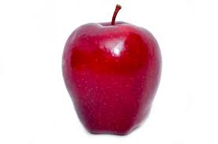 | 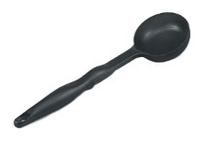  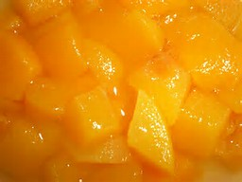  2 Scoops of Canned Fruit | Lettuce (1 cup = Size of Baseball)  = | 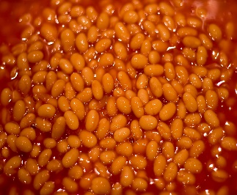  2 Scoops of Baked Beans
1 Orange  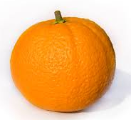 | 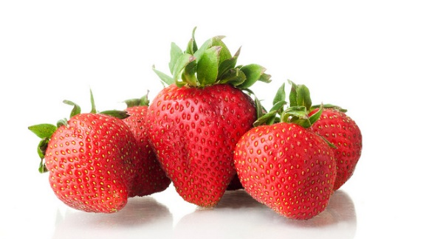  04 Large Strawberries  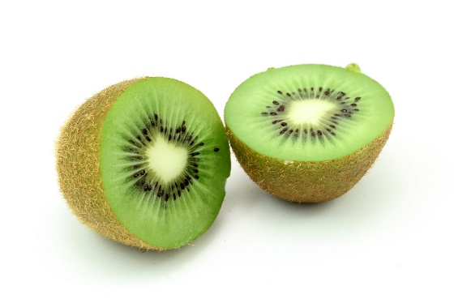 | 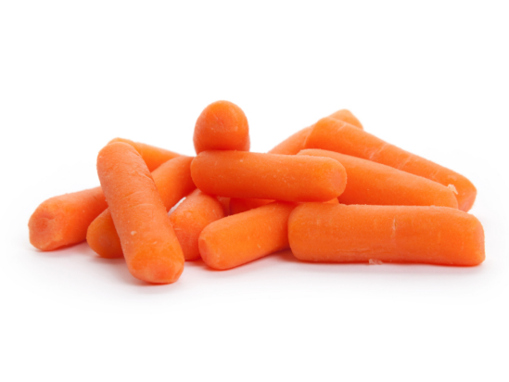  8 Baby Carrots | 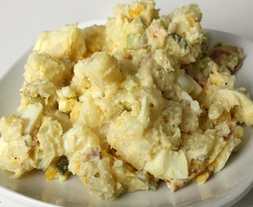  2 Scoops of Potato Salad
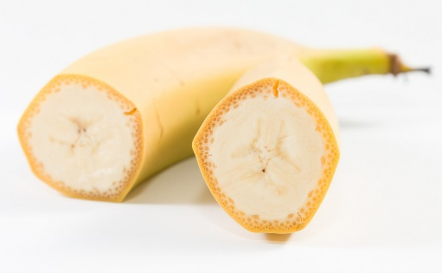  1 Banana | 1 Kiwi | 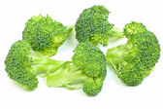  5 Broccoli Florets | 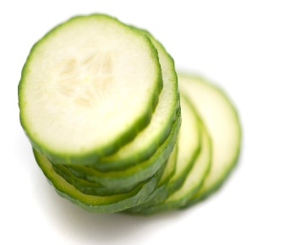  Cucumbers (Size of Small Mouse)  =
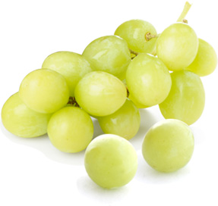  15 Grapes | 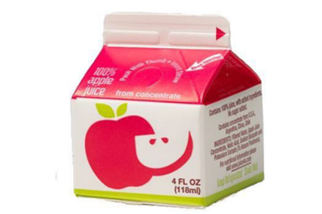  1 Carton of 100% Fruit Juice | 2 Tangerines | 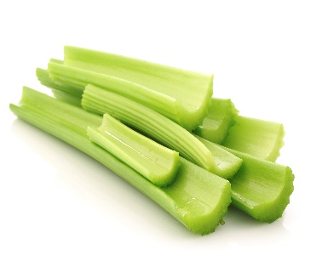  Celery (Size of Small Mouse)  =
Please take only what you will eat after you get a ½ cup.
Instructions: Verify all serving sizes and serving utensils are correct with food yield test prior to service!

