Solicite en línea en [Insert Webpage]
[Insert District Name] 20__-20__ Solicitud del hogar para comida escolar gratuita y de precio reducido
Llene una solicitud por hogar. Por favor usa una pluma negra o azul (no lápiz).
PASO 1
Mencione a todos los estudiantes que asisten [Insert District Name] (si necesita más espacios para nombres adicionales, adjunte otra hoja)

Fecha de nacimiento
M M D D A A
Niño de Head Bajo Custodia
Acogida Start Temporal Sin Hogar Migrante
Apellido del estudiante
Inicial
Nombre del estudiante
Grado
Marque todas las que apliquen. Lea Cómo solicitar comida escolar gratuita y de precio reducido para más información.

PASO 2

Si algún miembro del hogar (incluido usted) actualmente recibe asistencia de cualquiera de los siguientes programas: SNAP, TANF o FDPIR enumeran el número de caso a continuación.

Programa de Asistencia Nutricional Suplementaria (SNAP), Asistencia Temporal para Familias Necesitadas (TANF/Colorado Works – Asistencia Básica en Efectivo o Asistencia Alternativa Estatal), o Programa de Distribución de Alimentos en Reservas Indígenas (FDPIR). Provea el número de caso y vaya al Paso 4.

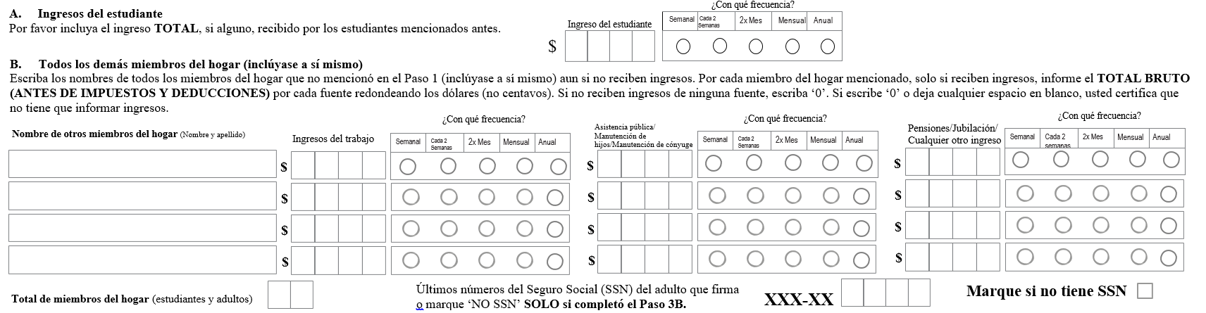
Número de caso FDPIR
Número de caso TANF
Número de caso SNAP
Informe el ingreso de TODOS los miembros del hogar (omita este paso si proporcionó un número de caso en el PASO 2)

PASO 3

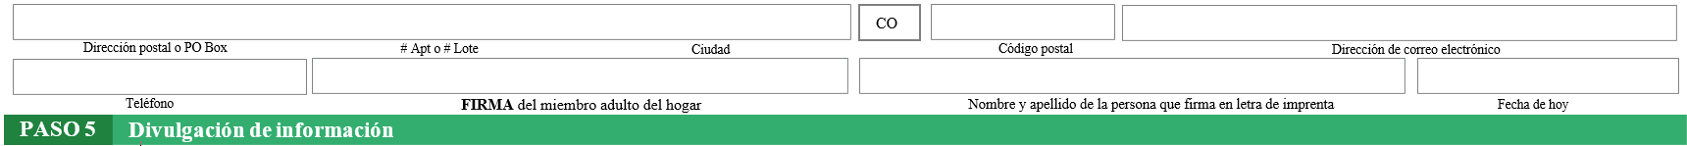
“Certifico (doy mi palabra) que toda la informacion en esta solicitud es verdadera y que todos los ingresos fueron informados. Entiendo que esta informacion es proporcionada en relacion con la recepcion de fondos federales, y que los oficiales de la escuela puedan verificar (comprobar) la informacion. Soy consiente de que, si doy falsa informacion a proposito, mis hijos pueden perder los beneficios de comida, y yo podria ser precesado criminalmente conforme a las leyes estales y federales”.
PASO 4 Información de contacto y firma del adulto. Envíe la solicitud firmada y completa a: [Insert School/District Mailing Address]

La información proporcionada en esta solicitud se utilizará junto con los programas educativos estatales y es posible que se comparta con las oficinas de Medicaid o del Programa Estatal de Seguro Médico para Niños (SCHIP). Por favor, marque la casilla para excluirse: t:
NO comparta información con Medicaid/SCHIP
List Specific Program

Para ahorrarle tiempo y esfuerzo, la información que usted proporcionó en este formulario se podrá compartir con otros programas para los cuales sus hijos puedan calificar. Para los siguientes programas, debemos tener su permiso para compartir su información. Rellenar esta sección del formulario no cambiará el hecho de que sus hijos reciban comidas gratuitas o a precio reducido. Su información NO SE COMPARTIRÁ a menos que marque una de las casillas siguientes:
Por favor, comparta mi información con los siguientes programas que he marcado:
Vea el reverso de la solicitud
Examen de Colocación Avanzada (AP) y/o Cuotas de Libros (AP)
Examen de Aceleración de Oportunidades Universitarias y/o Cuotas de Libros

OPCIONAL Identidad racial y étnica de los niños
Raza (marque una o más):
Indio americano o nativo de Alaska
Negro o afroamericano
Nativo de Hawái u otra isla del Pacífico
Hispano o latino
Ni hispano ni latino
Tenemos que pedir información sobre la raza y etnia de sus hijos. Esta información es importante y nos ayuda a asegurarnos de que estamos sirviendo plenamente a nuestra comunidad. Responder a esta sección es opcional y no afecta el cumplimiento de su hijo con los requisitos para comida gratuita o de precio reducido.

Etnica (marque una):
Asiático
Blanco

La ley Nacional de Comidas Escolares Richard B. Russell requiere esta información en esta solicitud. No está obligado a dar esta información, pero si no lo hace, no podemos autorizar que sus niños reciban comidas gratis o a precio reducido. Debe incluir los últimos cuatro dígitos del número de la Seguridad Social del miembro adulto de la vivienda que firma la solicitud. No son obligatorios los últimos cuatro dígitos del número de la Seguridad Social cuando realiza la solicitud en nombre de un niño en régimen de acogida o si proporciona un número de expediente de Supplemental Nutrition Assistance Program (SNAP - Programa de asistencia de nutrición complementaria), Temporary Assistance for Needy Families (TANF Asistencia temporal para familias necesitadas) Program or Food Distribution Program on Indian Reservations (FDPIR Programa de distribución de alimentos en reservas indias) u otro identificador FDPIR de su niño, o cuando indica que el miembro adulto de la vivienda que firma la solicitud no tiene un número de la Seguridad Social. Usaremos su información para determinar si su niño tiene derecho a recibir comidas gratis o a precio reducido, y la administración y ejecución de los programas de comida y desayuno. PODEMOS compartir esta información con los programas de educación, salud y nutrición para ayudarlos a evaluar, financiar o determinar las prestaciones de sus programas, auditores para revisar los programas, y agentes del orden público para ayudarlos a investigar violaciones de las normas del programa.
De acuerdo con la ley federal de derechos civiles y las normas y políticas de derechos civiles del Departamento de Agricultura de los Estados Unidos (USDA), esta entidad está prohibida de discriminar por motivos de raza, color, origen nacional, sexo (incluyendo identidad de género y orientación sexual), discapacidad, edad, o represalia o retorsión por actividades previas de derechos civiles.

La información sobre el programa puede estar disponible en otros idiomas que no sean el inglés. Las personas con discapacidades que requieren medios alternos de comunicación para obtener la información del programa (por ejemplo, Braille, letra grande, cinta de audio, lenguaje de señas americano (ASL), etc.) deben comunicarse con la agencia local o estatal responsable de administrar el programa o con el Centro TARGET del USDA al (202) 720-2600 (voz y TTY) o comuníquese con el USDA a través del Servicio Federal de Retransmisión al (800) 877-8339.

Para presentar una queja por discriminación en el programa, el reclamante debe llenar un formulario AD-3027, formulario de queja por discriminación en el programa del USDA, el cual puede obtenerse en línea en: https://www.fns.usda.gov/sites/default/files/resource-files/usda-program-discrimination-complaint-form-spanish.pdf, de cualquier oficina de USDA, llamando al (866) 632-9992, o escribiendo una carta dirigida a USDA. La carta debe contener el nombre del demandante, la dirección, el número de teléfono y una descripción escrita de la acción discriminatoria alegada con suficiente detalle para informar al Subsecretario de Derechos Civiles (ASCR) sobre la naturaleza y fecha de una presunta violación de derechos civiles. El formulario AD-3027 completado o la carta debe presentarse a USDA por:
(1) correo:
U.S. Department of Agriculture
Office of the Assistant Secretary for Civil Rights
1400 Independence Avenue, SW
Washington, D.C. 20250-9410; or
(2) fax:
(833)256-1665 o (202) 690-7442; o
(3) correo electrónico:
program.intake@usda.gov

Esta entidad es un proveedor que brinda igualdad de oportunidades.

NO ESCRIBA DEBAJO DE ESTA LÍNEA. SOLO PARA USO DEL DISTRITO
Annual Income Conversion: Weekly x 52; Bi-Weekly x 26; 2 Times per Month x 24; Monthly x 12
Application Type:   Total Household Income: $ Household Size:_  Household Income Frequency -  Weekly  Bi-Weekly  2x/Month Monthly Annually  Categorical Eligibility - SNAP FDPIR TANF Foster  Homeless/Migrant/Runaway/Head Start | Application Status:  Approved - Free Reduced  Denied - Over Income Guidelines Incomplete/Missing: Notes:
Determining Official Signature: Approval/Denial Date: Notification Sent:

