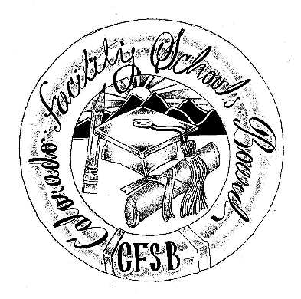

Colorado Facility Schools Board
of Education

2025 - 2026 Meeting Schedule

Date | Time | Location
August 7, 2025 | 9:30am – Completion of agenda (usually 3:30-4pm) | In Person - Shiloh House Family Resource Pavilion - 9700 E Easter Ln, Centennial, CO 80112
September 4, 2025 | 9:30am – Completion of agenda (usually 3:30-4pm) | In Person – Havern School 4000 S. Wadsworth Blvd.  Littleton, CO 80123
October 9, 2025 | 9:00am –TBD  Board Presentation at Kaleidoscope Conference | At Kaleidoscope conference
*October 10, 2025 | Board Presentation at Kaleidoscope Conference Board members will volunteer to attend | At Kaleidoscope conference
November 13, 2025 | 9:30am – Completion of agenda (usually 3:30-4pm) | In Person - Shiloh House Family Resource Pavilion - 9700 E Easter Ln, Centennial, CO 80112
December 11, 2025 | 9:30am – Completion of agenda (usually 3:30-4pm) | Virtual Via Zoom
January 8, 2026 | 9:30am – Completion of agenda (usually 3:30-4pm) | Virtual Via Zoom
February 12, 2026 | 9:30am – Completion of agenda (usually 3:30-4pm) | In Person - Shiloh House Family Resource Pavilion - 9700 E Easter Ln, Centennial, CO 80112
March 12, 2026 | 9:30am – Completion of agenda (usually 3:30-4pm) | TBD/ Site Visit
April 9, 2026 | 9:30am – Completion of agenda (usually 3:30-4pm) | In Person - Shiloh House Family Resource Pavilion - 9700 E Easter Ln, Centennial, CO 80112
May 7, 2026 | 9:30am – Completion of agenda (usually 3:30-4pm) | SBE Presentation
June 11, 2026 | 9:30am – Completion of agenda (usually 3:30-4pm) | In Person - Shiloh House Family Resource Pavilion - 9700 E Easter Ln, Centennial, CO 80112

