# Academic Growth

## Performance Frameworks Indicator Overview

**Overview**

This resource describes the current growth indicator (including English Language Proficiency growth) and a description of an additional growth indicator called On Track Growth. This resource assumes knowledge about [state accountability](http://www.cde.state.co.us/accountability/stateaccountability) and [performance frameworks](https://www.cde.state.co.us/accountability/performanceframeworks). See the links for additional information.

**Background**

**Growth Indicator**

**Current Growth Weighting**

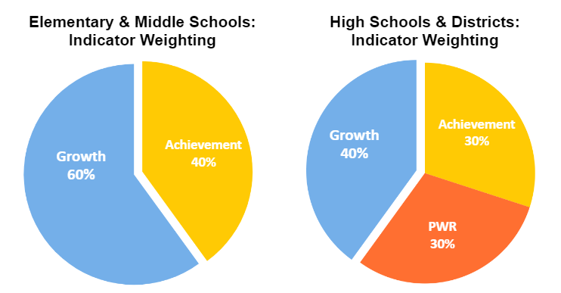

The Growth Indicator is included within the elementary, middle, high, and district performance frameworks. The Growth Indicator contributes 60% of the overall score in determining elementary and middle school plan type assignments and 40% for high schools and districts (detailed in the green sidebar). Currently, growth is calculated for the following assessments and grade levels: [CMAS English language arts and math](https://www.cde.state.co.us/assessment/cmas) (4th-8th grade), [PSAT and SAT reading & writing and math](https://www.cde.state.co.us/assessment/sat-psat) (9th-11th grade in math, 10-11th in reading & writing), and [WIDA ACCESS](https://www.cde.state.co.us/assessment/ela) (grades 1-12 for students with a language proficiency designation of Non-English Proficient or Limited English Proficient).

**What is Growth?**

**Growth calculations are a normative measure that report how much progress individual students have made on state assessments between last year and this year.** In Colorado, growth scores are calculated for every student who has at least two consecutive years of valid scores. Colorado reports growth results for individual students (using **student growth percentiles**) or for groups (using **median growth percentiles**).

|  |  |  |
| --- | --- | --- |
|  | Definition | Typical Range |
| Student Growth Percentile (SGP) | Describe how a student’s growth compares to the growth of their **‘academic peers’** (or students across the state with similar prior test scores). A **percentile score** indicates a student's relative position within a group. For example, a student with a growth percentile of 65 has demonstrated growth greater than 65% of their academic peers. | **SGPs range from 1-99.** |
| Median Growth Percentile (MGP) | Summarizes growth for a particular group of students (e.g., school, grade, student group) and can be used to describe that group’s growth relative to other groups. The **median** reflects the middle number in an ordered set of SGPs. It is used instead of the mean because it is less impacted by outliers (i.e., extremely low or high values). | **MGPs range from 1-99, but** **tend to fall between 20 and 80 for schools and districts**. |

**Calculation Methodology Big Ideas**

**Colorado Growth Model Big Ideas**

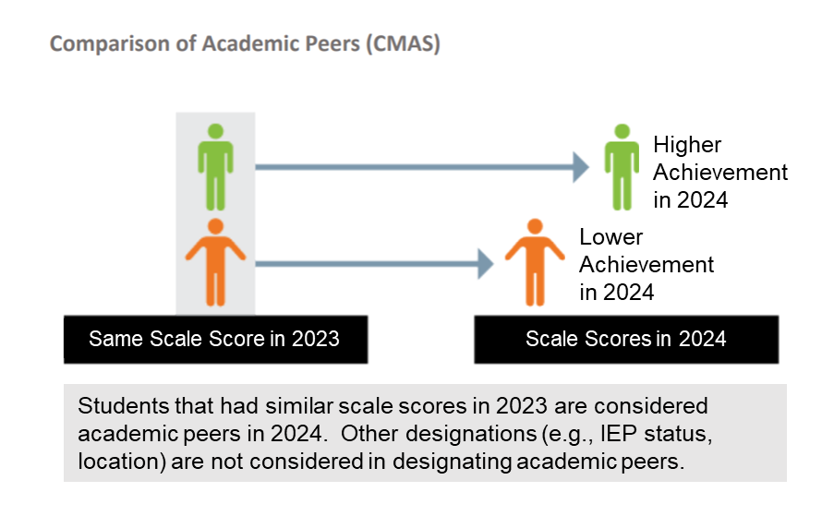

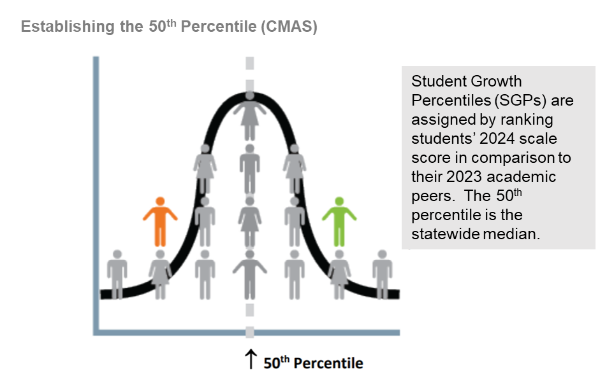

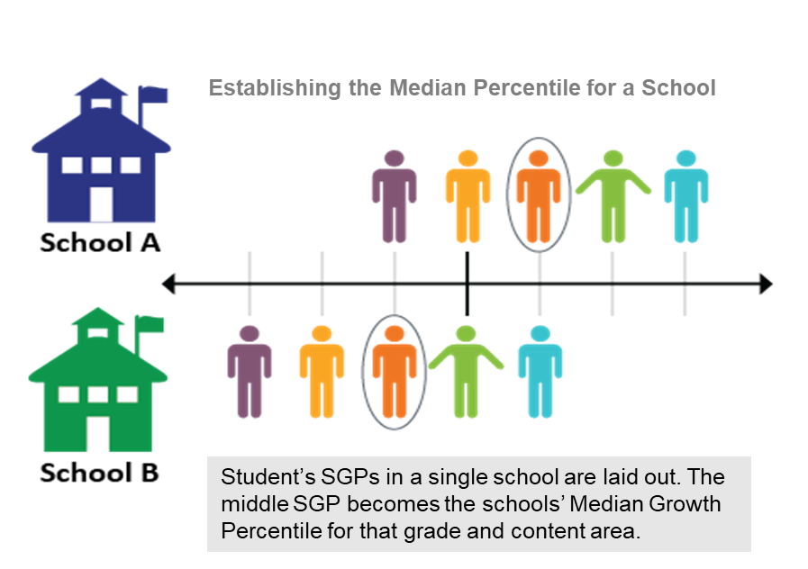

The Colorado Growth Model (CGM) was developed jointly by Colorado school districts, the Colorado Department of Education (CDE), the [Technical Advisory Panel for Longitudinal Growth (TAP)](https://www.cde.state.co.us/accountability/tap), and the [National Center for the Improvement of Educational Assessment (NCIEA)](https://www.nciea.org/). Its development was required by state statute (SB09‐163), and the model was designed to serve as a primary driver within the state educational accountability system. First utilized for the state performance frameworks in 2009, the CGM is now used in some fashion by at least half the states in the country.

**Big Idea #1 - Academic Peers:** The CGM, also known as a student growth percentile model or a conditional status model, uses quantile regression to model a student’s performance gains across time and assign a growth percentile based on the student’s standing in comparison to their academic peers (i.e., students with the same score history). This means that expected student growth is conditioned on (i.e., normed against) students’ past achievement scores. In Colorado, other designations (e.g., demographics, location) are not considered in establishing academic peers.

**Big Idea #2 - Establishing the 50th Percentile:** The growth model measures growth for every student regardless of where they start. Student growth percentiles are calculated by ranking each student’s amount of growth against their academic peer group. The 50th percentile is the statewide median and provides a measure of the average progress of students across the state in the current year.

**Big Idea #3 - Establishing the Median Percentile for Groups:** Median growth percentiles can be used to represent average growth for different groups of students. To calculate the median growth percentile for any group (e.g., school, grade, or disaggregated demographic group), all student SGPs within that group are first ordered numerically. The median is the middle number in this series (or the mean of the two middle numbers if there are an even number of values).

**Big Idea #4 - Sample Sizes and Reporting:** The CGM relies on large sample sizes to generate reliable estimates. Given that the calculations are based on a statewide data set, the minimum n‐size requirement typically only impacts calculations during assessment transitions or when smaller groups of students experience atypical student assessment progressions (e.g., students may take the Colorado Spanish Language Arts assessment in 3rd grade, but there is not a large enough population that also takes the assessment in 4th grade to calculate growth percentiles). Within the performance frameworks, student counts of fewer than 20 are hidden to protect student privacy and ensure reliable estimates can be generated.

**Why Does Growth Matter?**

As described above, growth data demonstrates year-over-year progress on state assessments. This information is important for several reasons:

* **Growth helps show how well schools are doing in helping each student progress.** 
  + All students can show growth – even high performing students.
  + There is a much weaker relationship between growth and student characteristics outside the control of schools (e.g., poverty) as compared to other student performance measures (e.g., achievement, postsecondary workforce readiness).
* **Growth is integral for accountability determinations.** 
  + As written in current accountability law, growth must be given the most weight in the frameworks.
* **Growth informs improvement planning within schools and districts.**

**Interpreting and Analyzing Growth Data**

**Interpreting Low, Typical, or High Growth Percentiles:** One way to interpret individual student growth percentiles is to determine whether a student falls into low, typical, or high growth categories. Students with low growth are progressing at a rate lower than what would be expected compared to their academic peer group. This is helpful to understand because students with low growth may not be demonstrating the academic progress expected for that subject area, which is particularly important to consider for those students already below grade-level expectations. Students with typical growth are progressing at a rate typical to what would have been expected compared to their academic peer group, while students with high growth are progressing at a rate higher than what would have been expected compared to their academic peer group. However, typical or high growth may not indicate whether a student is reaching benchmark expectations for their grade level in that subject area. When analyzing growth results, it is necessary to consider whether similar results are evidenced for all student groups or if there are large gaps in performance between groups.

**Low, Typical, and High Growth Percentiles**

There are three categories of percentiles the state uses to interpret low, typical, and high growth.

|  |  |
| --- | --- |
| Low Growth | Below 35th Percentile |
| **Typical Growth** | At or above 35th but below 65th |
| **High Growth** | At or above 65th Percentile |

**Analyzing Achievement and Growth Results**

The below screenshot captures achievement and growth scatter plots available within the Data Explorer Tool, available here: <https://www.cde.state.co.us/accountability/schoolviewdataandresults>

Screenshot of Data Explorer Tool dashboard

**Analyzing Achievement and Growth Results:** Growth should always be considered in relation to achievement. As mentioned in the previous section, typical or high growth percentiles can be an indicator of progress but may not be enough to show that students are catching up to grade-level expectations. CDE provides visualizations that can support interpretations of achievement and growth results in the performance frameworks. For instance, the [Data Explorer Tool](https://www.cde.state.co.us/code/accountability-dataexplorertool) includes achievement and growth scatter plots for each assessment to provide state-level, district-level, and school-level comparisons of achievement and growth results. The four quadrants on the scatter plot describe high growth/low achievement results, high growth/high achievement results, low growth/low achievement results, low growth/high achievement results. A screenshot of this visualization is included above. To aid additional interpretation of both achievement and growth results, the state is planning to reintroduce a measure called On Track Growth, described in the section below.

**Inclusion in Frameworks**

Calculating growth in the frameworks requires two or more consecutive assessment scores for each student (e.g., for 2024 performance frameworks in 2024, data would be needed from Spring 2023 and Spring 2024 assessments). In the performance frameworks, growth is worth 28 points overall for each school level. Aggregate growth results (i.e., representing all students in a school) are worth 8 points per subject, and disaggregated growth results for each student group (i.e., students with disabilities, multilingual learners, minority students, students eligible for free or reduced price lunch) are worth 1 point each (i.e., 4 points per subject). English Language Proficiency (ELP) growth is worth 2 points, as is ELP On Track growth. For more information, see the section on English Language Proficiency Growth below. The growth percentile cut points used for scoring in performance frameworks are listed below and in [this guide](https://www.cde.state.co.us/accountability/frameworkscoringguide2023).

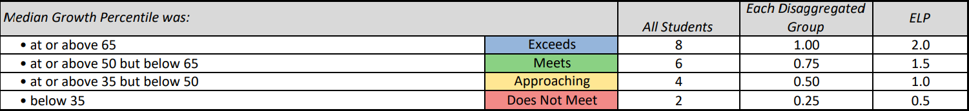

|  |
| --- |
| **Key Takeaways:** The Colorado Growth Model demonstrates how much progress students are making in comparison to their academic peers.   * All students can show growth, regardless of where they start. * Growth should always be considered in relation to achievement. * High growth can be an indicator of progress, but it may not be enough to help students catch up to grade level expectations. * Can be used to understand school/district effectiveness (i.e., impact on outcomes). * Helpful for assessing the progress of one school/program/group relative to another. |

**On Track Growth Indicator**

On Track Growth is a “growth to standard” measure, meaning that it draws upon both achievement and growth indicators to provide a view of student growth in relation to established assessment benchmarks. It is a key measure to help determine whether a student or site is making enough growth to meet or maintain academic expectations.On Track Growth assesses whether students are ***catching up*** to grade-level expectations or ***keeping up*** with expectations. Using each student’s achievement performance level in combination with their assessed growth trajectory, On Track Growth provides a measure of the likelihood that students with below-proficient scores will reach proficiency, or that currently proficient students will maintain proficiency, within a given time frame. Thus, individual students fall into one of the following categories:

* **Catch up**: Indicates whether students scoring below grade level are catching up to grade-level expectations quickly enough.
* **Keep Up**: Indicates whether students who are already meeting grade-level expectations are maintaining their performance.

CDE adopted an On Track Growth calculation methodology for elementary and middle schools in 2019. The inclusion of this measure in performance frameworks is paused until a methodology is developed for high schools and districts. The department will be releasing public reports on this measure for elementary and middle school levels as they become available. It is anticipated that informational reports will be released at the elementary and middle school levels in 2024, but not for high schools.

More information about the indicator is available in the [On Track Growth fact sheet](https://www.cde.state.co.us/accountability/ontrackgrowthfactsheet).

|  |
| --- |
| **Key Takeaways:** On Track Growth measures whether the amount of growth a student or site is making is enough to meet or maintain academic expectations.   * Combines elements of both Achievement and Growth. * Can be used to understand student growth within the context of state standards and vice versa. * Useful to compare the percent of students either catching up or keeping up to grade level expectations. |

**English Language Proficiency Growth**

Beginning in 2017 with the state’s transition to the ACCESS for ELLs® 2.0 assessment, CDE convened stakeholder groups to determine the Colorado criteria for identifying a student as eligible to be redesignated as Fluent English proficient (FEP) and no longer in need of English language program support. CDE adopted a maximum timeline of 6 years for students to move from non-English proficient newcomer to FEP.

The adopted 6-year timeline is broken down into interim stepping-stones of 1-2-3-years, meaning that a student initially scoring an overall ACCESS proficiency level of 1 will have 1-year to move to level 2 or higher, 2-years to move from level 2 to level 3 or higher, and then 3-years to move from level 3 to level 4 or higher. Upon initial entry to a Colorado school and with their initial ACCESS performance, a student’s projected English-acquisition timeline will be established and used to determine whether they are on or off-track in future years to meet their proficiency targets. Students entering at higher levels of language proficiency will be given a shortened timeline corresponding to their initial language proficiency level.

The adopted timelines are used to calculate a progress-monitoring metric for reporting whether students are on track to achieve language proficiency within their allotted timeline. The Colorado Growth Model calculates projected targets that indicate how much growth would be required for an individual student to achieve a specified level of proficiency within 1, 2, or 3 years. These projected targets can then be compared against the student’s observed growth percentile to determine whether the student is on track to meet their proficiency goal within the allotted timeline.

More information about the WIDA ACCESS growth measure is available in the [ACCESS On Track Growth fact sheet](https://www.cde.state.co.us/accountability/access-on-track-growth).

|  |
| --- |
| **Key Takeaways:** English Language Proficiency growth measures whether students are on track to achieve English language proficiency within a six-year timeframe.   * Establishes a student’s projected English-acquisition timeline. * Can be used as a data point to redesignate a student as Fluent English Proficient and no longer in need of English language program support. * Useful to compare the percent of students that are on track to meet their English proficiency goal. |

|  |
| --- |
| If you have questions about the contents of this fact sheet or need further assistance: contact [accountability@cde.state.co.us](mailto:accountability@cde.state.co.us). |