Part 1: The Why
Purpose/vision statement for engaging community partners (business+civic) in career-connected learning for your students, schools, families, and community:

Part 2: The What
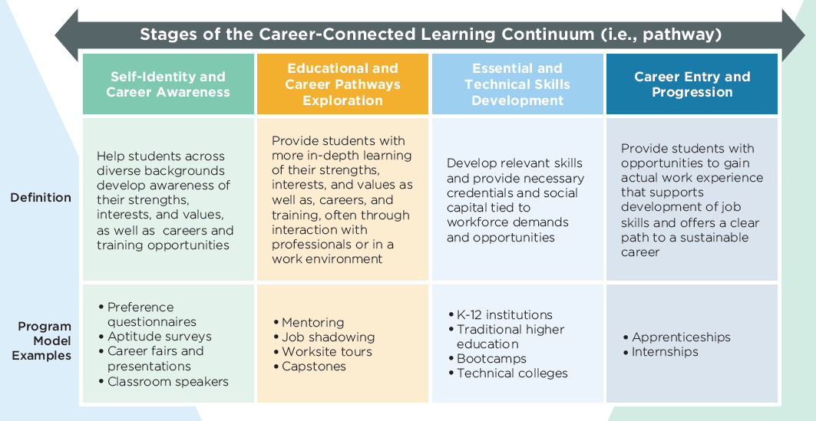

Outline your career-connected learning assets along the continuum:
Existing or In Progress Assets

Part : The Who & The How
Outline your industry or community partnerships along the continuum for the assets outlined above (include partner type and role - e.g., local business, internship host; or hospital and nurse practitioner, guest speaker):
Partners

Building your business case:
Value Proposition:

The Ask:

Name Success / Desired Outcomes:

Other considerations for sustaining work-based learning and business partnerships - where are there gaps and opportunities in your current strategy(ies)?
- Staff capacity and role clarity
- Marketing / awareness (among students, teachers, parents, community) - and - marketing tools
- Tracking / monitoring of opportunities
- Evaluation of experiences (students, staff, partners)
- Diversity of experiences and career pathways to meet diverse student needs
- Sustaining partnerships and WBL experiences
- Other partners/champions outside of business - chamber of commerce, local nonprofits, school board, parents, local philanthropy, etc.

Priority Gaps/Opportunities:

