Insufficient State Data Ratings
Assignment and Implications

Overview
This resource outlines the assignment and implications of receiving an Insufficient State Data rating on the performance frameworks. This resource assumes knowledge about state accountability, performance frameworks, performance watch, and participation rates. See the links for additional information.
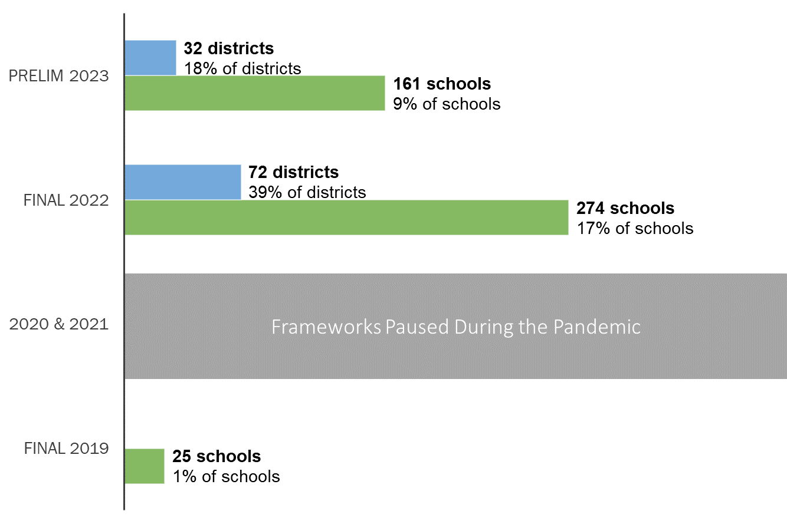
Beginning last year, there has been an increase in the number of schools and districts assigned an ISD rating. This was due to several factors: (1) limited data due to pandemic interruptions have prevented the availability of three-year frameworks and/or, (2) decreases in student participation or coding errors on state assessments. Note that ISD ratings are more likely linked to systems with smaller student populations than low test participation. The department anticipates that ISD assignments will return to more typical levels by 2024 when three years of data can be aggregated for smaller systems. In 2023, the department is using two years of data when appropriate. This resource has been created to support schools and districts in understanding the ISD assignments and implications of the assignment.

Insufficient State Data Plan Assignments Over Time

Assigning Insufficient State Data (ISD) Ratings
Insufficient State Data (ISD) ratings are assigned when the state does not have enough data to assign a district rating or school plan type. See the blue sidebar for the types of ratings available to schools and districts. In 2023, an ISD plan type is automatically assigned if:
- Total participation rates (i.e., parent excusals are included in the calculation denominator) are at or below 25% in both English language arts and math, and/or
- Reportable data are not available for all applicable performance indicators (i.e., achievement, growth, and postsecondary workforce readiness). For multi-level schools (i.e., combined elementary, middle and/or high schools) and districts, ISD is assigned if elementary, middle, or high school levels do not have reportable data for one or more applicable performance indicators.
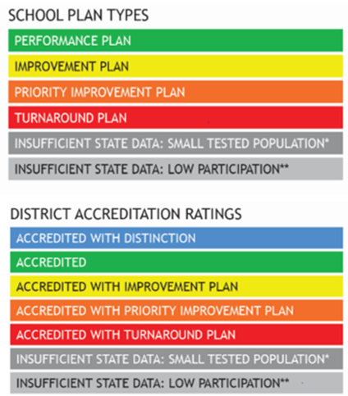
Note that sites with an ISD rating (i.e., this does not include Small Tested Populations or Schools with No Students in Tested Grades) are not eligible to change their rating assignment through request to reconsider. Sites in this category likely have a smaller student population or had a high number of parent excusals, students that did not participate in the assessment without a valid excuse, and/or coding issues (see Student Biographical Data - SBD - in accountability guidance) during the state assessments.
Performance Framework Ratings

Small Tested Populations and Schools with No Students in Tested Grades
In certain circumstances, schools receive ISD ratings with an additional descriptor, either: “Small Tested Population” or “No Students at Grade Levels Tested for State Assessments.” “Small Tested Population” refers to schools and districts that do not enroll enough students, even with the multi-year framework, to calculate a performance rating. “No Students at Grade Levels Tested for State Assessments” refers to schools that operate programs for students that do not test on the state assessments (e.g., a school that serves only grades K-2). Districts may select a plan type for these schools with either of these designations in the Accreditation Form (due in September each year) using their own locally developed criteria.
Requesting an Insufficient State Data Rating
For districts and schools experiencing low participation on state assessments (e.g., parent excusals, non-tested students), a change in plan type to “Insufficient State Data” may be requested if the district can establish that the tested population is not representative of the overall student population. This option is available only to schools or districts with total participation rates at or below 85% that can demonstrate that the participating student population is not representative of the full school/district population.

Description of Insufficient State Data Ratings for Different Types of Schools

For some sites, the ISD assignment has some additional implications. In this section, additional detail is provided for sites on Performance Watch, multi-level schools, and alternative education campuses.

ISD Assignments for Schools/Districts on Performance Watch
Schools and districts assigned an ISD rating that were previously on Performance Watch (i.e., on clock, on watch) hold that status until the site is able to fully exit by earning a Performance or Improvement rating. The previous year’s Performance Watch status will be reported along with “hold” language. The table below highlights a few examples (for more examples, see the Performance Watch Progression Fact Sheet).
Clock Progression with ISD Ratings
Final 2022 Rating | Final 2023 Rating | Final 2024 Rating
Priority Improvement - Year 3 On Clock | ISD - Year 3 Hold On Clock | Improvement - Year 3 On Watch
Priority Improvement - Year 3 On Clock | ISD - Year 3 Hold On Clock | Priority Improvement - Year 4 On Clock
Improvement - Year 3 On Watch | ISD - Year 3 Hold On Watch | Performance (exit performance watch)
ISD - Year 1 Hold On Clock | ISD - Year 1 Hold On Clock | Improvement (exit performance watch)

The hold on Performance Watch status means that the site remains eligible for additional supports and school improvement grants (e.g., EASI Grant); the site is also expected to continue to implement requirements associated with being on Performance Watch. For sites that are “On Watch,” UIPs must be submitted for public posting; districts must also sign their accreditation contracts annually. For sites that are “On the Clock,” sites have additional requirements around parent notification, additional improvement planning expectations, the local board must adopt the plan, and districts must sign their accreditation contracts annually. See the section on Impacts on Other Accountability Processes for additional detail.

ISD Ratings for Multi-level Schools
In the performance framework, multi-level schools will have a rating calculated for the overall school, as well as at each school level (i.e., elementary, middle, and/or high) - also referred to as EMH levels - based on available state data. These EMH-specific ratings are informational and should not be used to represent the whole school. If any of the school levels does not have reportable data for one or more indicators, then the overall rating will be ISD. To better understand why a school is identified as ISD, all publicly reportable data is reflected in the performance framework report. Below are examples of ISD performance frameworks.
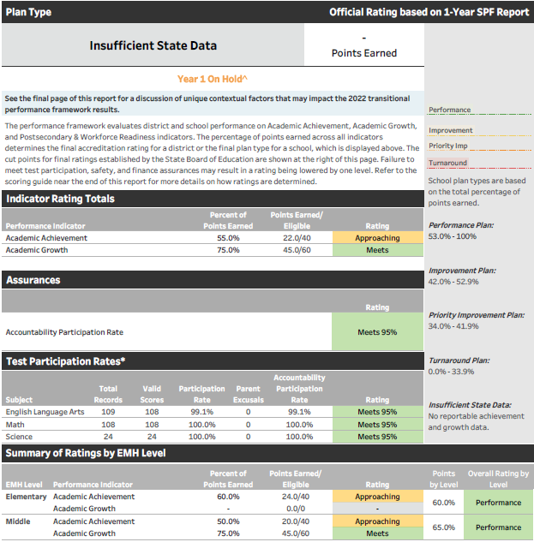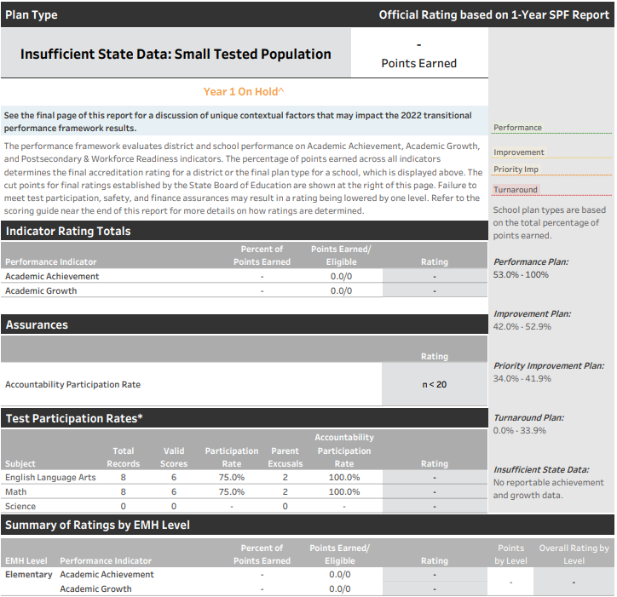

Identified as ISD because no growth data at the Elementary level
Identified as ISD because not enough reportable state data
Examples of ISD Performance Frameworks

ISD Ratings for Alternative Education Campuses (AECs)
A portion of AECs do not have enough data to meaningfully determine their plan type (e.g., lack of optional measures data, access to two years of data instead of three years due to pandemic). For this reason, AECs are now eligible to receive an ISD rating consistent with other schools. Any AECs that participated in the Selection of Measures process and submitted both local achievement and growth data, will receive a rating based on their optional measures data instead of ISD.

Impacts of an ISD Rating on Additional Accountability Processes

Implications for Improvement Planning
Despite not having enough data to assign a performance framework, all sites are still expected to engage in the continuous improvement process. There are some implications for the annual submissions of improvement plans to be aware of. This resource also offers suggestions on ways to approach public reporting when working with more limited data.

Annual Submission of Improvement Plans for Sites with ISD Assignments
- All ISD sites must submit by the October deadline for public posting. Sites with an ISD assignment are not eligible for biennial flexibility on public posting.
- Other types of planning flexibility (e.g., combined plan for small districts) are still available.
- If a site’s previous plan type was Priority Improvement or Turnaround (i.e., current framework will list “Hold On Clock”), then the site must still implement additional requirements in UIP.

Considerations for Improvement Planning With Small Numbers
While there may not be enough data for determining a state accountability rating, it’s important to maintain momentum on the improvement planning process. For sites with smaller student numbers (e.g., smaller enrollment, low state assessment participation), it is still possible to engage in a robust data analysis to guide improvement planning. Consideration, however, must be given to handling data (low N) for public reporting.

Data analysis as reflected within the UIP template, includes a review of historical and recent state and local data to understand current performance and persistent patterns over time. UIP writers also provide a narrative and descriptions of current and trend data for public consumption. For those with ISD ratings:
- Use State Level Performance Data, if possible. Consider ways the district/school can describe its performance using available state aggregate data, combining groups to increase the reporting group size (e.g., grades 3-5 instead of each grade level), or other data sources to illustrate current performance.
  - Look at any available sections in the current Performance Framework for indications of need. It may be helpful to consult some of the dashboards available on SchoolView.org, such as the District and School Dashboard. Note that the Secure Data Explorer Tool allows you to analyze state data down to an N of 1 to understand performance on state measures. For access, contact your district’s Local Account Manager/LAM for the Role: Tableau~AccountabilityContact. If you do not know your LAM, use the assistance request form.
  - Combine results of smaller groups (e.g., Our school wide MGP for 6-8th grade multilingual learners on ACCESS was 48.0).
  - In cases where aggregating data is not feasible, an analysis of individual student performance may be conducted internally and used to inform a plan, while the public report should describe patterns observed in the data generally without including specific numbers. Refer to Data Analysis for Small Student Populations, Appendix: Detailed Guidance (page 4) for more examples.
- Use Local Data. Use local assessment data (e.g., iReady, NWEA MAP) and non-assessment data to enhance data analysis and identify areas of strength and opportunities for improvement. This non-assessment data document highlights key considerations for data use and includes data sources that may not have previously been considered for improvement planning, and use cases related to improvement planning.
For more information to support data analysis and improvement planning as an ISD school or district, see Insufficient State Data Rating Informational Webinar.
Implications for Accreditation Contracts
For districts with an ISD rating, the district accreditation contract must be signed annually by the superintendent and local board president. Consult local policy on the accreditation process for schools with an ISD assignment. More information about the accreditation process can be found on the accreditation website, including access to the most current signed contracts for each district.

Considerations for Communicating the ISD Rating to Your Community
Some stakeholders may struggle to understand the reasons for the ISD assignment. This last section is provided as a resource to think about ways to anticipate questions and provide reassurance to your community.
- Insufficient State Data does not imply a value judgment. The ISD assignment means that the state simply did not have enough data to calculate a rating and share a public report.
- The state as a whole is experiencing higher levels of ISD assignments due to the pandemic.
- The state still publishes the performance framework with any publicly reportable data. While some information may be available for particular indicators (e.g., achievement), it is important not to characterize the performance for the whole school based on representation of limited performance indicators. It may be helpful to look at available data over time compared to historical performance to gain context.
- Leverage available state resources for language in describing accountability information. Engage stakeholders in the improvement planning process and emphasize other local data sources.
- Talk about projections for receiving a plan type in the future (e.g., expansion to three years of data for next year’s framework) and encourage participation in state assessments.
In some cases, district leadership have requested that CDE provide a customized letter that explains the ISD rating. Please contact the Accountability and Continuous Improvement Unit (accountability@cde.state.co.us) if you need any help.

If you have questions about the contents of this fact sheet or need further assistance: Email accountability@cde.state.co.us.

