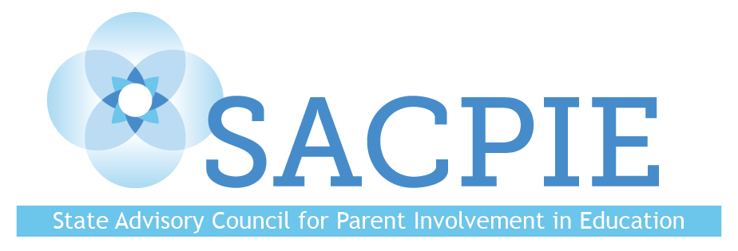
Tuesday August 30, 2022
AGENDA

9:00 Welcome and Introductions

9:30 Business

9:45 State Board of Education and SACPIE Updates—Dr. Lisa​ Escárcega

10:00 CDE Update—Dr. Darcy Hutchins
Small Group Discussion—Planning for Family and School Partnership in Education Month

10:30 Break

10:45 Parent-Facing Assessment Resource Feedback—Dr. Jared Anthony, Colorado Education Initiative

11:30 SACPIE Member Resource Sharing

12:00 Lunch

12:45 SACPIE’s Legislated Responsibilities
Small Group Discussion—Prepping for SACPIE’s Annual Report

1:30 Break

1:45 SACPIE Website Revisions

2:15 Q&A and Networking

2:45 Wrap-Up

3:00 Adjourn

