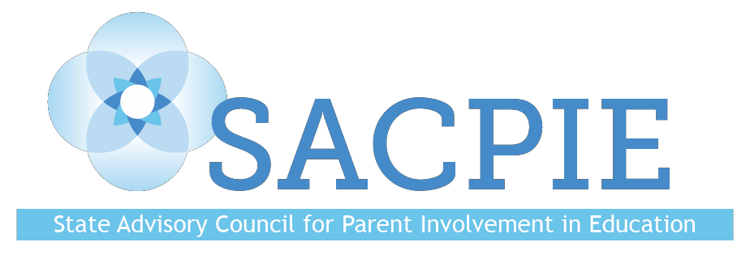

SACPIE Quarterly Meeting
May 17, 2022
Virtual Meeting Minutes

Members Present: Ayde Avila, Joyce Thiessen-Barrett, Mary McNeill, Mark Sass, Kristine Geer, Jason Taylor, Brooke Cote, Yoni Dobie-Geffen, Michael Vente, Angie Frank, Stacey Zis, Jenny Lerner, Dee Leyba, Chelsey Hall, Staci Ruddy, Michelle Zeles-Hahn, Jess Welch, Kristin Dalton, Kim Chatman

Absences: Joyce Thiessen-Barrett

Guests: Darcy Hutchins, Jes Stroope

Meeting began at 9:00AM

New members Kim Chatman and Jes Stroope introduced themselves.

Members discussed promising partnership practices in small groups.

Charter School Institute and Keystone Policy Center Family-School Partnership Survey

The Need: Schools say they need survey tools that reveal perception gaps, provide timely feedback, are feasible, customizable, and actionable. CSI and KPC developed an initial tool that address the need; are working on an online platform for the survey. Schools select 3-5 questions and will receive automatic feedback?

SACPIE members met in small groups to provide feedback on survey design, process design, and next steps. Interested SACPIE members may form an ad hoc committee to help with the survey development, dissemination, and technical assistance.

CDE Update:

Darcy shared several updates:

Time Sensitive
- Promising Partnership Practices (June 3)
- Empathy Interviews
Updates
- May District Leaders Retreat
- Liaison Course Pilot
- Partnership with Brookings
- INET/AERA recap
Upcoming
- SAC/DAC supports moving forward?
- National Standards Revisions
- Website revamp
- LearnWorlds groups

SACPIE Learning:

SACPIE members read a research-brief from the Center for Universal Education at Brookings Institute and discussed two questions: 1) what insights did you gain? 2) how do you plan to share the information?

Kris Greer and Angie Frank discussed how to use the information in coursework at Fort Lewis College and as a parent in Douglas County School District.

SACPIE Member Sharing:

Jason Taylor: Asked the group how they structure parent-teacher conferences because they aren’t very effective as currently constituted.

Mark Sass: Shared a resource about conflict resolution, a book called “High Conflict” by Amanda Ripley. He recommended a potential book study about it.

Kris Greer: Shared the Preservice Community of Practice with faculty across Colorado. Groups of prep-program faculty meet monthly to discuss how to improve FSCP in educator prep programs. National framework will be released in the fall.

Meeting adjourned at 11:30AM.

