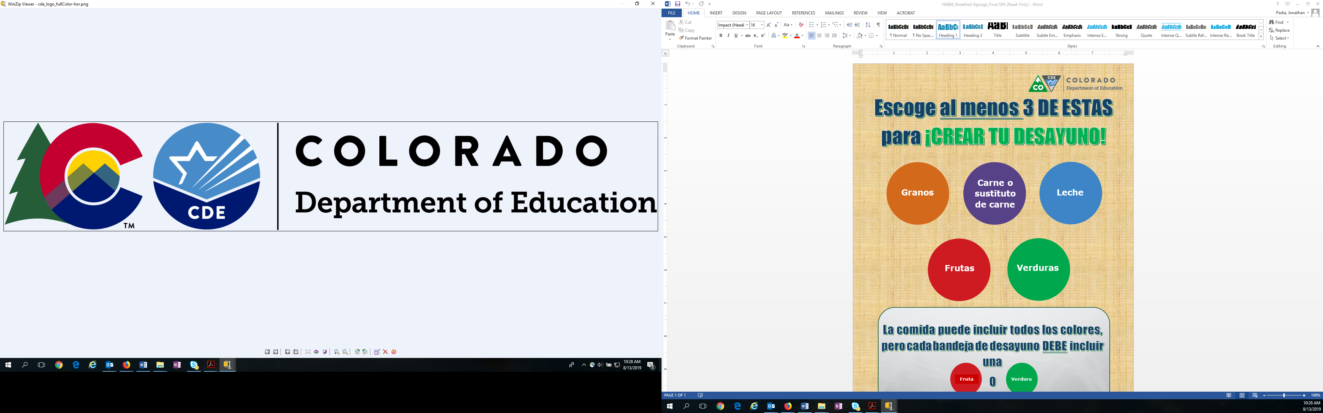

**Choose at least 3 ITEMS to BUILD YOUR BREAKFAST!**

**Items may include all colors, but each breakfast tray MUST include a**

**Or**

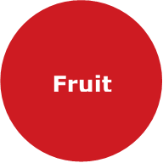

**Vegetable**

**Milk**

**Grains**

**Meat or**

**Meat Alternate**

**Fruits**

**Vegetables**