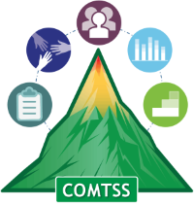
Colorado Multi-Tiered System of Supports
OFFICE OF LEARNING SUPPORTS

Colorado Multi-Tiered System of Supports (COMTSS) Acronyms

Action Planning Tool
May 2022 Version 1.0
Team members present:

Planning Date | Precise Problem Statement | Root Cause/  Contributing Factors | Goal (Outcome/Target) | Review Date

Fidelity data to be collected  (How will we know we implemented our plan as intended?) | Outcome data to be collected  (How will we know our plan has worked?)
Who will collect the data? | Who will collect the data?
When will data be collected? | When will data be collected?

Action Step | Person(s) Responsible | Resource(s) Needed | Target Date | Date Completed

