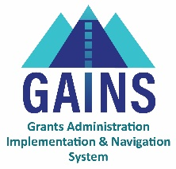

GAINS Training and System Navigation

Logging into GAINS (IdM- School Districts, BOCES)

This training is to help users log into GAINS with CDE Identity Management.

GAINS Homepage: https://colorado.egrantsmanagement.com/

- Find the GAINS Sign-In button on the top right of your screen. This will take you to the GAINS Sign-In page.
- Click “Sign in with CDE Identity Management System (IdM)”
- The next page you will see is where you enter your Single Sign-on credentials.
  - The username will be your full email and the password will align to other CDE logins.
- If your IdM login doesn’t work:
  - Contact your district’s Local Access Manager (LAM) to make sure you have access to the Identity Management System (IdM).
  - Try the CDE IdM Password Reset.
  - Submit a Help Desk Ticket in GAINS.

Related GAINS Training and Navigation Topics
- LAM User Access Instructions
- GAINS Small Bites - Locating Organizations & Applications

