Local Access Manager (LAM) Instructions for Accessing GAINS
CDE uses Identity Management to streamline the user login process for CDE data systems and enhances security to student-level data. It automates the user registration, approval, and password reset processes and provides districts and administrative units with the ability to maintain users via a Delegated Administration model.

District LAMs will be assigned User Administrator Access and can add and assign roles to district staff members. This process will ensure that those who are authorized to complete grant applications on behalf of the district have access to the grant application system.

To access GAINS:
1. Visit https://colorado.egrantsmanagement.com/. Click on the GAINS Sign-In icon in the upper right side of the screen.
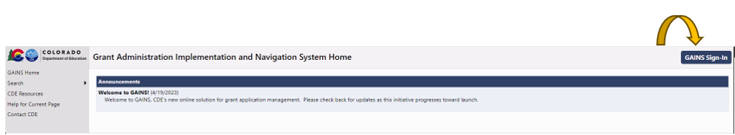
2. Click on the Sign in with CDE Identity Management (IdM) link.
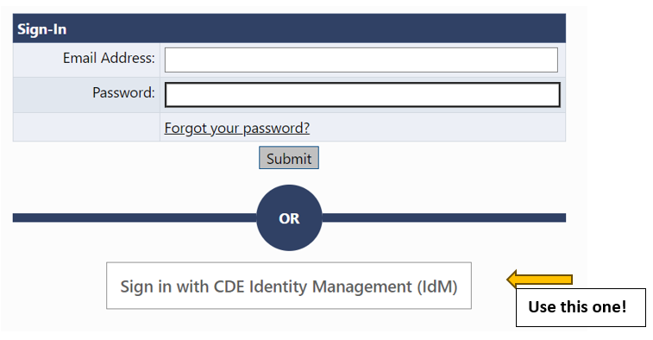
3. The next page you will see is where you enter your Single Sign-on credentials. Your username will be your full CDE email. Your password will align to the password you enter to access your computer each day.
Once you are logged in, you will be able to see your program’s application. Please note that the applications will appear once the GPA team has met with your team and configured your application.

Creating New Users
Note: Only create new users for people who have never had access to the system.

- From Administer on the main menu, select User Access. (This menu item only appears for persons with User Access Administrator Role.)
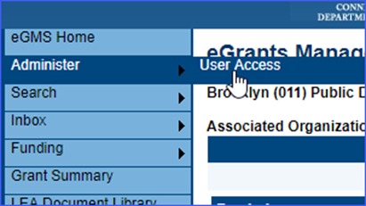

- The User Access page provides the ability to search for existing users using several filters – name, role, organizations.
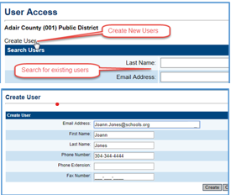
- Click on the “Create User” link to open a screen to create a new user.

- Enter the email address, first name and last name. It is advisable to add a phone number if it is known. However, the user can add it later from the user profile. Click on “Create.” The system sends an email to the address permitting the new user to set a password. If the user will authenticate using IdM, they can ignore this email.

- The system next displays the Administer Roles page. Click on Create Role.
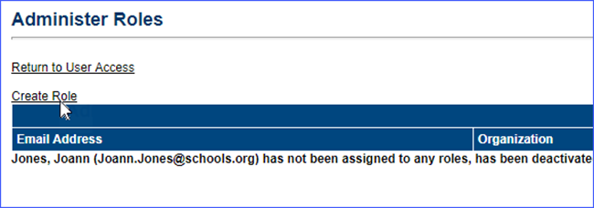
- LEA user access administrators can only create roles for their own district. SEA administrators can select a district from the drop-down menu. Select a role or roles for the user using the drop-down box and click on the Create button. Note: for Grant application users leave the school selection at “ALL”.
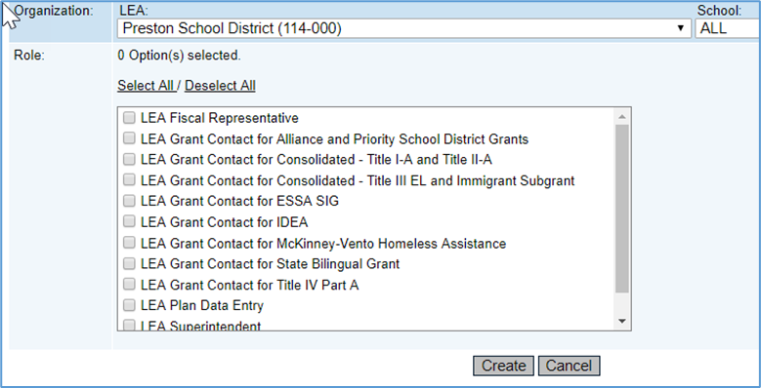
- New users are sent an email from “GAINS.NoReply@eGrantsManagement.com” as soon as they are added to the system. This email allows them to set their own password. If the user will authenticate using IdM, they should ignore this email.
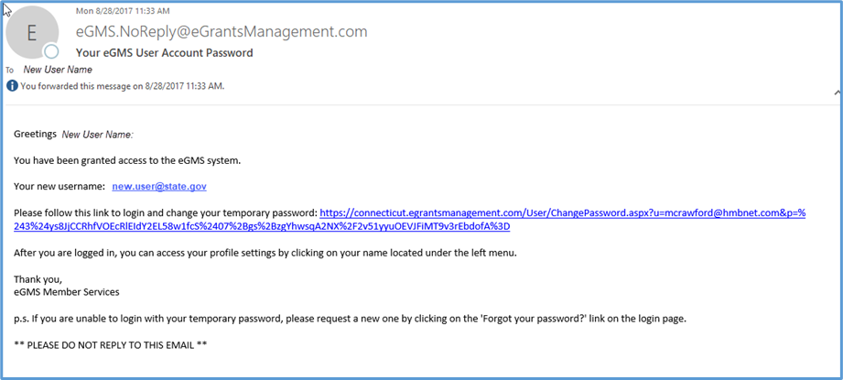

Modifying and Removing Users
- Changing roles
  - To change, delete or add a new role for an existing user, search for the user from the User Access screen.
  - Click on the Administer Roles icon.
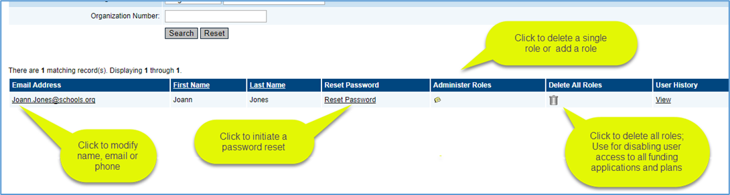
  - From the Administer Role screen, you can add a new role by clicking on “Create Role” or delete an existing role by clicking on the trashcan icon beside the unwanted role.
- Deleting a User
- Users cannot be deleted from the system to preserve the integrity of audit records. However, by deleting all roles, they no longer have access to any funding applications. Click on the “Delete All Roles” trashcan icon to disable a user.
- Updating a profile
- Users can update their own profiles - change their name, email address or phone number - once they are logged into the system. However, a user access administrator can also modify the profile by searching for the user and clicking on the user email address from the search results.
- Managing Passwords
- If users forget their password or want to reset their password, they can use the “Forgot your password?” link on the GAINS sign-in screen or, if they are logged in and wish to change their password, they can find the link by clicking on their name to bring up the user profile.
- User Access administrators can also generate a new password email by searching for the user and clicking on “Reset Password.” This is sometimes necessary if the first email was lost, or the email address was incorrect.
- An LEA user access administrator can grant a role in their district to any user in the GAINS system.
- Search for the user. Click on the “Administer Roles” icon.
- Assign the user a role within your district. Note: User roles in other districts are not visible to District user access administrator and they can only modify roles for their district

User Roles
There are several roles that will be available to use when providing access to district users. The list below contains the role and the definition/access the user will have once assigned to the role. User Access Administrators can provide users with access to all grants in the system or, as grants are created, assign users to specific grants.

For ALL Applications in the LEA
Role | Access
LEA Data View | View application contents
LEA Fiscal Representative | Edit the contents of the district’s application; perform LEA Fiscal Representative review of applications
LEA Authorized Representative | Edit the contents of the district’s application; perform LEA Authorized Representative review of applications.
User Access Administrator | Manage users within the district
LEA All Funding Applications Update | Edit the contents of all funding applications for that district
*NEW* LEA All Funding Applications | Authorized to create and complete all eligible and available grants. Could be a grant manager or grant writer.

Additional roles automatically get created as applications are added to the system. When an application is created, the following roles may be created. User Access Administrators can assign users to specific applications.

For SPECIFIC Applications in the LEA
Role | Access
LEA [Funding Application Name] Update | Edit the contents of the district’s application
LEA [Funding Application Name] Director | Edit and change the status of the application (open, submit for review, create revisions)

If you have any issues with logging into the system, please reach out to us at GAINS@cde.state.co.us.

