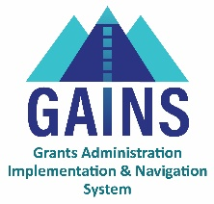

GAINS Training and System Navigation

# Navigating to the Monitoring Instruments in GAINS

## Users will learn how to locate and access a Monitoring Instrument within GAINS. Monitoring Instruments can only be located using the left navigation menu and will not appear in the organization’s Funding Application list.

**GAINS Home Page**

1. After first logging in, users will be on the GAINS Home page. In the left navigation menu, users will hover over **Monitoring** and select **Monitoring Instruments**.
   1. Similar to Funding Applications, users can move between different fiscal years by selecting a year in the first drop-down field at the top of the page.
   2. Users can filter the status of the monitoring instrument shown by using the second drop-down field at the top of the page. Users can choose between “Active”, “All Approved”, and “Last Approved”.
   3. The **Monitoring Instruments** page will also show other basic details about the instrument including Revision numbers, current Status, and the date the last Status update occurred.
   4. To enter any instrument, click on the name of the instrument.

# Related GAINS Training and Navigation Topics

* Small Bites - Logging into GAINS (Native login- Charters, CBOs)
* Small Bites – Logging into GAINS (IdM)
* Roles Webpage