ESSA Application for School Improvement (EASI)

Online Application Handbook
Table of Contents
Accessing the Application 3
Navigating the Application 4
EASI Application Home 5
LEA Information Page 5
Route Selection for Schools 6
LEA Application Summary 8
Exploration Supports Route 9
Exploration Supports Route: Diagnostic Review and Planning Grant 10
Exploration Supports Route: Accountability Pathways Planning 12
Exploration Supports Route: Stakeholder and Community Engagement Planning 14
District Designed and Led Improvement Strategies Route 15
CDE Offered Services Route 17
CDE Offered Services Route: Connect for Success 18
CDE Offered Services Route: School Turnaround Network 19
Districtwide Supports Route 20
Districtwide Supports Route: Consultation 21
Districtwide Supports Route: Colorado Multi-Tiered System of Supports 22
Districtwide Supports Route: School Turnaround Leaders Development Program 23
Requested Funds Page 26
Supporting Documentation Uploads 27
Summary and Submit Page 28

Accessing the Application
- To receive access to the application through your LEA’s application contact(s), use the EASI Online Application Access Form.
- You should receive a confirmation email with a one-pager of instructions for accessing EASI.
- To access EASI, click the green button under “EASI Application” on the EASI landing page.
- Go to the above link and click “forgot password” at the bottom of the log-in module on the far right.
- Enter your email address under “password reset” module and click “submit”.
- You should receive email instructions on how to set up your password.
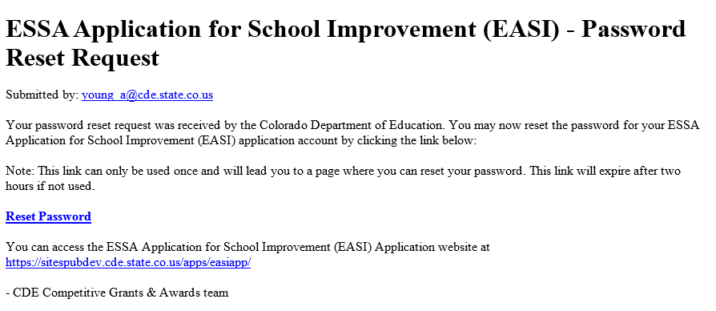
- Once you receive that email, follow the link and instructions to set up your password and to access the application.

Navigating the Application
- Use the Application Menu to easily jump to other sections of the application.
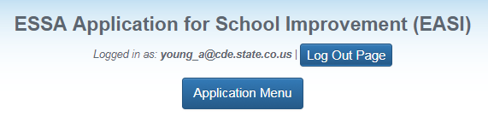
- The Navigation window that pops up when you click the “Application Menu” button provides access to all parts of the application in one location.
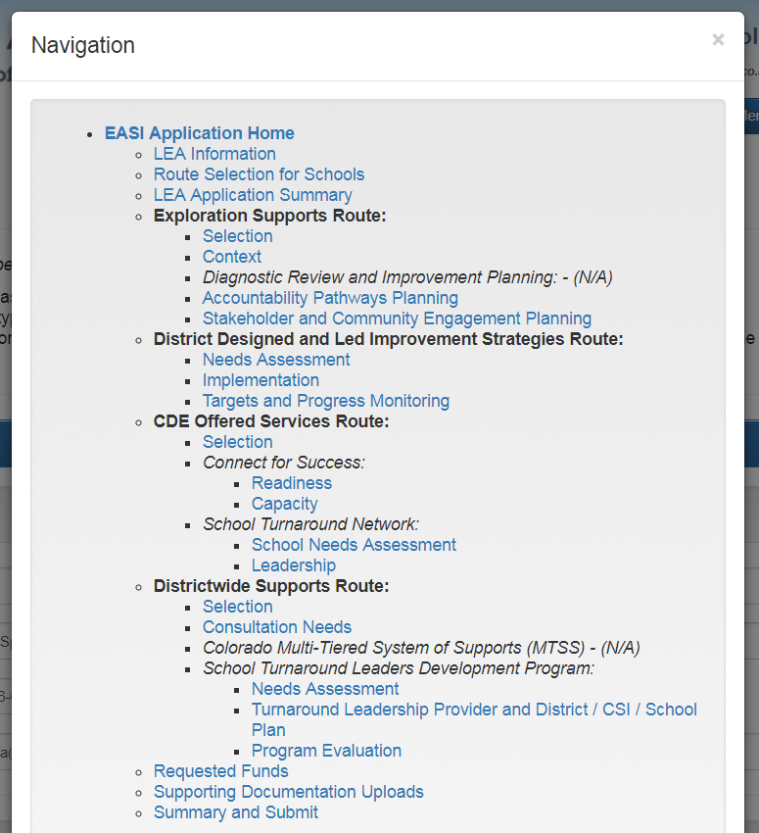
- Use the navigation buttons at the bottom of each page to go to the “previous” or “next” page within the sections of the application.
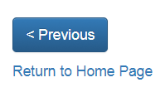

PRO TIP:
Always hit “save” if you are jumping around the application/working on the application in a non-linear fashion. For example, when you are changing the route selection for schools, make your selection and hit “save”. Then, the schools will display where needed throughout the application.

EASI Application Home
- Read the information and click on the links contained in the grey boxes to learn more about each of the EASI Routes you may choose.
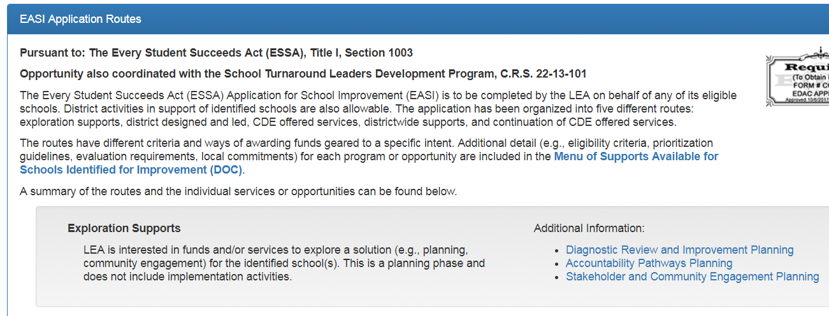
PRO TIP:
Throughout the application, be sure to click on and refer to any links to documents, particularly the application planning document and the Menu of Supports.

LEA Information Page
- All fields for each of the three contacts (Application Contact, Authorized Representative, and Fiscal Manager) are required.
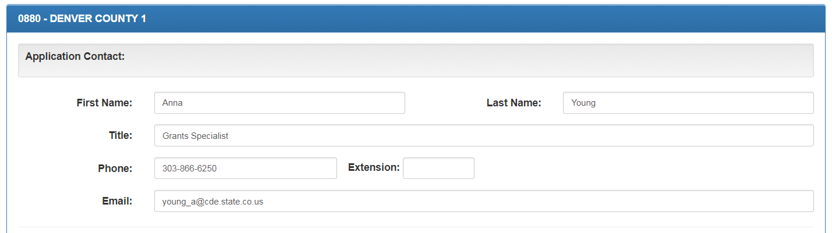

Route Selection for Schools
- Refer to the school-specific eligibility in the grey box for possible route and program selections and funds for the LEA’s schools.
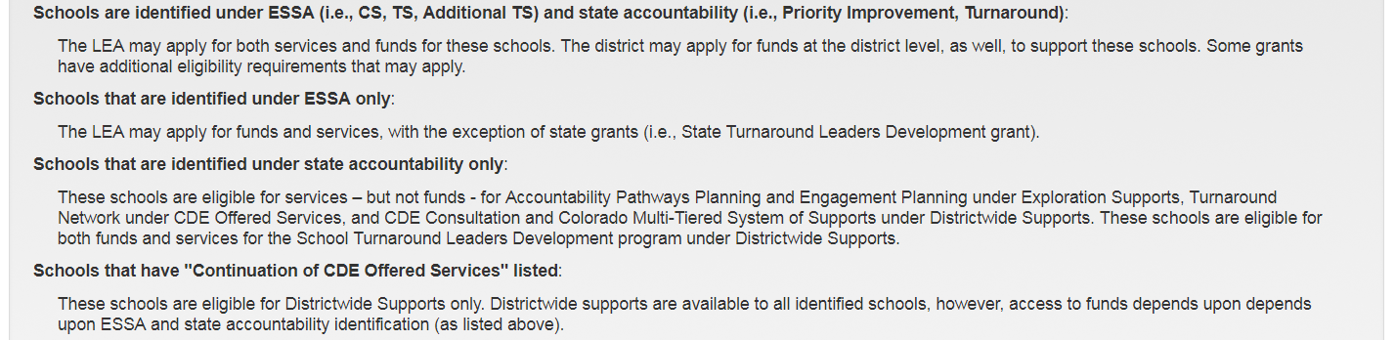
- Follow the instructions for choosing route(s) for each eligible school(s). Pay attention to the available options for each school and at the district level.
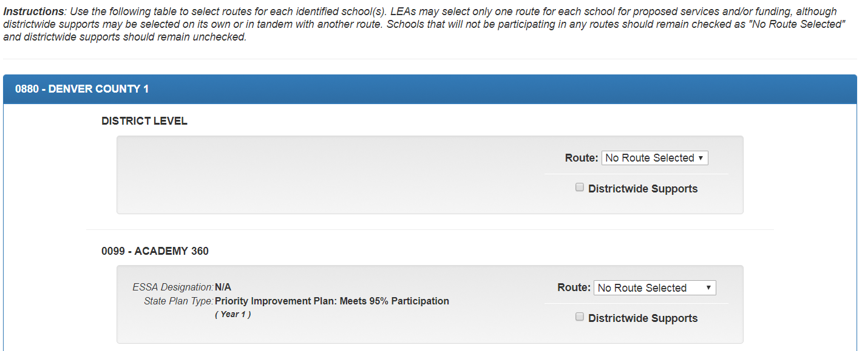
Below are some examples of the routes available depending on how a school(s) is identified. For more information on route and program availability, see the ‘Program Options and Eligibility’ matrix in the application planning document.

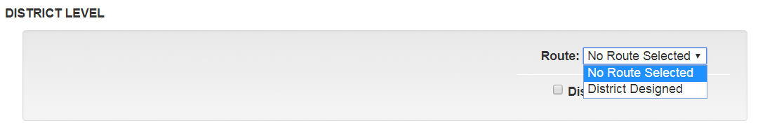
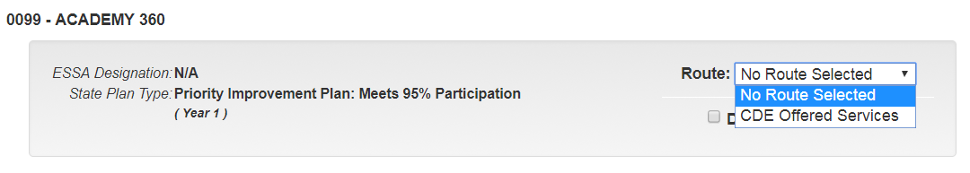
PRO TIP:
To change a route selection for any school, use the Application Menu button at the top of the screen. After making changes don’t forget to click “Save” before navigating around the rest of the application.
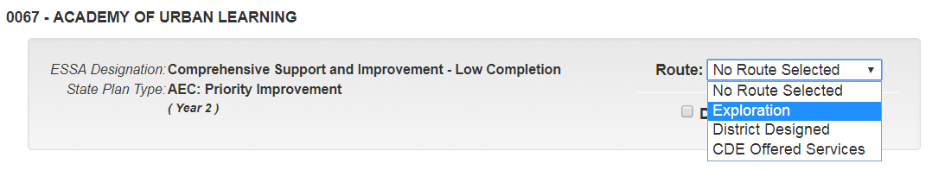
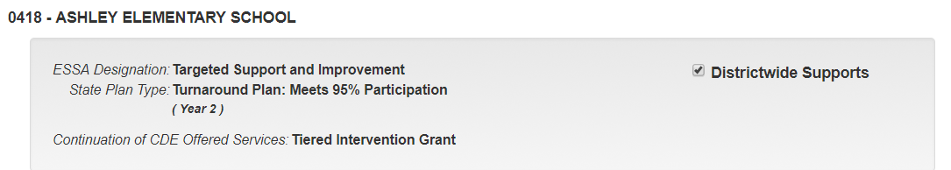
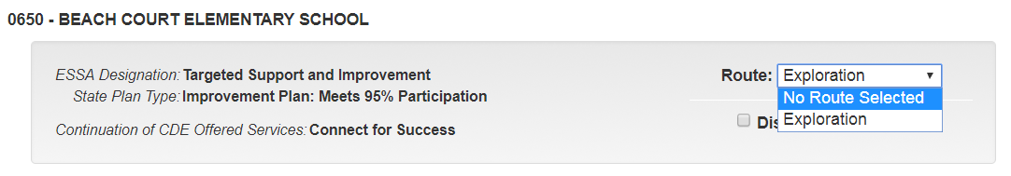

LEA Application Summary
- There are three narrative questions required of all LEAs applying for EASI.
- CDE encourages LEAs to limit the narrative responses in the LEA application summary to no more than 500 words. The system will not restrict word count and responses may be copied and pasted from another document.
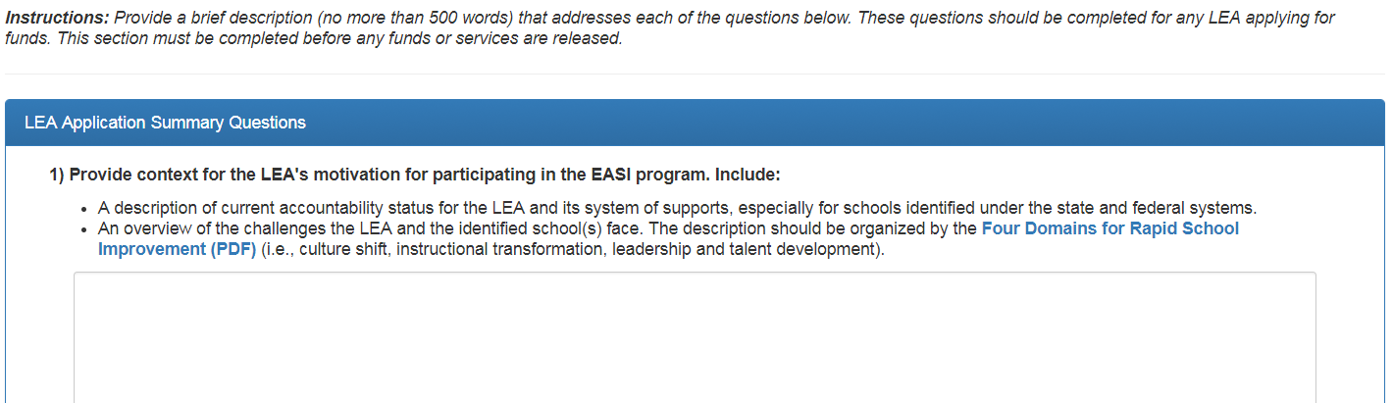
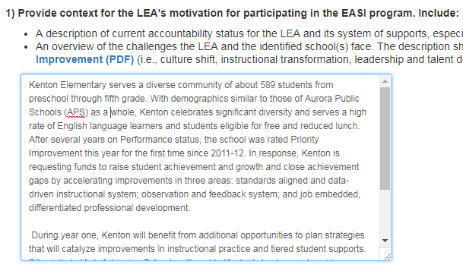
PRO TIP:
All text boxes for the narrative questions throughout the application can expand and condense, including those in the table modals that pop up when adding grant activities. To expand or condense any text boxes, click and drag the lower right corner of the box.

Exploration Supports Route
- This is the first route in the application and will appear only if the Exploration Supports Route has been selected for a school(s).
- This route contains three programs: Diagnostic Review and Improvement Planning, Accountability Pathways Planning, and Stakeholder and Community Engagement Planning.
- Carefully read the instructions at the top of each page.
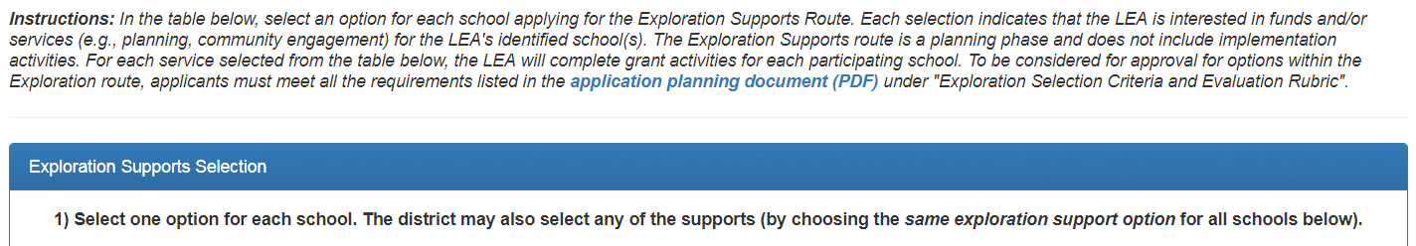
- On this first page under Exploration Supports, select the program for which each school plans to apply.
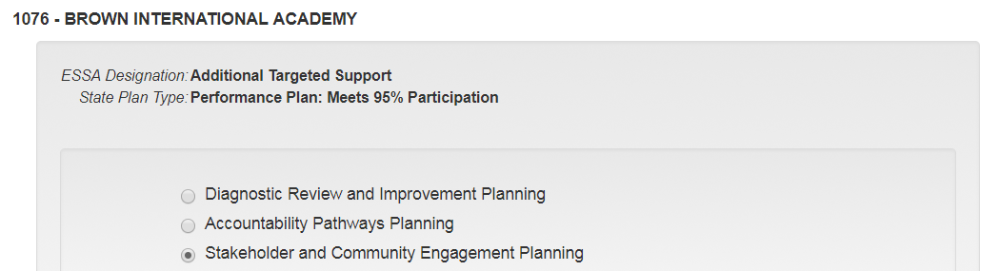
PRO TIP:
Pay attention to the options for program eligibility and participation options for each school depending on how they are identified (under ESSA and/or State Plan type).

For schools that are continuing either Connect for Success OR School Turnaround Network, the only option available to those schools is Accountability Pathways Planning.
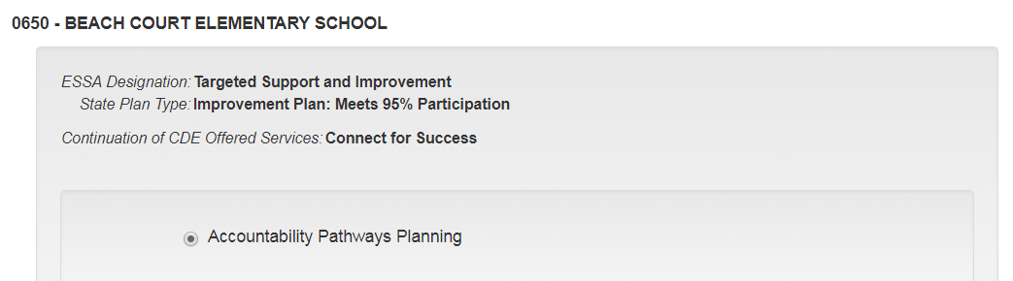

- The second page under Exploration Supports contains a narrative question about the current context of the LEA and why the Exploration Supports route is the best choice for the school(s).
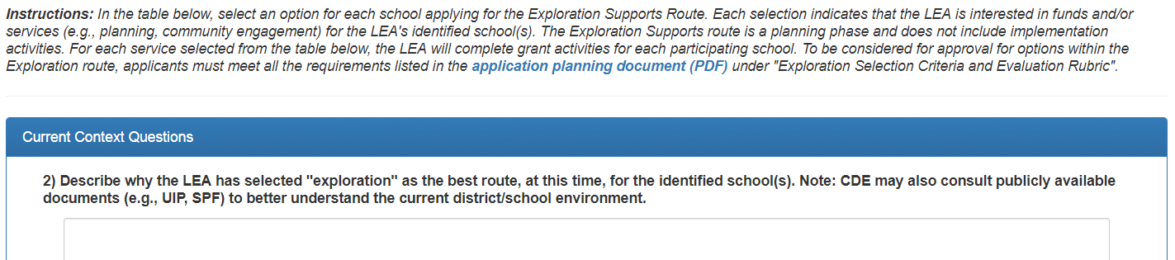

Exploration Supports Route: Diagnostic Review and Planning Grant
- If “Diagnostic Review and Planning Grant” was selected for any school, the Diagnostic Review and Planning Grant pages will appear. There are two pages for this section.
- On the first page, select whether schools will undergo a Diagnostic Review and Improvement Planning or Improvement Planning only.
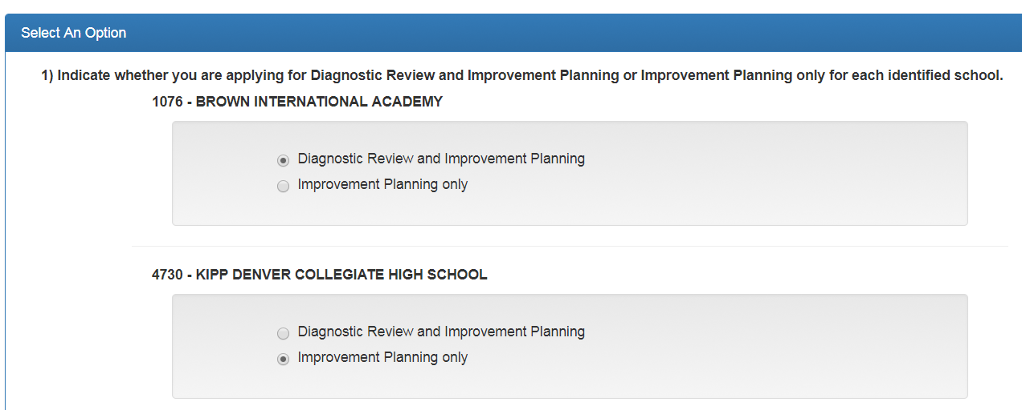
- On the second page, complete the table provided to list the grant activities for all of schools selected for a Diagnostic Review and/or Improvement planning.
- To add a grant activity, select “Add Grant Activities”. Choose your location from the dropdown (the list is prepopulated with the schools applying for this support) and fill out the rest of the fields as thoroughly as possible. When finished, click “add activity” the pop-up form will clear and the activity will be added to the table. 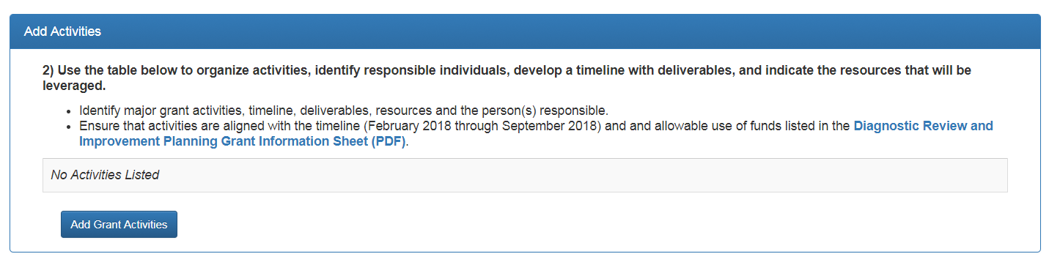
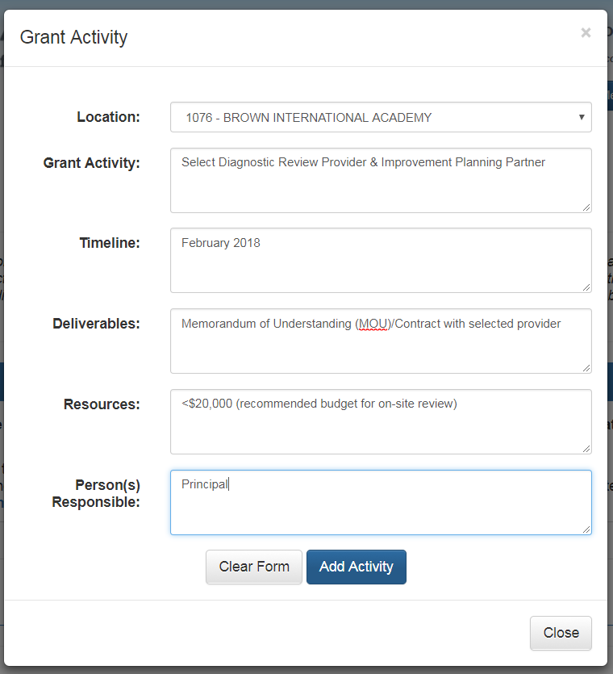
PRO TIP:
Use the “edit” (pen) and “delete” (trashcan) buttons to the far right of each row in the table to modify grant activities.

Exploration Supports Route: Accountability Pathways Planning
- If applying for the “Accountability Pathways Planning” support for any of the LEAs eligible schools, the Accountability Pathways Planning page will appear. There is one page for this section.
- On this first page, list the contact information for the program’s point person at the LEA and complete a “grant activities” table.
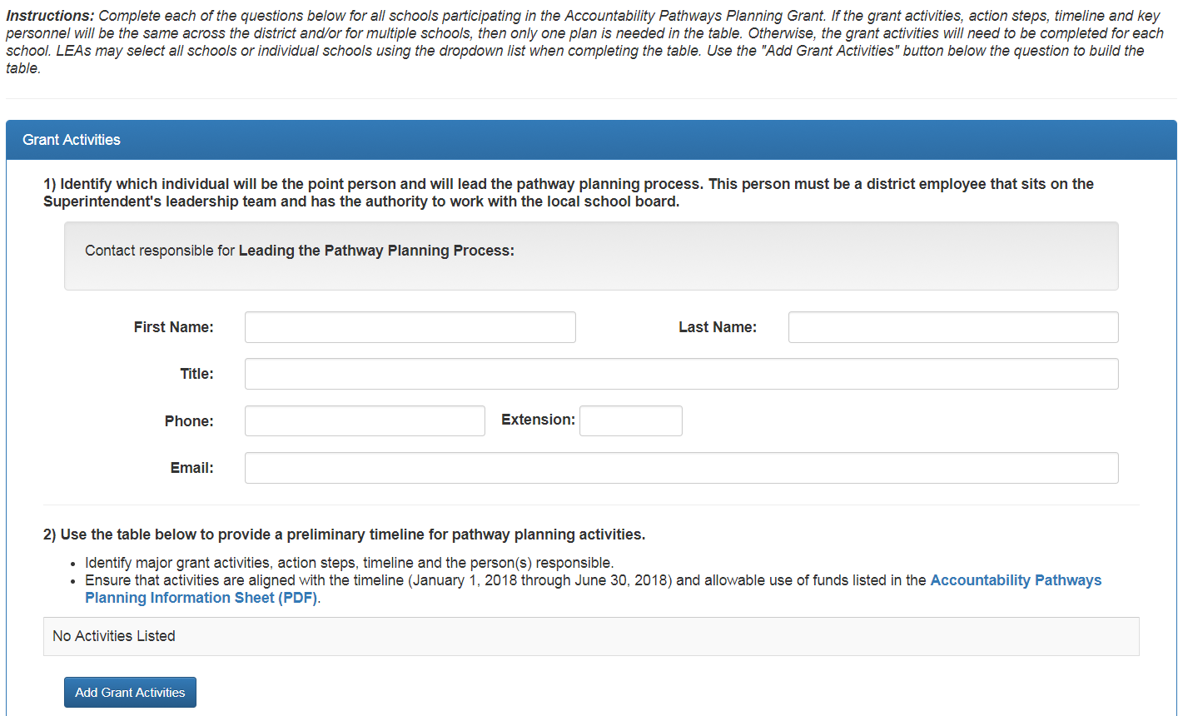

- Each grant activity you add will populate the table. To add a grant activity, select “Add Grant Activities”. Choose your location from the dropdown (the list is prepopulated with the schools applying for this support) and fill out the rest of the fields as thoroughly as possible. When finished, click “add activity” the pop-up form will clear and the activity will be added to the table.
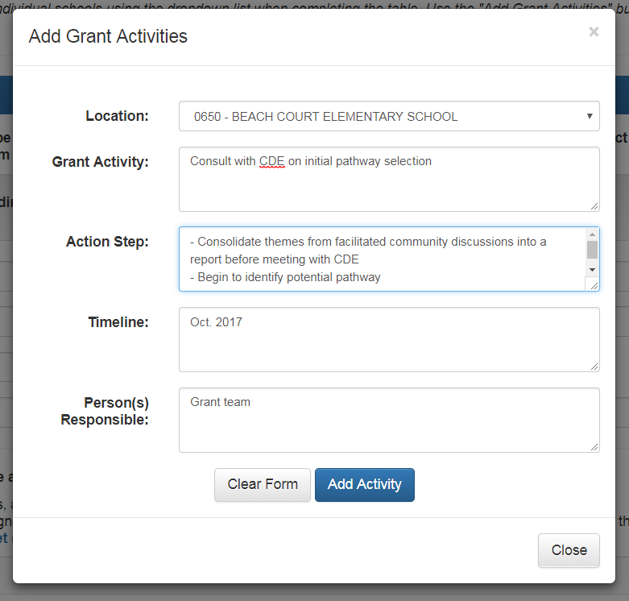
PRO TIP:
To add multiple action steps for each grant activity y copy and paste a list into the “action step” field.

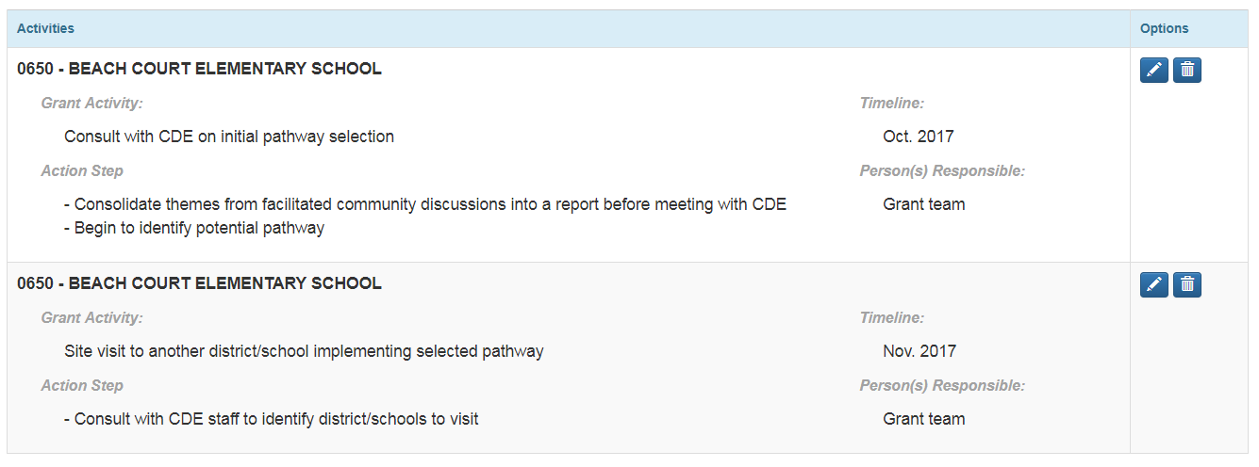
PRO TIP:
Use the “edit” (pen) and “delete” (trashcan) buttons to the far right of each row in the table to modify grant activities.

Exploration Supports Route: Stakeholder and Community Engagement Planning
- If applying for “Stakeholder and Community Engagement Planning” for any of any schools, the Stakeholder and Community Engagement Planning page will appear. There is one page for this section.
- On this first page answer the two narrative questions and complete a “grant activities” table.
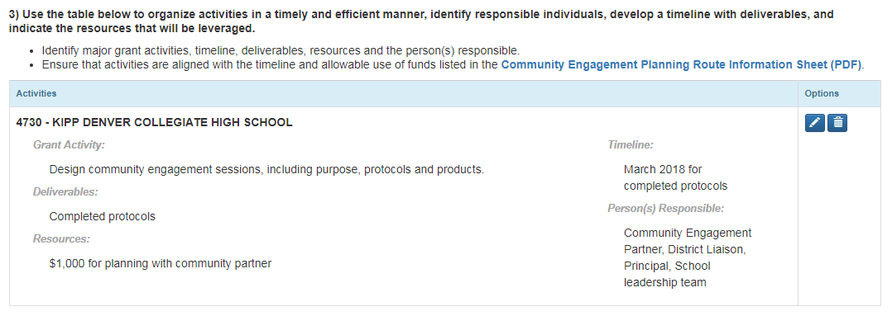
PRO TIP:
To add multiple deliverables and resources for each grant activity copy and paste a list into these fields in the pop-up form that appears when the applicant clicks “add grant activities”.

PRO TIP:
Use the “edit” (pen) and “delete” (trashcan) buttons to the far right of each row in the table to modify the grant activities as needed.

District Designed and Led Improvement Strategies Route
- This is the second route in the application and will appear only if select for any schools.
- This route contains three pages: Needs Assessment, Implementation, and Targets and Progress Monitoring.
- Carefully read the instructions at the top of each page in this route.
- The Needs Assessment page has four narrative questions.
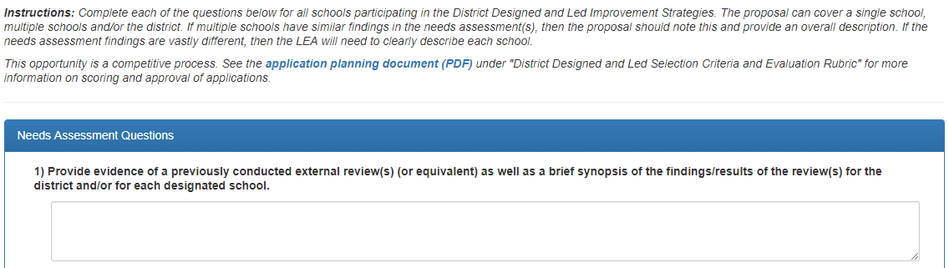
- The Implementation page has three narrative questions and an “action plan” table.
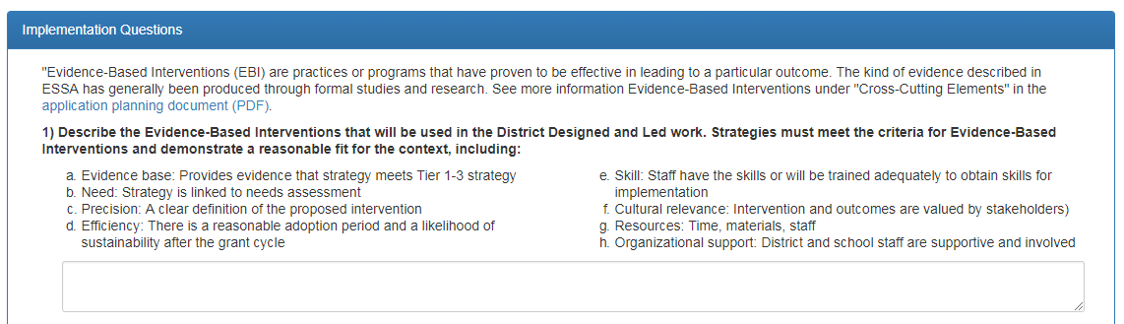

- On the Implementation page, complete a table to list the action plan items for all of schools (or district level) that selected this route. To populate the table, click the “add action plan” button.

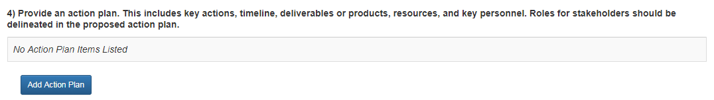

- To add a grant activity, select “Add Grant Activities”. Choose your location from the dropdown (the list is prepopulated with the schools applying for this support) and fill out the rest of the fields as thoroughly as possible. When finished, click “add activity” the pop-up form will clear and the activity will be added to the table.
- Each action plan item added will populate the table. Choose the location from the dropdown (depending on the schools you selected or the district level) and fill out the rest of the fields as thoroughly as possible.
- When finished, click “add activity” the pop-up form will clear and the activity will be added to the table.
PRO TIP:
To add multiple actions, deliverables, and resources for each grant activity by copy and paste a list into these fields in the pop-up form that appears when the applicant clicks “add action plan”.
REMEMBER: The fields expand so the reader can see all the text entered.

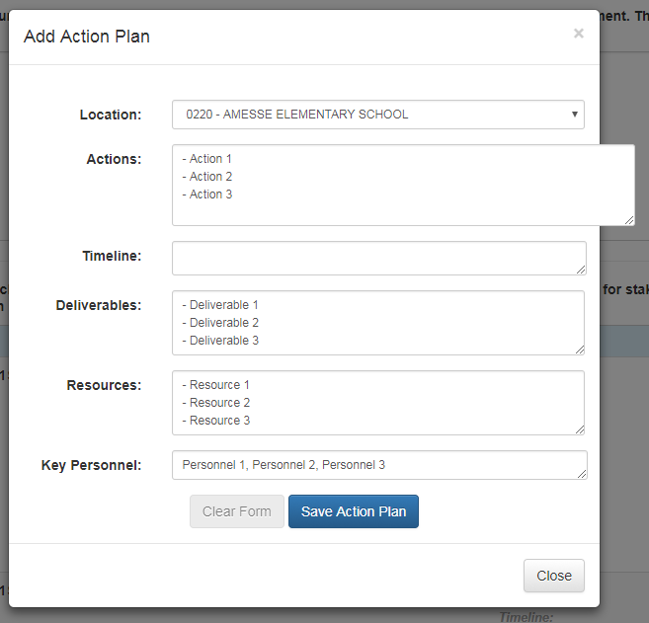
PRO TIP:
Use the “edit” (pen) and “delete” (trashcan) buttons to the far right of each row in the table to modify the action plan.

- The Targets and Progress Monitoring page has three narrative questions.
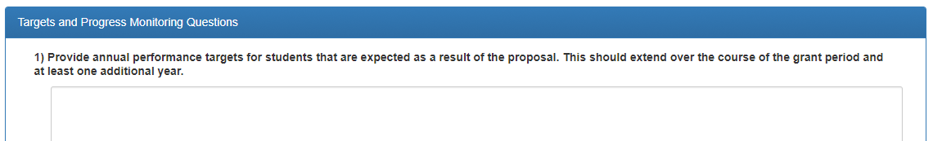

CDE Offered Services Route
- This is the third route in the application and will appear only if this route was selected for any of your schools.
- This route contains two programs: Connect for Success and School Turnaround Network.
- Carefully read the instructions at the top of each page in this route.

- On this first page under CDE Offered Services, you will select which program you would like each of your schools to participate.
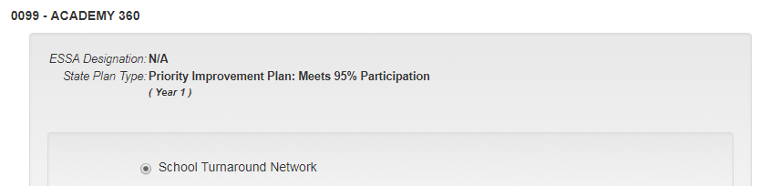
PRO TIP:
Pay attention to the options for program eligibility for each school depending on how they are identified (under ESSA and/or State Plan type).

For schools that are identified with only a State Plan Type (not an ESSA designation), the only option available is School Turnaround Network.
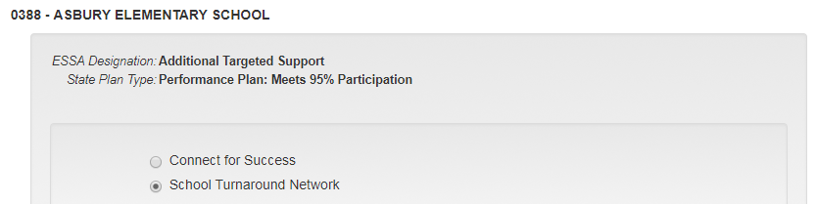

CDE Offered Services Route: Connect for Success
- If you selected “Connect for Success” for any of your schools, the Connect for Success pages will appear. There are two page of this section: Readiness and Capacity.
- The first page, Readiness, contains three narrative questions.

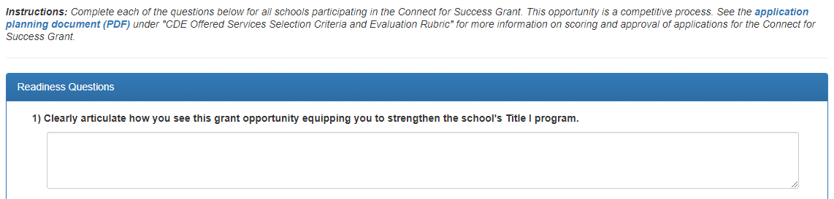
- The second page, Capacity, contains four narrative questions.
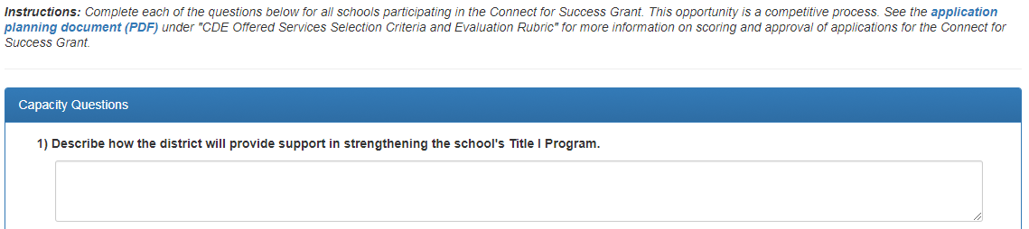

CDE Offered Services Route: School Turnaround Network
- If you selected “School Turnaround Network” for any of your schools, the School Turnaround Network pages will appear. There are two page of this section: School Needs Assessment and Leadership.
- The first page, School Needs Assessment, contains four narrative questions.
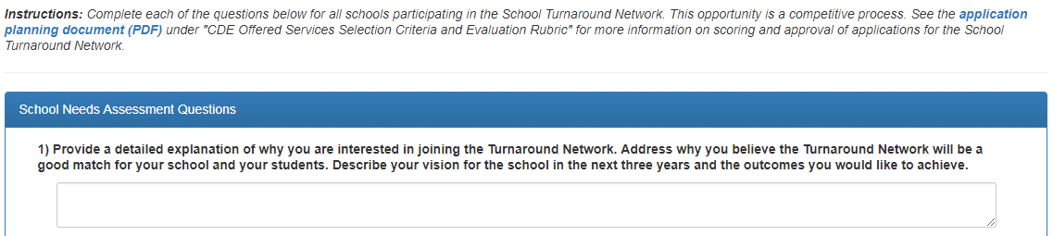
- The second page, Leadership, contains four narrative questions.
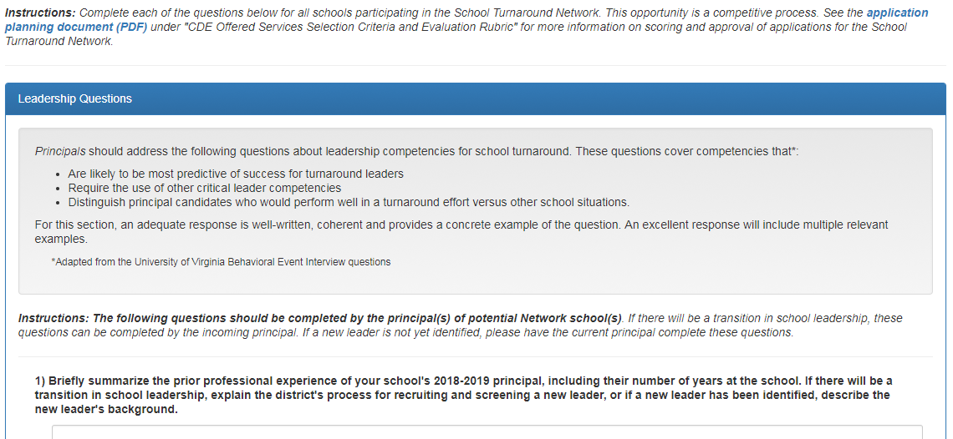
PRO TIP:
Consider sending the Leadership questions to the principal(s) to complete outside of the application, then copy and paste all of the principal(s)’ responses into the text boxes for this section.

Districtwide Supports Route
- This is the fourth route in the application and it will appear only if you select this route for any of your schools or district level.
- REMEMBER: You can choose this route in addition to any other route selected for the school(s)/district. You can also choose multiple supports under this route for each school or at the district level.
- This route contains Consultation services as well as two programs: Colorado Multi-Tiered System of Supports and School Turnaround Leaders.
- Carefully read the instructions at the top of each page in this route.

- On this first page under Districtwide Supports, you will select which program you would like each of your schools to participate.
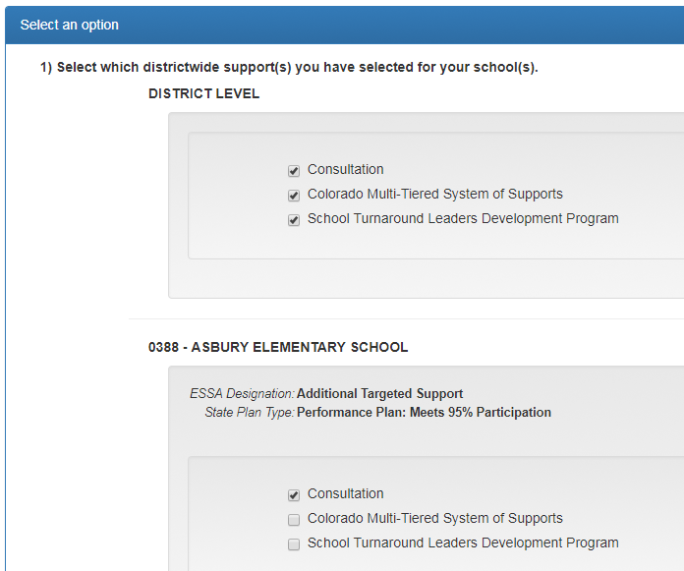
PRO TIP:
Pay attention to the options for program eligibility for each of school depending on how they are identified (under ESSA and/or State Plan type).

For schools that have a State Plan Type of Priority Improvement or Turnaround, the School Turnaround Leaders Development Program will appear as an option. If schools do not have these two State Plan Types, the School Turnaround Leaders Development Program will not appear as an option.

Districtwide Supports Route: Consultation
- If you selected “Consultation” for any of your schools, the Consultation page will appear.
- There are two narrative questions for this section.

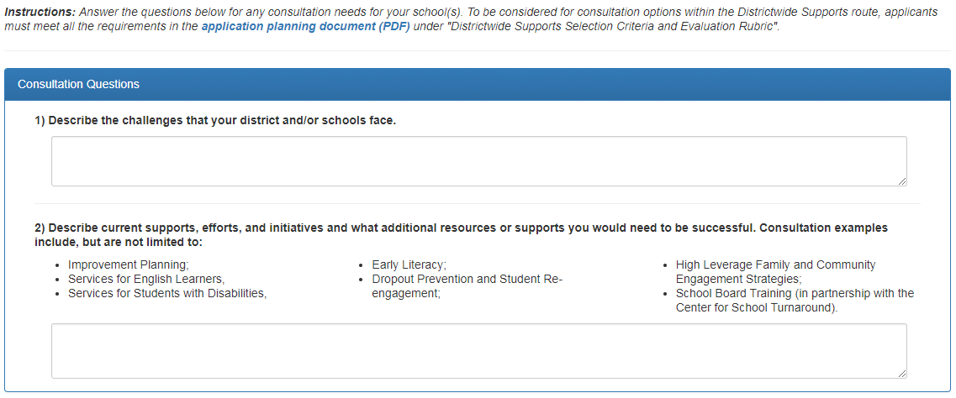

Districtwide Supports Route: Colorado Multi-Tiered System of Supports
- If you selected “Colorado Multi-Tiered System of Supports” for any school, the Colorado Multi-Tiered System of Supports page will appear.
- There is one page containing three different sections for this program. Each section contains one narrative question.
- REMEMBER: This program requires one document, the CO-MTSS Team Membership Signature Form, to be completed and submitted with the application. The document can also be downloaded by clicking the link on this page. 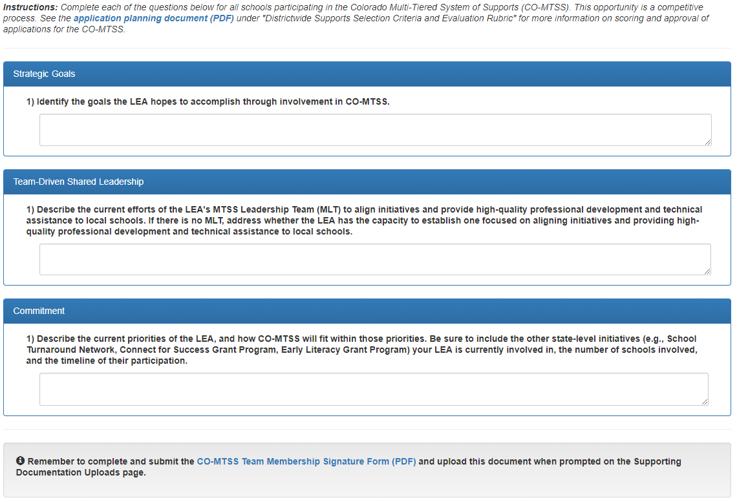

Districtwide Supports Route: School Turnaround Leaders Development Program
- If you selected “School Turnaround Leaders Development Program” for any school, the School Turnaround Leaders Development Program pages will appear.
- For this program, there are three pages: Needs Assessment, Turnaround Leadership Provider and District/CSI/School Plan, and Program Evaluation.

- On the first page, Needs Assessment, complete a table for the identified leaders participating in the program (school or district level). To populate the table, click the “add leader” button.

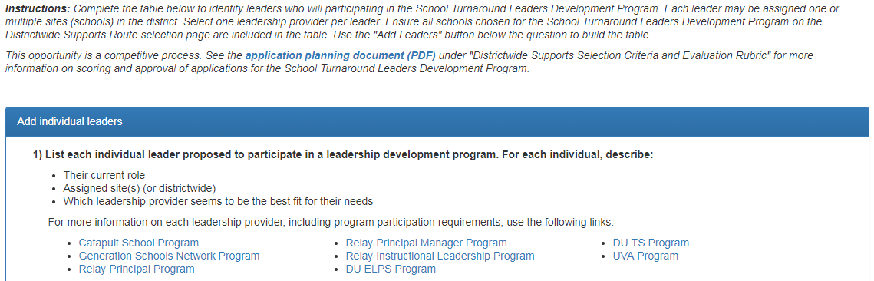

PRO TIP:
To learn more about each leadership provider and see provider-specific requirements, click on the links listed in this question.

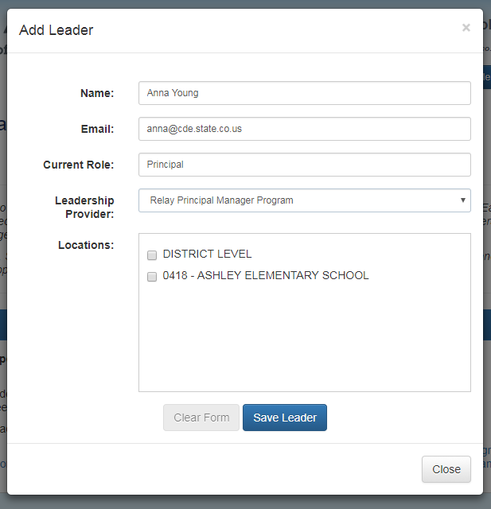
- For the leaders table, each item added will populate the table.
- Fill out each field as completely as thoroughly as possibly.
- Choose the leadership provider from the dropdown menu.
- There is the option to select the district level, a single school, or
multiple schools for each leader.
- Click “save leader” to add the leader to the table and clear the form
so additional leaders may be added.
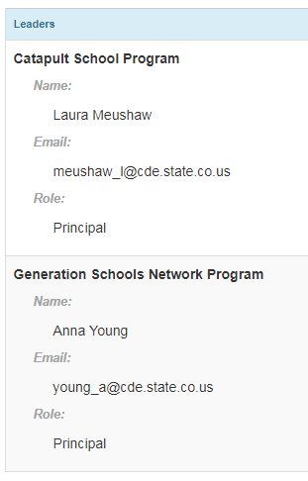
PRO TIP:
Use the “edit” (pen) and “delete” (trashcan) buttons to the far right of each row in the table to modify the leaders field.

PRO TIP:
This table is organized by the leadership provider selected. Make sure to enter all leaders that will participate with each leadership provider.

On the second page, Turnaround Leadership Provider and District/CSI/School Plan, answer the two narrative questions and complete a table for the grant activities for each identified leadership provider. To populate the table, click the “add grant activities” button.
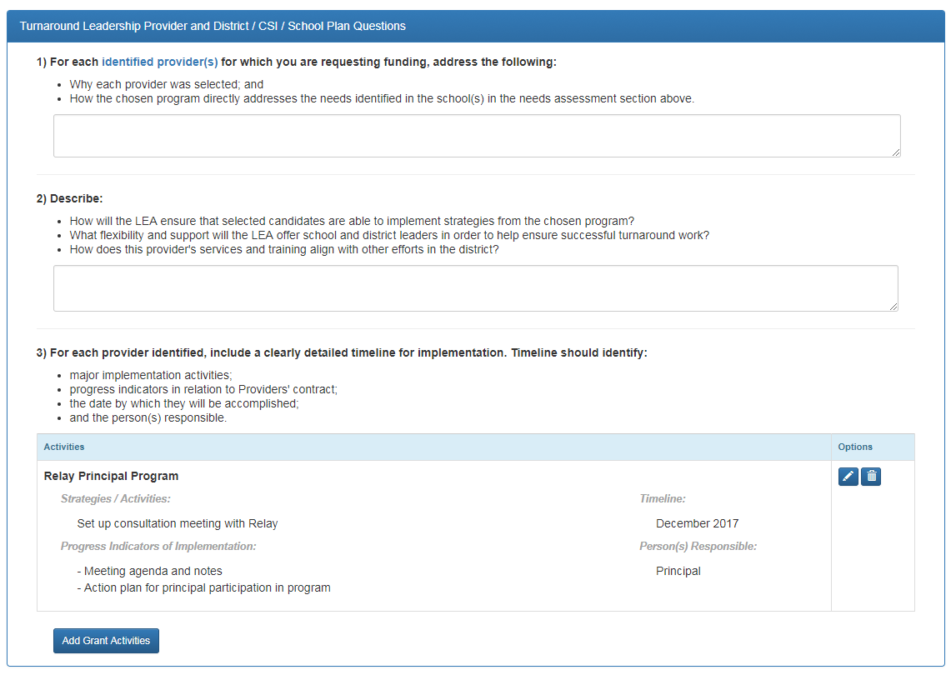
PRO TIP:
To add multiple strategies/activities and progress indicators for each provider by copy and paste a list into these fields in the pop-up form that appears when the application clicks “add grant activities”.

- On the third page, Program Evaluation, answer one narrative question.
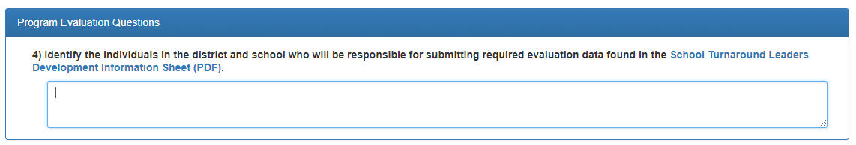

Requested Funds Page
- On this page, review the school(s) (or district level) selected for each route and program. Identify the school(s) (or district level) that will be applying for funds.
- Read the important information in the grey box and click on the links to prepare for completing this page.
- All school selections under default to “No (services only)”. You must manually select “Yes” for any school that is requesting funds.
- REMEMBER: For any school the LEA identifies for funds, ensure the school is included in the uploaded Electronic Budget spreadsheet.
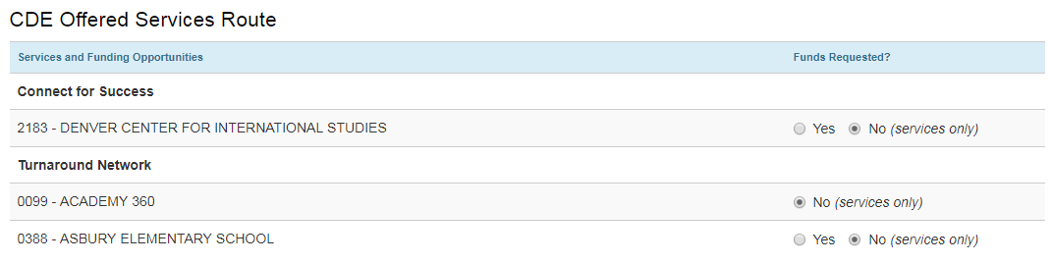
PRO TIP:
Schools will have only a “No (services only)” option if their designation does not make them eligible for funds under a particularly program/route. An LEA can check the school’s designation(s) on the Route Selection for Schools page at the beginning of the application.

Supporting Documentation Uploads
- On this page, upload the required and optional documents before submitting the application.
- Read the important information in the grey box and click on the links to download documents and prepare for completing this page.
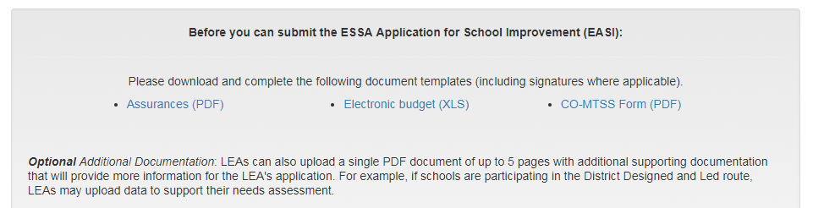
PRO TIP:
The CO-MTSS form will appear as a link only if completing that section of the application.

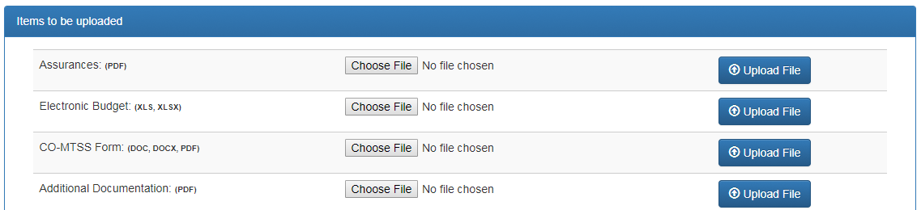
PRO TIP:
Pay attention to the required file formats for each document upload.

Examples of file upload messages:

Summary and Submit Page
- Review the information on this page before submitting the application.
- At this time, the “Submit” button is disabled but CDE will activiate this button closer to the deadline of the application (December 6, 2017).
