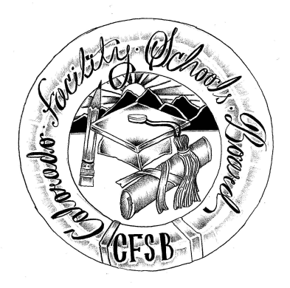
Colorado Facility Schools Board Agenda
April 6, 2023
11:00 a.m. until the completion of the agenda

Shiloh Family Resource Pavilion In-Person & Zoom

11:00  11:30  11:35  11:45  12:20 | Lunch  Board Meeting will start - Call to Order  Approval of Minutes  Approval of Agenda  Candidate Review -  Board Discussion  Board Vote  Candidate Interview -  Board Discussion  Candidate Interview -  Board Discussion  Board Vote | Action Item  Action Item  Board  Action Item  Board  Board  Action Item
12:50  1:00  3:05  3:15 | BREAK  Board Development  - Facilitator’s Role, What We Can Accomplish By June  - Beyond Our Operating Principles - the Collective Responsibilities of the Board  - Activity  - Developing an Annual Lifecycle of the Board ‘Calendar’  Scheduling  Free Reduced Lunches for students at Facility Schools  Facility Schools Unit Update via Email  * JECC/ Joshua Academy review of Approval documents  - Documents will be sent electronically to the Board 4/13  - Approval presentation by Joshua Academy 5/11  Workgroup Update | Virginia Winter/Robin/Ann  Betsy Peffer  Facility Schools Team  Wendy
3:20  3:30 | Opportunity for the Public to Address the Board  Members of the public who wish to address the board must sign up prior to the meeting. Presentations are limited to 5 minutes.  Next Steps/Adjournment of Meeting

