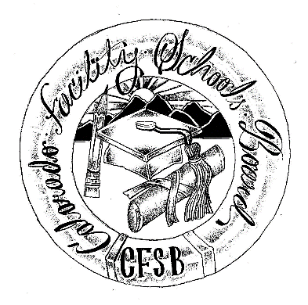

Colorado Facility Schools
Education Director’s Meetings

2022 - 2023 Meeting Schedule

Date | Time | Location
July 8, 2022 | 9:00am – 4:00pm
August 12, 2022 | 9:00am – 4:00pm
September 9, 2022 | 9:00am – 4:00pm
October 14, 2022 | 9:00am – 4:00pm
November 11, 2022 | 9:00am – 4:00pm
December 9, 2022 | 9:00am – 4:00pm
January 13, 2023 | 9:00am – 4:00pm
February 10, 2023 | 9:00am – 4:00pm
March 10, 2023 | 9:00am – 4:00pm
April 14, 2023 | 9:00am – 4:00pm
May 12, 2023 | 9:00am – 4:00pm
June 9, 2023 | 9:00am – 4:00pm

