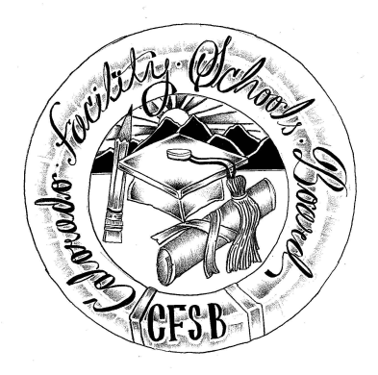
Colorado Facility Schools Board Agenda
August 11, 2022
11:30 a.m. until the completion of the agenda

Shiloh Family Resource Pavilion In-Person & Zoom Virtually

11:30  12:00 | Lunch  Board Meeting will start - Call to Order  Approval of Minutes  Approval of Agenda | Action Item  Action Item
12:05 | Facility Schools Unit Update  - CDE/Facility Internal Updates  - Data Management and Systems Support  - iReady/Tuition Cost  - Monitoring/Updates from the Field  - Frontline/State Assessments  - Curriculum/Induction/OOD Consortium  - Update from Attorney General’s Office | Judy Stirman  Quinn Enright  Lori Kochevar  Robin Singer/Ann Symalla  Annie Haskins  Wendy Dunaway  Isabel Broer
12:30  1:15  1:30  2:00  2:15 | SB21-274 Workgroup Update  September Board Meeting & Kaleidoscope  IEP System Update  Policies & Procedures  Opportunity for the Public to Address the Board  Members of the public who wish to address the board must sign up prior to the meeting. Presentations are limited to 5 minutes. | Judy Stirman/Wendy Dunaway  Judy Stirman  Annie Haskins  Robin Singer
2:20 | Next Steps
2:25 | Adjournment of Meeting

