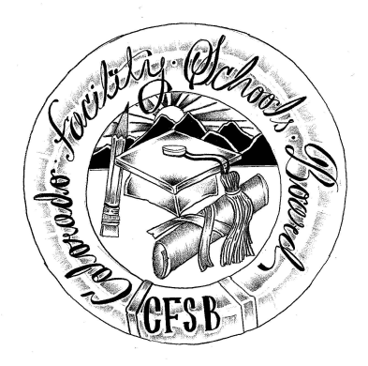
Colorado Facility Schools Board Agenda
December 12, 2019
11:30 a.m. until the completion of the agenda

Colorado Talking Book Library
180 Sheridan Blvd., Denver, CO 80226

Time | Activity | Presenter
10:00 | TACT – Board Site Visit
11:30 | Working lunch – Board will review documents
12:15-1:00 | Strategic Planning | Judy Stirman
1:00 | Board Meeting will start - Call to Order  Approval of Minutes  Approval of Agenda | Action Item  Action Item
1:05 | Facility Schools Unit Update  - CDE/Facility Internal Updates/TACT  - Infinite Campus/iReady Data/Assessments  - iReady/Website  - Monitoring/Updates from the Field/Training  - Curriculum/Induction/Out of District Consortium | Judy Stirman  Brittany Hanley/Erik Hilton  Lori Kochevar  Robin Singer / Ann Symalla  Wendy Dunaway
1:45 | Book | Judy Stirman
1:55 | Finance Update | Judy Stirman
2:15 | Finance – Elevator Speech | Carolena Steen
2:30 | Board Seats – Review Interview Questions | Judy Stirman
2:45 | Trainings, Board Meetings SY20-21 | Judy Stirman
3:00 | Tuition Cost | Judy Stirman
3:15 | Opportunity for the Public to Address the Board  Members of the public who wish to address the board must sign up prior to the meeting. Presentations are limited to 5 minutes.
3:30 | Next Steps
3:45 | Adjournment of Meeting

