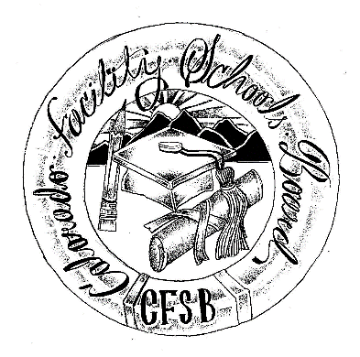

Colorado Facility Schools Board
of Education

2019 - 2020 Meeting Schedule

Shiloh Pavilion – Conference Room
9700 E Easter Lane, Centennial, CO 80112
Date | Time | Location
August 8, 2019 | 11:30am – Completion of agenda (usually 3:30-4pm) | Shiloh Pavilion  Conference Room
September 12, 2019 | 11:30am – Completion of agenda (usually 3:30-4pm) | Shiloh Pavilion  Conference Room
October 10, 2019 | 11:30am – Completion of agenda (usually 3:30-4pm) | Shiloh Pavilion  Conference Room
November 7, 2019 | 11:30am – Completion of agenda (usually 3:30-4pm) | Shiloh Pavilion  Conference Room
December 12, 2019 | 11:30am – Completion of agenda (usually 3:30-4pm) | Shiloh Pavilion  Conference Room
January 9, 2020 | 11:30am – Completion of agenda (usually 3:30-4pm) | Shiloh Pavilion  Conference Room
February 13, 2020 | 11:30am – Completion of agenda (usually 3:30-4pm) | Shiloh Pavilion  Conference Room
March 12, 2020 | 11:30am – Completion of agenda (usually 3:30-4pm) | Shiloh Pavilion  Conference Room
April 9, 2020 | 11:30am – Completion of agenda (usually 3:30-4pm) | Shiloh Pavilion  Conference Room
May 7, 2020 | 11:30am – Completion of agenda (usually 3:30-4pm) | Shiloh Pavilion  Conference Room
June 11, 2020 | 11:30am – Completion of agenda (usually 3:30-4pm) | Shiloh Pavilion  Conference Room
**Unless otherwise specified, the Colorado Facility Schools Board of Education holds its meetings at the Shiloh Pavilion in Centennial, CO

