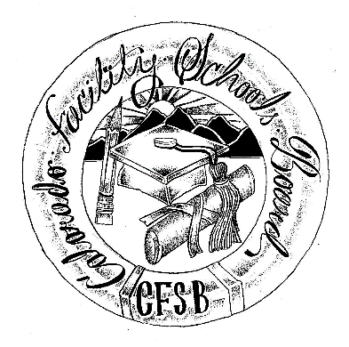

Colorado Facility Schools Board
of Education

2024 - 2025 Meeting Schedule

Date | Time | Location
August 8, 2024 | 9:30am – Completion of agenda (usually 3:30-4pm) | In Person - Shiloh House Family Resource Pavilion - 9700 E Easter Ln, Centennial, CO 80112.
September 12, 2024 | 9:30am – Completion of agenda (usually 3:30-4pm) | In Person - Shiloh House Family Resource Pavilion - 9700 E Easter Ln, Centennial, CO 80112.
October 10, 2024 | 9:30am – Completion of agenda (usually 3:30-4pm) | Virtual Only – Virtual Only via Zoom
October 24, 2024 | Board Presentation at Kaleidoscope Conference | The Adams 12 Conference Center 1500 E 128th Avenue  Thornton CO  80241
November 7, 2024 | 9:30am – Completion of agenda (usually 3:30-4pm) | In Person – TACT- 2960 S Umatilla St, Englewood, CO 80110
December 12, 2024 | 9:30am – Completion of agenda (usually 3:30-4pm) | In Person - Shiloh House Family Resource Pavilion - 9700 E Easter Ln, Centennial, CO 80112.
January 9, 2025 | 9:30am – Completion of agenda (usually 3:30-4pm) | Virtual Only- Via Zoom
February 13, 2025 | 9:30am – Completion of agenda (usually 3:30-4pm) | In Person – Spectra –  7205 West 120th Avenue,  Broomfield, CO 80020
March 13, 2025 | 9:30am – Completion of agenda (usually 3:30-4pm) | In Person - Shiloh House Family Resource Pavilion - 9700 E Easter Ln, Centennial, CO 80112.
April 10, 2025 | 9:30am – Completion of agenda (usually 3:30-4pm) | In Person - Shiloh House Family Resource Pavilion - 9700 E Easter Ln, Centennial, CO 80112.
May 8, 2025 | 9:30am – Completion of agenda (usually 3:30-4pm) | In Person – ACES- 8040 Southpark Ln, Littleton, CO 80120
June 12, 2025 | 9:30am – Completion of agenda (usually 3:30-4pm) | In Person - Shiloh House Family Resource Pavilion - 9700 E Easter Ln, Centennial, CO 80112.

