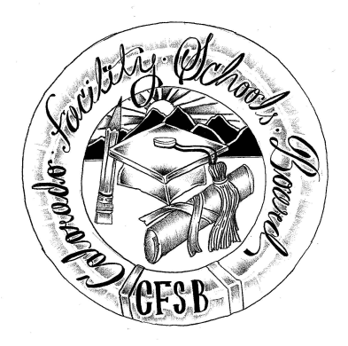
Colorado Facility Schools Board Agenda
November 9, 2023
9:30am until the completion of the agenda

In-Person Only

9:15am  9:30am  9:35am  10:20am  11:30am  12:00pm  12:30pm  1:00pm | Arrival  Board Meeting will start - Call to Order  Approval of Minutes  Approval of Agenda  Implementation/Rules Updates  Board Development  Lunch  Implementation Updates Continued  Board Seat  Facility Schools Unit Update  CDE/Facility Internal Updates  Data Management and Systems Support  Tuition Cost/December Staff  Monitoring/Updates from the Field  IEP System Updates/ State Assessments/ML Students  OOD Consortium/Workgroup  Program Support  Attorney General’s Office update | Action Item  Action Item  Facility Schools Staff/Board  Board/Virginia Winter  Facility Schools Staff/Board  Judy Stirman  Judy Stirman  Lori Kochevar  Robin/Ann  Annie Haskins  Wendy Dunaway  Darren Serrato  Jenna Zerylnick
1:30pm  2:00pm | Opportunity for the Public to Address the Board  Members of the public who wish to address the board must sign up prior to the meeting. Presentations are limited to 5 minutes.  Next Steps/Adjournment of Meeting | Members of the Public  Board

