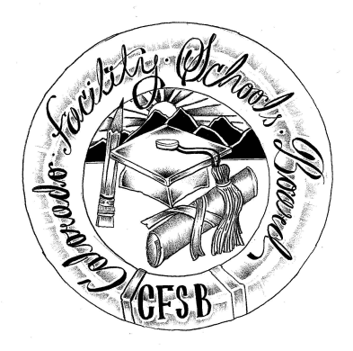
Colorado Facility Schools Board Agenda
May 9, 2024
9:30a.m. until the completion of the agenda

Venue: Shiloh House Family Resource Pavilion
9700 E Easter Ln, Centennial, CO 80112
In-Person

9:15am  9:30am  9:35am  9:50am  10:00am  10:10am  10:35am  10:45am  11:45am  12:00pm  12:30pm  12:45pm  1:00pm  1:45pm  2:00pm | Arrival  Board Meeting will start – (Chair calls meeting to order)  Approval of Minutes Action Item  Approval of Agenda Action Item  School Accreditation Organizations  Final Review of Specialized Day School Documents  Tuition Cost  December Count PowerPoint  Break  Board Strategic Planning  Logistics for June Retreat, Board Commitment  Lunch/ Discussion Time?  Graduation Guidance Discussion  Review Operating Procedures  Facility Schools Unit Update  CDE/ESSU/Facility Internal Updates  Data Management and Systems Support  Monitoring/Updates from the Field/ Annual Report  IEP System Updates/ State Assessments  Induction/Workgroup/Accreditation  Program Support  Opportunity for the Public to Address the Board  Members of the public who wish to address the board must sign up prior to the meeting. Presentations are limited to 5 minutes.  Next Steps/Adjournment of Meeting  Next Meeting Date – Board Retreat June 13th | Wendy Dunaway  Robin Singer/Ann Symalla/Lori Kochevar  Virginia Winter  Judy Stirman  Ann Symalla  Board/Jenna Zerylnick  Judy Stirman  Lori Kochevar  Ann Symalla/Robin Singer  Annie Haskins  Wendy Dunaway  Darren Serrato  Members of the Public  Board

