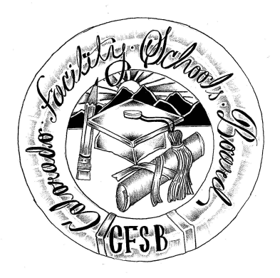
Colorado Facility Schools Board Agenda
April 11, 2024
9:30a.m. until the completion of the agenda

Venue: Morgridge Academy - 1400 Jackson St, Denver, CO 80206
Meeting Location: Molly Blank Conference Center, Room: J-104
https://www.nationaljewish.org/patients-visitors/visiting-us/campus-building-maps
In-Person

8:20 – 9:15am School Tour
9:15am  9:30am  9:40am  11:10am  11:15am  11:40am  12:00pm  12:15pm  12:30pm  1:00pm  1:15pm  1:45pm  1:50pm | Arrival  Board Meeting will start – (Chair calls meeting to order)  Approval of Minutes Action Item  Approval of Agenda Action Item  Board Strategic Planning  Break  Board Vacancies  Board Seat Recommendations Action Item  Tuition Cost  Graduation Guidance  Lunch  Morgridge School  Facility Schools Unit Update  CDE/ESSU/Facility Internal Updates  Data Management and Systems Support  Monitoring/Updates from the Field/ Annual Report  IEP System Updates/ State Assessments  Induction/Workgroup/Accreditation  Program Support  Opportunity for the Public to Address the Board  Members of the public who wish to address the board must sign up prior to the meeting. Presentations are limited to 5 minutes.  Next Steps/Adjournment of Meeting  Next Meeting Date – May 9, 2024  (In-person Shiloh House) | Virginia Winter  Jenna Zerylnick/Board  Board  Robin Singer  Ann Symalla  Jennifer McCullough/ Michael Dickman/ Katie Tilton  Judy Stirman  Lori Kochevar  Ann Symalla/Robin Singer  Annie Haskins  Wendy Dunaway  Darren Serrato  Members of the Public  Board

