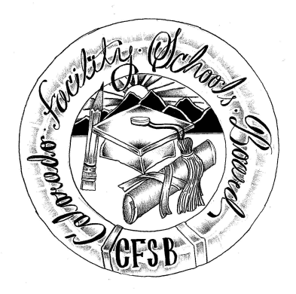
Colorado Facility Schools Board Agenda
January 12th, 2023
11:30 a.m. until the completion of the agenda

Shiloh Family Resource Pavilion In-Person & Zoom Virtually

11:30  12:00 | Lunch  Board Meeting will start - Call to Order  Approval of Minutes  Approval of Agenda | Action Item  Action Item
12:15 | Facility Schools Unit Update  - CDE/Facility Internal Updates  - Data Management and Systems Support  - iReady/Tuition Cost/December Staff  - Monitoring/Updates from the Field  - IEP System Updates/ State Assessments  - Curriculum/Induction/OOD Consortium  - New Program Support  - Update from Attorney General’s Office | Judy Stirman  Judy/Annie/Lori  Lori Kochevar  Robin Singer/Ann Symalla  Annie Haskins  Wendy Dunaway  Darren Serrato  Isabel Broer
12:45  1:00  1:10  1:30  2:00  3:00  3:30  4:00 | Board Notebooks  Break  Multilingual students  Strategic partners/Strategic plans  Common Assessment  JBC/Stakeholders Group/Bill – Update and Feedback  Opportunity for the Public to Address the Board  Members of the public who wish to address the board must sign up prior to the meeting. Presentations are limited to 5 minutes.  Next Steps/Adjournment of Meeting | Judy, Darren  Annie  Judy /Robin  Judy/Wendy/Lori  Judy /Wendy /Board

