This document contains the steps required to export the course code mappings from CDE’s Statewide Standard Course Code system, modify the course code values, and upload the courses into CDE’s Statewide Standard Course Code system.
- Go to the following link: https://cdeapps.cde.state.co.us/index.html

- Click on the Statewide Standard Course Codes System (SSCC) menu option on the left side of the screen.

- Log into the system using your single sign on. (Note: if you get an error indicating you do not have privileges please contact your local access manager to get the appropriate privileges.)

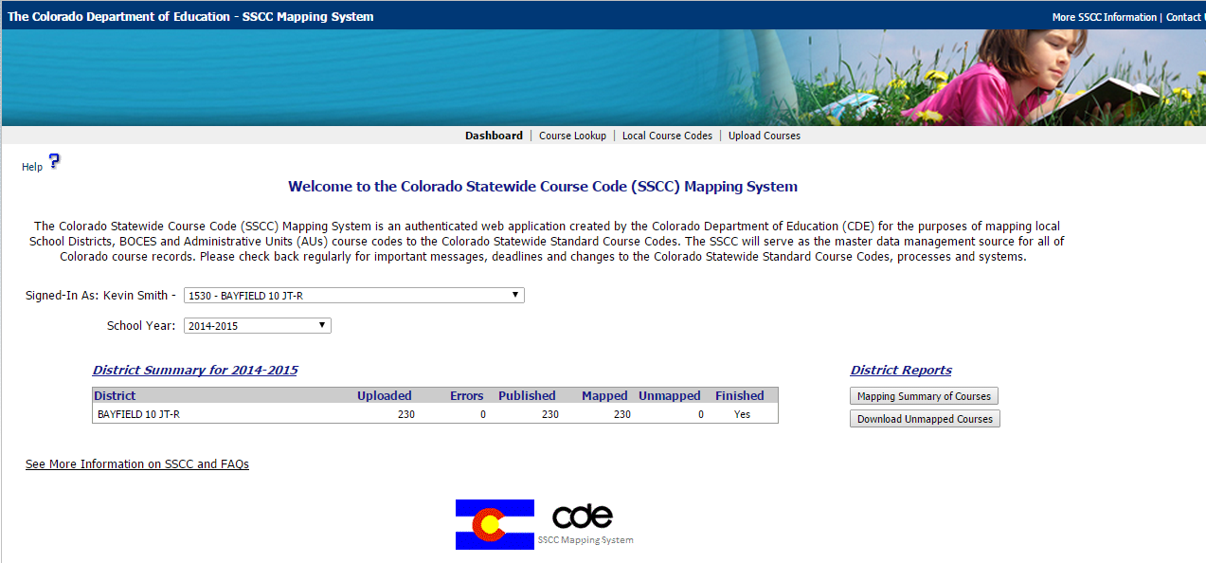

- Make sure you select the appropriate school year. This example uses the 2014-2015 school year, but you will want to select the 2019-2020 school year.

- At the top select the Local Course Codes option

- Click on the Export Courses button

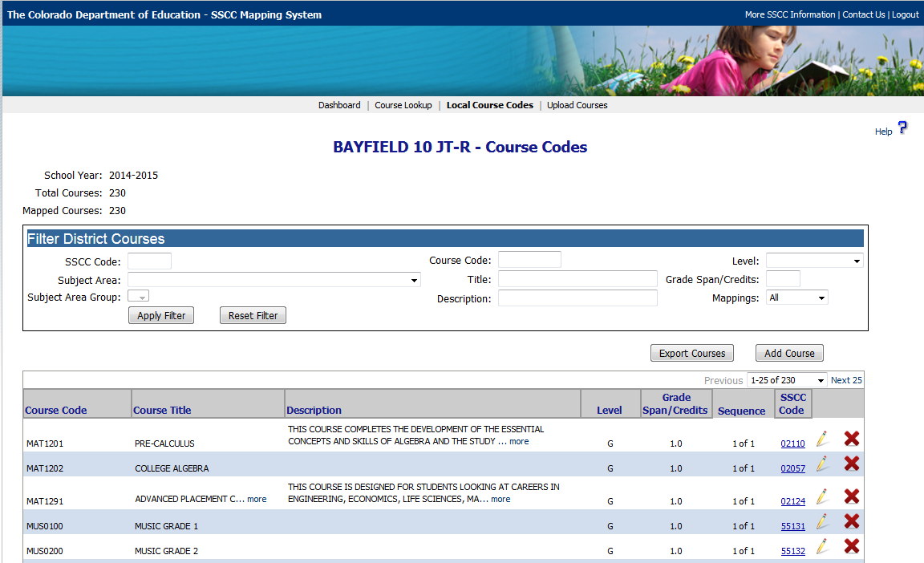
- Depending on the browser you are using, this will either prompt you to open a spreadsheet or download a spreadsheet in the bottom left hand corner of the browser. (In the example below: I was using Mozilla Firefox browser)
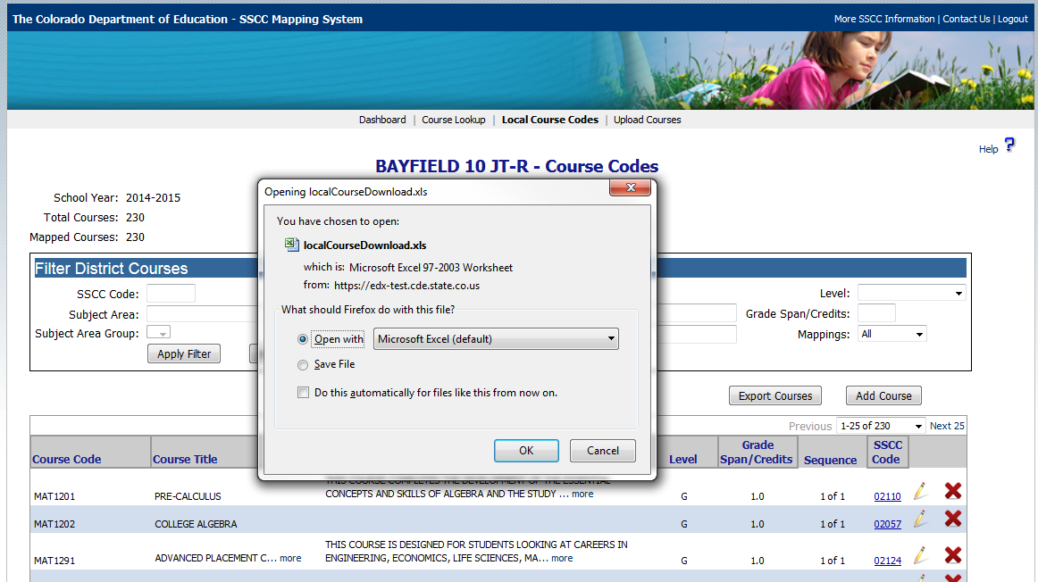
- Open the spreadsheet in excel and click Enable Editing
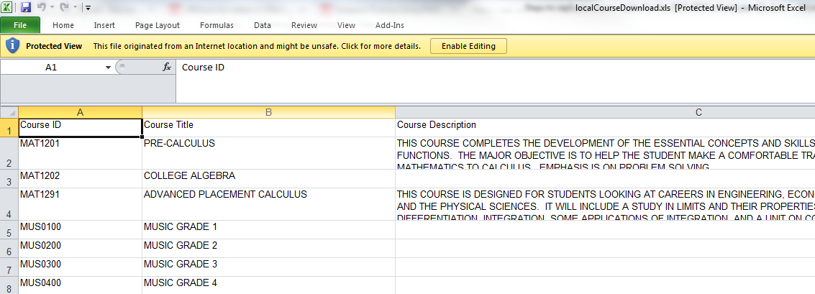

- Make any changes required to the spreadsheet. In this case, I added a description for the MUSIC GRADE 1 course.
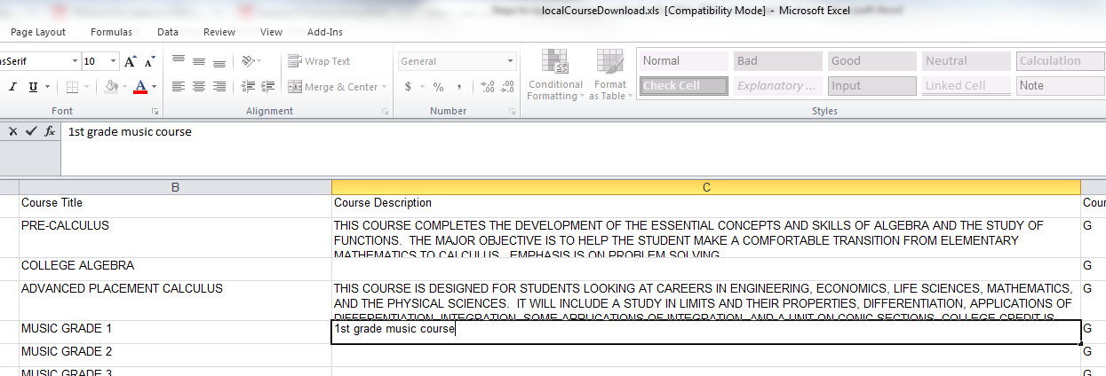

- After completing all the changes to the courses, click the file save as option.
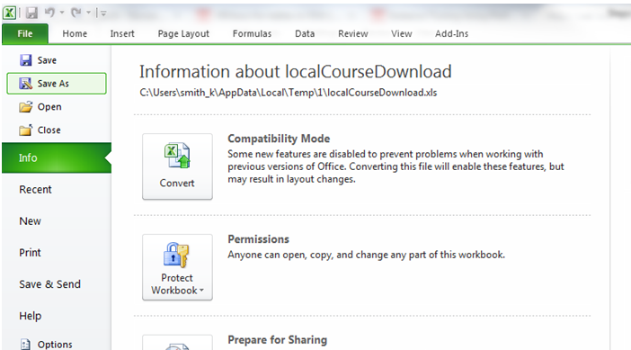

- This will open a file save as window. Please type in the file name and select Text (tab deliminted) from the Save as type: option.
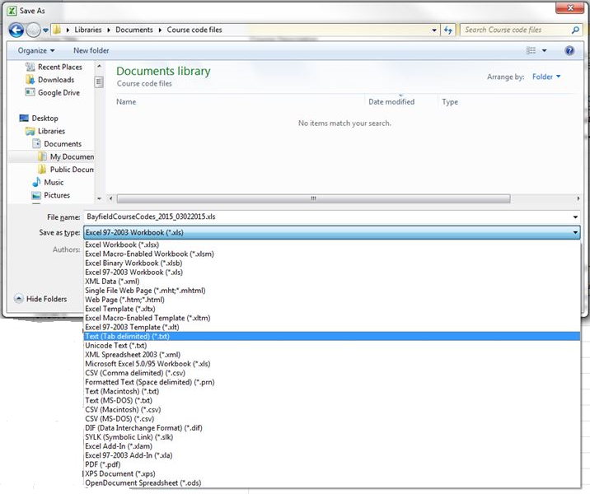

- Save the file as Text (tab delimited). This is done so the changes can be uploaded to the Statewide Standard Course Code system.
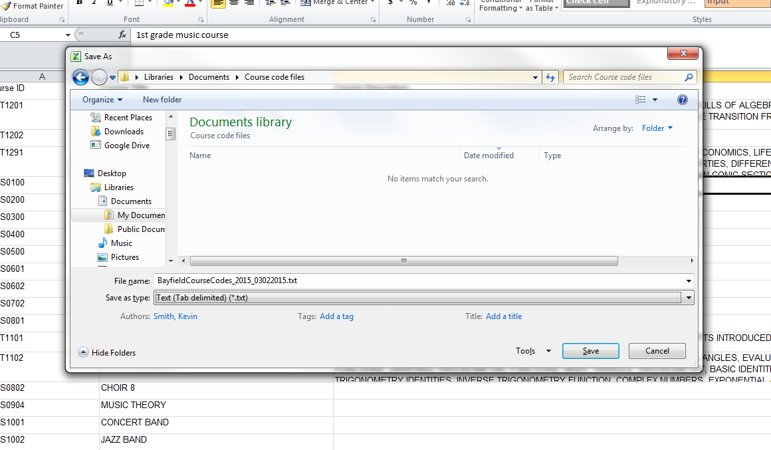
- System will prompt a warning message about some features not being compatible with Text (Tab Delimited). Do you want to keep the workbook in this format? Select Yes
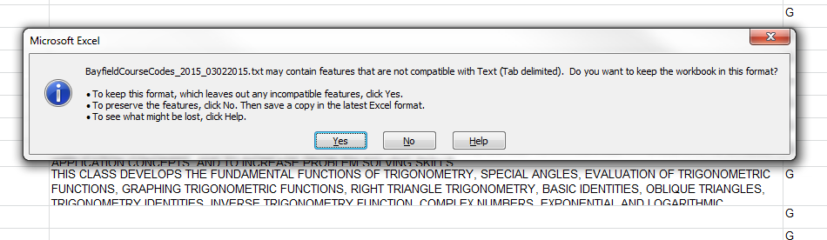
- Exit out of Excel. There is no need to save the file again unless other changes have been made. If you do want to save the file again, please repeat step 13 above.
That is it. You have exported the course code mapping from CDE’s Statewide Standard Course Code system, made changes and you now have a file you can import into CDE’s Statewide Standard Course Codes system. Please follow the steps in Uploading a file to the SSCC system video which located at the following link: http://www.youtube.com/watch?v=C_US5JRTmWw
Please feel free to contact Annette Severson at 303-866-6824 or severson_a@cde.state.co.us if you have any questions.

