INFANT (AGES 0-2)
Determination of primary setting should be based on the IFSP in place on December 1. For example, if the IFSP says that the child will receive one hour of physical therapy services in their home each week, then the home is the primary setting.
Special circumstances to consider:
- If a child is receiving services in more than one setting, count the child in the setting in which he or she receives the most hours of early intervention services. For example, a toddler who receives one hour of home-based service a month and four hours of service per month in a clinic (a service provider location) would be counted under the category “service provider location.”
- If services are delivered to a child and family members, count the child only under the primary setting in which the child is being served.
Infant Educational Environment Codes and Definitions
101 Program Designed for Children with Disabilities – This setting refers to an organized program of at least one hour duration provided on a regular basis. The program is usually directed toward the facilitation of one or more developmental areas. Examples include early intervention classrooms/centers and developmental child care programs.

102 Program Designed for Typically Developing Children – Services are provided in a program regularly attended by a group of children. Most of the children in this setting do not have disabilities. For example, this includes children served in regular nursery schools and child care centers.

103 Home – Services are provided in the principal residence of the child’s family or caregivers.

104 Hospital (inpatient) – Hospital refers to a residential medical facility. The child must be receiving services on an inpatient basis.

105 Residential Facility – Residential facility refers to a treatment facility which is not primarily medical in nature, where the infant or toddler currently resides.

106 Service Provider Location – Services are provided at an office, clinic, or hospital where the infant or toddler comes for short periods of time (e.g., 45 minutes) to receive services. These services may be delivered individually or to a small group of children.

107 Other Setting – Any service setting not included in the settings or programs listed above. For example, if the only component of the infant’s early intervention services is parent counseling during which the child is not present, and the child receives no direct service, count as “other.”

EARLY CHILDHOOD (AGES 3-5)
When reporting educational environments for children, ages three through five, please use the decision tree in the next page to determine which environment most accurately reflects where the child’s service is received.
Early Childhood Environment Codes and Definitions
204 Separate class – Report children who attend a special education program in a class with less than 50 percent of nondisabled children. Do not include children who also attend a regular early childhood program. They should be reported in one of the categories below (209 through 212).

205 Separate school – Report children who receive their education programs in public or private day schools designed specifically for children with disabilities. Do not include children who also attend a regular early childhood program. They should be reported in one of the categories below (209 through 212).

206 Residential facility – Report children who receive their education programs in publicly or privately operated residential schools or residential medical facilities on an inpatient basis. Do not include children who also attend a regular early childhood program. They should be reported in one of the categories below (209 through 212).

207 Home – Report children who receive special education and related services in the principal resident of the child’s family or caregivers, and who do not attend an early childhood program or a special education program provided in a separate class, separate school, or residential facility. Include children who receive special education both at home and in a service provider location. The term caregiver includes babysitters.

208 Service provider location – Report children who receive all of the special education and related services from a service provider, and who do not attend an early childhood program or a special education program provided in a separate class, separate school, or residential facility. For example: speech instruction provided in a private clinician’s office, clinician’s offices located in school buildings, hospital facilities on an outpatient basis, and libraries and other public locations. Do not include children who also receive special education at home. Children who receive special education in a service provider location and at home should be reported in the home category.

209 At least 10 hours per week and majority in regular early childhood program – Report children who receive the majority of hours of special education and related services in the Regular Early Childhood Program (and the children attend a Regular Early Childhood Program at least 10 hours per week).

210 At least 10 hours per week and majority in some other location – Report children who receive the majority of hours of special education and related services in a location other than the Regular Early Childhood Program (and the child attends a Regular Early Childhood Program at least 10 hours per week).

211 Less than 10 hours per week and majority in regular early childhood program – Report children who receive the majority of hours of special education and related services in the Regular Early Childhood Program (and the child attends a Regular Early Childhood Program less than 10 hours per week).

212 Less than 10 hours per week and majority in some other location – Report children who receive the majority of hours of special education and related services in some other location (and the child attends a Regular Early Childhood Program less than 10 hours per week).

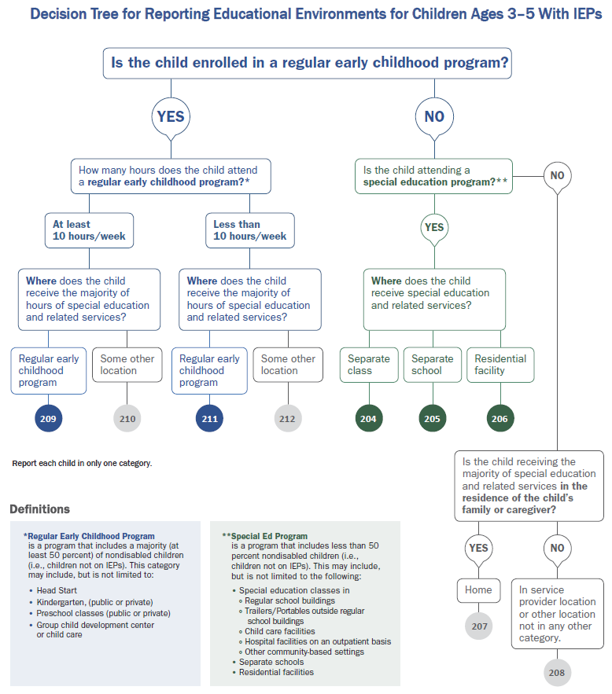
Clarifications
How should children receiving the majority of special education and related services in a location other than the child’s classroom but within the same building be reported? | Special education and related services delivered to the child in the course of daily activities and routines in which all children in the classroom participate (e.g., “circle time,” “learning centers”) would be considered as being received in the Regular Early Childhood Program. However, services delivered in a location that removes the child from the opportunity to interact with nondisabled children would not be considered as being received in the Regular Early Childhood Program. These include, but are not limited to, services delivered in a 1:1 therapeutic setting, or in a small group comprised solely of children with disabilities whether or not they are provided in another location within the building where the regular early childhood program is located.
When considering if a child is attending a regular early childhood program, does the child need to be enrolled in the program, vs. attending as a ‘visitor’ for a portion of time? | Administrative Units should report these data based on children with disabilities being enrolled in these types of programs. Children with disabilities being enrolled in a regular early childhood program most closely aligns with the intent of the least restrictive environment provisions of the IDEA.
Would informal settings with children without disabilities be considered as Regular Early Childhood Programs? | Informal settings, such as weekly school-based or neighborhood playgroups, or home settings are not considered Regular Early Childhood Programs for the data collection purposes, as these informal settings are generally not required to comply with a State’s early learning programs standards or curricula.

SCHOOL AGE (AGES 6-21)
Children should be reported according to the setting in which they have been placed for educational services.
To calculate the percentage of time inside the regular classroom, divide the number of hours the child spends inside the regular classroom by the total number of hours in the school day (including lunch, recess and study periods). The result is multiplied by 100. Time spent outside the regular classroom receiving services unrelated to the child’s disability, e.g., time receiving LEP services, should be considered time inside the regular classroom.
Educational time spent in age-appropriate community-based settings that include individuals with and without disabilities, such as college campuses or vocational sites, should be counted as time spent inside the regular classroom.
School Age Environment Codes and Definitions
301 Inside the regular class 80 percent or more of the time – Report children who receive special education and related services inside the regular classroom for 80 percent or more of the time. These are children who receive special education and related services outside the regular classroom for less than 21 percent of the time. This may include children with disabilities placed in the regular class with: (a) special education and related services provided within regular classes; (b) special education and related services provided outside the regular classes; or (c) special education services provided in resource rooms.

302 Inside the regular class no more than 79 percent of the time and no less than 40 percent of the time – Report children who receive special education and related services inside the regular classroom for no more than 79 percent of the time and no less than 40 percent of the time. These are children who receive special education and related services outside the regular classroom for at least 21 percent but no more than 60 percent of the time. Do not include children who are reported as receiving education programs in public or private separate schools or residential facilities. This may include children placed in: (a) resource rooms, with special education and related services provided within the resource rooms; or (b) resource rooms, with part-time instruction in a regular class.

303 Inside the regular class less than 40 percent of the time – Report children who receive special education and related services inside the regular classroom less than 40 percent of the time. These are children who receive special education and related services outside the regular classroom for more than 60 percent of the time. Do not include children who are receiving educational programs in public or private separate schools or residential facilities. This category may include children placed in (a) self-contained special education classrooms with part-time instruction in a regular class; or (b) self-contained special education classrooms with full-time special education instruction on a regular school campus.

304 Separate school – Report children who receive their educational programs in public or private separate day school facilities. This includes children with disabilities receiving special education and related services, at public expense, for greater than 50 percent of the time in public or private separate schools. This may include children placed in: (a) a public or private day schools for children with disabilities for a portion of the school day (greater than 50 percent) and in regular school buildings for the remainder of the school day; or (b) public and private residential facilities if the child does not live at the facility.

305 Residential facility – Report children who receive their educational programs in, and live in, public or private residential facilities during the school week. This includes children with disabilities receiving special education and related services, at public expense, for residential facilities. This may include children placed in: (a) public and private residential schools for students with disabilities; or (b) a portion of the school day (greater than 50 percent) and in separate day schools or regular school buildings for the remainder of the school day. Do not include children who receive education programs at the facility, but do not live there.

306 Homebound/hospital – Report children who receive education programs in a homebound/hospital environment. This includes children with disabilities placed in and receiving special education and related services in: (a) hospital programs; or (b) homebound programs. Do not include children with disabilities whose parents have opted to home-school them and who receive special education at the public expense.

307 Correctional facilities – Report children who receive special education in correctional facilities. Include all children receiving special education in: (a) short-term detention facilities (community based or residential); or (b) correctional facilities.

308 Private/Parochial Student on ISP – Report children who have been enrolled by their parents or guardians in regular parochial or other private schools and whose basic education is paid through private resources and who receive special education and related services at public expense from an administrative unit under a service plan.

Where can I learn more?
- Making Least Restrictive Environment Placement Decisions for Preschoolers – Technical Assistance Document
- Least Restrictive Environment (LRE) and Service Delivery YODEL – Guidance Video

