SPECIAL NOTE: This primary source set should be used within a unit on the Ute in Colorado. It should not be used as a standalone to teach about the Ute.
Grade Level:
4th

Essential Question:
What were the conflicts between the Ute and the Anglo-American settlers during the 1800s?

Supporting Questions:
- What were various perspectives on the Meeker Massacre?
- What were the results of 1868 Treaty?
- How did the Ute land change after 1882?

Source 1  New York Times Article, Oct. 1879. Colorado Governor Pitkin urges warfare on the Utes and Secretary Schurz (federal government) replies.  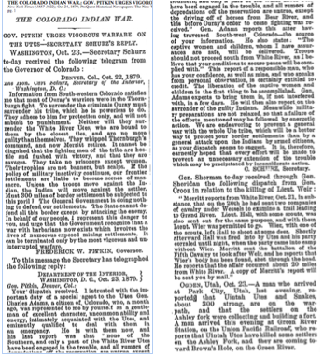  http://query.nytimes.com/gst/abstract.html?res=9B04E3D8103EE73BBC4C51DFB6678382669FDE&legacy=true | Source 2  Interview with Larry Cesspooch - a modern day Ute Storyteller (bottom of p. 2).  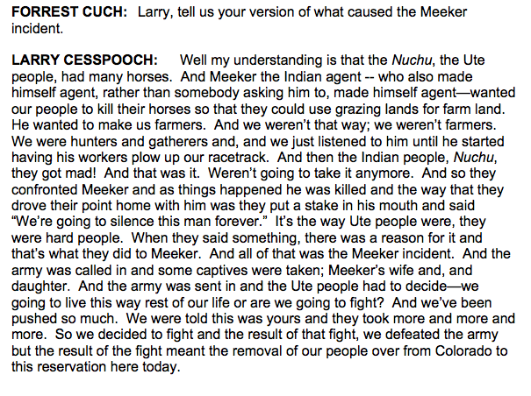  NOTE: The key perspective here is where he says that the army was called in. That happened prior to the attack at the Agency, and the Ute perspective is that the US Army illegally invaded the reservation in violation of the 1868 treaty. And they did that before Meeker was killed.  http://www.kued.org/sites/default/files/larrycesspooch.pdf

Source 3  Colorado Ute Indian Delegation in Washington DC, to sign the 1868 Treaty.  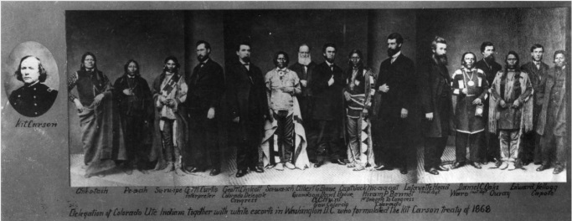  https://coloradoencyclopedia.org/image/colorado-ute-indian-delegation-1868 | Source 4  Treaty between the U.S. Government and the Ute Indians, 1868 (page 1)  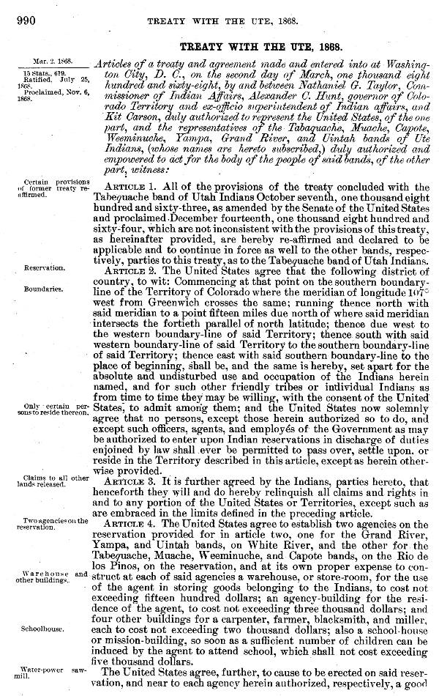  http://digital.library.okstate.edu/kappler/vol2/pgimages/ute0990.jpg
Source 5  Treaty between the U.S. Government and the Ute Indians, 1868 (page 2)  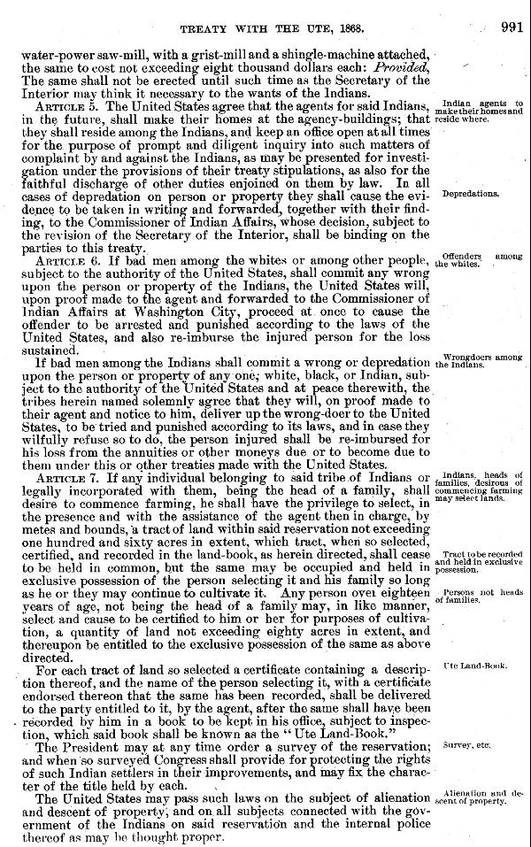  http://digital.library.okstate.edu/kappler/vol2/pgimages/ute0991.jpg  Link to complete text of the Treaty of 1868: http://digital.library.okstate.edu/kappler/vol2/treaties/ute0990.htm#mn1 | Source 6  Colorado-Utah map illustrating the stages of Ute removal from southwestern Colorado. (Delaney, 1974).  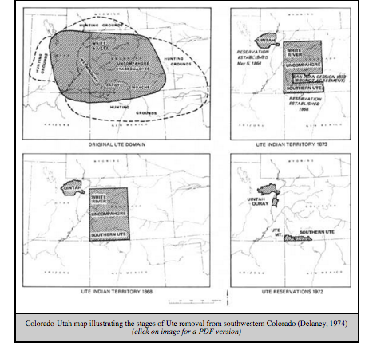  https://www.nps.gov/parkhistory/online_books/blm/co/10/images/map8.pdf

Background Knowledge / Contextual Paragraph for Teachers:
The Ute American Indians are some of the very first people to live in Colorado. Colorado has two different Ute tribes: The Ute Mountain Ute and the Southern Ute. The majority of the Ute people live on reservations that they govern themselves. Their language and culture has remained constant in their lives.
In early times, changes occurred after the Utes began interacting with Spanish explorers and traders. For example, the Utes began to incorporate horses into their daily lives. Almost 200 years later, many Anglo-Americans attempted to take Ute land as well as force the Ute people to adopt the culture of Anglo-Americans, which caused conflicts. In 1879, some of the Ute Indians fought against the U.S. Army and other representatives of the U.S. government on Ute reservations lands along the White River. During the fighting, Utes killed several people including soldiers and the Indian agent Nathan Meeker. U.S. soldiers also killed some Ute warriors. After the fighting, the U.S. government and the Colorado government tried to force the Utes off their land, and succeeded.

Additional Resources:
Horn, J. C. (2016, May 18). Brunot Agreement. Colorado Encyclopedia. Retrieved from http://coloradoencyclopedia.org/article/brunot-agreement

[Rocky Mountain PBS]. (2013, June 14). Colorado Experience: The Original Coloradans. [Video File]. Retrieved from https://www.youtube.com/watch?v=lWLdijamdcQ

Silbernagel, R. (2015, August 18). Meeker. Colorado Encyclopedia. Retrieved from http://coloradoencyclopedia.org/article/meeker-0

Building Background Knowledge for the Student
- To activate students’ background knowledge and/or build it on the topic of The Utes, ask the students: “Do you know who the first people in Colorado were?” If they do not know the answer, share with the students that it was The Ute American Indians. Next, create a KWL chart (divide anchor chart into three sections, and label the sections know, want, and learn). Have them complete the Know and Want section with what they know and what they want to learn. They can share what they know about Native Americans if they do not yet have background knowledge on this specific tribe.
- To build students’ background knowledge, conduct a shared reading of the book “The Utes” by Allison Lassieur.
- After the shared-reading, students will further their knowledge on the Utes by exploring History Colorado’s online exhibit on the Utes, called Ute Tribal Paths: http://exhibits.historycolorado.org/utes/utes_home.htm
  - Divide students into four groups. Each group will be assigned a subtopic on the site, such as Hides for Horses, Invasion, Reservation Life, and We Are Still Here. Groups will take notes using the Building Background graphic organizer (Material 1). After all groups have explored their subtopic, students will come together and share with their peers what they learned, using a jigsaw model. Students will take notes on the other topics.
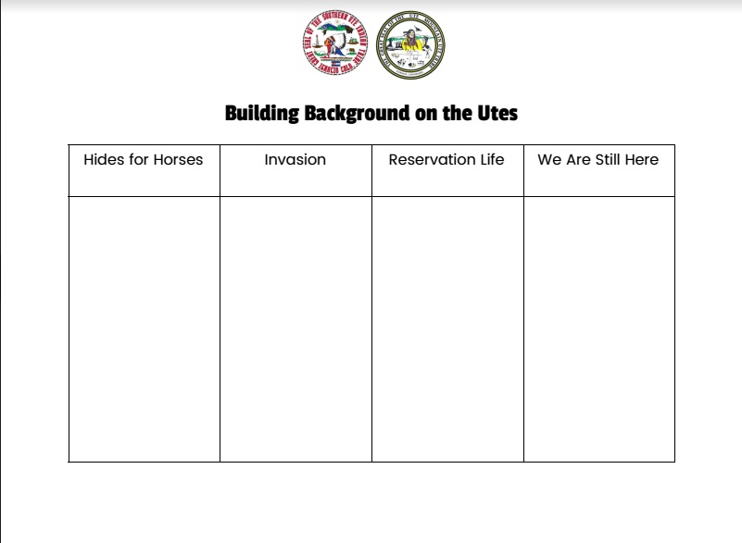

STRATEGY INSTRUCTION:

SOURCES 1-2:
- Quote-It Strategy
  - Students will explore three different viewpoints of the Meeker Massacre, using the Quote-It activity sheet (Material 2). Source 1 is a newspaper article from 1879. Students will read the telegram conversation between Governor Pitkin and Secretary Schurz, who were both working on the same side (for the U.S. government). Governor Pitkin provides a viewpoint that the Ute people are dangerous while the U.S. Secretary Schurz offers a viewpoint that the Indians are no threat. Source 2 is a transcription of an interview with Larry Cesspooch, a modern Ute storyteller.
  - Students will look for a viewpoint from each person, then quote and translate it into their own words to show their understanding of the viewpoint. The following worksheet (Material 2) can be used.
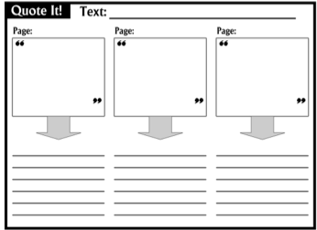
Source: Linder, R., Dr. (2013, September 21). Graphic Organizer: Practicing Textual Evidence. Retrieved May 25, 2017, from http://ontheweb.rozlinder.com/graphic-organizer-practicing-textual-evidence-using-quote-it/
SOURCE 3:
- Photo Analysis Sheet
Using the Photo Analysis Sheet (Material 3), the students will do a quick analysis of Source 3, a picture of Colorado Ute Indian Delegation in Washington DC, to sign the 1868 Treaty.

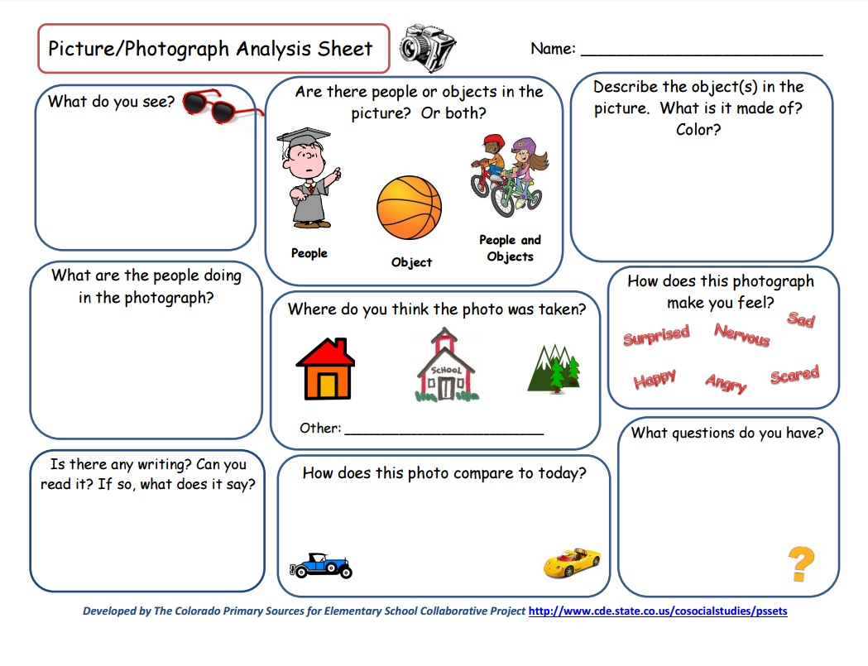
Source: The Colorado Primary Sources for Elementary School Collaborative Project. (n.d.). Elementary Primary Source Sets. Retrieved from https://www.cde.state.co.us/cosocialstudies/imageworksheetpdf

SOURCE 4:
- Close Read
  - Students will read Source 4 (the Ute Treaty), the treaty that was made between the Utes and the U.S. government in 1868.
  - Students will do a close read activity by answering the questions on the close read activity worksheet (Material 4).
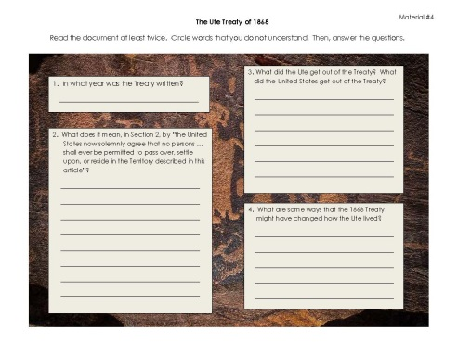
SOURCE 5:
- Map Analysis Sheet
  - Students will use the Map Analysis Sheet (Material 5) to analyze the maps depicting Ute land and then discuss how the land changed after the Utes’ interaction with the Anglo-American settlers.
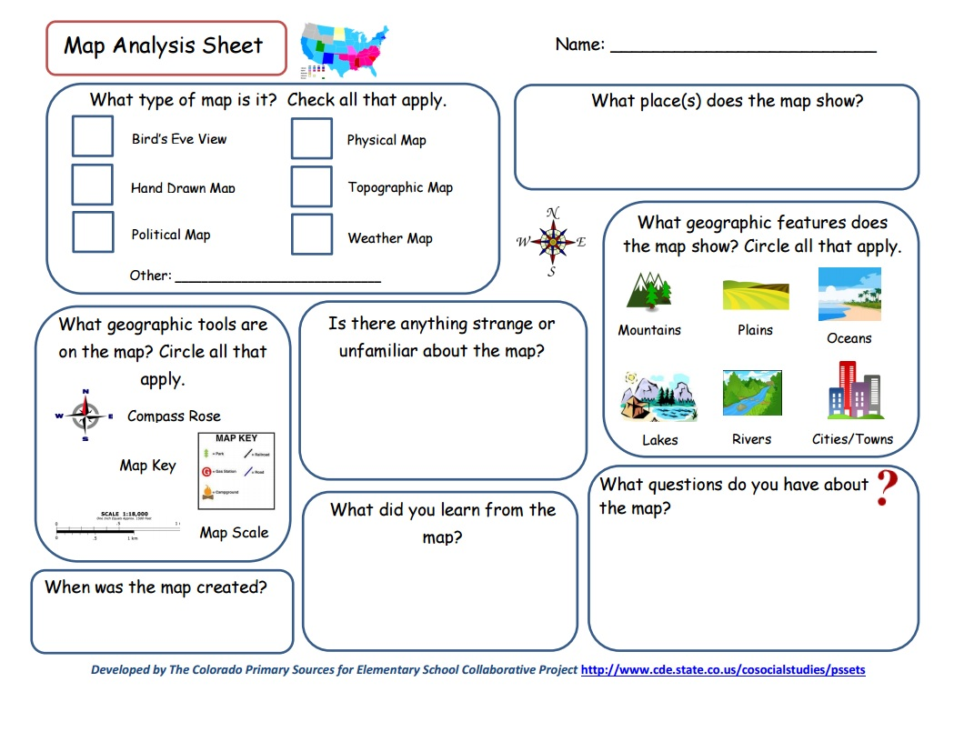
Source: The Colorado Primary Sources for Elementary School Collaborative Project. (n.d.). Elementary Primary Source Sets. Retrieved from https://www.cde.state.co.us/cosocialstudies/mapworksheetpdf

Strategy Instruction Differentiation:
Teachers can read the interview with Larry Cesspooch aloud for students who need support.

Additionally, teachers may provide students with sections of the 1868 Treaty highlighted for focused reading, or create simplified versions of the treaty and the newspaper article for students to read. These texts are challenging, therefore, it will take some consideration of reading levels in the classroom before having students read the texts.

Cause and Effect Poster on Interactions between the Ute and Anglo-American Settlers:
- Students will create posters in groups of four. Before they begin on their posters, group roles should be assigned so every student is held accountable.
- Students will make a cause and effect poster about the interaction between the Ute and the Anglo-American settlers during the 1800s. The poster should have a title, pictures, proper grammar and punctuation, and should answer the essential question: What were the interactions between the Ute and the Anglo-American settlers during the 1800s? Students may explore the topics of The Meeker Massacre, the Brunot Agreement, or Ute land loss in order to answer the question.

Assessment:
Gallery walk presentation:
- Have the students place their posters around the classroom. Groups will visit each poster, observing their peers’ work. After all posters have been viewed, students will come back together as a group and share what they learned from others’ work.
- The teacher will use a rubric (Material 6) to grade the students’ posters on how they answered the essential question, their use of pictures, use of conventions, and their organization and creativity.
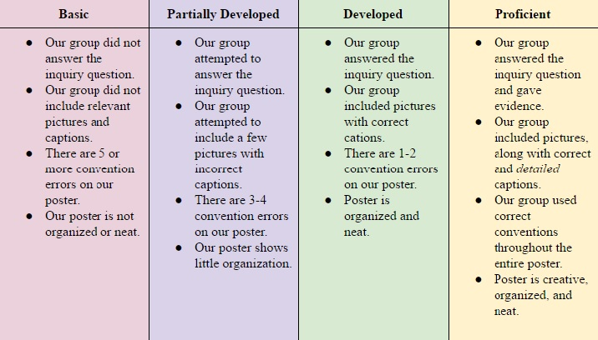

Colorado Social Studies Standards:

- SS4. S1. GLE4. EOb: Describe interactions among people and cultures that have lived in Colorado
- SS4.S1.GLE4.EOd: Identify and describe how major political and cultural groups have affected the development of the region
- SS4. S1. GLE4. EOc: Explain the cause-and-effect relationships in the interactions among people and cultures that have lived in or migrated to Colorado
- SS4. S1. GLE4. EOb: Analyze primary source historical accounts related to Colorado history to understand cause-and-effect relationships
- SS4. S2. GLE4. EOa: Answer questions about Colorado regions using maps and other geographic tools.

Colorado Reading & Writing Standards:

- RWC4. S1. GLE4. EOa: Engage effectively in a range of collaborative discussions (one-on-one, in groups, and teacher-led) with diverse partners on grade 4 topics and texts, building on others' ideas and expressing their own clearly
- RWC4. S1. GLE4. EOb: Paraphrase portions of a text read aloud or information presented in diverse media and formats, including visually, quantitatively, and orally
- RWC4. S2. GLE4. EOa.ii: Refer to details and examples in a text when explaining what the text says explicitly and when drawing inferences from the text.
- RWC4.S4.GLE4.EOa: Conduct short research projects that build knowledge through investigation of different aspects of a topic.
- RWC4.S1.GLE4.EOd: Report on a topic or text, tell a story, or recount an experience in an organized manner, using appropriate facts and relevant, descriptive details to support main ideas or themes; speak clearly at an understandable pace.

