

Poster Analysis Sheet

Name: _______________________________

Are there any words you don’t know?

If so, write them here:



What is the purpose of the poster?





What questions do you have?

Who designed the poster?

What time period is the poster from?

What is the main idea of the poster?

How does the poster make you feel?

What grabs your attention first when you look at the poster?

**Word(s)**

Other: _________________

**Color(s)**

**Picture(s)**

Look them up in the dictionary to learn what they mean.



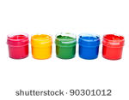

What are the main colors in the poster?

What symbols are used in the poster?

