Name: _________________________

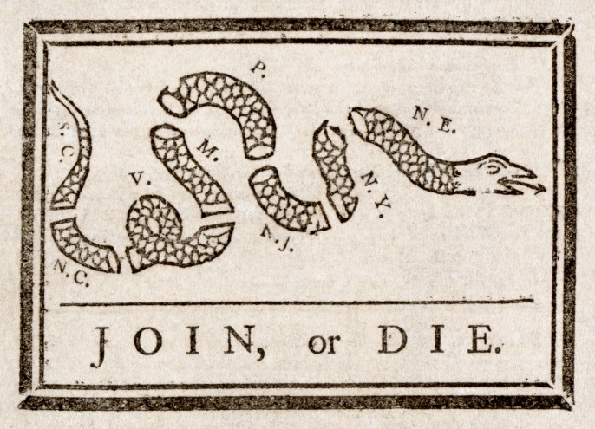

Political Cartoon Analysis Sheet

Describe the action taking place in the cartoon.

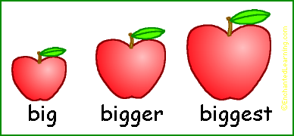



What is the cartoonist’s opinion on this issue?

Record any important dates or numbers that appear in the cartoon.

What is the cartoon caption or title?





What issue is this political cartoon about?

What questions do you have?

What time period is the political cartoon from?

List adjectives that describe the emotions portrayed in the cartoon.

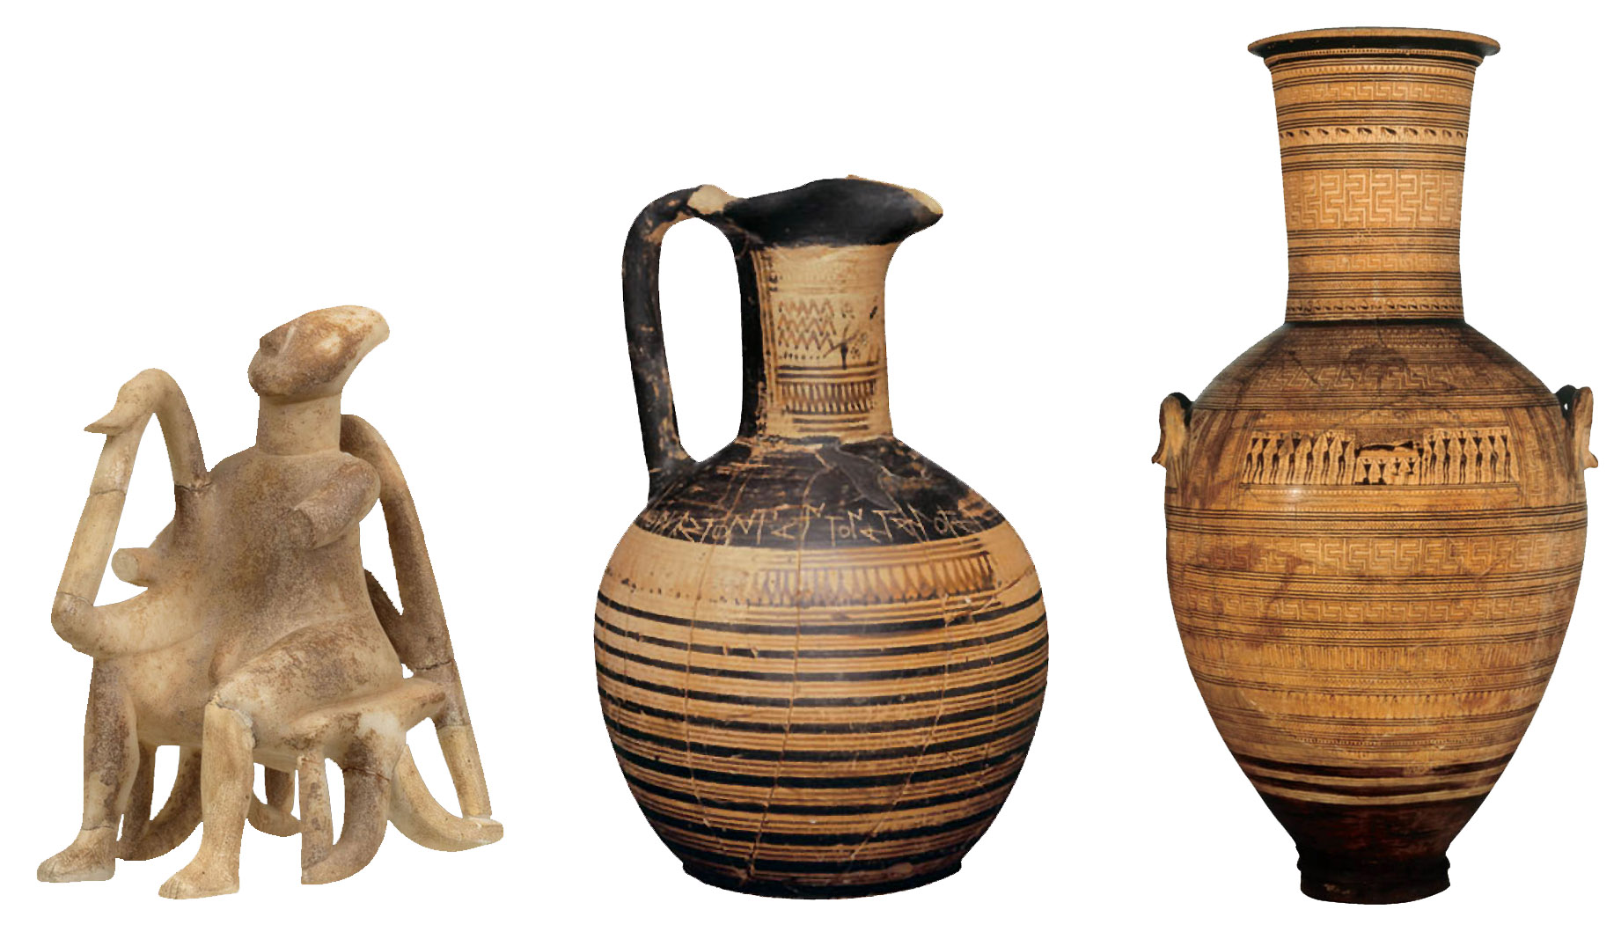

List the objects or people you see in the cartoon.