Grade Level/ 5th

Essential Question:
Is the Declaration of Independence the best breakup letter in history?

Supporting Questions:
- What were the reasons why the colonists wanted to declare their independence?
- How did the points of view of the British and the American colonists differ?
- How does the Declaration make an argument for independence?

Source 1  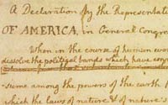  Original Rough Draft of the Declaration of Independence | Source 2  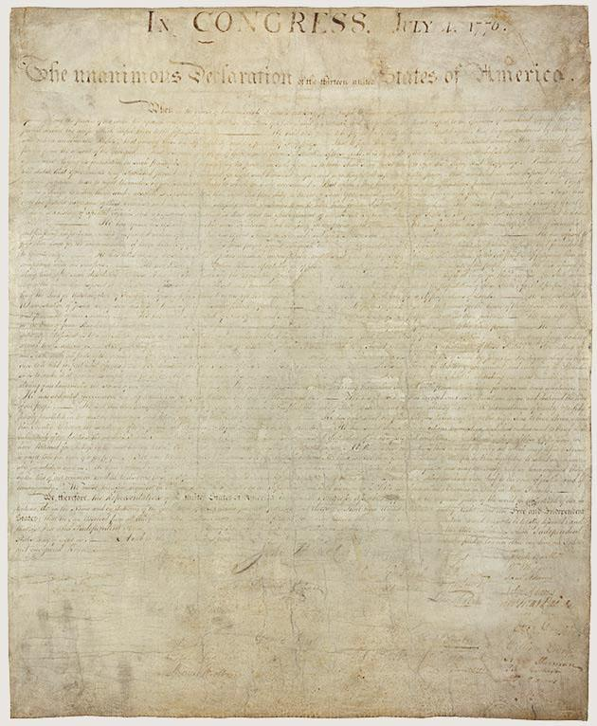  The Declaration of Independence

Background Knowledge / Contextual Paragraph for Teachers:
The Declaration of Independence is one of the seminal texts in American history, and students’ understanding of it is an important part of the standards for 5th grade social studies in Colorado. However, the original text is not written at a 5th grade reading level. The purpose of this resource set is to help teachers place the Declaration in context to help students understand why it was written, to compare the point of view of King George III and the American colonists, and then to deconstruct the reasons and evidence that were articulated in the document. A suggested assessment to use with these resources has students write a “breakup letter,” taking the point of view of the colonists writing to King George to explain the reasons for them declaring the independence. Through this assessment, students will summarize the arguments presented in the Declaration in an engaging and creative mode of writing.

Building Background Knowledge for the Student
Prior to reading the Declaration of Independence, it may be helpful for students to have some background on the events leading up to the American Revolution that angered many of the colonists. These events may include the Stamp Act, the Boston Massacre, the Boston Tea Party, and the first and second Continental Congress.
Sample introduction paragraph for students:
- What do you do when you want to break up with someone? Do you call them on the phone? Write them a text? Tell them in person? When the thirteen U.S. colonies decided they wanted to “break up” with the king of England, King George III, they called on a group of men, including Thomas Jefferson, John Adams, Benjamin Franklin, Roger Sherman, and Robert R. Livingston, to draft a declaration that would outline the reasons why they believed they no longer wanted to be a part of Great Britain. This document, the Declaration of Independence, is one of the most important pieces of writing in American history. You will explore the different versions of the Declaration that were created, read other documents showing other points of view, and then rewrite the Declaration of Independence in your own words as a break-up letter from the colonists to King George III.

Strategy Instruction:
- Summarizing: Get the GIST Strategy
- Have students read aloud a version of the Declaration of Independence.
- The teacher can read aloud the original version to students so they can hear the original language and compare it to the rewritten version
- Have students re-read the leveled version of the text and summarize it using the “Get the GIST” strategy (find a sample student handout here). They will identify the 5 Ws and an H (who, where, what, why, when and how the article is about). Then, they will write a summary of the article that is 20 words or less.
- Analyze point of view: Circle of Viewpoints
  - Once students have demonstrated a level of literal comprehension of the Declaration, they can begin to analyze the text and its effect by comparing different points of view.
  - Viewpoints students could compare include: the authors of the Declaration, Patriot colonists, Loyalist colonists, King George III/British citizens, and/or citizens of other nations, such as France.
  - Suggested sources for this activity include King George’s address to Parliament, the letter from a loyalist to his patriot father, and the timeline of events leading up to the Declaration.

Strategy Instruction Differentiation:
Provide the students with an annotated Declaration of Independence.
Sentence stems: provide sentence stems for students inferring and analyzing points of view.
- The colonists believed...
- However, the loyalists thought…
- King George responded by…
- This makes me think....
- This makes me wonder...
Chunking the text: Have students read and analyze the text in different chunks. Three chunks you could break the Declaration into are the introduction or preamble, the list of grievances against the British, and the conclusion with the formal declaration of war. You can also add line numbers to the text to aid in discussion with students.

Discussion:
Suggested discussion questions:
- When the Declaration was written, the colonists and the British had already been fighting for more than a year. Why did the Founding Fathers think it was necessary to write the Declaration of Independence down?
- Thomas Jefferson began the Declaration by saying that the Declaration was “unanimous.” What does this word mean here? Why would it be important that the Declaration was a unanimous document?
- Which of the grievances against the king do you think was the worst? Why?
- The closing sentence states, “...we mutually pledge to each other our Lives, our Fortunes, and our sacred Honour.” What do you think this means? What were they promising to each other? What problems or dangers might they face because of this promise?
Suggested discussion strategies to use:
- Human timeline: Have students create a human timeline of events leading to and following the Declaration of Independence. Give students (or have them brainstorm) a list of important events. Assign students or groups of students different events from the list and write a short summary of the event. Then have them line up around the room in order and share their event, the date of the event, and why it has significance to the time period.
- Thrash-out: A thrash-out is a short, informal, whole class discussion of a controversial question or idea. Students can use a trash-out to help them clarify the points of view and arguments made by the different sides during the American Revolution. First, students read the various documents, then have them role play the different sides to restate their arguments and viewpoints on the events leading up to the Revolution. The entire thrash-out should take no more than 10-15 minutes and can be followed by students informally writing to reflect on the activity.

Assessment:
Students re-write the Declaration as a breakup letter. They take on the viewpoint of the colonists and write a letter to King George III detailing the reasons why they are “breaking up” with him.
- Start by having the whole class make a list of characteristics of a breakup letter. You may want to have them read a sample break-up letter first. Some of the things they may list could include
  - Emotion: Is the letter sad, angry, happy, or a combination of emotions?
  - Reasons: What reasons does the writer give for breaking up?
  - Evidence: What evidence does writer use to support their reasons?
  - Letter format: What makes the document a letter? How is it formatted?
- Then, have students plan for how they will write their break-up letter to King George. What emotions did the colonists have about Great Britain and about the king? What reasons did they have for wanting to break-up with Great Britain? What events and actions supported their reasons?
- Finally, have students take their planning and write a letter.
- Sample extension activities:
  - As a follow-up, students may read their letters aloud or use them to create a role-play that they perform.
  - Students may also choose to write letters from other points of view, such as a loyalist, King George III, or a resident of a different country, such as France.
Note: Depending on your students and your personal preference, you may choose to frame this assignment as a breakup between friends or as a breakup between romantic partners/boyfriend and girlfriend/etc.

Colorado Academic Standards for Social Studies:
- SS.5.4.2.b. Explain the foundational documents and significance of the events that led to the establishment of the United States government. Including but not limited to the Philadelphia Convention, the Declaration of Independence, the Articles of Confederation, the Iroquois Confederacy, the Constitution, and the Bill of Rights.

Reading and Writing Standards:
- Write narratives to develop real or imagined experiences or events using effective technique, descriptive details, and clear event sequences. (CCSS: W.5.3)
- Explain the relationships or interactions between two or more individuals, events, ideas, or concepts in a historical, scientific, or technical text based on specific information in the text. (CCSS: RI.5.3)

Sample Activities:
- Why are there so many versions of the Declaration? Have students analyze some of the various versions of the Declaration of Independence from the Library of Congress, including the versions that show Thomas Jefferson’s revisions, handwritten, and printed copies. Use these versions to have students discuss and write about the writing process, and how writers edit their work, look for feedback, and publish their writing in various forms, both in the past and today.
- Role playing the Revolution: Have students research and create either a role play or a tableau of various events from the lead-up to the American Revolution.

Source 3:    Timeline of events from June 7, 1776 to January 18, 1777 | Source 4:  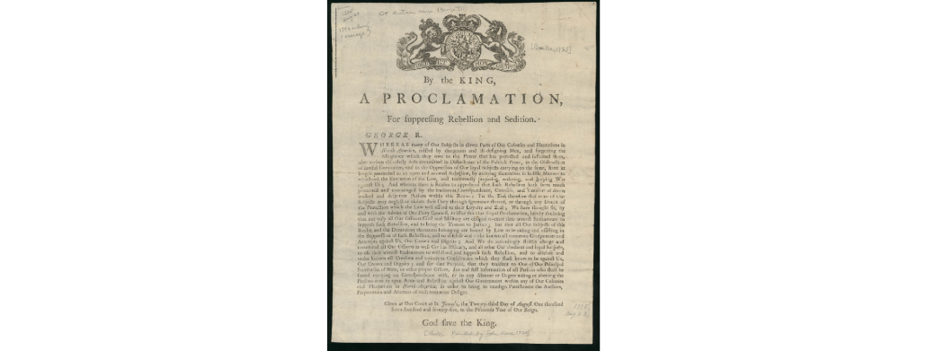  King George III's address to Parliament discussing his views on the rebellion in the American Colonies
Source 5:  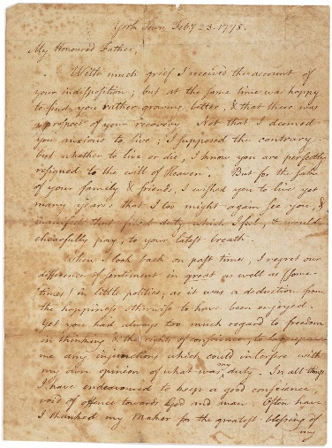  A patriot’s letter to his loyalist father | Source 6:  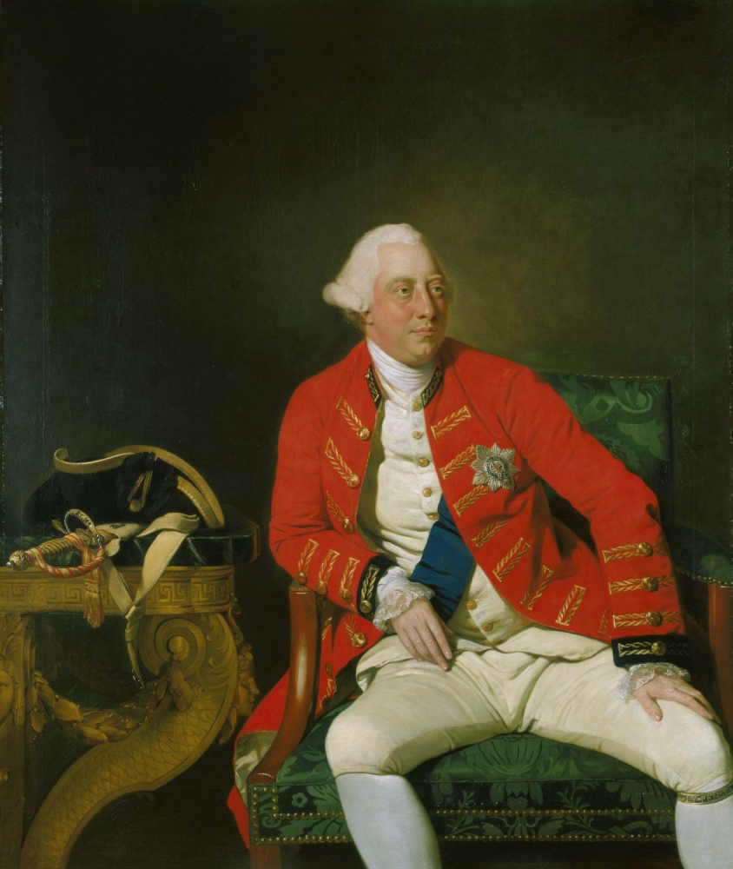  “Extravagant and Inadmissible Claim of Independency”  Article with the story of England's reaction to the Declaration of Independence including King George III address to Parliament Oct. 31, 1776.

