Grade Level:
6th Grade

Essential Question:
How does art represent the values of a people?

Supporting Questions:
- What can this painting and map tell us about Aztec culture, life, society, etc.?
- What do Aztec symbols represent?

Source #1
Aztec Codex Mendoza (Folio 2)
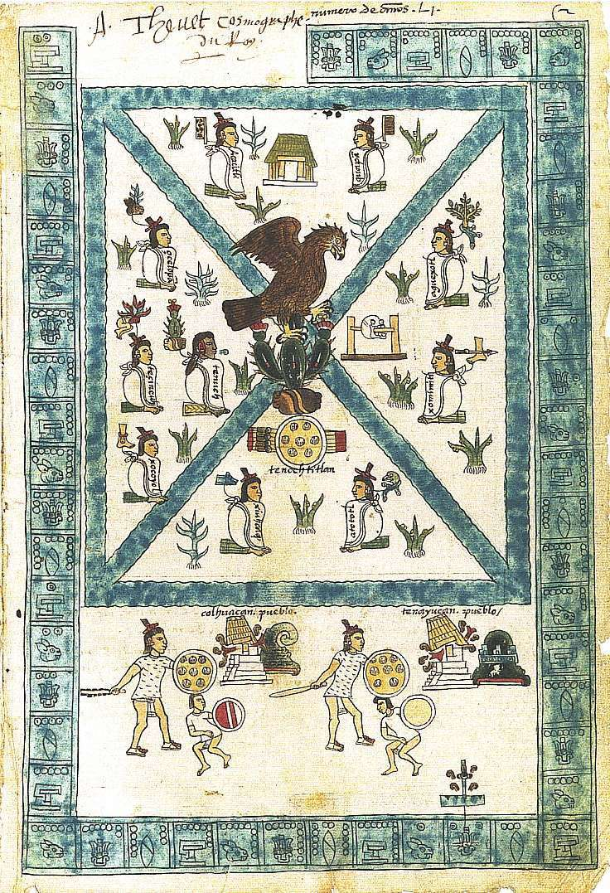
PublicDomainReview.org

Background Knowledge / Contextual Paragraph for Teachers:
After the Spanish conquered the Aztecs in 1519, some Spanish priests and colonial leaders asked Aztec artists and priests to describe Aztec life and culture. This codex is a book that was created in 1541-1542 for the Spanish ruler of Mexico, Antonio de Mendoza. The image appears as the frontispiece of the book and includes information about the Aztec capital city, Tenochtitlan.

For more background information on the Codex Mendoza and other MesoAmerican art:
- Check SmartHistory.org
- Public Domain Review
- La Gente Online Exhibit at History Colorado

Building Background Knowledge for the Student
When Hernan Cortes led the Spanish military force that conquered the Aztec people in 1519, he was mainly concerned with replacing Aztec culture and religion with Spanish traditions and Catholicism. The Spanish conquerors destroyed the main temples and religious artifacts in the Aztec capital of Tenochtitlan, for example. But a few Aztec young men educated by Spanish priests were later invited to record some details about Aztec life before contact with Europeans. Education had been compulsory for male Aztec children before the Spanish arrived. Boys were taught to read and interpret ritualistic calendars and Aztec history. Memorization was very important to these Aztec students, and this allowed for some recovery of Aztec poems and traditions by later scholars. Most of the information about the Aztecs, however, comes from Spanish colonizers. So this codex, and others like it, offer an unusual opportunity to recover lost perspectives.

For additional background information, see Miguel Leon-Portilla, ed. The Broken Spears: The Aztec Account of the Conquest of Mexico (1962)

Strategy Instruction:
This collection of sources is designed to build visual literacy skills and use images to explore cultural and symbolic meaning.
Students could begin this interpretive work either before or after a study of the Spanish Conquest of the Aztecs. The sources can be useful for understanding some basic details about pre-conquest Aztec society.
- Invite students to compare the Codex Mendoza image and the current Mexican Flag.
- Then guide student analysis of the details and subsections of the Codex.
- Students can also compare the Codex Mendoza image with the 16th century map drawn after the conquest.
- To make a modern connection, students could examine the Colorado State Seal for symbols as well.
- An assessment of student understanding could invite students to consider useful symbols for representing their own city or community in ways similar to the Aztec artists who created the Codex Mendoza.

Strategy Instruction Differentiation:
This collection of sources is organized chiefly around images, thus, would not pose as many barriers to student interpretation as text might. Included below are suggestions for extending the investigation with additional research.

Discussion:
- Start with a comparison of the Section 1 of Codex Mendoza showing the eagle symbol and the Mexican flag also showing the eagle symbol. Invite students to compare and contrast these images.
- Now look at the other symbols in the Codex Mendoza. Which of the men drawn are differently from the others? Do you think one of the figures is more or less important than the others? Why? What symbols and colors signify importance?
- Next ask students to compare the entire Codex Mendoza and the Map of Tenochtitlán. Does the representation of the original map from 1541 by an Aztec artist coincide with the map drawn in 1550 by a different Aztec artist supposedly with European schooling?
- After reviewing these sources, students could begin to consider broader questions: What kind of society did the Aztecs organize? How did the Aztecs record history in the Codex Mendoza?

Assessment:
- How would you (students) draw a representation of your own city in ways similar to the Aztec artists who created the Codex Mendoza? What key symbols would help tell the history of this place? What geographical features should be included?
- What do the symbols represent in the Colorado state seal? How do these symbols represent your own city or state? If we were to recreate the Colorado state seal, how would it differ from the current seal? What should be included or taken out?
- For an extended project, students could research the unexpected journey of the Codex Mendoza as it was captured by pirates when en route from Mexico to Spain. What does that journey of this document tell us about European competition for colonizes and resources in the Western Hemisphere? Should the Codex be returned to modern Mexico as its ultimate “home”? Why or why not?

Colorado Academic Standards for Social Studies:
- History Standard 6.1.1a: Identify ways different cultures record history in the Western Hemisphere through written and oral sources.
- History Standard 6.1.1b: Analyze multiple primary and secondary sources while formulating historical questions about the Western Hemisphere. For example: Oral histories, art, artifacts, eyewitness accounts, letters, and diaries, real or simulated historical sites, charts, graphs, diagrams, and written texts.

2020 Colorado Reading, Writing, & Communicating Standards
6th Grade Reading for All Purposes
a. Use Key Ideas and Details to:
i. Cite textual evidence to support analysis of what the text says explicitly as well as inferences drawn from the text. (CCSS: RL.6.1)

Sample Activities:
- Examine primary source images to analyze symbols.
- Compare sources.
- Create a symbolic map of your own community.

Extra Source 1  Section 1 of Codex Mendoza - 1542  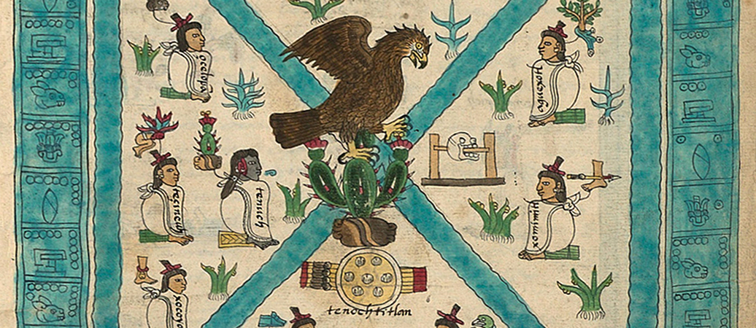  Mexican Flag  Mexican Flag | Extra Source 2  Topographical map of Tenochtitlán (Mexico City) and its surroundings, 1521  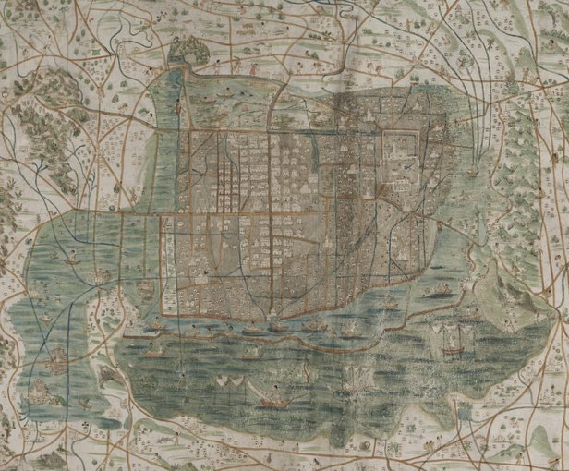
Extra Source 3  Section 2 of Codex Mendoza  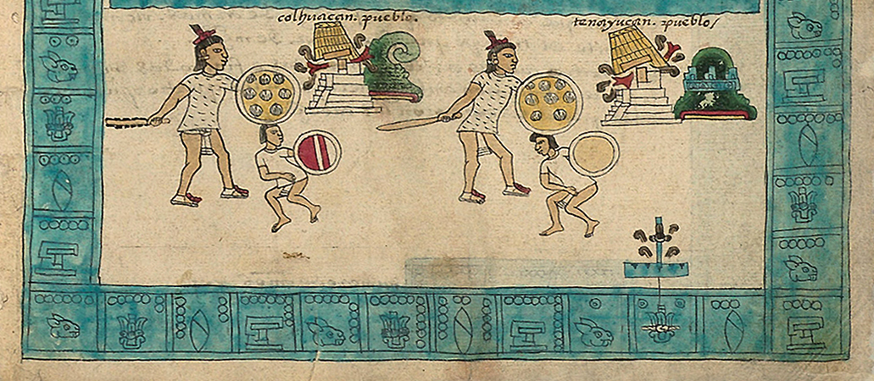 | Extra Source 4  Colorado State Seal  